Overall survival
Follow-up for 2 years = 87%
Median FU (Range) = 51 months (0 – 288 months)

Case Processing Summary
Total N | N of Events | Censored
 |  | N | Percent
486 | 15 | 471 | 96.9%

Time (years) | Survival probability | SE
2 | 97.1 | 0.8

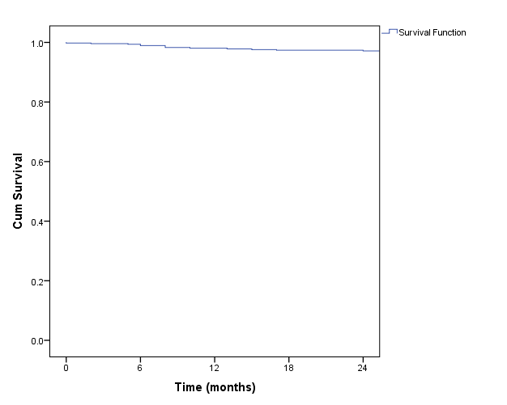

Case Processing Summary
Gal3Cy | Total N | N of Events | Censored
 |  |  | N | Percent
>40 - 150 | 171 | 12 | 159 | 93.0%
>150 | 315 | 3 | 312 | 99.0%
Overall | 486 | 15 | 471 | 96.9%

Gal3Cy | >40 - 150 |  | >150 |  | P-value
Time (years) | Survival probability | SE | Survival probability | SE
2 | 93.7 | 1.9 | 99.0 | 0.6 | 0.001*

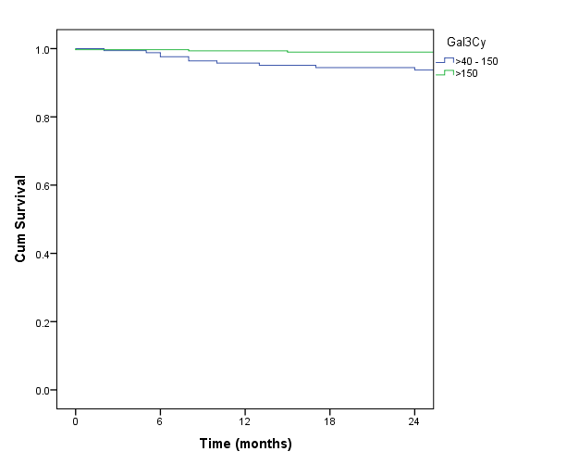

Disease free survival

Case Processing Summary
Total N | N of Events | Censored
 |  | N | Percent
486 | 41 | 445 | 91.6%

Time (years) | Survival probability | SE
2 | 94.3 | 1.1

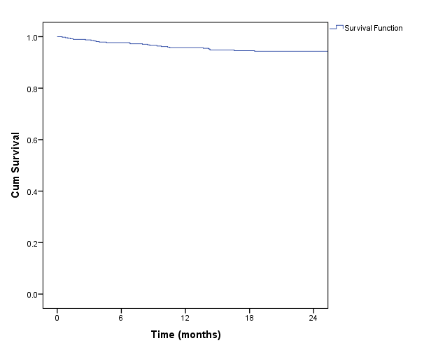

Case Processing Summary
Gal3Cy | Total N | N of Events | Censored
 |  |  | N | Percent
>40 - 150 | 171 | 35 | 136 | 79.5%
>150 | 315 | 6 | 309 | 98.1%
Overall | 486 | 41 | 445 | 91.6%

Gal3Cy | >40 - 150 |  | >150 |  | P-value
Time (years) | Survival probability | SE | Survival probability | SE
2 | 86.1 | 2.7 | 99.0 | 0.6 | 0.001*

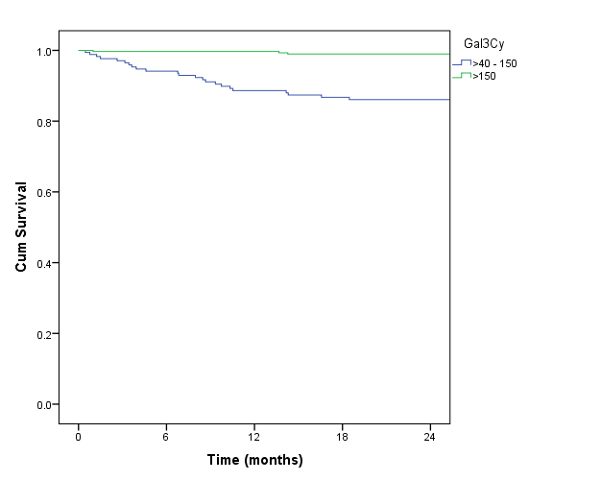

Univariate analysis-OS
 | Hazard ratio | 95.0% CI for HR |  | P-value
 |  | Lower | Upper
Gal3 Cy ( >40 -150 v/s >150) | 7.67 | 2.16 | 27.20 | 0.002*

Univariate analysis-DFS
 | Hazard ratio | 95.0% CI for HR |  | P-value
 |  | Lower | Upper
Gal3 Cy ( >40 -150 v/s >150) | 11.16 | 4.69 | 26.56 | 0.001*

