How to use breathing exercise devices
Breathing exercise devices
Breath goal-in | 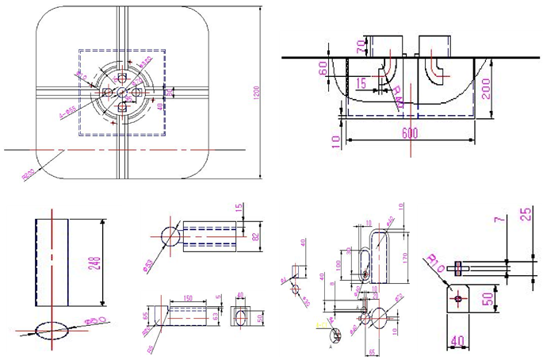  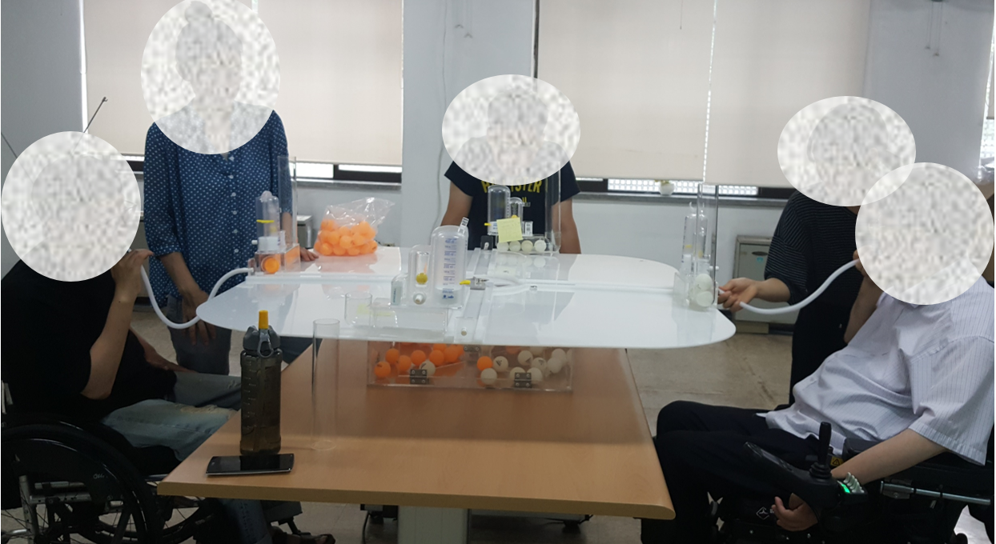  - One to four people can participate.  - After inserting the hose into the Spiral Ball inspiration part, move a table tennis ball (using inspiration).  - After inserting the hose into the Spiral Ball expiration part, avoid the obstacles and put a table tennis ball into the goal (using expiration).  ※ You can freely modify the rules (e.g., put a table tennis ball in another goal) and play.  Improvement is needed so that the user can use inspiration and expiration without moving the hose.
Breathing billiard | 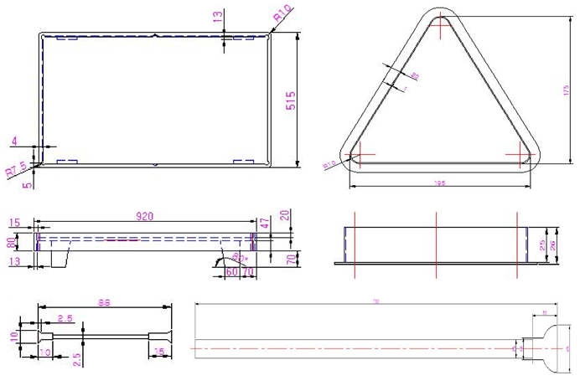  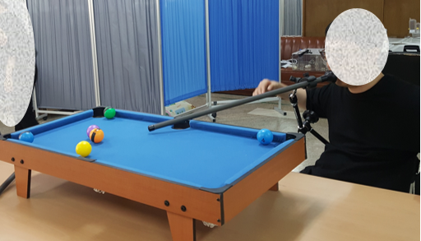  - 1:1 individual match or 2:2 team match-up method and game order  - Fixing the breathing cue to the cradle  - Fire the pin of the breathing cue toward the ball and put it into the hole  - The game ends when all balls enter the hole. The individual or team with many balls wins.
Multi-play ball | 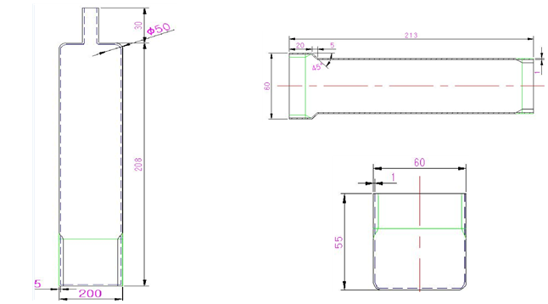  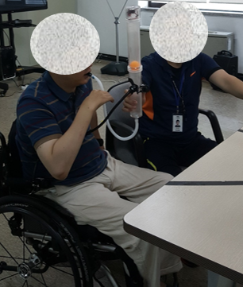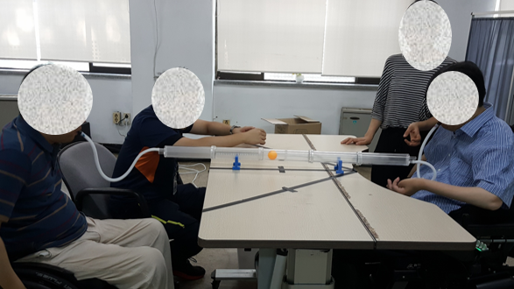
 | Lift ball competition | After the start signal, measure the height of the bottom of the ball raised to the highest level through a ruler attached to the body acrylic.
 | Ball reciprocating count battle | After the start signal, measure the frequency of touching the sound sensor using inhalation and exhalation for a given time.
 | Holding the ball | After the start signal, raise the ball and touch the sound sensor at the top of the body (20 cm) and measure the sound retention time.
 | Breathing tug-of-war | A two-player exercise where players need to breathe and move the ball towards their side.
- Depending on lung capacity, additional cylinders are combined to allow the game to progress.
- Two or more players possible in a tournament format.
Breathing marble | 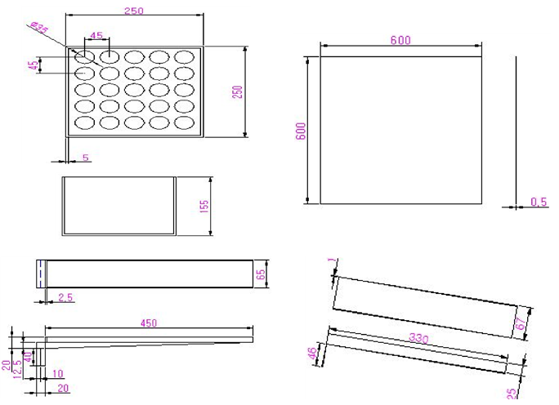  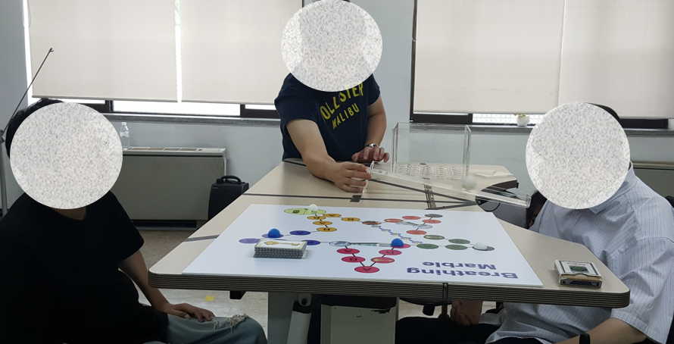  - In a board game method using breathing, the match-up method and game order are decided in a 1:1 individual match or a 2:2 team match.  - Blow the table tennis ball placed in front of the breathing inclined plate to determine the number of moves  - There are two types of breathing plates. A type: the ball is blown with the mouth according to the number written in the randomly placed space on the marble plate. B type: the number of seconds that the ball is blown from the breathing incline determines how the ball is moved.  ※ You can freely modify the rules (e.g., increase the game board space, change the contents of the golden key card, etc.) to play.
Breathing curling | 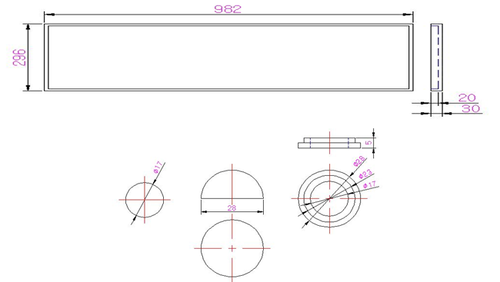  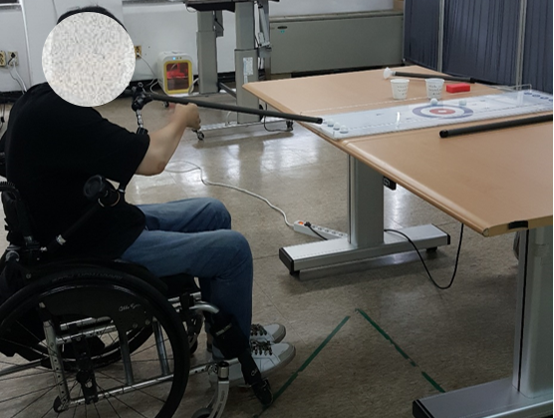  - 1:1 individual match or 2:2 team match-up method and game order  - Using the stone with a ball on the bottom so that it can move even if it is blown with the mouth.  After sending stones by using the unit, the team sent close to the circle decides the game’s order.  1:1 individual matches use five stones, 2:2 team matches use four stones.  The closer the stone is to the center of the circle, the higher the score.
Boroling | 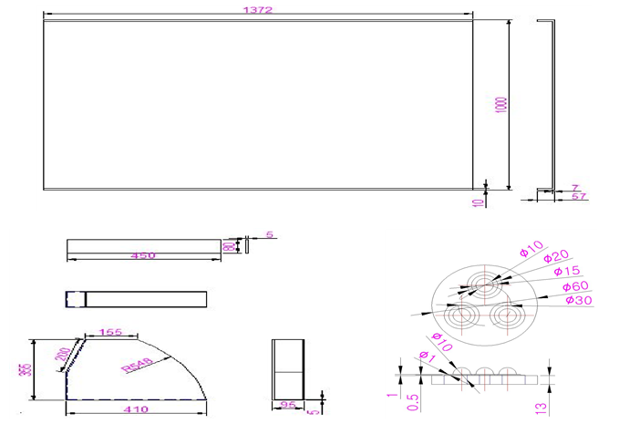  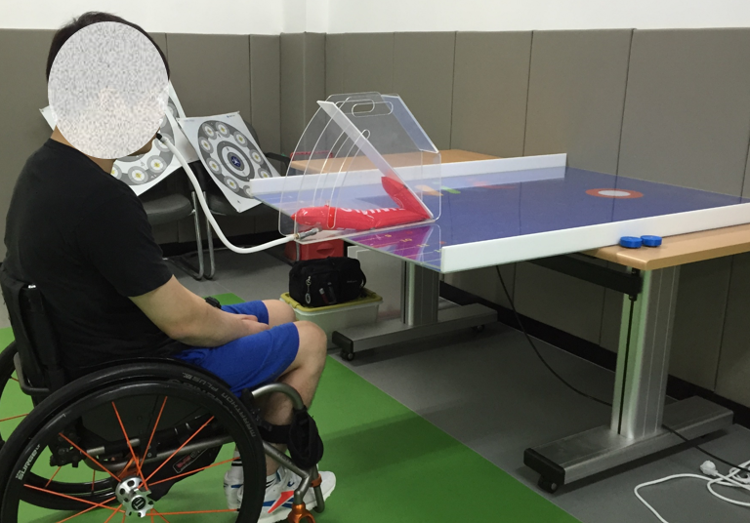  - 1:1 individual match or 2:2 team match-up method and game order  - Using expiration, raise the respirator to the desired height and lower the puck toward the circle’s center.  - Individuals or teams located closest to the center of the circle can decide the order of the games.  - The closer the puck is to the center of the circle, the higher the score.

