**Passion Fruit Seeds with Piceatannol: Anti-aging and Wound Healing Effects**

**Supplement 1**

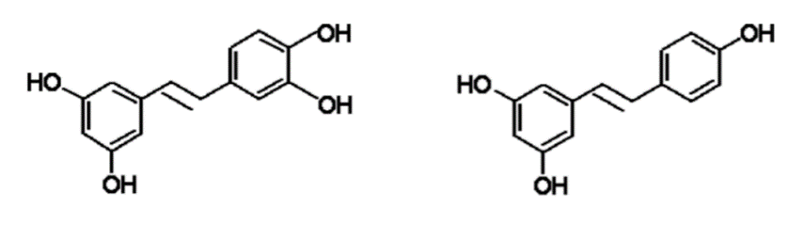

**Figure S1.** Structure of piceatannol (3,3’,4’,5-*trans*-tetrahydroxystilbene)

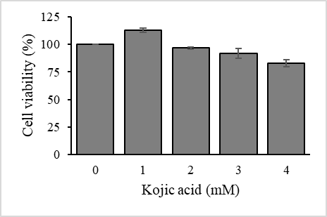

**Figure S2.** Non-lethal concentration of kojic acid which derived from performing MTT assay with HaCaT cells.