Supplementary data

Supplement tables

Table S1. 2-way ANOVA of the impact of the study conditions on body weight.
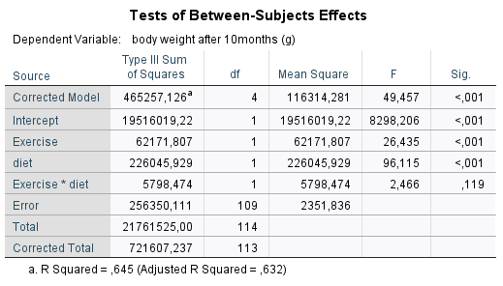

Table S2. Multiple comparisons of TMAO concentrations between the five study groups.
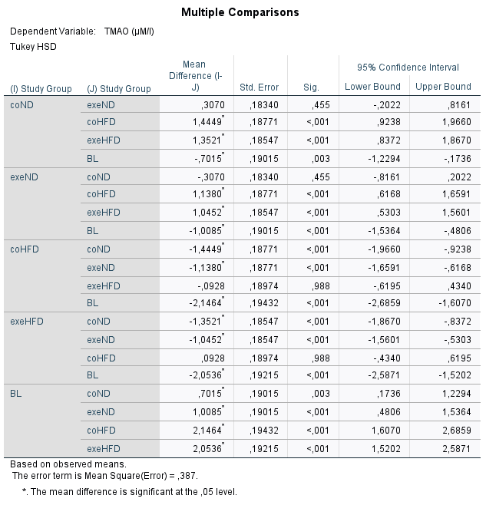

Table S3. 2-way ANOVA of the impact of the study conditions on TMAO.
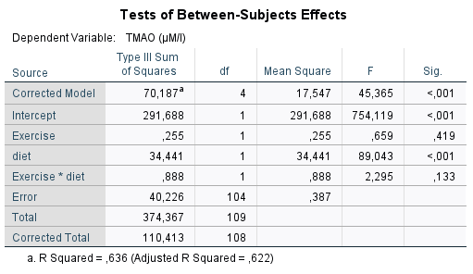

Table S4. Determination of TMAO concentrations in the applied rat diets.
Analysis by high-performance liquid chromatography-tandem mass spectrometry. Measurements were performed in triplicates. The concentrations are given as mean value including standard deviation.

 | Mean ± SD | Mean ± SD
 | µmol/L | ng/g
Normal diet | 18.1 ± 0.90 | 27.0 ± 1.3
High-fat diet | 0.051 ± 0.020 | 0.08 ± 0.03

Table S4 Appendix

Estimation of the influence of TMAO from ND and HFD on serum concentrations.

According to most studies, we expected TMAO levels to be lower in young adult rats and highest on HFD. Due to the observed higher levels in the ND groups, we also determined the TMAO concentrations of the used diets. We detected TMAO in the ND at an average amount of 27 ng per g and calculated a theoretical impact on the measured serum concentrations, in terms of average consumed diet amount according to the average body weight (Figure 1). The distribution volume of TMAO is roughly given by the extracellular volume (central compartment and peripheral compartment), in a range of 12%-18% of the body weight [1, 2]. The desired plasma concentrations of TMAO in the groups with ND were measured between 2.0 µmol/l (180 µg/l) to 2.7 µmol/L (235 µg/l). The daily food intake of ND is approx. 5 g/100 g bodyweight/rat, this corresponds to 135 ng TMAO/100 g body weight/day. The average intake amount of a refined HFD is about 20% lower (4 g/100 g). Assuming that the measured blood concentration of TMAO is in equilibrium with the compartments and the intake of TMAO, the total concentrations of TMAO were between 10.8 and 12.3 µg, which can be derived from the roughly estimated volume of distribution from the weight of the rats (young adults, 350 g x 0.15 = 52.5 ml; long term groups on ND, 400 g x 0.15 = 60 ml, respectively). The theoretical impact of dietary TMAO on the serum concentrations of the young adult group was calculated at +3.8% and on the long-term groups on ND at +5%. In the HFD groups, it was below 0.1%.

Calculation

Young adult rats on ND:
ca 350 g body weight, ca 20 ml blood volume, ca 17.5 g diet intake/day
Measured: 2.7 µmol TMAO/l (=235 µg/l) on average
Amount of TMAO/rat in average blood volume: 4.7 µg
Average consume: 472.5 ng TMAO/day
Theoretical maximum impact of dietary TMAO according to blood volume: 10%
Theoretical TMAO conc/rat distributed in whole body liquid: 12.3 µg (350 g * 0.15 = 52.5 ml)
Realistic maximum impact of dietary TMAO according to amount of whole body liquids: 3.8%

Elder rats on ND:
ca 400 g body weight, ca 25 ml blood volume, ca 20 g diet intake/day
Measured: 2 µmol TMAO/l (=180 µg/l) on average
Amount of TMAO/rat in average blood volume: 4.5 µg
Average consume: 540 ng TMAO/day
Theoretical maximum impact of dietary TMAO according to blood volume: 12%
Theoretical TMAO conc./rat distributed in whole body liquid: 10.8 µg (400 g * 0.15 = 60 ml)
Realistic maximum impact of dietary TMAO according to amount of whole body liquids: 5%

Elder rats on HFD:
ca 500 g body weight, ca 35 ml blood volume, ca 20 g diet intake/day
Measured: 0.5 µmol TMAO/l (=45 µg/l) on average
Amount of TMAO/rat in average blood volume: 1.6 µg
Average consume: 1.6 ng TMAO/day
Theoretical maximum impact of dietary TMAO according to blood volume: 0.1%
Theoretical TMAO conc./rat distributed in whole body liquid: 3.4 µg (500 g * 0.15 = 75 ml)
Realistic maximum impact of dietary TMAO according to amount of whole body liquids: 0.05%

Supplement figures

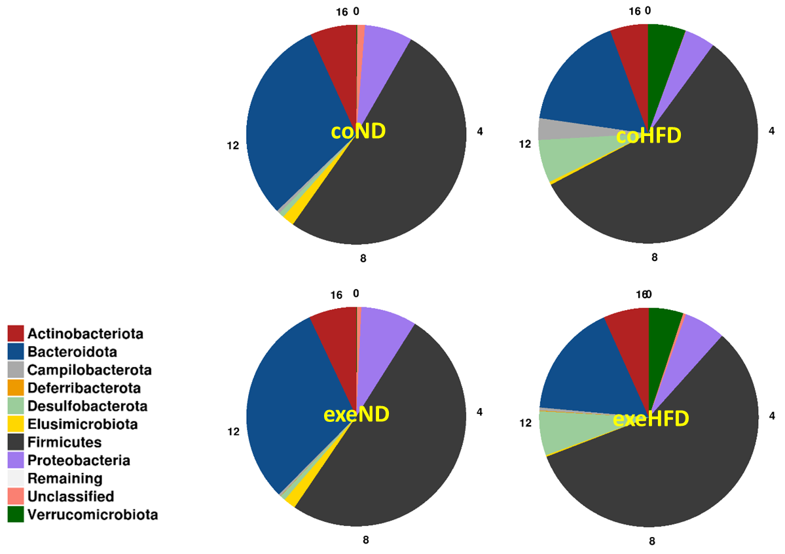
Figure S1. Phylum distribution in feces from rat study groups. Long-term study groups separated in diet and physical activity.

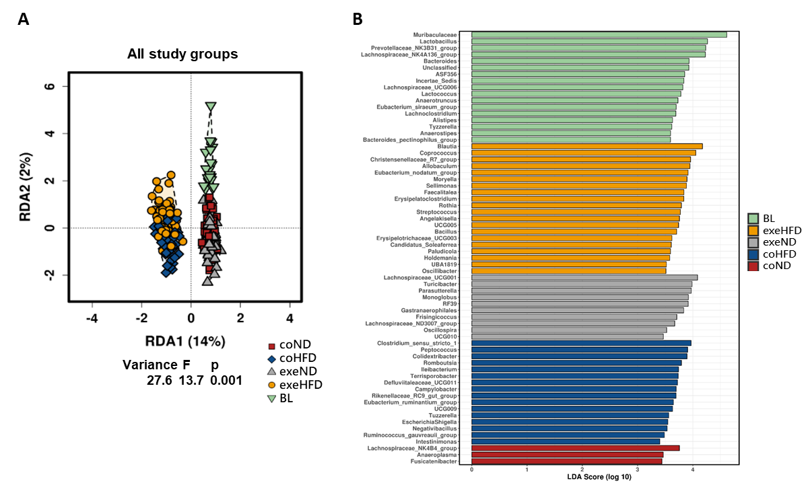
Figure S2. Beta diversity analysis with all study groups. (A) Variances between all study groups shown by Redundancy analysis (RDA). (B) Linear discriminant analysis effect size analysis (LefSe) with all study groups. Shown are most abundant genera.

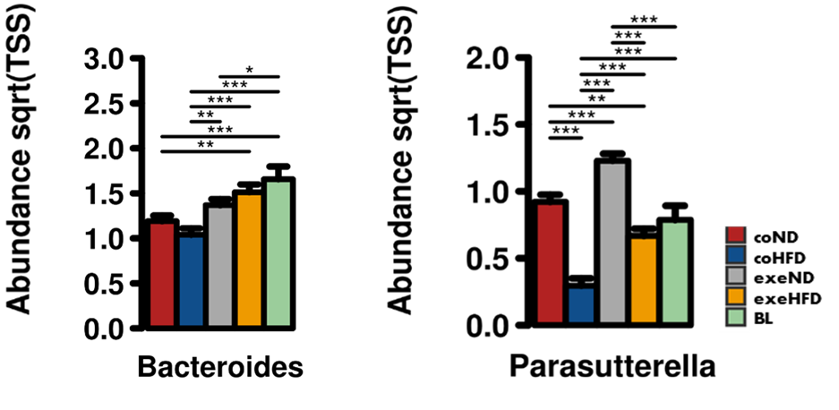
Figure S3. Bacteroides and Parasutterella abundancies between study groups. Significance of differences in abundancies between study groups was calculated with 2-way ANOVA. *p<0.05; **p<0.01; ***p<0.001.

Figure S4. Course of microbiome alpha diversity over the duration of study. Study groups were combined and differences analysed just by collection timepoint. No significant differences were found between the collection timepoints (2-way ANOVA).

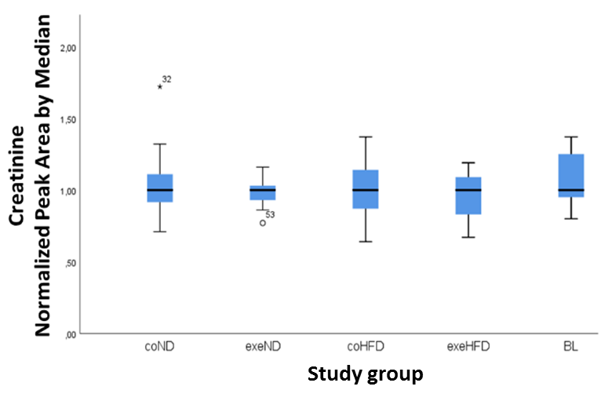
Figure S5. Determination of creatinine levels from rat serum from all study groups. Blood was collected and serum prepared from all groups at the end of the runtime and from the young adult group (BL). Creatinine as normalized peak areas determined by HPLC/MS. No significant differences were found between average creatinine levels from the study groups.

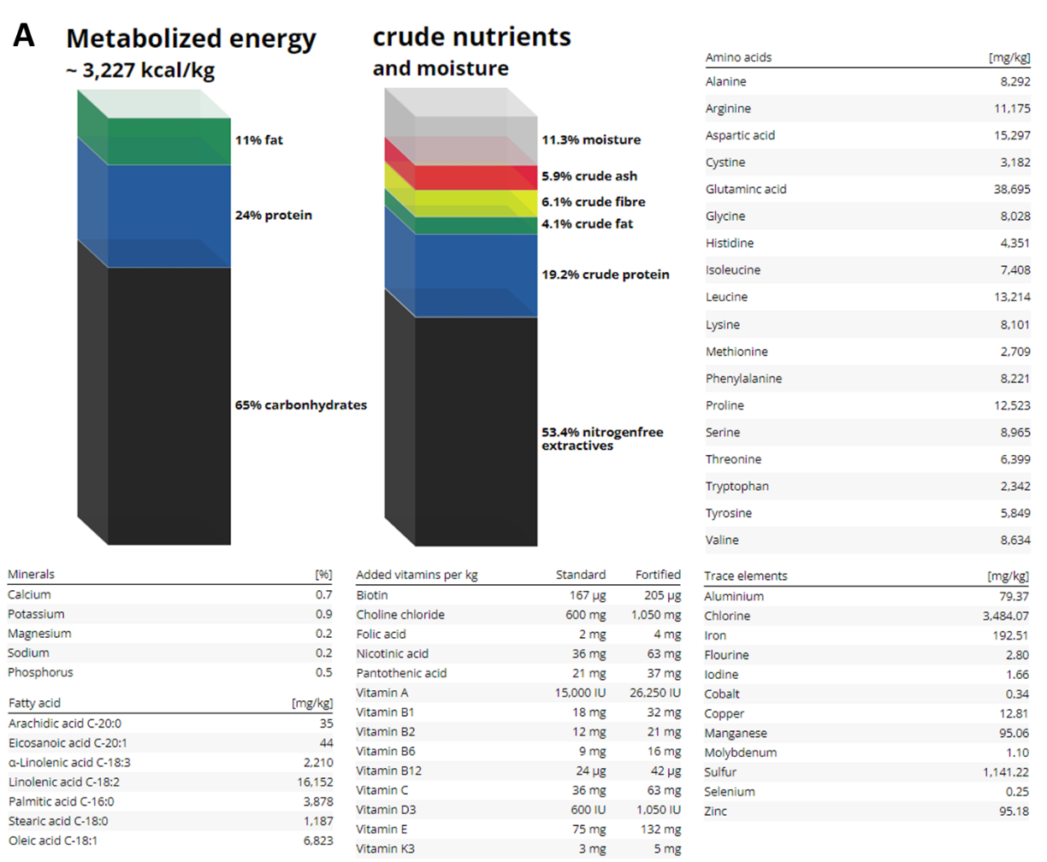
Figure S6. Dietary components as described by the manufacturers. (A) Standard diet. (B) High-fat diet.

Supplement references
1. Bischoff KB, Dedrick RL. Generalized solution to linear, to-compartment, open model for drug distribution. J Theor Biol. 1970;29(1):63-8.
2. Sapirstein LA, Vidt DG, Mandel MJ, Hanusek G. Volumes of distribution and clearances of intravenously injected creatinine in the dog. Am J Physiol. 1955;181(2):330-6.

