Supplemental Table 1. Effect and sample size calculations from each meta-analyses the effect of protein supplementation during RET on whole body and regional lean mass, strength, physical function and and muscle mass in older adults
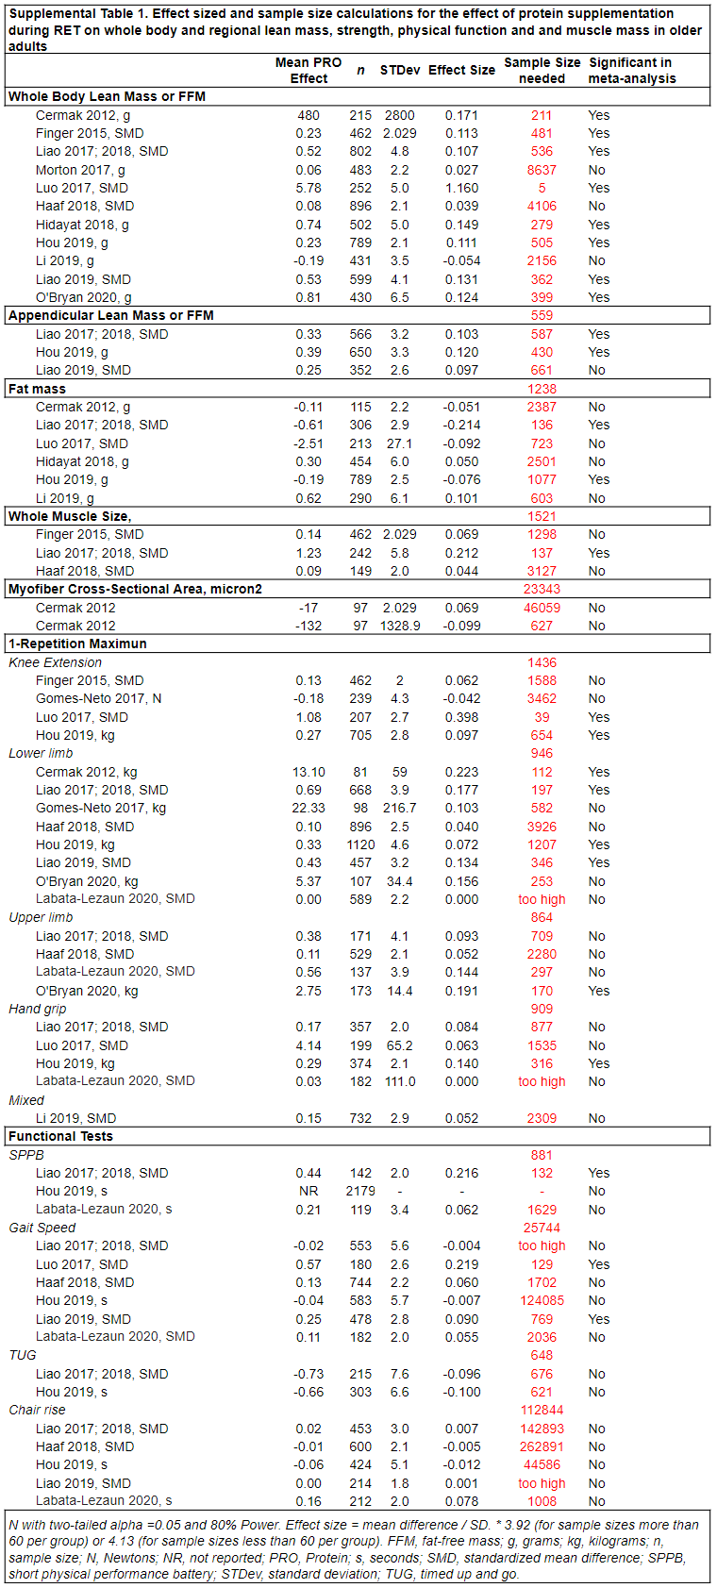

Supplemental Table 2. RCTs included in the meta-analyses sorted by effectiveness, supplement comparison type (rows), a by inclusion into the meta-analyses (columns) and then by frequency of use in meta-analytical analysis.
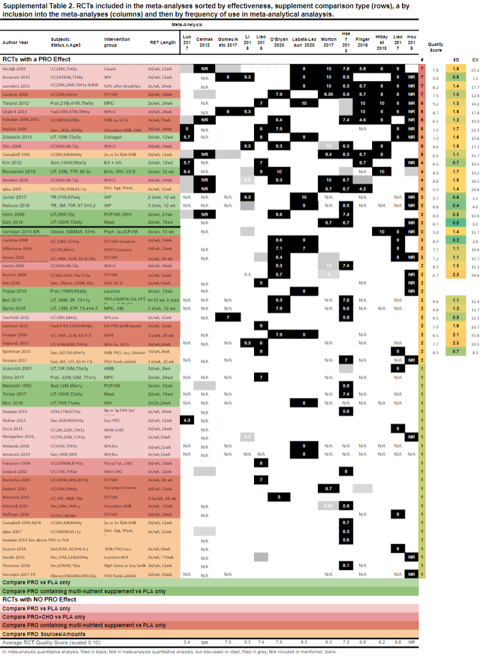
Supplemental Table 3. Articles discussed or cited in meta-analyses examining the chronic effect of resistance exercise training with protein and/or amino acid nutrition on muscle size and strength in older adults.
 | Meta-Analysis
Author Year | Cermak 2012 | Finger 2016 | Gomes-Neto 2017 | Morton 2017 | Liao 2017 | Luo 2017 | Haaf 2018 | Hidayat 2018 | Hou 2019 | Li 2019 | Liao 2019 | Labata-Lezaun 2020 | O'Bryan 2020
Cermak 2012 | N/A
Finger 2016 | N/A | N/A
Gomes-Neto 2017 | N/A | N/A | N/A
Morton 2017 | N/A | N/A | N/A | N/A
Liao 2017 | N/A | N/A | N/A | N/A | N/A
Luo 2017 | N/A | N/A | N/A | N/A | N/A | N/A
Haaf 2018 | N/A | N/A | N/A | N/A | N/A | N/A | N/A
Hidayat 2018 | N/A | N/A | N/A | N/A | N/A | N/A |  | N/A
Hou 2019 | N/A | N/A | N/A | N/A | N/A | N/A | N/A | N/A | N/A
Li 2019 | N/A | N/A | N/A | N/A | N/A | N/A | N/A | N/A | N/A | N/A
Liao 2019 | N/A | N/A | N/A | N/A | N/A | N/A | N/A | N/A | N/A | N/A | N/A
Labata-Lezaun 2020 | N/A | N/A | N/A | N/A | N/A | N/A | N/A | N/A | N/A | N/A | N/A | N/A | N/A
O'Bryan 2020 | N/A | N/A | N/A | N/A | N/A | N/A | N/A | N/A | N/A | N/A | N/A | N/A | N/A
In meta-analysis, discussed or cited, filled in grey; Not included or mentioned, blank. N/A, not applicable.

Supplemental Table 4. Inclusion and exclusion criteria used in meta-analyses examining the chronic effect of resistance exercise training with protein and/or amino acid nutrition on muscle size and strength in older adults.
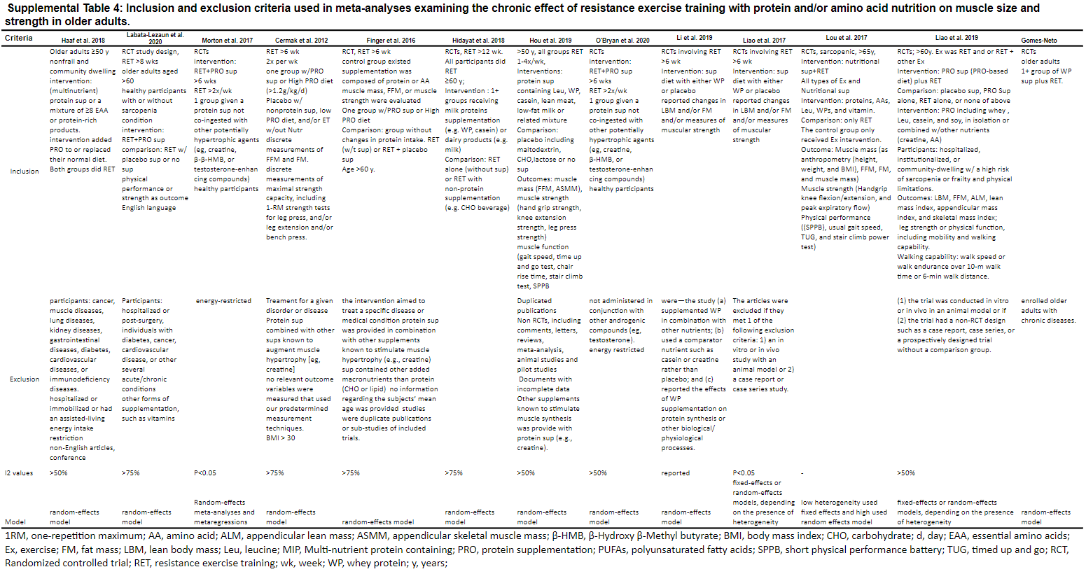

Supplemental Table 5. Type of nutritional intervention included and actually used in meta-analyses examining the chronic effect of resistance exercise training with protein and/or amino acid nutrition on muscle size and strength in older adults.
