Supplementary materials
Supplementary file 1: The inclusion and exclusion criteria
Individuals with the following characteristics were included: (1) those aged 40–65 years; (2) those with a first-ever unilateral ischemic or hemorrhagic stroke; (3) those with a period after stroke of <6 months; (4) those who had undergone ≥12 RAGT sessions; (5) those who had been informed of the purpose of the study and the anonymity and confidentiality of the study participants, agreed to participate in the test, and signed the consent form; and (6) those judged to understand and cooperate with the contents of the clinical study and be able to participate by the end of the clinical study. The exclusion criteria were (1) severe cognitive impairment of not more than 10 points for MMSE score; (5) orthopedic problems having difficulty walking with lower extremity fractures or osteoarthritis; (6) instability angina; (7) neurological surgery or epilepsy; (8) other clinical studies related to rehabilitation therapy aimed at improving motor function within 30 days before the start of this study; (9) weight >100 kg and height <150 cm; (10) pregnant individuals; and (11) those judged to be inappropriate by the person in charge to be included in the study.
Supplementary file 2: The feature importance of the five-machine learning (ML) model in minimal clinical importance difference (a) and effect level (b).
Table 1-(a) The feature importance of the five-machine learning (ML) model in minimal clinical importance difference (MCID)
Variable|ML | DT | RF | XGB | LGB | CAT | Average
Final BBS | 0.4358 | 0.1948 | 0.2077 | 0.1922 | 0.2628 | 0.2586
FinalMBI | 0.0559 | 0.0978 | 0.0814 | 0.0953 | 0.0884 | 0.0838
InitialBBS | 0.0605 | 0.0544 | 0.0701 | 0.1109 | 0.0752 | 0.0742
FinalFMA | 0.1391 | 0.0512 | 0.0456 | 0.0781 | 0.0416 | 0.0711
InitialMBI | 0.0566 | 0.0631 | 0.0486 | 0.0906 | 0.0379 | 0.0594
FinalTIS | 0.0669 | 0.0920 | 0.0721 | 0.0281 | 0.0360 | 0.0590
FinalMAS | 0.0711 | 0.0282 | 0.0693 | 0.0297 | 0.0433 | 0.0483
Age | 0.0000 | 0.0533 | 0.0466 | 0.0797 | 0.0559 | 0.0471
weight | 0.0410 | 0.0487 | 0.0265 | 0.0453 | 0.0521 | 0.0427
FinalMMSE | 0.0364 | 0.0626 | 0.0400 | 0.0297 | 0.0381 | 0.0414
Height | 0.0190 | 0.0401 | 0.0547 | 0.0344 | 0.0406 | 0.0378
InitialTIS | 0.0177 | 0.0414 | 0.0415 | 0.0281 | 0.0382 | 0.0334
InitialFMA | 0.0000 | 0.0431 | 0.0253 | 0.0578 | 0.0301 | 0.0313
InitialMMSE | 0.0000 | 0.0358 | 0.0411 | 0.0375 | 0.0418 | 0.0312
InitialMAS | 0.0000 | 0.0257 | 0.0336 | 0.0219 | 0.0438 | 0.0250
Onset time | 0.0000 | 0.0261 | 0.0548 | 0.0109 | 0.0236 | 0.0231
Diagnosis | 0.0000 | 0.0066 | 0.0214 | 0.0078 | 0.0099 | 0.0091
Sid of lesion | 0.0000 | 0.0083 | 0.0125 | 0.0047 | 0.0088 | 0.0069
Sex | 0.0000 | 0.0065 | 0.0072 | 0.0031 | 0.0078 | 0.0049

Table 1-(b) The feature importance of the five-machine learning (ML) model in effect level
Variable|ML | DT | RF | XGB | LGB | CAT | Average
FinalBBS | 0.2244 | 0.1246 | 0.1434 | 0.1261 | 0.1722 | 0.1582
Age | 0.1094 | 0.0744 | 0.0795 | 0.0900 | 0.1009 | 0.0908
FinalMBI | 0.0882 | 0.0842 | 0.0473 | 0.0801 | 0.0656 | 0.0731
InitialBBS | 0.0559 | 0.0575 | 0.0646 | 0.0882 | 0.0498 | 0.0632
FinalFMA | 0.0653 | 0.0582 | 0.0465 | 0.0666 | 0.0661 | 0.0605
FinalMMSE | 0.0556 | 0.0698 | 0.0527 | 0.0485 | 0.0557 | 0.0564
InitialMBI | 0.0273 | 0.0601 | 0.0568 | 0.0886 | 0.0459 | 0.0557
weight | 0.0754 | 0.0492 | 0.0256 | 0.0574 | 0.0579 | 0.0531
height | 0.0781 | 0.0526 | 0.0387 | 0.0400 | 0.0484 | 0.0516
InitialMMSE | 0.0562 | 0.0481 | 0.0524 | 0.0517 | 0.0432 | 0.0503
InitialFMA | 0.0464 | 0.0531 | 0.0428 | 0.0680 | 0.0351 | 0.0491
onset time | 0.0334 | 0.0396 | 0.0610 | 0.0340 | 0.0704 | 0.0477
FinalTIS | 0.0000 | 0.0700 | 0.0417 | 0.0499 | 0.0441 | 0.0412
InitialMAS | 0.0311 | 0.0259 | 0.0724 | 0.0252 | 0.0334 | 0.0376
InitialTIS | 0.0292 | 0.0463 | 0.0419 | 0.0354 | 0.0275 | 0.0361
FinalMAS | 0.0076 | 0.0273 | 0.0348 | 0.0174 | 0.0353 | 0.0245
Side of lesion | 0.0029 | 0.0105 | 0.0513 | 0.0078 | 0.0129 | 0.0171
Diagnosis | 0.0000 | 0.0094 | 0.0224 | 0.0145 | 0.0097 | 0.0112
Sex | 0.0000 | 0.0091 | 0.0242 | 0.0007 | 0.0035 | 0.0075

Supplementary file 3: Partial dependency plot (PDP) of random forest algorithm on MCID
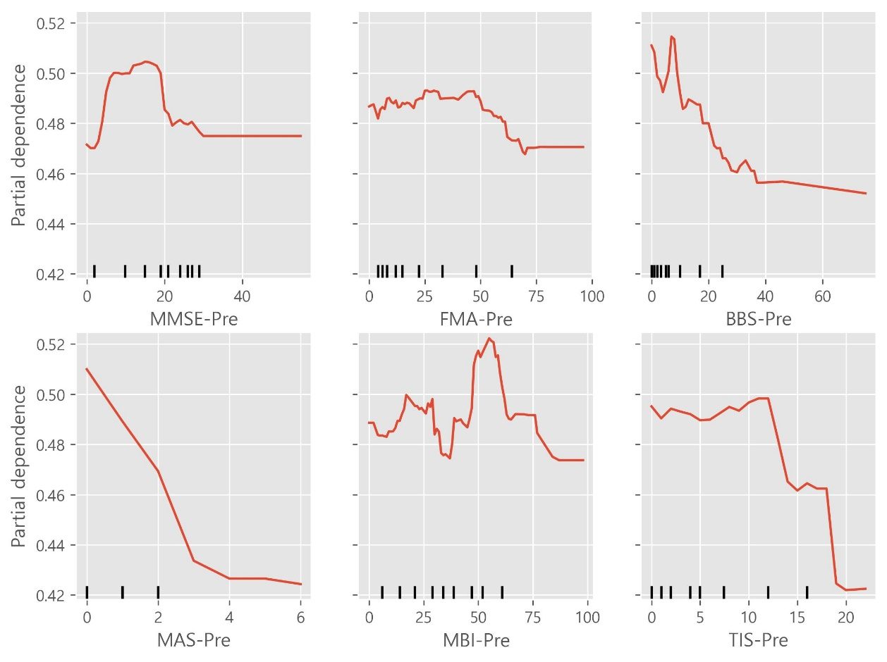

Supplementary file 4: Partial dependency plot (PDP) of categorical boosting (CAT) on MCID
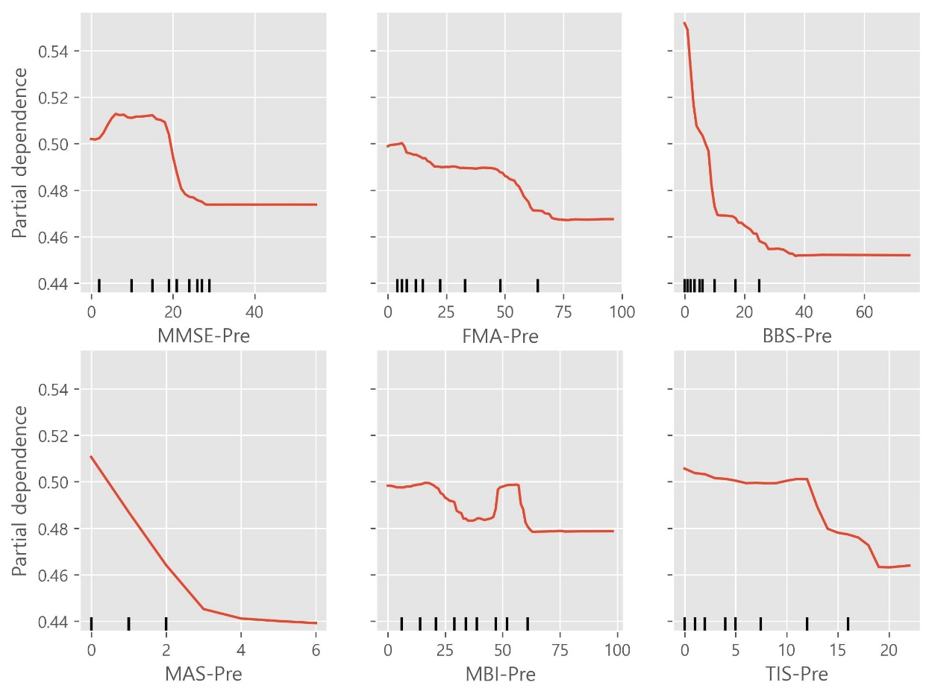

Supplementary file 5: Partial dependency plot (PDP) of light gradient boosting (LGB) on MCID
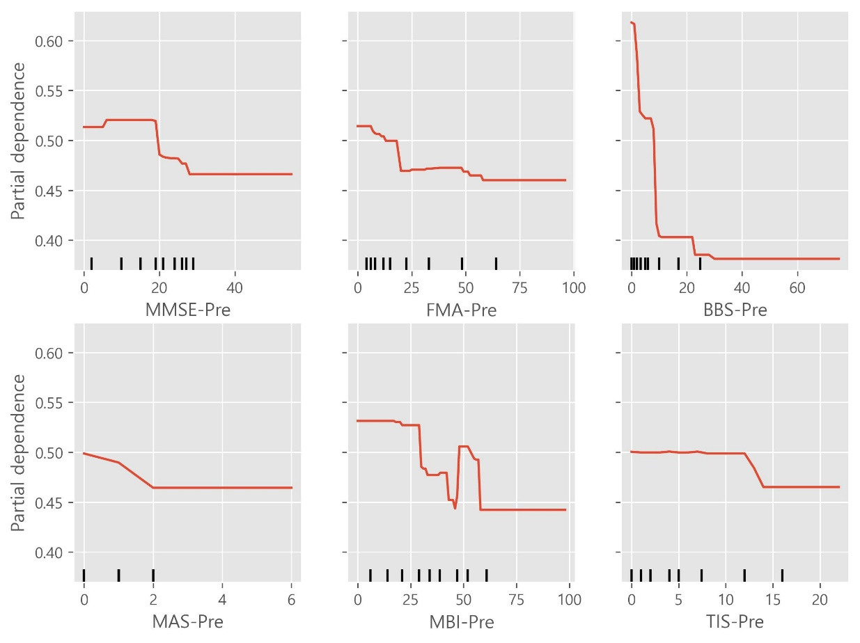

Supplementary file 6: Partial dependency plot (PDP) of decision tree on MCID
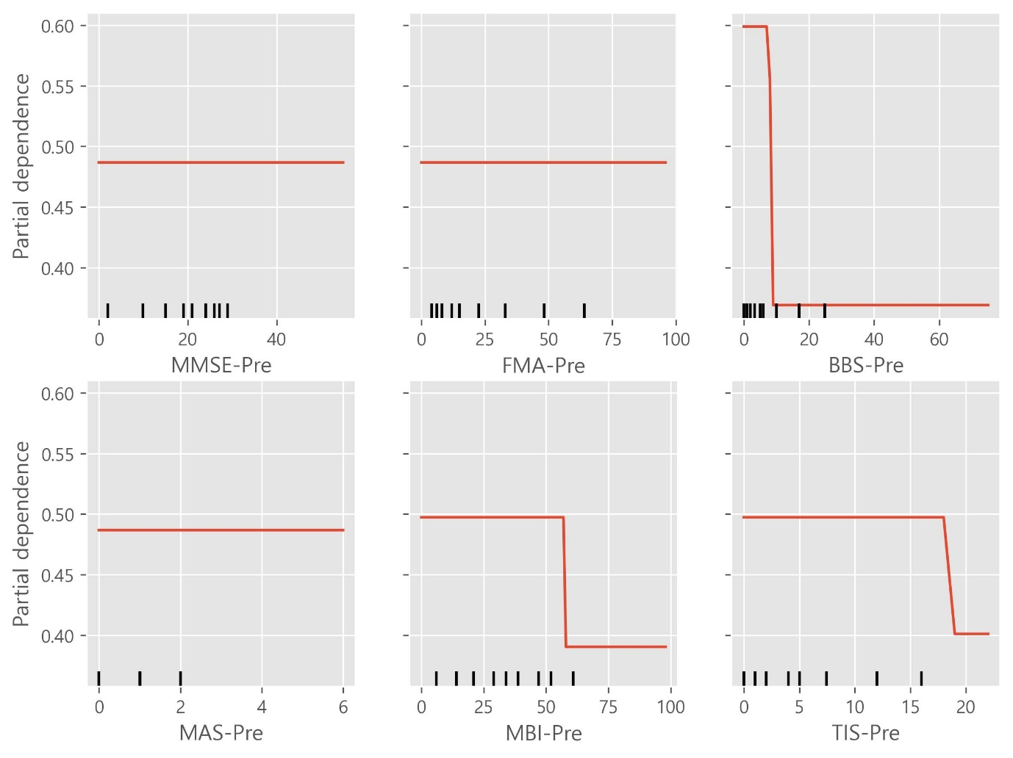

Supplementary file 7: Partial dependency plot (PDP) of eXtreme Gradient Boosting on four effect level (multiclassification)
