**SUPPLEMENTARY DATA (2 figures):**

Supplementary fig. 1. **Example of a behavioural chain analysis and solution analysis**

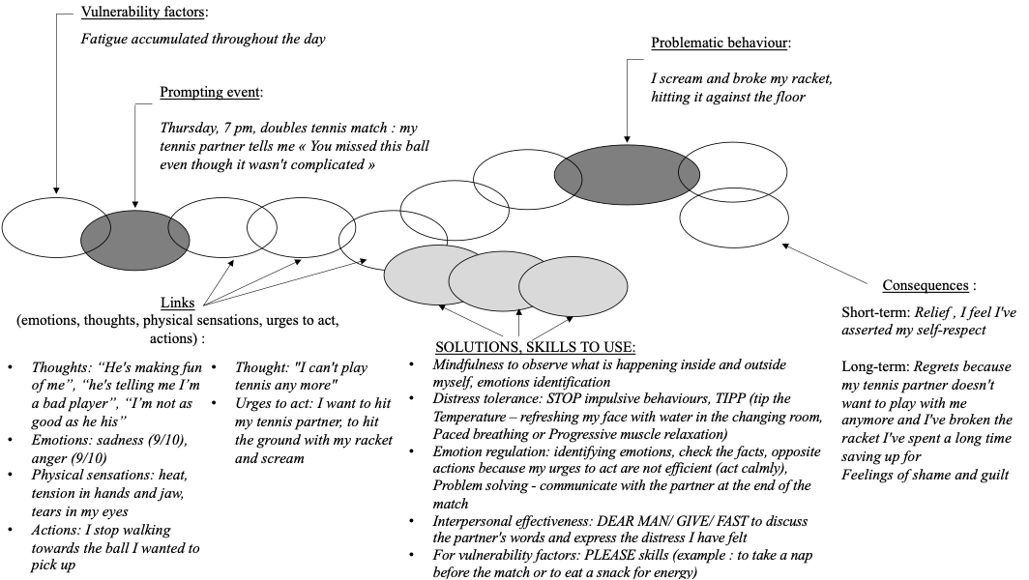

Please refer to Figure 2 for acronyms meaning and Table 2 for brief description of the DBT skills modules

Supplementary fig. 2. **Satisfaction questionnaire results**

