Appendix

ROBOTIC UPPER LIMB TREATMENT PROTOCOL
_______________________________________________________________________________________
Table of contents
Introduction 2
End-Effector Devices 3
Exergames chosen in the protocol - MOTORE 3
Flowchart - MOTORE 4
Exercises and assistance modalities chosen in the protocol – AMADEO 5
Flowchart - AMADEO 6
Electromechanical Devices 7
Exergames chosen in the protocol – DIEGO 7
Flowchart - DIEGO 9
Sensor-Based Devices 10
Exergames chosen in the protocol – PABLO 10
Flowchart - PABLO 11
Bibliography 12

Introduction

This appendix lists the main characteristics of the robotic and sensor-based device, along with the exergames chosen, the flowcharts, and the rehabilitation protocol developed in this study for each class of devices.
Regarding the rehabilitation protocol, the exercise lists refer to a typical 45-minutes rehabilitation session specifically for the upper limb affected by post-stroke and to the four robotic devices of the RobotAREA.
To tailor the protocol to the patient's level of impairment:
- four main clinical characteristics, or domains, selected from the International Classification of Functioning, Disability and Health (ICF) core set of categories of body functions for stroke (Geyh et al., 2004) were identified:
  - ROM;
  - Strength;
  - Spasticity;
  - Pain;
- each patient was daily evaluated, before and after the treatment, with the following clinical assessment:
  - Numerical Rating Scale (NRS) (Downie et al., 1978);
  - ROM;
  - Medical Research Council (MRC) (James, 2007);
  - Modified Ashworth Scale (MAS) (Carr et al., 1985).

End-Effector Devices

These robotic devices, used in upper limb rehabilitation, work by having a point of contact known as an effector (end-effector) to which the subject is attached via a mechanical interface. The latter enables fixation of the affected limb's distal segment, training of individual movements in a smaller range of motion (ROM) than is physiologically possible and facilitates patient adaptation to the device. In rehabilitation practice, these devices allow working specifically on the hand and fingers, wrist, elbow, and shoulder joints in flexion-extension movements, sensibility and proprioceptive rehab, and planar exploration in passive, active, and active-assisted modes.

Exergames chosen in the protocol – MOTORE

EXERGAME | FIGURES | DESCRIPTION | PARAMETERS
Trajectories/Chase | 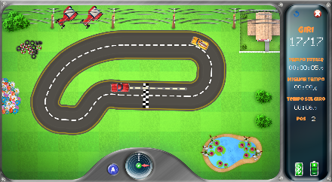 | Drive the red car or chase the yellow car along one of the chosen tracks. | Shape: Oval, Eight, letter P or D
 |  |  | Circuit position: center or lateral
 |  |  | Direction: clockwise (CW) or counterclockwise (CCW)
 |  |  | Size: small or large
 |  |  | Number of laps
Coins | 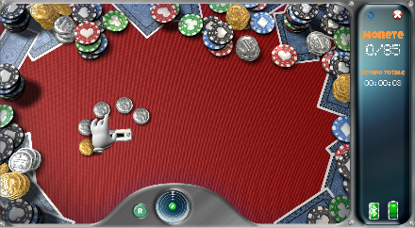 | Collect coins arranged around the central hole and put them in. | Direction: clockwise (CW) or counterclockwise (CCW)
 |  |  | Depth: small or width
 |  |  | Coins arrangement: translated ellipse, inclined ellipse, incoming ellipse, ellipse, incoming spiral, outgoing spiral
 |  |  | Number of coins
Washing dishes | 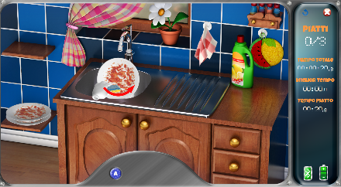 | Wash the dishes according to a pre-established sequence of actions (bring the plate into the sink, open the water tap, reach the sponge, etc). | Number of dishes

Flowchart - MOTORE
Clinical domains | Scale | Score | Treatment protocol
Pain | NRS | ≤4 | Yes
 |  | 5-8 | Yes, (with antalgic movement) for example choose a clockwise or counterclockwise mode
 |  | >8 | No
Muscle Tone | ASHWORTH | 2 | Yes
 |  | 3 | Yes, (in passive and active-assisted mode)
 |  | 4 | Yes, (in passive and/or active-assisted mode)
 | FLACCIDITY |  | Yes, (in active-assisted mode by the unaffected limb)
Strength | MRC | ≤ 2 | Yes, (in passive and/or active-assisted mode)
 |  | =3 | Yes, (in active-assisted and/or active mode)
 |  | >4 | Yes
ROM |  | Conserved | Yes
 |  | Reduced | Yes, (with small trajectories)

Exercises and assistance modalities chosen in the protocol – AMADEO
THERAPY | FIGURES | DESCRIPTION | PARAMETERS
Sensitivity training | 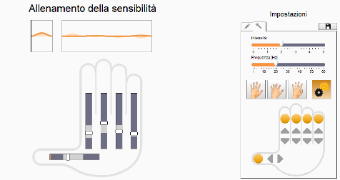 | It’s a vibratory treatment which increases proprioception and helps to reduce spasticity and pain | - Frequency (always 60Hz)  - Intensity calibrated on the patient’s symptomatic response
CMP Plus | 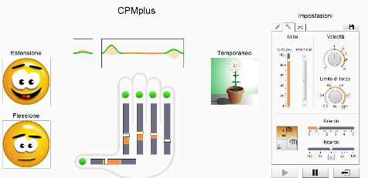 | It is a passive mobilization of the fingers and thumb, which can also be performed actively by the patient within his range of motion | ROM
Spasticity treatment | 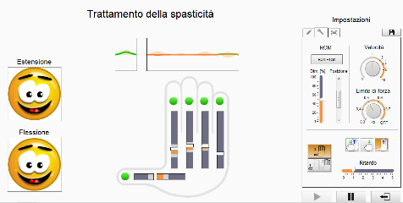 | It is a passive flexion-extension mobilization of the fingers and thumb, which must be followed by accommodation to the movement by the patient | ROM
Assistive therapy | 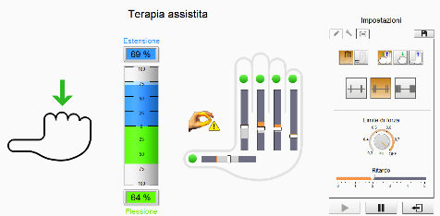 | This program offers the patient the opportunity to actively execute the movement with the strength of his own fingers while respecting his ROM. The system then completes the flexion-extension action if necessary. It is also an exercise in coordination in time and movement. | ROM

Flowchart - AMADEO

Clinical domains | Scale | Score | Vibration | Movement
Pain | NRS | ≤ 4 | Yes. | Isotonic - Isometric
 |  | 5-8 | Yes, (intensity ≤1). | Isotonic (tolerated) - Isometric.
 |  | >8 | No. | Isometric (tolerated ROM)
Muscle Tone | ASHWORTH | 2 | Yes. | Isotonic – Isometric (active-assisted)
 |  | 3 | Yes. | Isotonic
 |  | 4 | Yes, (before treatment). | -
 | FLACCIDITY |  | Yes. | Isometric (active-assisted)
Strength | MRC | ≤ 2 | Yes. | Isotonic
 |  | =3 | Yes. | Isotonic – Isometric (active-assisted)
 |  | >4 | No. | Isotonic – Isometric
ROM |  | Conserved | Yes, (both in extension and flexion). | Isotonic – Isometric
 |  | Reduced | Yes, (in intermediate position). | Isotonic – Isometric (adjusting the range of motion)

Electromechanical Devices

These are multidimensional robotic systems that facilitate mobilization and movements of the upper limb in unilateral mode and, in some cases, also in bilateral mode, on which multiple exercises can be performed by implementing parameters such as assistance, strength, endurance, and range of motion. In addition, some devices allow working with arm weight relief, simultaneous limb movements in mirror therapy mode, and virtual reality training.

Exergames chosen in the protocol – DIEGO

CATEGORIES | EXERGAME | FIGURES | DESCRIPTION
1D precision | Elevator | 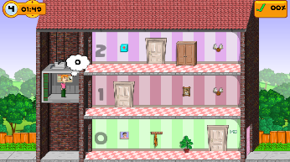 | Operating an elevator in a building: people must be picked up and taken to the correct floor.
 | Hot air balloon | 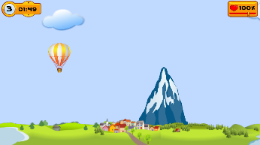 | Move a balloon through a course and paste obstacles.
 | Applehunter | 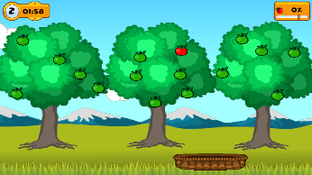 | Move a basket to catch the falling apples.
 | Firefighters | 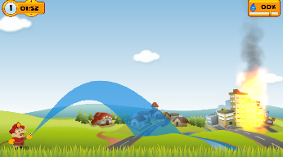 | Extinguish with a water jet the flaring flames.
 | Highway | 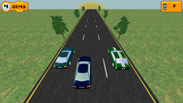 | Steer a vehicle in traffic.
1D reaction | Shooting Cans | 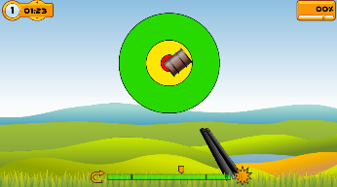 | Pull the trigger at the right time to shoot the cans.
 | Recycle | 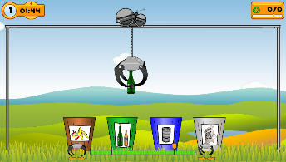 | Pick up different pieces of waste and deposit them in the corresponding container.
2D motricity | Dinner | 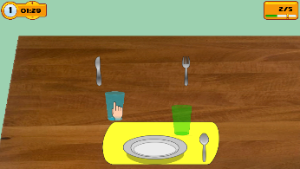 | Place the plates, glasses, knives, forks, and spoons in the correct match position.
 | Get green | 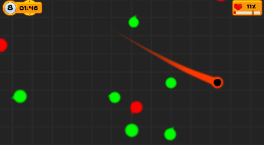 | Guide the dot into the green circle, trying to avoid the red ones.
 | Crab | 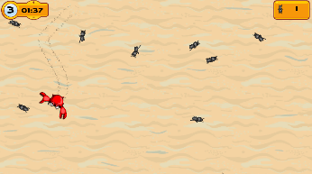 | Move the crab to catch as many ants as possible.
 | Chicken and worm | 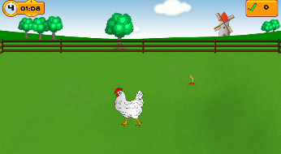 | Move the chicken to eat as many worms as possible.
2D cognitive | Symbols | 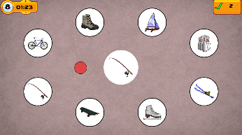 | A symbol will appear in the center of the playing surface; locate the symbol corresponding to that pattern, and hold the cursor to select it.
 | Missing symbols | 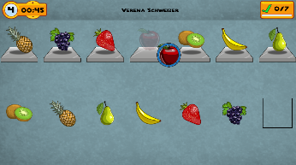 | Select the symbol missing from the line above and place it in the line below in the correct position.
 | Draw by numbers | 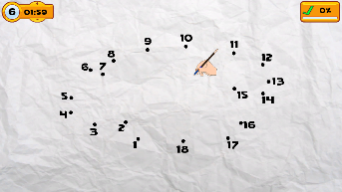 | Draw with the pen by connecting the dots in the correct numerical order.
 | Grid | 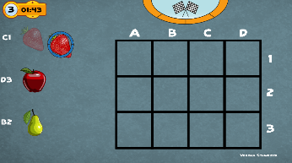 | Place the symbols in the designed grid positions.
Virtual reality | Swimming | 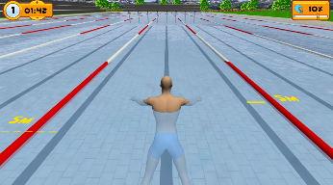 | Swim to move forward.
 | Box and blocks | 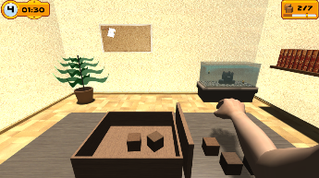 | Carry the cubes, one by one, over an obstacle.
 | Hang up the laundry | 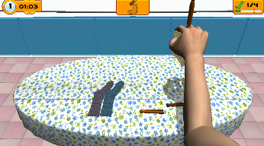 | Collect the clothes and clothespins from the table and hang them on the clothesline.

Flowchart - DIEGO

Clinical domains | Scale | Score | Treatment protocol
Pain | NRS | ≤ 4 | Yes.
 |  | 5-8 | Yes, with weight relief.
 |  | >8 | Yes, with weight relief and reduced ROM.
Muscle Tone | ASHWORTH | 2 | Yes.
 |  | 3 | Yes, with weight relief.
 |  | 4 | Yes, with weight relief and reduced ROM.
 | FLACCIDITY |  | Yes, (with palm-forearm support) if necessary, with assistance of the unaffected limb.
Strength | MRC | ≤ 2 | Yes, (considering the joint excursion of the patient) if necessary, with assistance of the unaffected limb.
 |  | =3 | Yes.
 |  | >4 | Yes.
ROM |  | Conserved | Yes.
 |  | Reduced | Yes, (considering the joint excursion of the patient).

Sensor-Based Devices

These are interactive systems used in sensorimotor rehabilitation of the entire upper limb with wearable integrated sensors and real-time control: through rapid data exchange between sensor and control, the systems can react to changes in degrees of body segments in space by determining a trajectory aimed at an exergame. Its bilateral system allows the subject to exercise various movements such as grasping, reaching, pinching, and lifting, as well as more complex functions such as dual task exercises, balance, trunk control, coordination and motor control in different positions and postures, including sitting and standing.

Exergames chosen in the protocol – PABLO

Consult the exergames table of Diego on pages 7-8-9, for the explication of the chosen exergames for Pablo.
After selecting the exergame, you have to select which type of accessory you want to use for the patient:
- Handpiece:
    - Measurement: it can be used the handpiece as a dynamometer for strength exercises.
    - Single movement: unilateral exercises such as prono-supination, ulnar and radial deviation and wrist flexion and extension.
    - Combined movements: 2-dimensional movements from those described above (for the entire UL)
- Multiboard:
- Single movement: bilateral movement such as frontal and sagittal plane.
- Combined movements: 2D movements chosen from those described above.
- Ball:
  - Single movement: unilateral exercises such as wrist prono-supination and flexion and extension.
  - Combined movements: 2D movements chosen from those described above.

Flowchart - PABLO

Clinical domains | Scale | Score | Handpiece | Multiboard | Ball
Pain | NRS | ≤ 4 | Yes. | Yes. | Yes.
 |  | 5-8 | Yes, (without strength exercises). | Yes. | Yes.
 |  | >8 | Yes, (with reduced ROM and without pain) | No. | Yes.
Muscle Tone | ASHWORTH | 2 | Yes. | Yes. | Yes.
 |  | 3 | Yes. | Yes. | Yes.
 |  | 4 | No. | Yes, (with limb fixed on handlebar). | Yes, (with unaffected limb help).
 | FLACCIDITY |  | Yes. | Yes. | Yes.
Strength | MRC | ≤ 2 | Yes. | Yes. | Yes.
 |  | =3 | Yes. | Yes. | Yes.
 |  | >4 | Yes, (with strength exercises). | Yes. | Yes.
ROM |  | Conserved | Yes. | Yes. | Yes.
 |  | Reduced | Yes. | Yes. | Yes.

Bibliography
Carr, J. H., Shepherd, R. B., Nordholm, L., & Lynne, D. (1985). Investigation of a New Motor Assessment Scale for Stroke Patients. Physical Therapy, 65(2), 175–180. https://doi.org/10.1093/ptj/65.2.175
Downie, W. W., Leatham, P. A., Rhind, V. M., Wright, V., Branco, J. A., & Anderson, J. A. (1978). Studies with pain rating scales. Annals of the Rheumatic Diseases, 37(4), 378–381. https://doi.org/10.1136/ard.37.4.378
Geyh, S., Cieza, A., Schouten, J., Dickson, H., Frommelt, P., Omar, Z., Kostanjsek, N., Ring, H., & Stucki, G. (2004). ICF Core Sets for stroke. Journal of Rehabilitation Medicine, 44 Suppl, 135–141. https://doi.org/10.1080/16501960410016776
James, M. A. (2007). Use of the Medical Research Council Muscle Strength Grading System in the Upper Extremity. The Journal of Hand Surgery, 32(2), 154–156. https://doi.org/10.1016/j.jhsa.2006.11.008

