Supplementary materials legends
Figure S1 The DMIST training equipment
Figure S2 The GaitWatch Gait Analyser

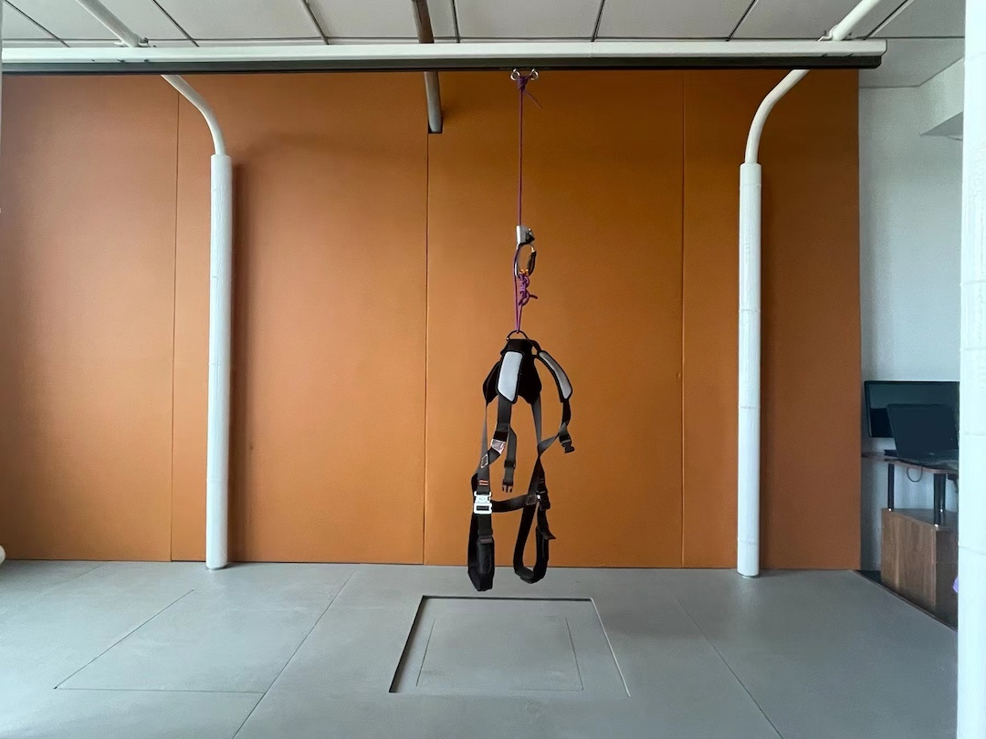
Figure S1 The DMIST training equipment

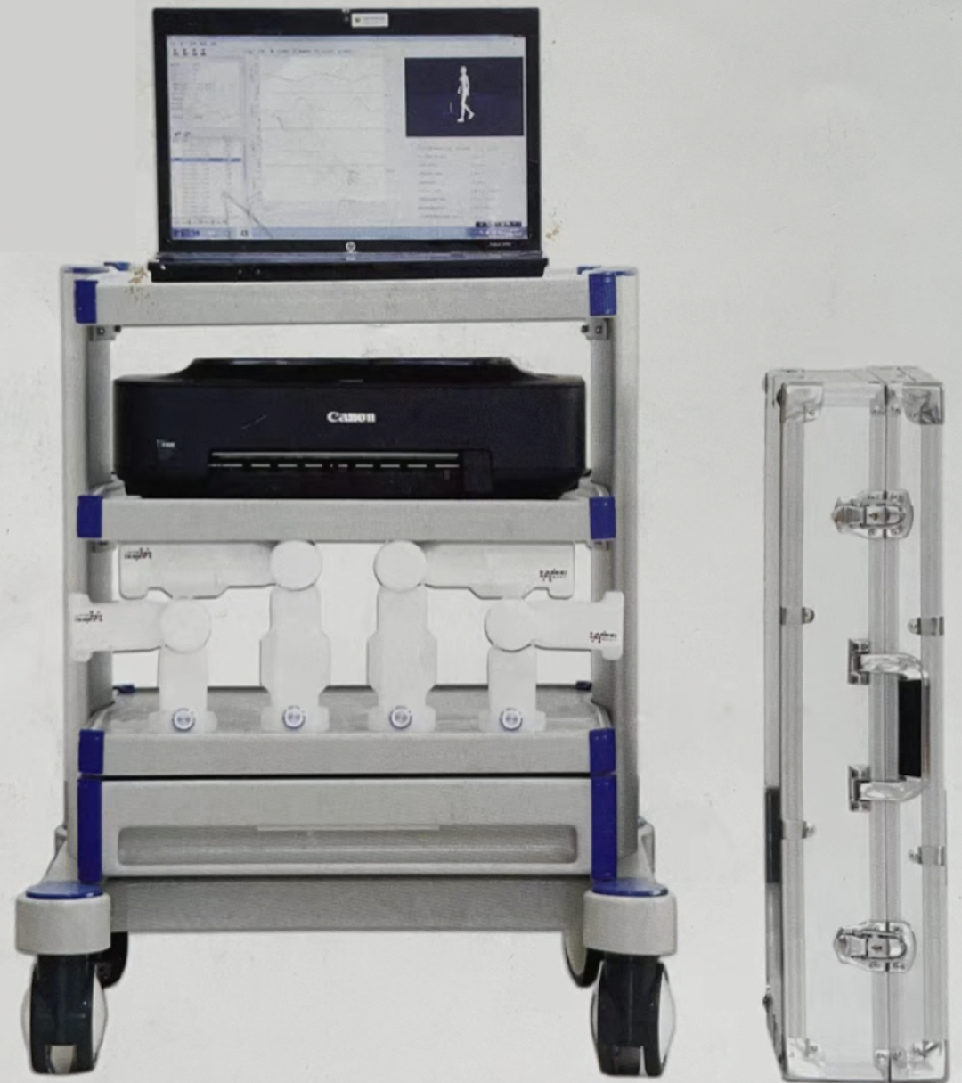
Figure S2 The GaitWatch Gait Analyser

