Supplementary Table 1
Optimised geometrical parameters of the three Isomers of title compound at B3LYP and CAM-B3LYP/6-311 G (d, p) level along with experimental values
Bond Length | Exp. | B3LYP |  |  | CAM-B3LYP
 |  | Isomer I | Isomer II | Isomer III | Isomer I | Isomer II | Isomer III
(C1=C2) | 1.401 | 1.402 | 1.405 | 1.404 | 1.395 | 1.397 | 1.396
(C1-C6) | 1.378 | 1.388 | 1.383 | 1.383 | 1.382 | 1.378 | 1.378
(C1-H7) | - | 1.084 | 1.082 | 1.082 | 1.084 | 1.082 | 1.081
(C2-C3) | 1.384 | 1.399 | 1.399 | 1.400 | 1.391 | 1.391 | 1.392
(C2-C13) | 1.482 | 1.499 | 1.466 | 1.466 | 1.495 | 1.466 | 1.467
(C3=C4) | 1.369 | 1.387 | 1.390 | 1.389 | 1.382 | 1.385 | 1.384
(C3-H8) | - | 1.083 | 1.082 | 1.082 | 1.082 | 1.082 | 1.081
(C4-C5) | 1.393 | 1.398 | 1.396 | 1.397 | 1.392 | 1.390 | 1.390
(C4-H9) | - | 1.086 | 1.086 | 1.086 | 1.085 | 1.085 | 1.085
(C5=C6) | 1.394 | 1.397 | 1.400 | 1.400 | 1.391 | 1.394 | 1.393
(C5-O11) | 1.360 | 1.361 | 1.362 | 1.361 | 1.355 | 1.356 | 1.355
(C6-H10) | - | 1.083 | 1.083 | 1.083 | 1.082 | 1.082 | 1.082
(O11-H12) | - | 0.963 | 0.963 | 0.963 | 0.961 | 0.961 | 0.961
(C13=O14) | 1.238 | 1.214 | - | - | 1.208 | - | -
(C13-O14) | - | - | 1.345 | 1.337 | - | 1.337 | 1.329
(C13-N15) | 1.373 | 1.388 | - | 1.302 | 1.380 | - | -
(C13=N15) | - | - | 1.297 | - | - | 1.286 | 1.292
(O14-H18) | - | - | - | 0.986 | - | - | 0.984
(O14-H28) | - | - | 0.978 | - | - | 0.976 | -
(N15-N16) | 1.380 | 1.358 | 1.388 | 1.395 | 1.356 | 1.388 | 1.394
(N16=C17) | - | - | 1.289 | 1.293 | - | 1.277 | 1.282
(N15-H17) | - | 1.015 | - | - | 1.013 | - | -
(N16=C18) | 1.278 | 1.284 | - | - | 1.273 | - | -
(C17-C20) | - | - | 1.434 | - | - | 1.437 | -
(C17-C22) | - | - | - | 1.435 | - | - | 1.437
(C17-H27) | - | - | 1.091 | - | - | 1.090 | -
(C17-H28) | - | - | - | 1.087 | - | - | 1.087
(C18=C19) | - | - | 1.383 | - | - | 1.375 | -
(C18-C21) | 1.440 | 1.439 | 1.413 | - | 1.442 | 1.414 | -
(C18-H28) | - | 1.096 | - | - | 1.095 | - | -
(C18-H25) | - | - | 1.078 | - | - | 1.078 | -
(C19=C20) | 1.380 | 1.382 | - | 1.388 | 1.375 | - | 1.380
(C19-C20) | - | - | - | - | - | - | -
(C19-N23) | - | - | - | 1.358 | - | - | 1.353
(C19-H25) | - | - | - | 1.078 | - | - | 1.078
(C19-N22) | 1.406 | 1.416 | 1.365 | - | 1.414 | 1.360 | -
(C19-H26) | - | 1.078 | 1.078 | - | 1.078 | 1.078 | -
(C20=C21) | - | - | 1.391 | - | - | 1.381 | -
(C20-N22) | - | - | 1.378 | - | - | 1.371 | -
(C20-N23) | 1.353 | 1.365 | - | - | 1.360 | - | -
(C20-H26) | - | - | - | 1.079 | - | - | 1.078
(C20-H27) | - | 1.078 | - | - | 1.078 | - | -
(C21=C22) | 1.392 | 1.389 | - | 1.396 | 1.379 | - | 1.386
(C21-N23) | 1.374 | 1.376 | - | - | 1.368 | - | -
(C21-H24) | - | - | 1.079 | - | - | 1.079 | -
(C21-H27) | - | - | - | 1.079 | - | - | 1.079
(N22-H23) | - | - | 1.007 | 1.378 | - | 1.006 | 1.371
(C22-H25) | - | 1.079 | - | - | 1.079 | - | -
(N23-H24) | - | 1.009 | - | 1.013 | 1.008 | - | 1.012

Supplementary Table 2
Polarizability and ﬁrst hyperpolarizability data for 4HBH and the three Isomers of title compound calculated at 6-311 G (d, p)
Parameters |  | Polarizability
 |  | 4HBH | Isomer I |  | Isomer II |  | Isomer III
 |  | B3LYP | B3LYP | CAM-B3LYP | B3LYP | CAM  -B3LYP | B3LYP | CAM-B3LYP
αxx |  | -49.3079 | -74.3664 | -76.7147 | -72.8100 | -74.9082 | -75.5030 | -76.5533
αxy |  | -5.5029 | -3.5662 | -4.0223 | -3.1991 | -3.5473 | 2.6741 | -2.2737
αyy |  | -59.8218 | -95.1766 | -94.7748 | -89.0573 | -88.8631 | -93.8017 | -93.7898
αyz |  | 2.3029 | -0.6645 | -0.6909 | 0.0050 | 0.0055 | -0.4319 | 0.4983
αzz |  | -63.4829 | -102.2838 | -102.4635 | -103.9933 | -104.1745 | -103.6719 | -103.7938
αzx |  | 4.8247 | 4.9030 | 4.8318 | -0.0028 | -0.0033 | -2.2710 | -2.5327
α |  | -57.5375 | -90.6089 | -91.3176 | -88.6202 | -89.3152 | -90.9922 | -91.3789
 | Hyperpolarizability
βxxx |  | 49.8478 | -107.4875 | -114.4099 | -70.8050 | -74.0321 | 132.8504 | -133.2511
βxxy |  | -58.9907 | 86.4829 | 87.8430 | 88.8542 | 89.8751 | 28.9769 | 32.4795
βxyy |  | -14.5516 | 15.1008 | 14.2825 | 17.6045 | 17.4885 | -24.5779 | 24.6468
βyyy |  | -22.1283 | -9.9111 | -9.8577 | 5.6924 | 5.6490 | -2.1903 | -0.7961
βzzz |  | 4.1706 | 1.8770 | 1.8465 | 0.0025 | 0.0009 | 0.1805 | -0.2319
βxxz |  | 6.26 | -21.5976 | -21.7170 | 0.0543 | 0.0503 | -13.7895 | 14.7455
βxzz |  | 9.0307 | -15.1689 | -15.4456 | -11.9637 | -12.0557 | 12.5529 | -12.7795
βyzz |  | -2.8536 | 3.7090 | -3.6485 | 4.2632 | 4.2631 | 4.9612 | 5.1998
βyyz |  | 2.3076 | -2.0170 | -2.0901 | 0.0031 | 0.0036 | -1.2995 | 1.3603
βxyz |  | -4.0292 | 18.5450 | 18.7084 | 0.0332 | 0.0172 | -2.9786 | -3.1799
βtotal |  | 95.8047 | 135.9671 | 140.8815 | 118.3596 | 121.0923 | 125.8132 | 127.8529

‬‬‬

Supplementary Table 3
Calculated Thermodynamic Properties of 4-HBH, I, II and III by B3LYP/CAM-B3LYP/ 6-311 G (d, p) methods
I
Parameters | E (Thermal) (kcalmol⁻¹) |  |  |  |  | CV (cal K⁻¹mol⁻¹) |  |  |  |  | S (cal K⁻¹mol⁻¹)
 | B3LYP |  | CAM-B3LYP |  |  | B3LYP |  | CAM-B3LYP |  |  | B3LYP | CAM-B3LYP
Total | 146.314 |  | 146.314 |  |  | 55.562 |  | 55.562 |  |  | 123.740 | 123.740
Translational | 0.889 |  | 0.889 |  |  | 2.981 |  | 2.981 |  |  | 42.189 | 42.189
Rotational | 0.889 |  | 0.889 |  |  | 2.981 |  | 2.981 |  |  | 33.290 | 33.290
Vibrational | 144.537 |  | 144.537 |  |  | 49.600 |  | 49.600 |  |  | 48.260 | 48.260
II
Total |  | 144.655 |  | 144.655 |  |  | 55.943 |  | 55.943 |  | 122.966 |  | 122.966
Translational |  | 0.889 |  | 0.889 |  |  | 2.981 |  | 2.981 |  | 42.189 |  | 42.189
Rotational |  | 0.889 |  | 0.889 |  |  | 2.981 |  | 2.981 |  | 33.236 |  | 33.236
Vibrational |  | 142.877 |  | 142.877 |  |  | 49.981 |  | 49.981 |  | 47.541 |  | 47.541
III
Total |  | 144.815 |  |  | 144.815 |  | 54.984 |  |  | 54.984 | 121.267 |  |  | 121.267
Translational |  | 0.889 |  |  | 0.889 |  | 2.981 |  |  | 2.981 | 42.189 |  |  | 42.189
Rotational |  | 0.889 |  |  | 0.889 |  | 2.981 |  |  | 2.981 | 33.403 |  |  | 33.403
Vibrational |  | 143.037 |  |  | 143.037 |  | 49.022 |  |  | 49.022 | 45.675 |  |  | 45.675
4 - Hydroxy Benzo Hydrazide
Total |  | 100.792 |  |  | 100.792 |  | 37.308 |  |  | 37.308 | 97.896 |  |  | 97.896
Translational |  | 0.889 |  |  | 0.889 |  | 2.981 |  |  | 2.981 | 40.967 |  |  | 40.967
Rotational |  | 0.889 |  |  | 0.889 |  | 2.981 |  |  | 2.981 | 30.246 |  |  | 30.246
Vibrational |  | 99.014 |  |  | 99.014 |  | 31.346 |  |  | 31.346 | 26.683 |  |  | 26.683

Table - 4
Second–order perturbation theory analysis of the Fock matrix, in the NBO basis for intermolecular interactions with in I: Stabilization energy of interactions (E(2)), Energy difference between donor (i) and acceptor (j) NBO orbitals (Ej– Ei), Fock matrix element between i and j NBO orbitals (Fij)
Donor  NBO(i) | Occupancy  (i) | Acceptor NBO(j) | Occupancy  (j) | E(2)  (kcal/mol | (Ej–Ei) a.u | F(i,j)  a.u
σ(C1-C2) | 1.97416 | σ*(C2-C3) | 0.02249 | 4.63 | 1.27 | 0.068
π(C1-C6) | 1.70461 | π*(C2-C3) | 0.37469 | 16.51 | 0.29 | 0.063
π(C1-C6) | 1.70461 | π*(C4-C5) | 0.39178 | 22.79 | 0.28 | 0.073
π(C2-C3) | 1.63635 | π*(C1-C6) | 0.32819 | 24.04 | 0.27 | 0.073
π(C2-C3) | 1.63635 | π*(C4-C5) | 0.39178 | 17.75 | 0.27 | 0.062
π(C2-C3) | 1.63635 | π*(C13-O14) | 0.28335 | 18.20 | 0.30 | 0.067
σ(C4-C5) | 1.63375 | σ*(C5-C6) | 0.02617 | 4.39 | 1.27 | 0.067
π(C4-C5) | 1.63375 | π*(C1-C6) | 0.32819 | 16.48 | 0.29 | 0.062
π(C4-C5) | 1.63375 | π*(C2-C3) | 0.37469 | 24.78 | 0.30 | 0.077
π(N16-C18) | 1.93335 | π*(C21-C22) | 0.40523 | 10.01 | 0.37 | 0.060
π(C19-C20) | 1.80384 | π*(C21-C22) | 0.40523 | 18.95 | 0.29 | 0.070
σ(C19-C22) | 1.97292 | σ*(C18-C21) | 0.02694 | 6.27 | 1.16 | 0.076
π(C21-C22) | 1.76143 | π*(C21-C22) | 0.40523 | 22.12 | 0.26 | 0.068
π(C21-C22) | 1.76143 | π*(N16-C18) | 0.23587 | 19.21 | 0.28 | 0.067
lp(1)N15 | 1.67850 | σ*(C13-O14) | 0.01727 | 44.30 | 0.32 | 0.107
lp(1)N15 | 1.67850 | π*(N16-C18) | 0.23587 | 28.03 | 0.29 | 0.082
lp(2)O11 | 1.97986 | σ*(C4-C5) | 0.02893 | 29.67 | 0.35 | 0.097
Lp(2)O14 | 1.85820 | σ*(C2-C13) | 0.06943 | 18.73 | 0.66 | 0.101
Lp(2)O14 | 1.85820 | σ*(C13-N15) | 0.08456 | 28.20 | 0.67 | 0.124
lp(1)N23 | 1.57608 | π*(C19-C20) | 0.34638 | 39.09 | 0.28 | 0.096
lp(1)N23 | 1.57608 | π*(C22-C21) | 0.40523 | 38.89 | 0.29 | 0.095

Table - 5
Second–order perturbation theory analysis of the Fock matrix, in the NBO basis for intermolecular interactions with in II: Stabilization energy of interactions (E(2)), Energy difference between donor (i) and acceptor (j) NBO orbitals (Ej– Ei), Fock matrix element between i and j NBO orbitals (Fij)
Donor  NBO(i) | Occupancy  (i) | Acceptor NBO(j) | Occupancy  (j) | E(2)  (kcal/mol) | (Ej–Ei) a.u | F(i,j)  a.u
σ(C1-H7) | 1.97704 | σ *(C2-C3) | 0.02356 | 4.61 | 1.09 | 0.063
σ(C1-H7) | 1.97704 | σ*(C5-C6) | 0.02702 | 4.06 | 1.07 | 0.059
π(C1-C6) | 1.70070 | π*(C2-C3) | 0.38719 | 16.64 | 0.29 | 0.063
π(C1-C6) | 1.70070 | π*(C4-C5) | 0.38954 | 24.22 | 0.28 | 0.075
π(C4-C5) | 1.64716 | π*(C1-C6) | 0.28931 | 14.94 | 0.30 | 0.061
π(C4-C5) | 1.64716 | π*(C2-C3) | 0.38719 | 23.96 | 0.30 | 0.076
σ(O11-H12) | 1.98824 | σ*(C5-C6) | 0.02702 | 4.46 | 1.31 | 0.068
σ (C1-C2) | 1.97051 | σ *(C2-C3) | 0.02356 | 5.06 | 1.27 | 0.072
σ(N15-N16) | 1.97241 | σ*(C13-C2) | 0.03909 | 5.11 | 1.25 | 0.072
π(C20-C21) | 1.75318 | π*(C18-C19) | 0.34445 | 19.35 | 0.28 | 0.067
π(C20-C21) | 1.75318 | π*(N16-C17) | 0.22644 | 23.12 | 0.27 | 0.071
lp(1)N15 | 1.93742 | π*(C13-N15) | 0.29225 | 43.60 | 0.35 | 0.113
lp(1)N15 | 1.93742 | σ*(C13-O14) | 0.04027 | 13.16 | 0.76 | 0.090
lp(1)N16 | 1.92381 | σ*(C17-H27) | 0.02984 | 7.98 | 0.82 | 0.073
lp(1)O11 | 1.97982 | π *(C4-C5) | 0.38954 | 30.11 | 0.35 | 0.098
Lp(2)O11 | 1.97982 | σ *(C4-C5) | 0.02901 | 6.26 | 1.17 | 0.077
lp(1)N22 | 1.58041 | π*(C18-C19) | 0.34445 | 39.31 | 0.29 | 0.097
lp(1)N22 | 1.58041 | π*(C20-C21) | 0.39868 | 38.02 | 0.30 | 0.095

Table - 6
Second–order perturbation theory analysis of the Fock matrix, in the NBO basis for intermolecular interactions with in III: Stabilization energy of interactions (E(2)), Energy difference between donor (i) and acceptor (j) NBO orbitals (Ej– Ei), Fock matrix element between i and j NBO orbitals (Fij)
Donor  NBO(i) | Occupancy  (i) | Acceptor NBO(j) | Occupancy  (j) | E(2)  (kcal/mol | (Ej–Ei) a.u | F(i,j)  a.u
σ(C1-H7) | 1.97754 | σ*(C2-C3) | 0.02343 | 4.45 | 1.09 | 0.062
σ(C1-H7) | 1.97754 | σ*(C5-C6) | 0.02695 | 4.00 | 1.08 | 0.059
π(C1-C6) | 1.70495 | π*(C2-C3) | 0.38635 | 16.52 | 0.29 | 0.063
π(C1-C6) | 1.70495 | π*(C4-C5) | 0.38812 | 23.67 | 0.28 | 0.074
π(C4-C5) | 1.64192 | π*(C1-C6) | 0.29664 | 15.32 | 0.30 | 0.062
π(C4-C5) | 1.64192 | π*(C2-C3) | 0.38635 | 24.32 | 0.30 | 0.077
σ(O11-H12) | 1.98809 | σ*(C5-C6) | 0.02695 | 4.48 | 1.31 | 0.069
σ (C1-C2) | 1.97087 | σ *(C5-C6) | 0.02695 | 13.37 | 0.29 | 0.056
σ(N15-N16) | 1.97518 | σ*(C13-C2) | 0.03904 | 5.29 | 1.24 | 0.073
σ(C19-C20) | 1.77943 | σ*(N23-H24) | 0.03107 | 4.17 | 1.13 | 0.061
σ(C2-C3) | 1.97146 | L_{p}(1)C21) | 1.05480 | 42.27 | 0.15 | 0.093
π(C19-C20) | 1.77943 | π*(C22-N23) | 0.79660 | 10.96 | 0.23 | 0.053
π(C22-N23) | 1.77943 | L_{p}(1)(C21) | 1.05480 | 14.20 | 0.22 | 0.068
π(C22-N23) | 1.77943 | π*(N16-C17) | 0.79660 | 9.07 | 0.35 | 0.052
π(C22-N23) | 1.77943 | π*(C19-C20) | 0.36031 | 20.73 | 0.36 | 0.081
lp(2)N14 | 1.81336 | π*(C13-N15) | 0.30512 | 47.65 | 0.34 | 0.116
lp(1)N15 | 1.92942 | σ*(C13-O14) | 0.03630 | 12.01 | 0.79 | 0.088
lp(1)N16 | 1.91658 | σ*(O14-H18) | 0.04407 | 11.88 | 0.78 | 0.087
lp(1)O11 | 1.86199 | σ*(C4-C5) | 0.02908 | 6.33 | 1.17 | 0.077
Lp(2)O11 | 1.97974 | π*(C4-C5) | 0.3881 | 30.39 | 0.35 | 0.099
lp(1)C21 | 1.05480 | π*(C19-C20) | 0.36031 | 58.85 | 0.13 | 0.094
lp(1)C21 | 1.05480 | π*(C22-N23) | 0.79660 | 234.74 | 0.08 | 0.124

Table - 7
Second–order perturbation theory analysis of the Fock matrix, in the NBO basis for intermolecular interactions with in 4-HBH: Stabilization energy of interactions (E(2)), Energy difference between donor (i) and acceptor (j) NBO orbitals (Ej– Ei), Fock matrix element between i and j NBO orbitals (Fij)
Donor NBO(i) | occupancy(i) | Acceptor NBO(j) | occupancy(j) | E(2)  (kcal/mol | (Ej–Ei) a.u | F(i,j)  a.u
π(C1-C2) | 1.65467 | π*(C3-C4) | 0.29206 | 23.09 | 0.29 | 0.074
π(C1-C2) | 1.65467 | π*(C5-C6) | 0.39322 | 23.09 | 0.29 | 0.074
σ (C2-C3) | 1.97089 | π*(C12-O13) | 0.27257 | 17.47 | 0.33 | 0.069
π(C3-C4) | 1.69253 | π*(C1-C2) | 0.37593 | 16.07 | 0.29 | 0.062
π(C3-C4) | 1.69253 | π*(C5-C6) | 0.39322 | 25.16 | 0.27 | 0.076
π (C5-C6) | 1.64837 | π *(C1-C2) | 0.37593 | 24.72 | 0.30 | 0.078
π(C5-C6) | 1.64837 | π*(C3-C4) | 0.29206 | 14.58 | 0.31 | 0.060
lp(2)O11 | 1.86567 | π *(C5-C6) | 0.39322 | 30.05 | 0.35 | 0.099
Lp(2)O13 | 1.86463 | σ*(C2-C12) | 0.06822 | 18.20 | 0.68 | 0.101
Lp(2)O13 | 1.86463 | σ*(C12-N14) | 0.07590 | 23.98 | 0.70 | 0.117
lp(1)N14 | 1.75191 | π*(C12-O13) | 0.27257 | 38.27 | 0.36 | 0.105

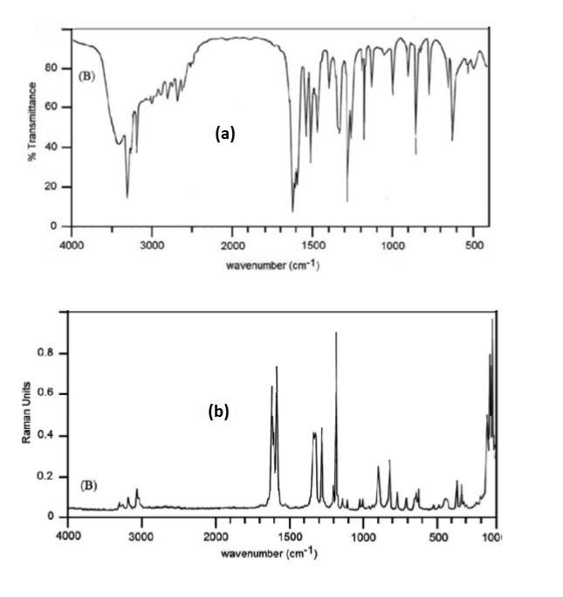
Supplementary Figure 1 - FTIR and FT-Raman spectra of 4 - Hydroxy Benzo Hydrazide
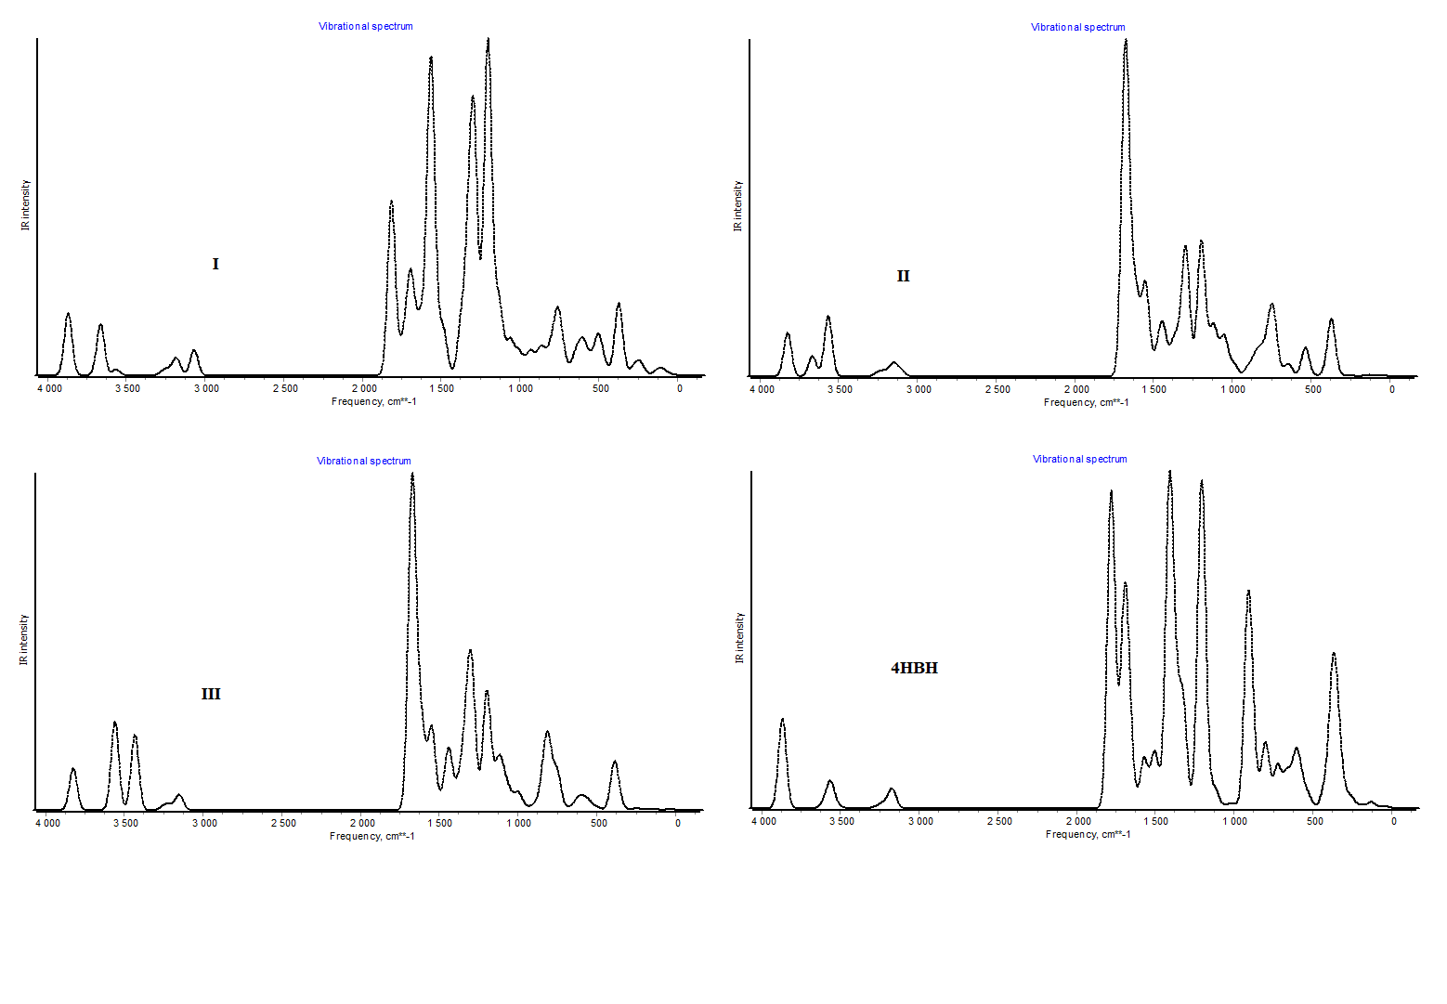
Supplementary Figure 2 - Theoretical Vibrational Spectrum of 4-HBH and three isomers of title compound
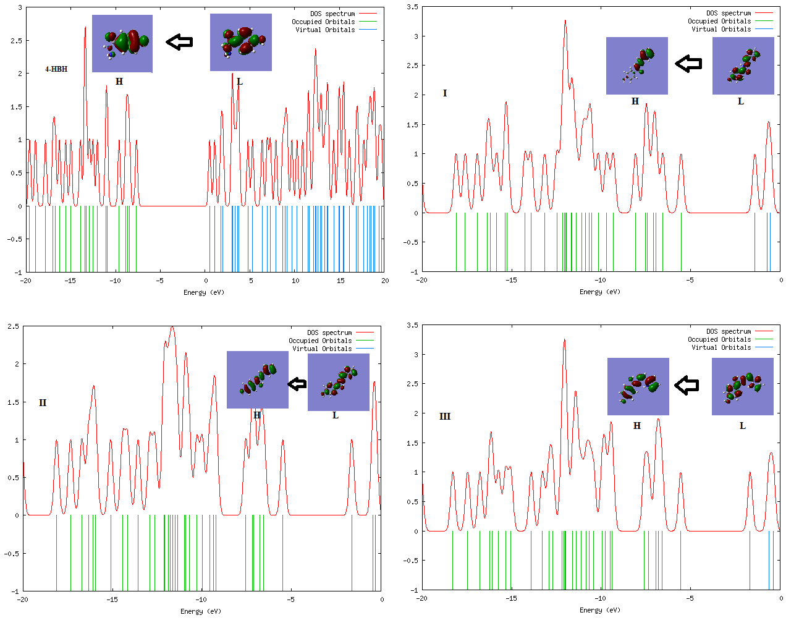
Supplementary Figure 3 - DOS Plots of 4-HBH and three isomers of title compound
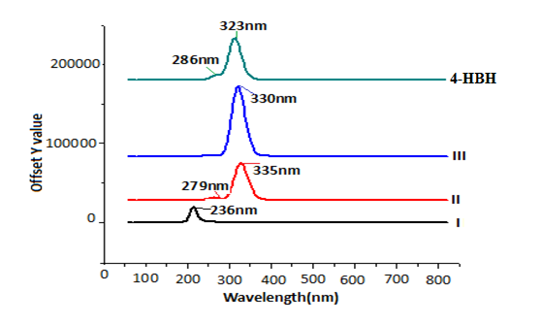
Supplementary Figure 4 - Theoretical UV spectra of 4-HBH and three isomers of title compound

