Supplementary Figures and Tables

Supplementary Figure 1: Volcano pot showing the overexpressed genes in the clinical benefit vs no clinical benefit cohorts.
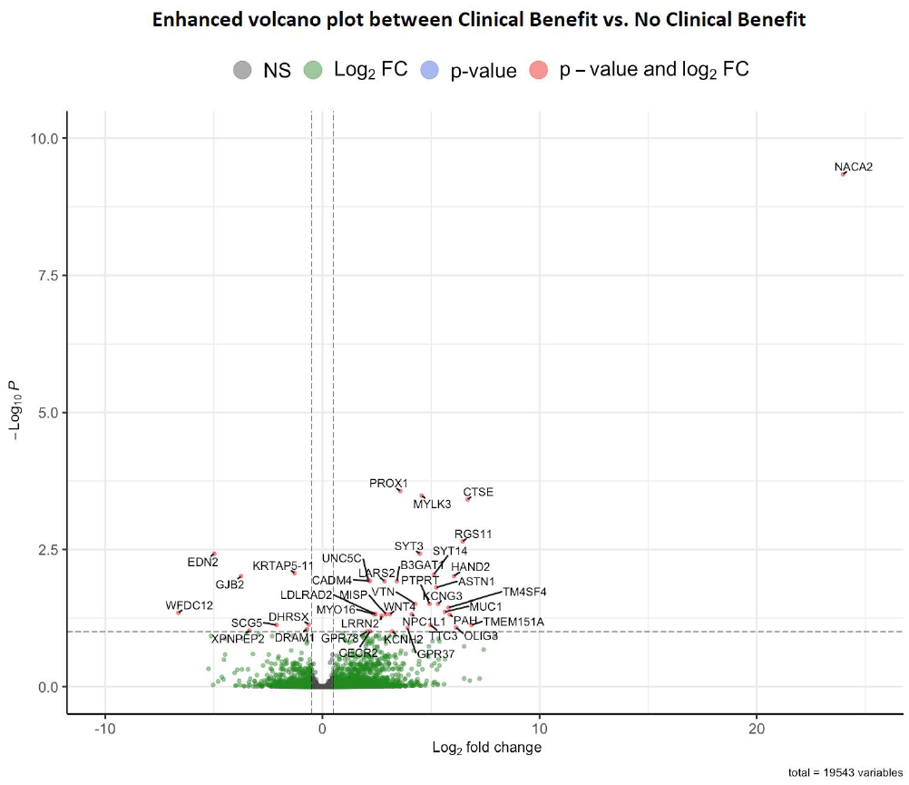

Supplementary Table 1: Frequency of genomic alterations observed in clinical benefit vs no clinical benefit cohort
Genes | Clinical Benefit (N=37) | No Clinical Benefit (N=16) | p-value
PBRM1 | 17 (45.9%) | 8 (50%) | 0.79
VHL | 20 (54.1%) | 10 (62.5%) | 0.57
KDM5C | 7 (18.9%) | 3 (18.8%) | 0.99
SETD2 | 7 (18.9%) | 4 (25%) | 0.62
CDKN2A | 0 (0%) | 1 (6.2%) | 0.12
MTAP | 0 (0%) | 1 (6.2%) | 0.12
CASP8 | 1 (2.7%) | 0 (0%) | 0.51
TSC1 | 5 (13.5%) | 1 (6.2%) | 0.44
BAP1 | 4 (10.8%) | 0 (0%) | 0.17
ARID1A | 2 (5.4%) | 1 (6.2%) | 0.90
TP53 | 2 (5.4%) | 2 (12.5%) | 0.37
PTEN | 2 (5.4%) | 2 (12.5%) | 0.37
STAG2 | 1 (2.7%) | 0 (0%) | 0.51
MUTYH | 1 (2.7%) | 0 (0%) | 0.51
MTOR | 1 (2.7%) | 0 (0%) | 0.51
PIK3CA | 2 (5.4%) | 0 (0%) | 0.34
TERT | 4 (10.8%) | 1 (6.2%) | 0.60
KMT2D | 0 (0%) | 1 (6.2%) | 0.12
MYC | 1 (2.7%) | 0 (0%) | 0.51
GRM3 | 0 (0%) | 1 (6.2%) | 0.12
SMARCB1 | 0 (0%) | 1 (6.2%) | 0.12
SMARCA4 | 0 (0%) | 1 (6.2%) | 0.12
NOTCH4 | 0 (0%) | 1 (6.2%) | 0.12
NF2 | 0 (0%) | 1 (6.2%) | 0.12
IDH1 | 1 (2.7%) | 0 (0%) | 0.51
MSH2 | 0 (0%) | 1 (6.2%) | 0.12
TET2 | 0 (0%) | 1 (6.2%) | 0.12
CXXC4 | 1 (2.7%) | 0 (0%) | 0.51
MSH3 | 1 (2.7%) | 0 (0%) | 0.51
PTCH1 | 1 (2.7%) | 0 (0%) | 0.51
RNF43 | 1 (2.7%) | 0 (0%) | 0.51
JAK1 | 1 (2.7%) | 0 (0%) | 0.51

Supplementary Table 2: Differentially expressed genes in the Clinical Benefit and no- Clinical Benefit cohort
Gene ID | Log2 Fold Change | p value | q value
Clinical Benefit
NACA2 | 23.96 | <0.001 | <0.001
TMEM151A | 6.85 | 0.0001 | 0.07
CTSE | 6.67 | <0.001 | 0.0003
RGS11 | 6.45 | <0.001 | 0.002
OLIG3 | 6.15 | 0.0001 | 0.083
HAND2 | 6.05 | <0.001 | 0.009
PAH | 5.85 | <0.001 | 0.048
TM4SF4 | 5.80 | <0.001 | 0.036
MUC1 | 5.63 | <0.001 | 0.043
KCNG3 | 5.32 | <0.001 | 0.030
ASTN1 | 5.24 | <0.001 | 0.015
SYT14 | 5.12 | <0.001 | 0.009
TTC3 | 4.97 | 0.0001 | 0.075
PTPRT | 4.92 | <0.001 | 0.030
MYLK3 | 4.56 | <0.001 | 0.0003
SYT3 | 4.48 | <0.001 | 0.003
VTN | 4.27 | <0.001 | 0.030
NPC1L1 | 4.11 | <0.001 | 0.047
GPR37 | 3.91 | 0.0001 | 0.085
PROX1 | 3.58 | <0.001 | 0.0002
B3GAT1 | 3.42 | <0.001 | 0.011
KCNH2 | 3.20 | 0.0002 | 0.098
WNT4 | 3.11 | <0.001 | 0.047
MISP | 2.91 | <0.001 | 0.047
LARS2 | 2.85 | <0.001 | 0.011
LRRN2 | 2.72 | <0.001 | 0.051
LDLRAD2 | 2.45 | <0.001 | 0.047
MYO16 | 2.37 | <0.001 | 0.047
CECR2 | 2.19 | 0.0002 | 0.098
CADM4 | 2.18 | <0.001 | 0.011
UNC5C | 2.11 | <0.001 | 0.011
GPR78 | 2.07 | 0.0002 | 0.098
No-Clinical Benefit
DHRSX | 0.6390601 | 0.0001 | 0.073
DRAM1 | 0.7176084 | 0.0001 | 0.089
KRTAP5-11 | 1.2809163 | <0.001 | 0.008
SCG5 | 2.1119639 | 0.0001 | 0.075
XPNPEP2 | 3.3636829 | 0.0002 | 0.095
GJB2 | 3.7490521 | <0.001 | 0.009
EDN2 | 4.9833096 | <0.001 | 0.003
WFDC12 | 6.6251082 | <0.001 | 0.044

Supplementary Table 3: Gene Set Enrichment Analysis showing pathways upregulated in the clinical benefit and the no clinical benefit cohort.
Pathways | NES | q-value
Clinical Benefit
Apical surface | 1.67 | 0.009
KRAS-downregulated pathways | 1.68 | 0.017
No Clinical Benefit
TNF-α Signaling via NFKB | 2.01 | 0.001
MTORC1 Pathway | 1.89 | 0.002
Glycolysis | 1.75 | 0.004
Reactive Oxygen Species | 1.75 | 0.005
Protein Secretion | 1.65 | 0.013
P53 Signaling | 1.59 | 0.020
IL6-JAK-STAT3 Signaling | 1.56 | 0.021
TGF-β Signaling | 1.52 | 0.027
MYC Targets_V1 Pathway | 1.51 | 0.028
Interferon-γ Response | 1.49 | 0.030
Inflammatory Response | 1.42 | 0.037
Myogenesis | 1.44 | 0.038
Epithelial-Mesenchymal Transition | 1.43 | 0.039
Interferon-α Response | 1.38 | 0.048
Apoptosis | 1.37 | 0.048
Heme Metabolism | 1.38 | 0.049
Adipogenesis | 1.31 | 0.07

