Supplementary Data
Figure 1
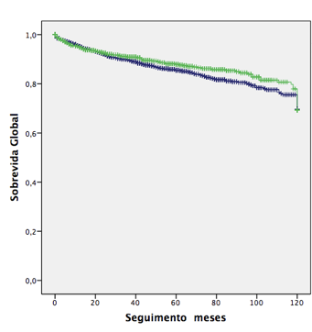
Follow up (months)
Overall Survival
Univariate analysis of overall survival according to the gender (Blue line: Male patients; Green line: Female patients). P = 0.282.
Figure 2
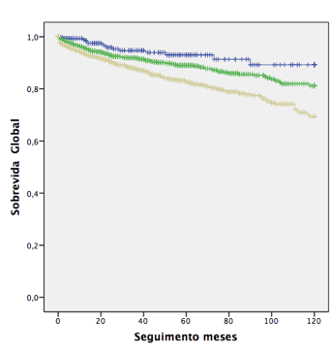
Follow up (months)
Overall Survival
Univariate analysis of overall survival according to the age (Blue line<40; Green line: 40-59; Yellow line ≥ 60). P < 0.001.
Figure 3
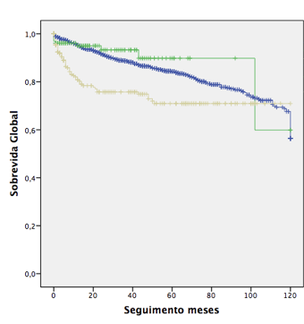
Follow up (months)
Overall Survival
Univariate analysis of overall survival according to the race (Blue line: White patients; Green line: Black or Mulatto patients; Yellow line: others). P < 0.001.
Figure 4
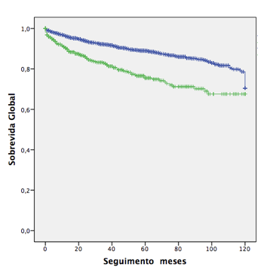
Follow up (months)
Overall Survival
Univariate analysis of overall survival according to the American Society of Anesthesiology classification (ASA) (Blue line: ASA 1 - 2; Green line: ASA 3 - 4). P < 0.001.
Figure 5
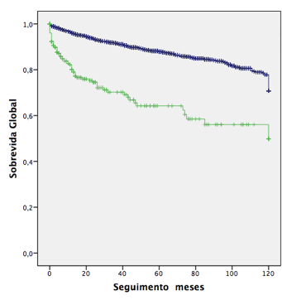
Follow up (months)
Overall Survival
Univariate analysis of overall survival according to the Eastern Cooperative Oncology Group (ECOG) performance scale (Blue line: ECOG 0-1; Green line: ECOG ≥ 2). P < 0.001.
Figure 6
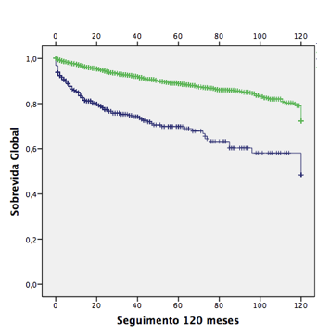
Follow up (months)
Overall Survival
Univariate analysis of overall survival according to the Karnofsky performance scale (Blue line: KPS ≤ 80; Green line: KPS > 80). P < 0.001.
Figure 7
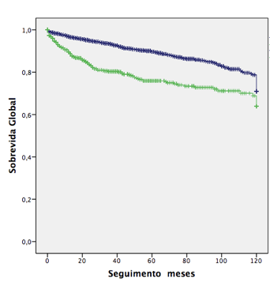
Follow up (months)
Overall Survival
Univariate analysis of overall survival according to the presence of anemia (Hb < 10g/dL) (Blue line: No; Green line: Yes). P < 0.001.
Figure 8
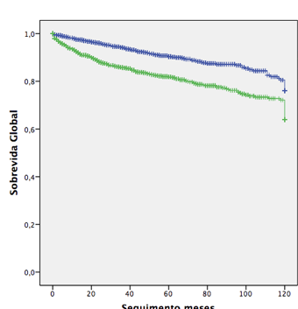
Overall Survival
Follow up (months)

Univariate analysis of overall survival according to the presence of symptons at diagnosis (Blue line: Assymptomatic; Green line: Symptomatic). P < 0.001.
Figure 8
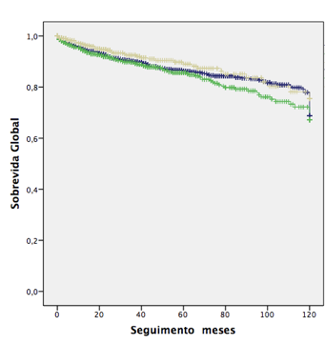
Follow up (months)
Overall Survival
Univariate analysis of overall survival according to the smoking status (Blue line: No; Green line: Former smoker; Yellow line: Smoker). P = 0.454.
Figure 9
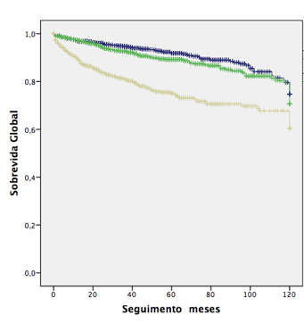
Follow up (months)
Overall Survival
Univariate analysis of overall survival according to the tumor size (Blue line: ≤ 4cm; Green line: 4.1 – 7cm; Yellow line: > 7cm). P < 0.001.
Figure 10
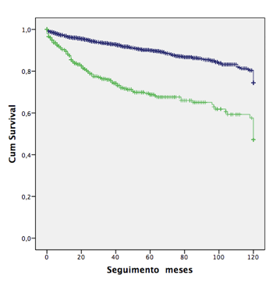
Follow up (months)
Overall Survival
Univariate analysis of overall survival according to the pathological tumoral stage (pT) (Blue line: pT1 – pT2; Green line: pT3 – pT4). P < 0.001.
Figure 11
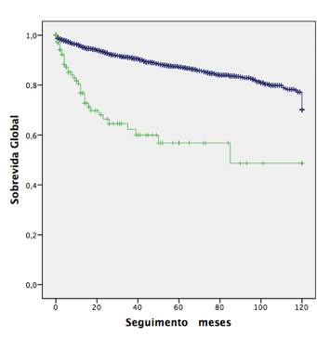
Follow up (months)
Overall Survival
Univariate analysis of overall survival according to the pathological node stage (pN) (Blue line: pN0 and pNx; Green line: pN1). P < 0.001.
Figure 12
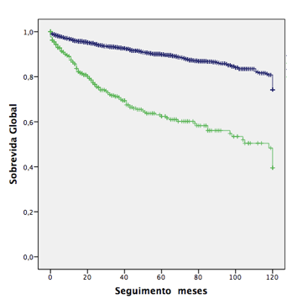
Follow up (months)
Overall Survival
Univariate analysis of overall survival according to the peri-renal fat invasion (Blue line: No; Green line: Yes). P < 0.001.
Figure 13
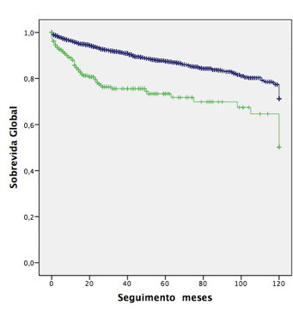
Follow up (months)
Overall Survival
Univariate analysis of overall survival according to the presence of renal vein invasion (Blue line: No; Green line: Yes). P < 0.001.
Figure 14
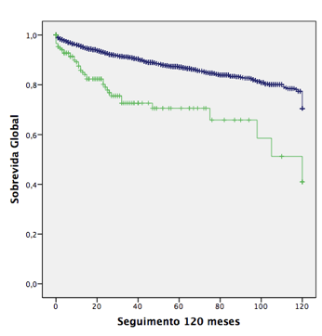
Follow up (months)
Overall Survival
Univariate analysis of overall survival according to the presence of inferior vena cava invasion (Blue line: No; Green line: Yes). P < 0.001.
Figure 15
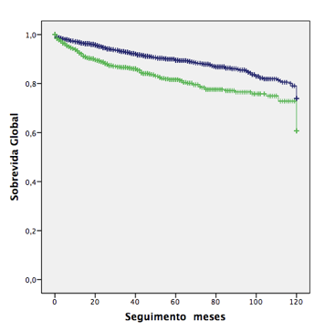
Follow up (months)
Overall Survival
Univariate analysis of overall survival according to the Fuhrman grade (Blue line: Grade 1 - 2; Green line: Grade 3 - 4). P < 0.001.
Figure 16
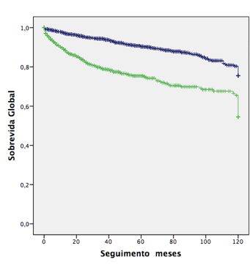
Follow up (months)
Overall Survival
Univariate analysis of overall survival according to the presence of tumoral necrosis(Blue line: No; Green line: Yes). P < 0.001.
Figure 17
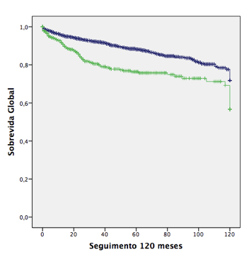
Follow up (months)
Overall Survival
Univariate analysis of overall survival according to the presence of microvascular invasion(Blue line: No; Green line: Yes). P < 0.001.
Figure 18
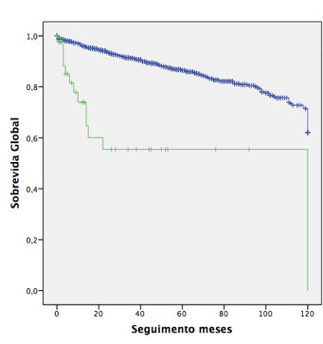
Follow up (months)
Overall Survival
Univariate analysis of overall survival according to the presence of sarcomatoid component (Blue line: No; Green line: Yes). P < 0.001.
Figure 19
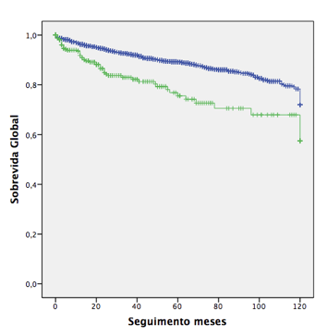
Follow up (months)
Overall Survival
Univariate analysis of overall survival according to the presence of renal pelvis invasion (Blue line: No; Green line: Yes). P < 0.001.
Figure 20
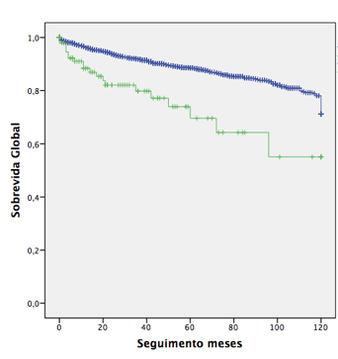
Follow up (months)
Overall Survival
Univariate analysis of overall survival according to the presence of adrenal gland infiltration (Blue line: No; Green line: Yes). P < 0.001.
Figure 21
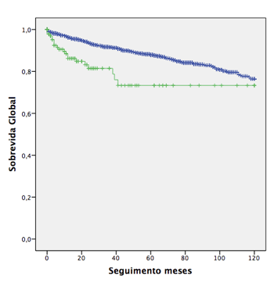
Follow up (months)
Overall Survival
Univariate analysis of overall survival according to the surgical margins status (Blue line: Negative; Green line: Positive). P < 0.001.

Figure 22
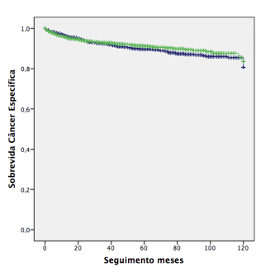
Follow up (months)
Cancer Specific Survival
Univariate analysis of cancer-specific survival according to the gender (Blue line: Male patients; Green line: Female patients). P = 0.351.
Figure 23
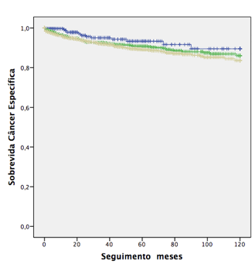
Cancer Specific Survival
Follow up (months)
Univariate analysis of cancer-specific survival according to the age (Blue line <40 years-old; Green line: 40 – 59 years-old; Yellow line ≥ 60 years-old). P = 0.067.
Figure 24
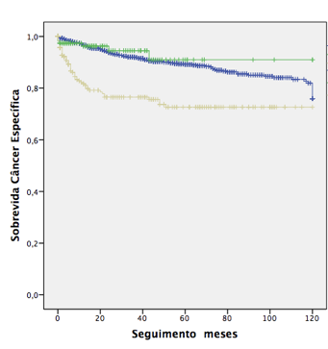
Follow up (months)
Cancer Specific Survival
Univariate analysis of cancer-specific survival according to the race (Blue line: White; Green line: Black/Mulatto; Yellow line: Others). P < 0.001.
Figure 25
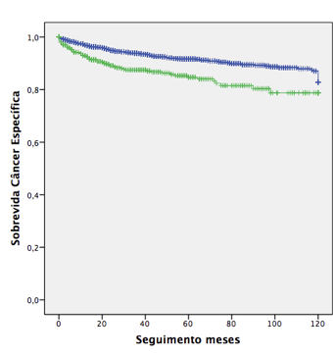
Follow up (months)
Cancer Specific Survival
Univariate analysis of cancer-specific survival according to the American Society of Anesthesiologists classification (ASA) (Blue line: ASA 1-2; Green line: ASA 3-4). P < 0.001.
Figure 26
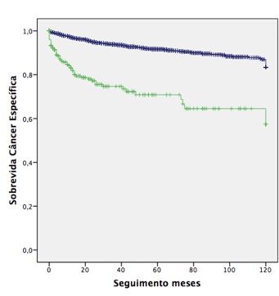
Cancer Specific Survival
Follow up (months)
Univariate analysis of cancer-specific survival according to the Eastern Cooperative Oncology Group (ECOG) performance scale (Blue line: ECOG 0-1; Green line: ECOG ≥2). P < 0.001.
Figure 27
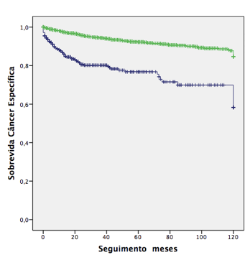
Cancer Specific Survival
Follow up (months)
Univariate analysis of cancer-specific survival according to the Karnofsky performance scale (Blue line: Karnofsky ≤80; Green line: Karnofsky >80). P < 0.001.

Figure 28
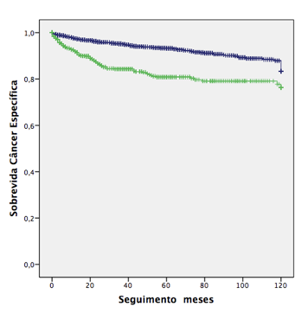
Follow up (months)
Cancer Specific Survival
Univariate analysis of cancer-specific survival according to the presence of anemia (Hemoglobin <10g/dL (Blue line: No; Green line: Yes). P < 0.001.
Figure 29
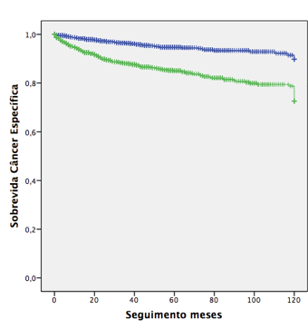
Follow up (months)
Cancer Specific Survival
Univariate analysis of cancer-specific survival according to the presence of symptons at diagnosis (Blue line: Assymptomatic; Green line: Symptomatic). P < 0.001.

Figure 30
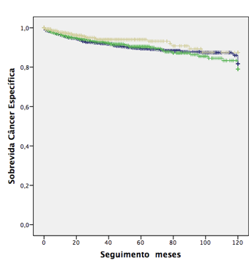
Follow up (months)
Cancer Specific Survival Survival
Univariate analysis of cancer-specific survival according to the smoking status (Blue line: No; Green line: Former smoker; Yellow line: Smoker). P = 0.129.
Figure 31
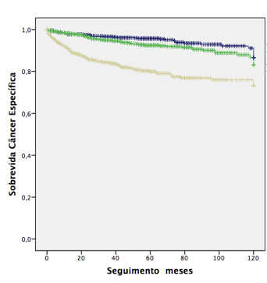
Cancer Specific Survival
Follow up (months)
Univariate analysis of cancer-specific survival according to the tumor size (Blue line: ≤4cm; Green line: 4.1 – 7cm; Yellow line: >7cm). P < 0.001.
Figure 32
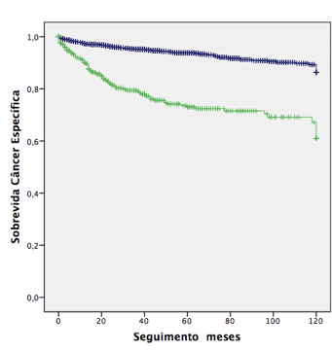
Follow up (months)
Cancer Specific Survival Survival
Univariate analysis of cancer-specific survival according the pathogical tumoral stage (pT) (Blue line: pT1 – pT2; Green line: pT3 – pT4). P < 0.001.
Figure 33
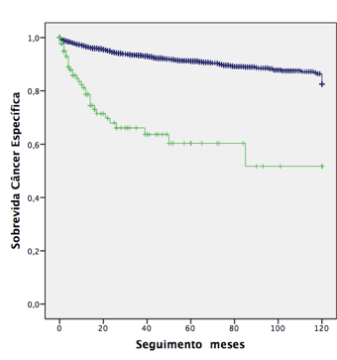
Follow up (months)
Cancer Specific Survival
Univariate analysis of cancer-specific survival according to the pathogical node stage (pN) (Blue line: pN0 and pNx; Green line: pN1). P < 0.001.
Figure 34
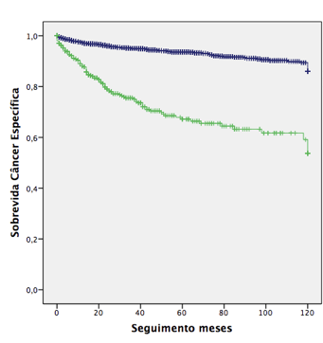
Cancer Specific Survival
Follow up (months)
Univariate analysis of cancer-specific survival according to the presence of perirenal fat invasion (Blue line: No; Green line: Yes). P < 0.001.
Figure 35
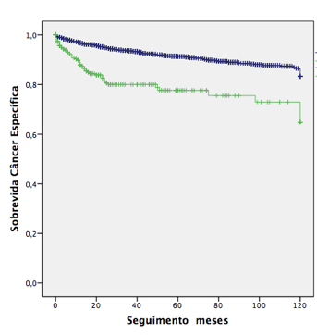
Follow up (months)
Cancer Specific Survival Survival
Univariate analysis of cancer-specific survival according to the presence of renal vein invasion (Blue line: No; Green line: Yes). P < 0.001.
Figure 36
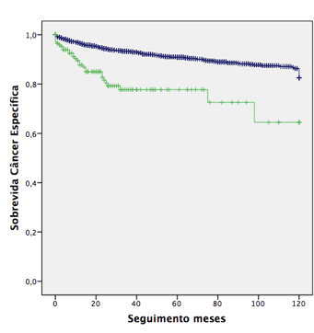
Cancer Specific Survival
Follow up (months)
Univariate analysis of cancer-specific survival according to the presence of inferior vena cava invasion (Blue line: No; Green line: Yes). P < 0.001.
Figure 37
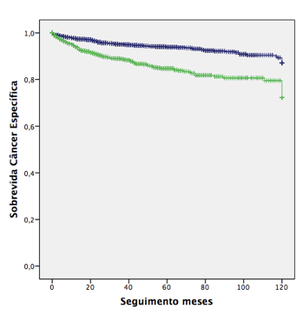
Cancer Specific Survival
Follow up (months)
Univariate analysis of cancer-specific survival according to the Fuhrman grade (Blue line: Grade 1-2; Green line: Grade 3-4). P < 0.001.
Figure 38
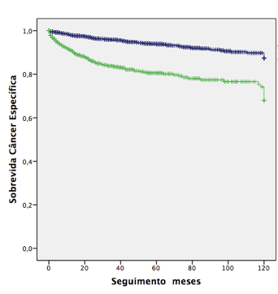
Follow up (months)
Cancer Specific Survival
Univariate analysis of cancer-specific survival according to the presence of tumoral necrosis (Blue line: No; Green line: Yes). P < 0.001.
Figure 39
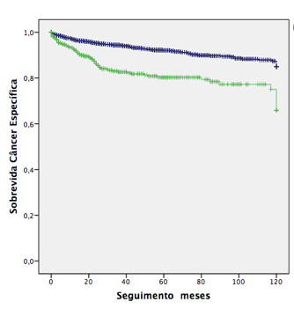
Cancer Specific Survival
Follow up (months)
Univariate analysis of cancer-specific survival according to the presence of microvascular invasion (Blue line: No; Green line: Yes). P < 0.001.
Figure 40
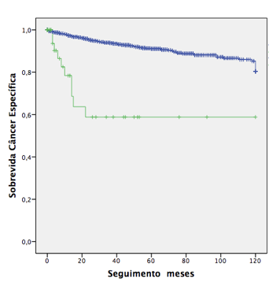
Follow up (months)
Cancer Specific Survival
Univariate analysis of cancer-specific survival according to the presence of sarcomatoid component (Blue line: No; Green line: Yes). P < 0.001.
Figure 41
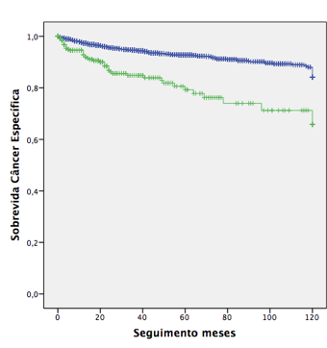
Cancer Specific Survival
Follow up (months)
Univariate analysis of cancer-specific survival according to the presence of renal pelvis invasion (Blue line: No; Green line: Yes). P < 0.001.
Figure 42
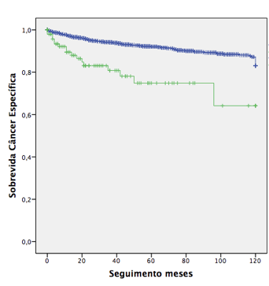
Follow up (months)
Cancer Specific Survival
Univariate analysis of cancer-specific survival according to the presence of adrenal infiltration (Blue line: No; Green line: Yes). P < 0.001.
Figure 43
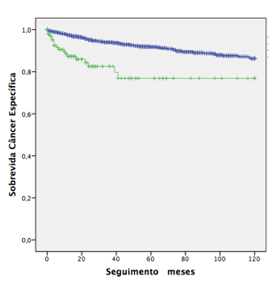
Cancer Specific Survival
Follow up (months)
Univariate analysis of cancer-specific survival according to the surgical margins status (Blue line: Negative; Green line: Positive). P < 0.001.

