Supplementary Material

# Modulation of Cerebellar Oscillations with Subthalamic Stimulation in Patients with Parkinson’s Disease

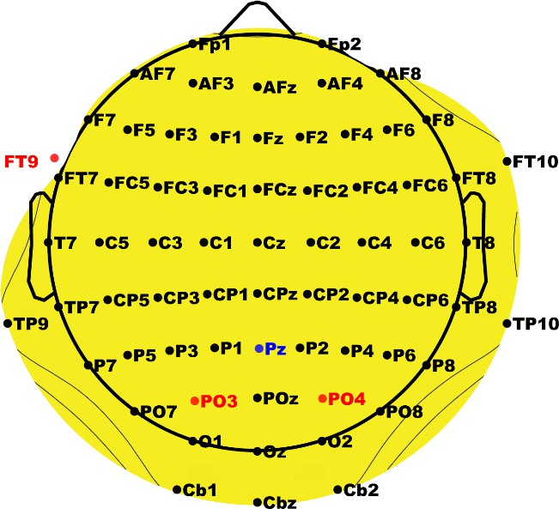

**Supplementary Figure 1. Customized electrode cap.** Pz was used as a reference (blue). This cap was customized to include left cerebellar (Cb1), right cerebellar (Cb2), and mid-cerebellar (Cbz) electrodes positioned over the posterior fossa corresponding to the medial aspects of cerebellar lobules VII, VIII, and IX. Red electrodes indicate those that were removed in place of the cerebellar electrodes.

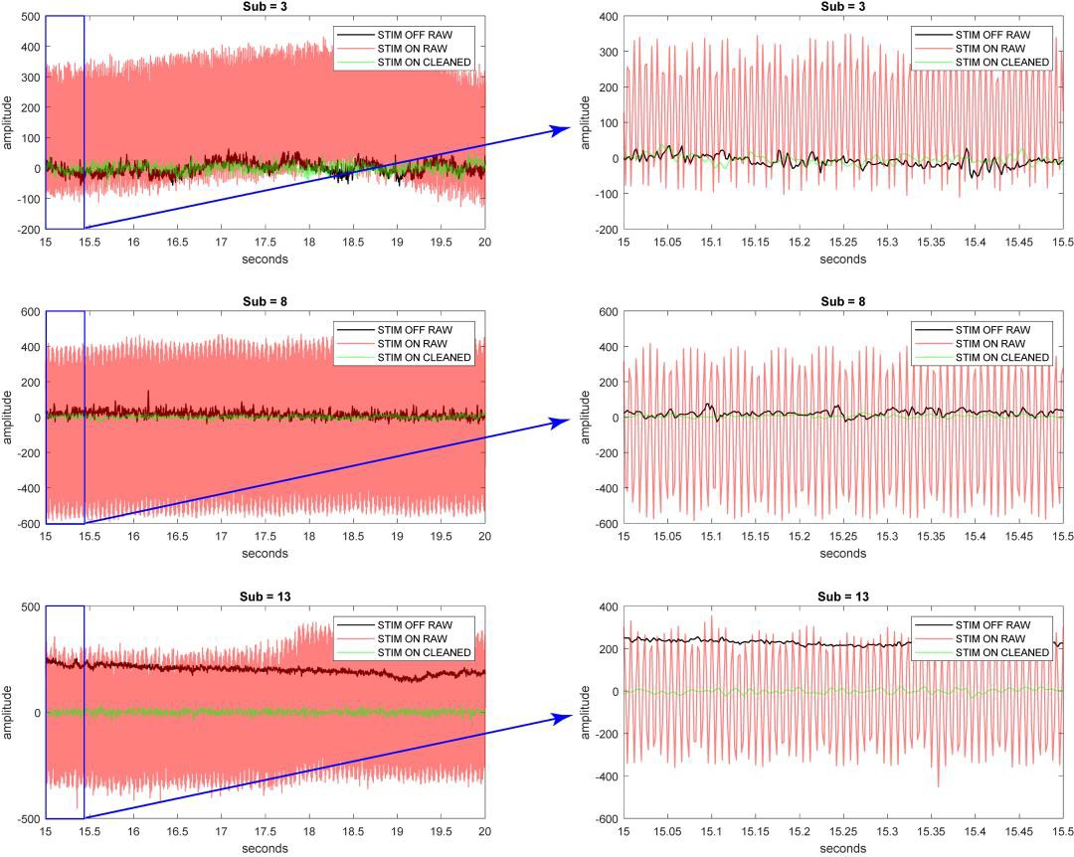

**Supplementary Figure 2.** Examples of the raw mid-cerebellar EEG signal (DBS-OFF), raw mid-cerebellar EEG signal (DBS-ON), and cleaned mid-cerebellar EEG signal (DBS-ON).

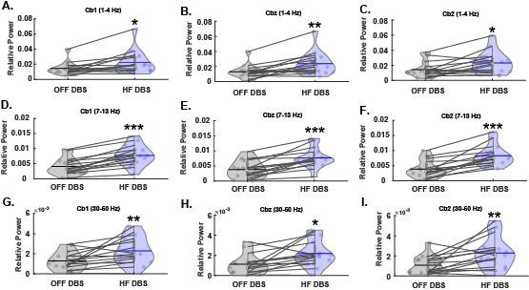

**Supplementary Figure 3. Effects of HF STN-DBS on cerebellar delta, alpha, and gamma oscillations.** HF STN-DBS increases relative power across B) delta, C) alpha, and D) gamma frequency bands. * p < 0.05, ** p < 0.01, *** p < 0.001 vs. OFF-DBS. In violin plots, horizontal lines and white circles represent the mean and median values, respectively.

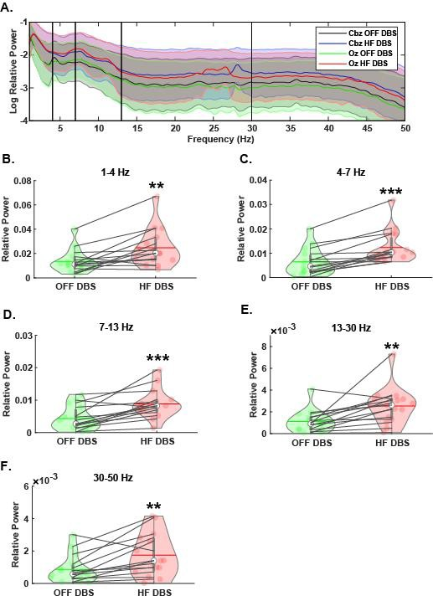

**Supplementary Figure 4. Effects of HF STN-DBS on mid-occipital oscillations.** A) Spectral power differences between OFF-DBS and HF-DBS at Oz. Mid-cerebellar electrode is also shown for reference. HF STN-DBS increases mid-occipital relative power across B) delta, C) theta, D) alpha, E) beta, and F) gamma frequency bands. ** p < 0.01, *** p < 0.001 vs. OFF-DBS. In violin plots, horizontal lines and white circles represent the mean and median values, respectively.

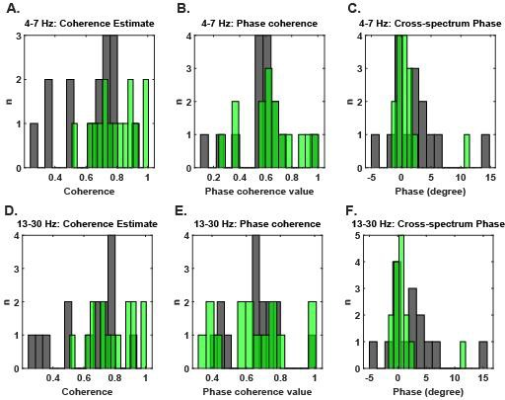

**Supplementary Figure 5. Similarity analyses between mid-cerebellar and mid-occipital theta and beta oscillations.** Coherence estimates, phase coherence, and cross-spectrum phase for A-C) theta oscillations and D-F) beta oscillations.

**Supplementary Table 1. Correlations between all frequency bands and all three cerebellar electrodes.**

|  |  |  |  |
| --- | --- | --- | --- |
|  | Cb1 | Cbz | Cb2 |
| *Delta (1-4 Hz)* |  |  |  |
| HF-DBS | 0.32 (0.24) | 0.35 (0.21) | 0.25 (0.37) |
| OFF-DBS | -0.29 (0.30) | -0.12 (0.66) | -0.07 (0.82) |
| *Theta (4-7 Hz)* |  |  |  |
| HF-DBS | -0.12 (0.66) | -0.14 (0.63) | -0.05 (0.86) |
| OFF-DBS | -0.04 (0.89) | 0.01 (0.97) | 0.08 (0.79) |
| *Alpha (7-13 Hz)* |  |  |  |
| HF-DBS | -0.22 (0.44) | -0.23 (0.4) | -0.23 (0.42) |
| OFF-DBS | 0.23 (0.42) | 0.32 (0.24) | 0.31 (0.25) |
| *Beta (13-30 Hz)* |  |  |  |
| HF-DBS | -0.27 (0.33) | -0.33 (0.23) | -0.17 (0.54) |
| OFF-DBS | 0.51 (0.05) | 0.56 (0.03) | 0.61 (0.02) |
| *Gamma (30-50 Hz)* |  |  |  |
| HF-DBS | -0.14 (0.61) | -0.13 (0.65) | -0.08 (0.77) |
| OFF-DBS | 0.54 (0.04) | 0.54 (0.04) | 0.62 (0.01) |

Associations between cerebellar EEG power and mUPDRS scores during HF-DBS and OFF-DBS at all frequencies. Values are reported as r2 (p-value). Reported p-values are uncorrected, but Bonferroni corrections can be applied by comparing the uncorrected p-value to an adjusted critical alpha level of 0.008 (0.05/6) for each frequency band, accounting for both HF-DBS and OFF-DBS as well as all three electrodes.

# Supplementary Table 2. Comparisons between OFF-DBS versus ON-DBS for sensorimotor regions.

|  |  |  |
| --- | --- | --- |
|  | Theta band | Beta band |
| Right Sensorimotor region | t(14) =-3.88, p=0.002 | t(14) =-3.62, p=0.003 |
| Left sensorimotor region | t(14) =-4.17, p=0.001 | t(14) =-2.0, p=0.065 |

**Supplementary Table 3. Correlation analyses between sensorimotor EEG power (theta band and beta band) and mUPDRS scores during HF-DBS and OFF-DBS.**

|  |  |  |
| --- | --- | --- |
|  | OFF-DBS | ON-DBS |
| Theta band | 0.52 (0.052) | 0.31 (0.26) |
| Beta band | -0.23 (0.40) | -0.02 (0.93) |

Values are reported as r2 (p-value).