Supplementary Material

Levodopa-Carbidopa Intestinal Gel Monotherapy: GLORIA Registry Demographics, Efficacy, and Safety

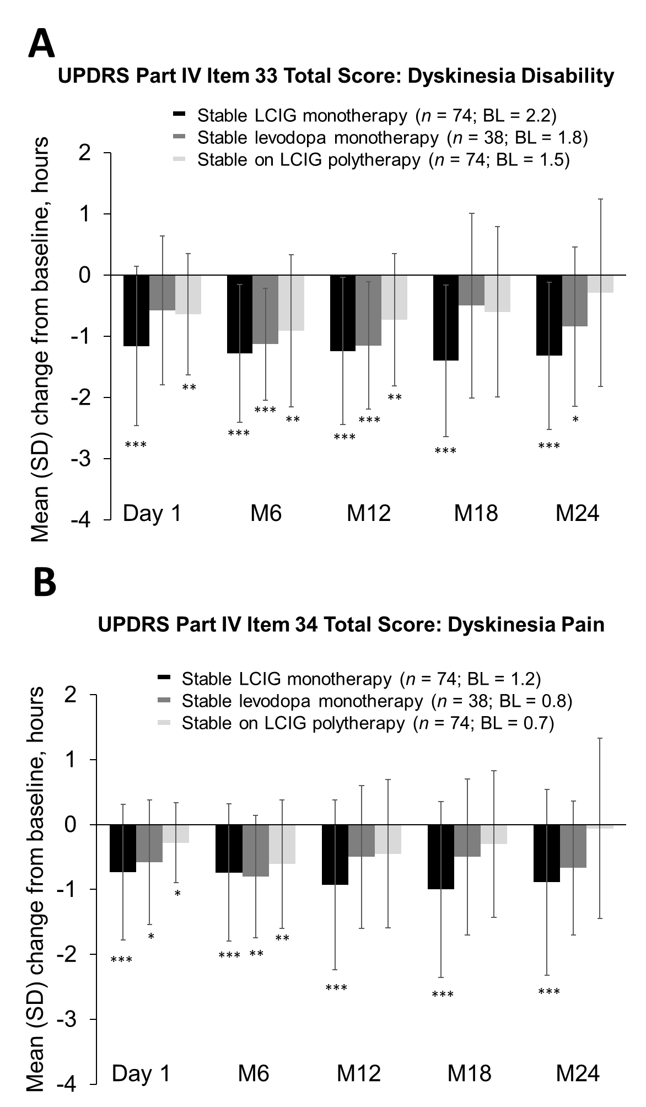

Supplementary Figure 1. Mean (SD) change from baseline in dyskinesia (A) disability and (B) pain. LCIG, levodopa-carbidopa intestinal gel; M, month; SD, standard deviation. ***p ≤ 0.001, **p ≤ 0.01, and *p ≤ 0.05.

