Supplementary Material

How I Do It: The Neuro-Ophthalmological Assessment in Parkinson’s Disease

Near Visual Acuity Chart
Standard Logarithmic Visual Acuity Chart 2000 “New ETDRS” Chart “1” used to compare the visual acuity needed for reading various print objects (ETDRS = Early Treatment Diabetic Retinopathy Study). (Reprinted with permission from Precision Vision).
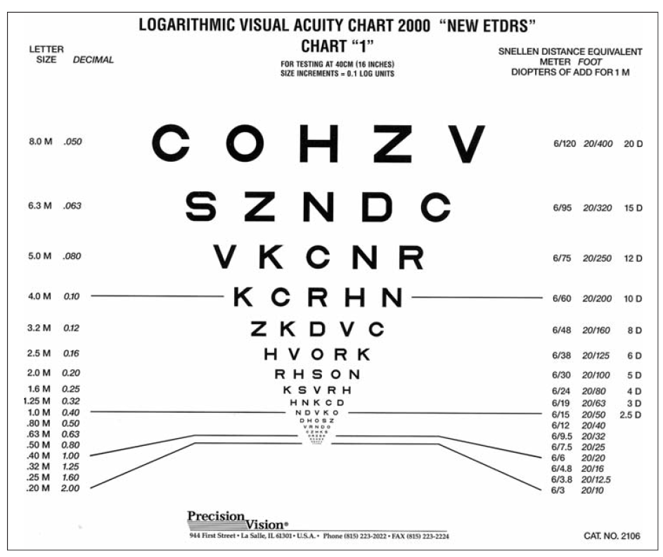

Amsler Grid

