**Supplementary material**

**Table S1.** Overview of details of genetics results.

|  |  |  |  |  |  |
| --- | --- | --- | --- | --- | --- |
| Patient  nr. | Variant | Type and location | ACMG classification | Parents | Phenotype |
| 1 | c.3215delG  p.(Cys1072Serfs*3)  heterozygous  c.5235-12G>A  r.(spl?), p.?  heterozygous | frameshift  exon 23  splice?  intron 36 | pathogenic (PVS1, PS4, PM2)  likely pathogenic (PS4, PM2, PP3, PP4) | unknown | CMD |
| 2 | c.6993-2A>C  r.(spl), p.?  heterozygous  c.2049_2050delAG  [p.(Arg683Serfs*21)](https://mutalyzer.nl/normalizer/NM_000426.4(NP_000417.3):p.(Arg683Serfs*21))  heterozygous | splice  intron 49  frameshift  exon 14 | pathogenic(PVS1, PS4, PM2, PM3)  pathogenic (PVS1, PS4, PM2, PM3) | Mat  Pat | CMD |
| 3 | c.3085C>T  p.(Arg1029*)  heterozygous  c.4960-17C>A  r.(spl), p.?  heterozygous | nonsense  exon 22  splice  intron 34 | pathogenic (PVS1, PS4, PM2)  pathogenic (PS4, PM2, PM3, PM4, PP3, PP4) | Mat  Pat | CMD |
| 4 | c.2749+2dupT  r.(spl), p.?  heterozygous  c.3283C>T  p.(Arg1095*)  heterozygous | splice  exon 19  nonsense  exon 23 | likely pathogenic (PVS1, PM2)  pathogenic (PVS1, PS4, PM2) | unknown | LGMD |
| 5 | c.4960-17C>A  r.(spl), p.?  homozygous | splice  intron 34 | pathogenic (PS4, PM2, PM4, PP3, PP4) | Pat/Mat | CMD |
| 6 | c.4960-17C>A  r.(spl), p.?  homozygous | splice  intron 34 | pathogenic (PS4, PM2, PM4, PP3, PP4) | Pat/Mat | CMD |
| 7 | c.437C>T  p.(Ser146Phe)  heterozygous  c.7865_7869delGAGAA  [p.(Arg2622Thrfs*9)](https://mutalyzer.nl/normalizer/NM_000426.4(NP_000417.3):p.(Arg2622Thrfs*9))  heterozygous | missense  exon 4  frameshift  exon 56 | VUS (PM2, PP3, PP4)  pathogenic (PVS1, PM2, PP4) | unknown  unknown | LGMD |
| 8 | c.7147C>T  p.(Arg2383*)  homozygous | nonsense  exon 50 | pathogenic (PVS1, PS4, PM2, PP4) | Pat/Mat | CMD |
| 9 | c.5235-12G>A  r.(spl?), p.?  homozygous | splice?  intron 36 | likely pathogenic (PS4, PM2, PM3, PP3, PP4) | Pat/Mat | Lost ambulation  LGMD |
| 10 | c.3976C>T  p.(Arg1326*)  heterozygous  c.5235-12G>A  r.(spl?), p.?  heterozygous | nonsense  exon 27  splice?  intron 36 | pathogenic (PVS1, PS4, PM2, PP4)  likely pathogenic (PS4, PM2, PM3, PP3, PP4) | Pat  Mat | CMD |
| 11 | c.4692_4695dup  [p.(Arg1566Cysfs*13)](https://mutalyzer.nl/normalizer/NM_000426.4(NP_000417.3):p.(Arg1566Cysfs*13))  heterozygous  c.8244 +1G>A  r.(spl), p.?  heterozygous | frameshift  exon 32  splice  intron 58 | pathogenic (PVS1, PS4, PM2, PM3, PP4)  pathogenic (PVS1, PS4, PM2, PM3, PP4) | Pat  Mat | CMD |
| 12 | “E967X” | nonsense | pathogenic (PVS1) | Pat/Mat | CMD |
| 13 | Dupl exons 10-12  homozygous (due to uniparental disomy) | dup | VUS | Pat (UPD) | CMD |
| 14 | unknown |  |  |  | CMD |
| 15 | c.3651del  p.(Ile1217Metfs*7)  heterozygous  c.8405T>G  p.(Leu2802Arg)  heterozygous | frameshift  exon 25  missense  exon 60 | pathogenic (PVS1, PS4, PM2, PP4)  VUS (PM2, PP3, PP4) | unknown  unknown | CMD |
| 16 | no report  “homozygous pathogenic” |  |  |  | CMD |
| 17 | c.2537G>T  p.(Arg846Met)  homozygous | missense/Splice?  exon 18 | VUS (PM2, PP3, PP4) | Pat/Mat | LGMD |
| 18 | c.7147C>T  p.(Arg2383*)  homozygous | nonsense  exon 50 | pathogenic (PVS1, PS4, PM2, PP4) | Pat/Mat | CMD |

**Table S2.** Gained Sitting without support for all patients

|  |  |  |  |  |
| --- | --- | --- | --- | --- |
| **Number** | **m/w** | **Sitting without support gained at age y;m** | **Walking alone gained** | **phenotype** |
| 4 | f | Gained but unknown when | unknown | LGMD |
| 7 | m | Gained but unknown when | 1;8 | LGMD |
| 9 | w | 2;3 | 3;5 | LGMD |
| 17 | f | 2;3 | 2;3 | LGMD |
| 1 | f | 12m | never | CMD |
| 2 | f | never | never | CMD |
| 3 | f | never | never | CMD |
| 5 | m | Gained and then lost at 18 month | never | CMD |
| 6 | f | 7;2 | never | CMD |
| 8 | m | 0;12 | never | CMD |
| 10 | m | 3;4 | never | CMD |
| 11 | w/d | unknown | never | CMD |
| 12 | m | unknown | never | CMD |
| 13 | m | 1;2 | never | CMD |
| 14 | m | unknown | never | CMD |
| 15 | m | Gained but unknown when | never | CMD |
| 16 | m | Unknown | never | CMD |
| 18 | m | never | never | CMD |

Notes. f, female; m, male

**Figure S1. Aberrant splicing of the variant c.4960-17C>A**

A) RT-PCR was performed with primers overlapping exons 33/34 and exons 36/37, respectively, on cDNA/RNA obtained from a PaxGene blood sample. While the wild-type control (WT) shows a product at the expected size of 395 bp, the two siblings carrying the homozygous variant (S1 and S2) had a larger product of 410 bp, respectively, indicating aberrant splicing. Both heterozygous parents (P1, P2) showed the wild-type and aberrant product. B) Sanger sequencing of the products confirmed that 15bp of intron 34 are retained in the mutant allele, as displayed in the electropherograms of the two affected siblings. Of note, the retained sequence would be in-frame, but contains a “TAG” stop codon, thus predicted to result in premature termination of translation.

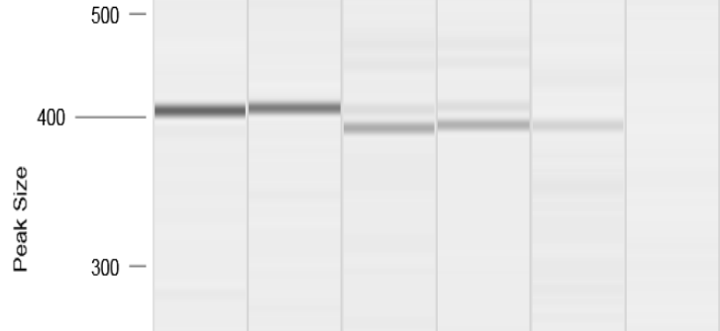

S1

S2

P1

P2

WT

**B)**

**A)**

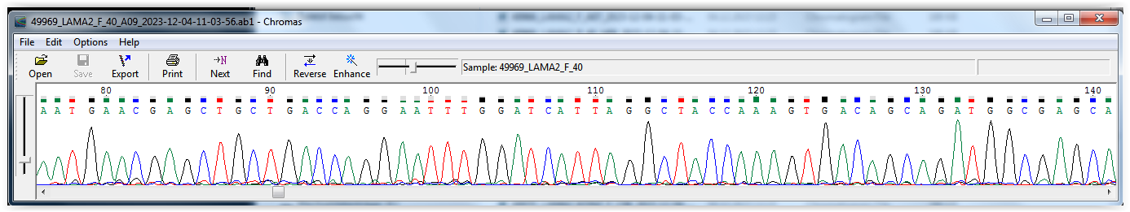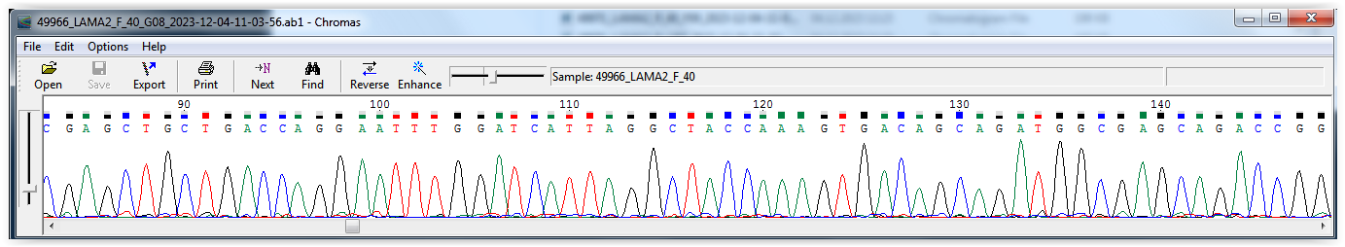

34

35

Intron 34

5’-

S1

S2

**Figure S2.** CHOP-INTEND and MFM-20/32 scores

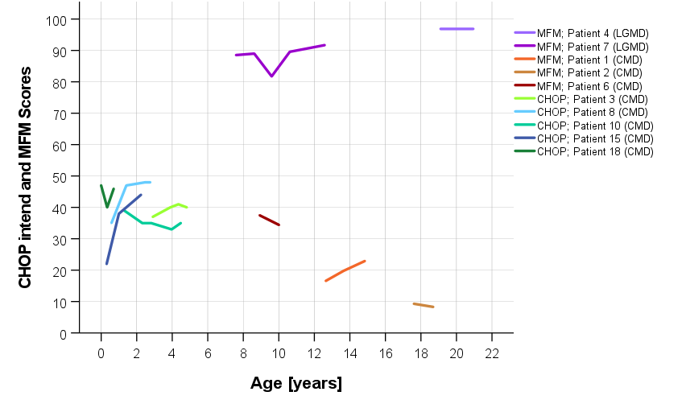

The MFM is also less feasible during a routine clinical visit. The subdomains did not reveal more information than the total score and showed similar relatively stable scores over time (see Fig. S4). These findings are in contrast with those of the prospective study by Bouman et al. [1], which found that domain 1 of the MFM-20/32 (standing and transfers) was most severely affected whereas domain 3 (distal muscle function) was relatively spared. The difference with the cohort of Bouman et al. [1] Bouman might be that the cohort includes more elder patients, with a less severe phenotype Jain et al. [2] reported meaningful decline in the ambulatory patients in domain 1, the non-ambulatory patients in domain two, and the total score. A score that can be used over the entire age range of the cohort and that is sensitive to small changes in severely affected patients would be ideal for longitudinal studies.

**References**

[1] Bouman K, Groothuis JT, Doorduin J, van Alfen N, Udink Ten Cate FEA, van den Heuvel FMA, et al. LAMA2-Related Muscular Dystrophy Across the Life Span: A Cross-sectional Study. Neurol Genet. 2023;9(5):e200089.

[2] Jain MS, Meilleur K, Kim E, Norato G, Waite M, Nelson L, et al. Longitudinal changes in clinical outcome measures in COL6-related dystrophies and LAMA2-related dystrophies. Neurology. 2019;93(21):e1932-e43.