Supplemental Material:
Supplemental Text:
Data pre-processing: For timed function outcomes also in the Northstar Ambulatory Assessment, two levels of grading were available: based on the NSAA test (corresponding to levels 0, 1, and 2) as well as the timed tunction test (corresponding to levels 1 through 6). For time to climb and time to stand from supine tests, only grade 2 or higher attempts had times recorded while for run/walk 10 m test, only grade 3 or higher attempts had times recorded. NSAA data was only collected when a subject was deemed ambulatory; in all other cases, EK responses were collected.
Supplemental Figures:
Supplemental Figure 1: Distribution of mutations
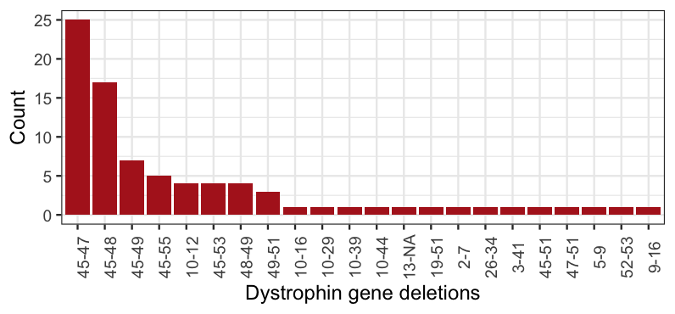

Supplemental Figure 2. Spearman correlation analysis of medians of each subject for each functional outcome test and age.
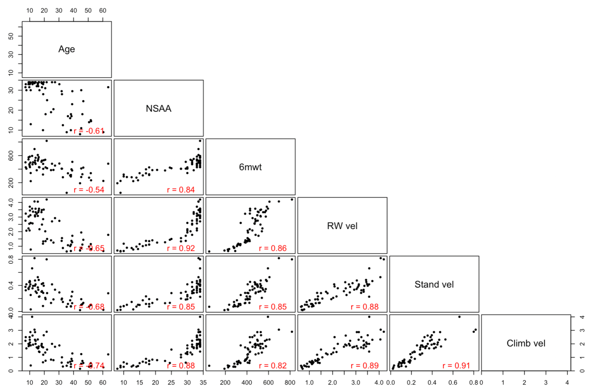

Supplementary Figure 3. Overall trajectory plots of change in outcomes for participants in the Becker Natural History
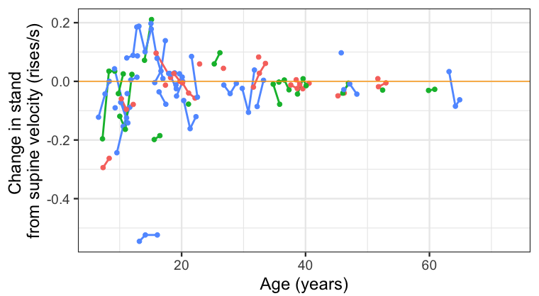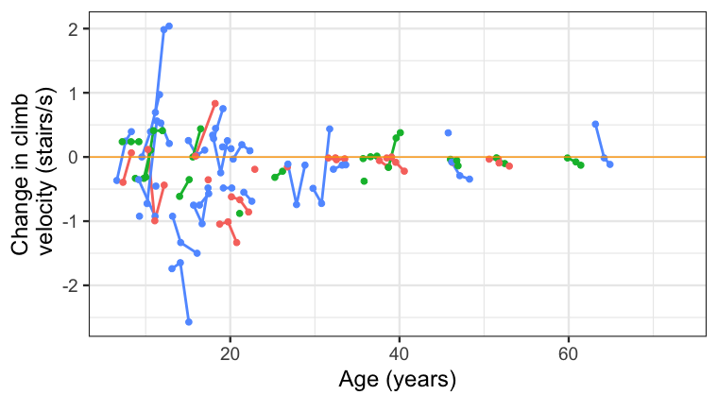
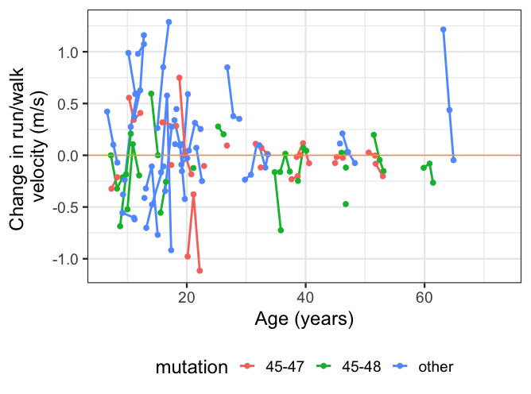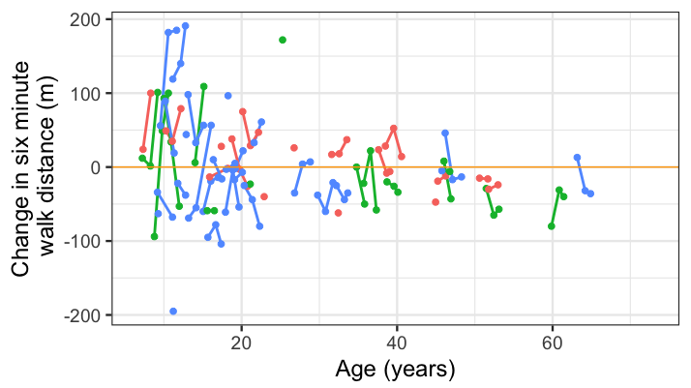
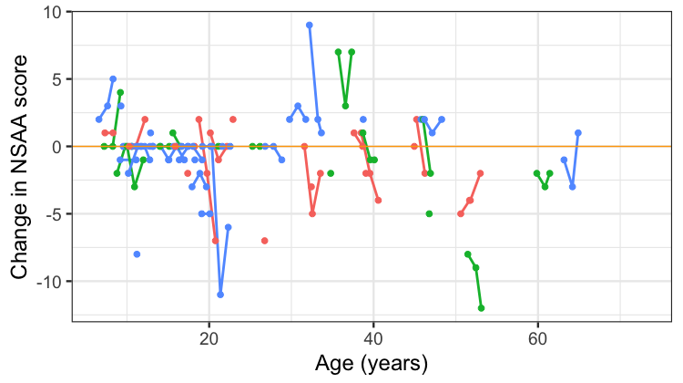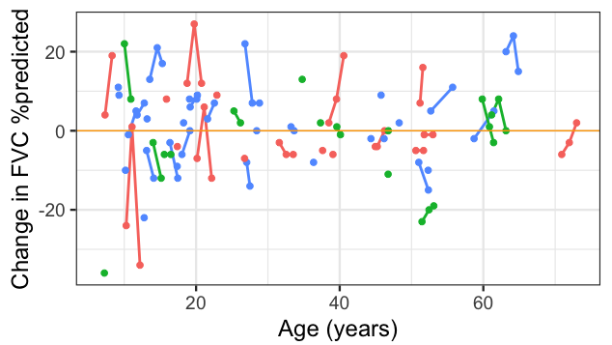

Supplemental Figure 4. Outcome individual trajectories stratified by enrollment age (< vs. ≥ 18 years of age for motor outcomes). The expected model fit for an individual with fixed baseline values based on model estimates are overlaid.
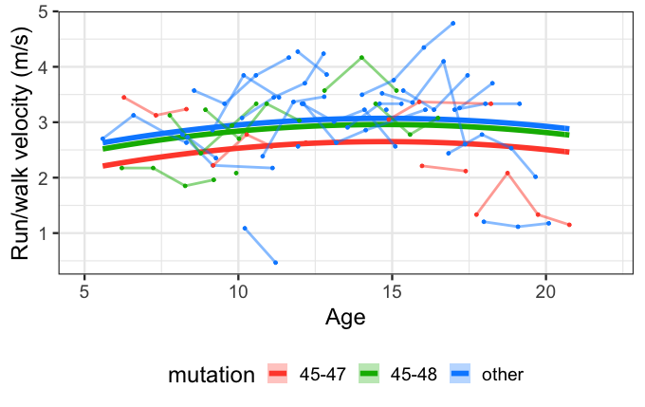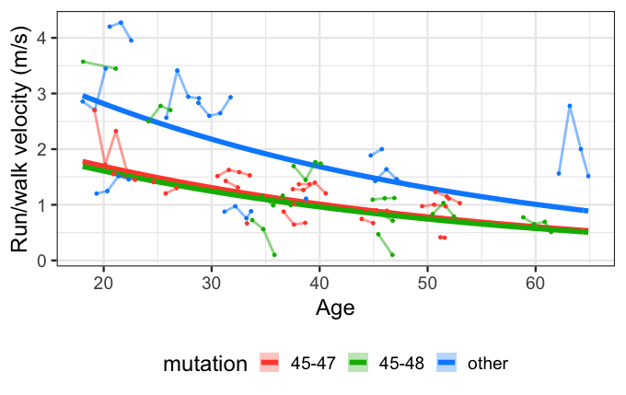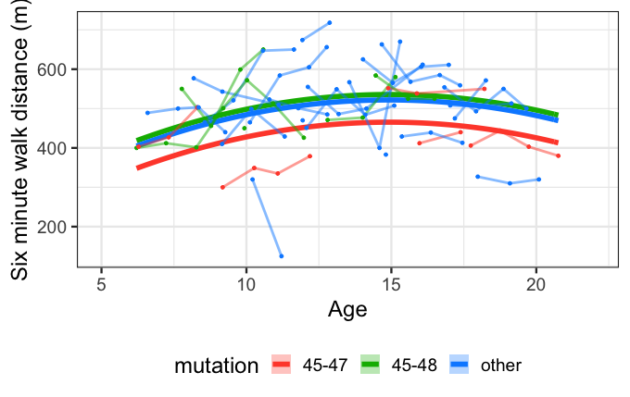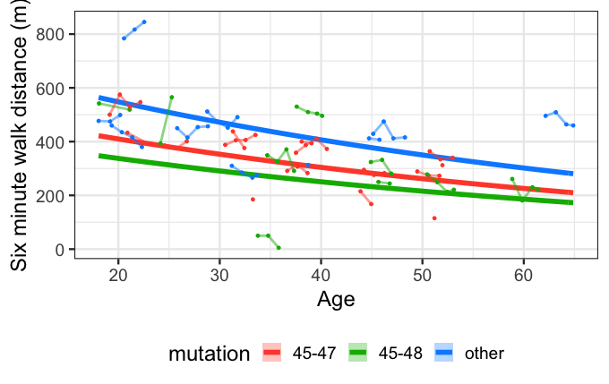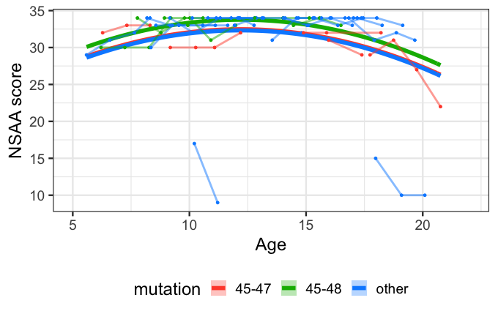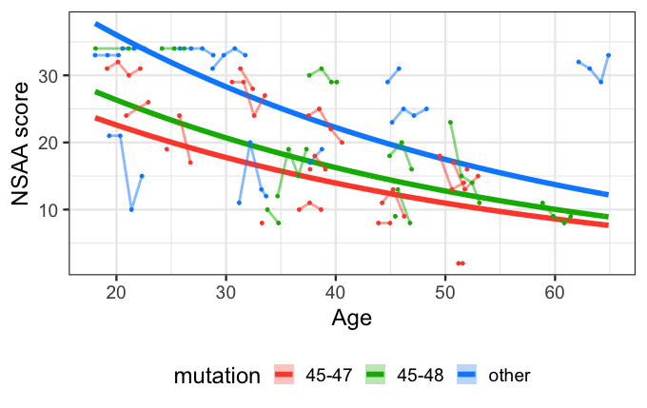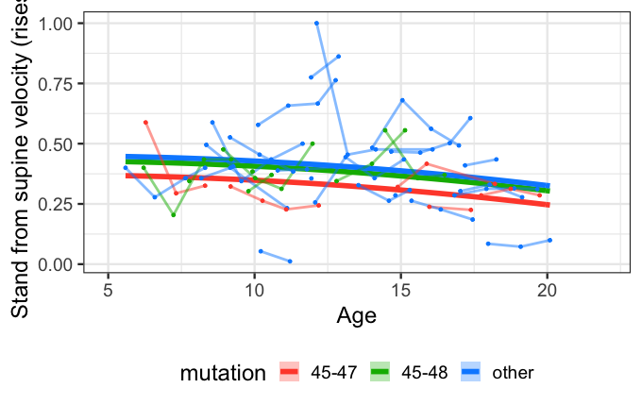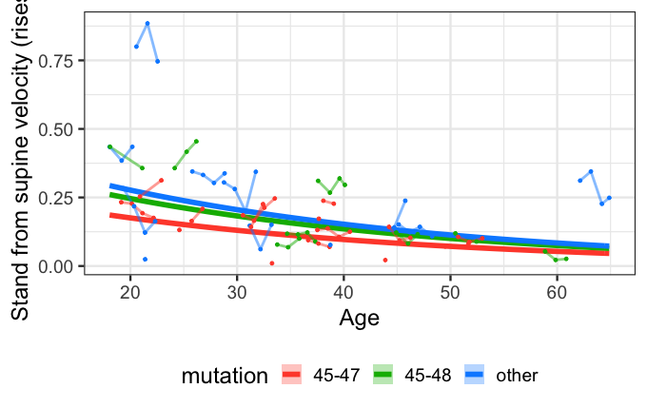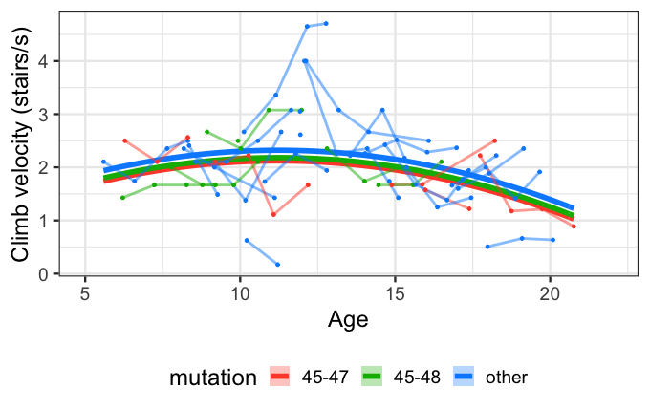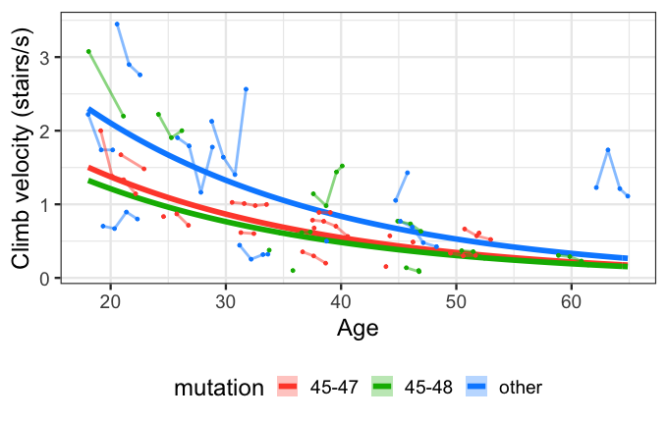

Supplemental Table 1: Summary baseline characteristics by genotype (at first visit)*
Characteristic  mean (SD); available n | 45-47 (n=25) | 45-48 (n=17) | Other (n=41)
Age in years; n = 83 | 35.7 (17.9) | 30.2 (18.7) | 24.7 (16.5)
TTSTAND (seconds) n=63 | 12.7 (22.6) | 5.7 (5.1) | 3.9 (3.6)
STAND velocity (rises/s); n=63 | 0.2 (0.1) | 0.3 (0.2) | 0.4 (0.2)
TTCLIMB (seconds); n=64 | 5.9 (5.5) | 6.3 (7.4) | 2.8 (2.1)
CLIMB velocity (stairs/s); n=64 | 1.1 (0.7) | 1.4 (1.0) | 2.0 (0.9)
TTRW (seconds); n=66 | 7.9 (3.2) | 7.7 (5.4) | 4.4 (2.3)
RW velocity (m/s); n=66 | 1.5 (0.8) | 1.9 (1.1) | 2.7 (0.9)
6MWD (m); n=64 | 362.3 (87.2) | 394.1 (145.0) | 489.5 (107.5)
NSAA (units); n=67 | 21.8 (8.4) | 24.5 (10.4) | 29.8 (6.8)
Standing height (cms); n=66 | 171.2 (16.4) | 159.8 (25.6) | 158.7 (19.5)
Weight (kgs); n=82 | 72.3 (17.9) | 60.9 (27.0) | 66.6 (30.5)
% predicted FVC; n=75 | 86.9 (15.1) | 89.8 (14.5) | 83.0 (20.7)
PUL 1.2 score; n=63 | 78.1 (3.0) | 79.0 (1.8) | 79.1 (1.8)
Ambulatory | 88% | 94% | 78%
% Minor; n = 83 | 20% | 35.3% | 51.2%
Note that the large differences in baseline age between different genotype groups. Abbreviations: TTSTAND: time to stand from supine; TTCLIMB: time to climb 4 steps; TTRW: time to run/walk 10m; 6MWD: six-minute walk distance; NSAA: NorthStar Ambulatory Assessment; FVC: Forced vital capacity; PUL 1.2: Performance of Upper Limb version 1.2

