Supplementary Figures
Supplementary Figure 1: Demographic information of participants. [A] Table showing number of participants, gender, ethnicity, role and genetic diagnosis of participants. [B] Pie chart showing percentage of participants by country (n=1147)
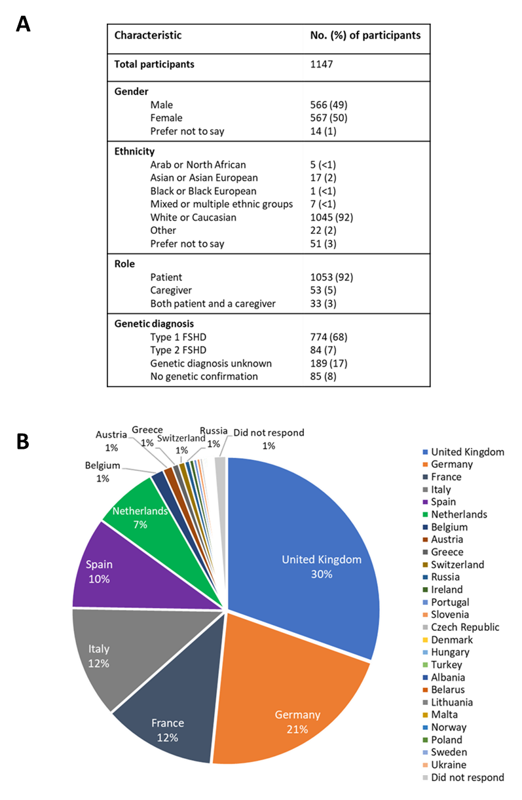

Supplementary Figure 2: Current condition of participants FSHD. [A] Walking ability: Pie chart showing the affect FSHD has had on the participants walking ability. Colours indicate severity: Green – not at all affected; yellow – mildly affected (affected but do not use walking aids); orange – moderately affected (requires aids to walk); red – severely affected (requires wheelchair). [B] Bar chart showing the mobility aids used by participants. Percentage of participants represents those who responded that their walking ability was moderately or severely affected in [A] (n=625). [C] Risk of falls: Bar chart showing percentage of participants who have experienced a fall and how often this occurs. Those who answered that they had experienced falls (n=725) were asked further related questions: [D] Pie chart indicating the causes of a fall. Green – muscle weakness; blue – poor balance; purple – fatigue; yellow – pain; grey – other. [E] Upper limb function vs age of participants. Participant’s upper extremity function was measured using the 20-item Upper Extremity Functional Index (UEFI-20). Each item (e.g. brushing your hair, driving, opening a jar etc) uses a 5-point adjectival response scale to rate difficulty in performing UE activities: 0=extreme difficulty or unable to perform activity, 1=quite a bit of difficulty, 2=moderate difficulty, 3=a little bit of difficulty, and 4=no difficulty. Summing the items yields a total score from 0 (worst) to 80 (best) points. Bar graph shows the percentage of participants (y axis) with UEFI scores of 0 – 20 (red); 21 – 40 (orange); 41 – 60 (yellow) and 61- 80 (green) by current age (x axis).
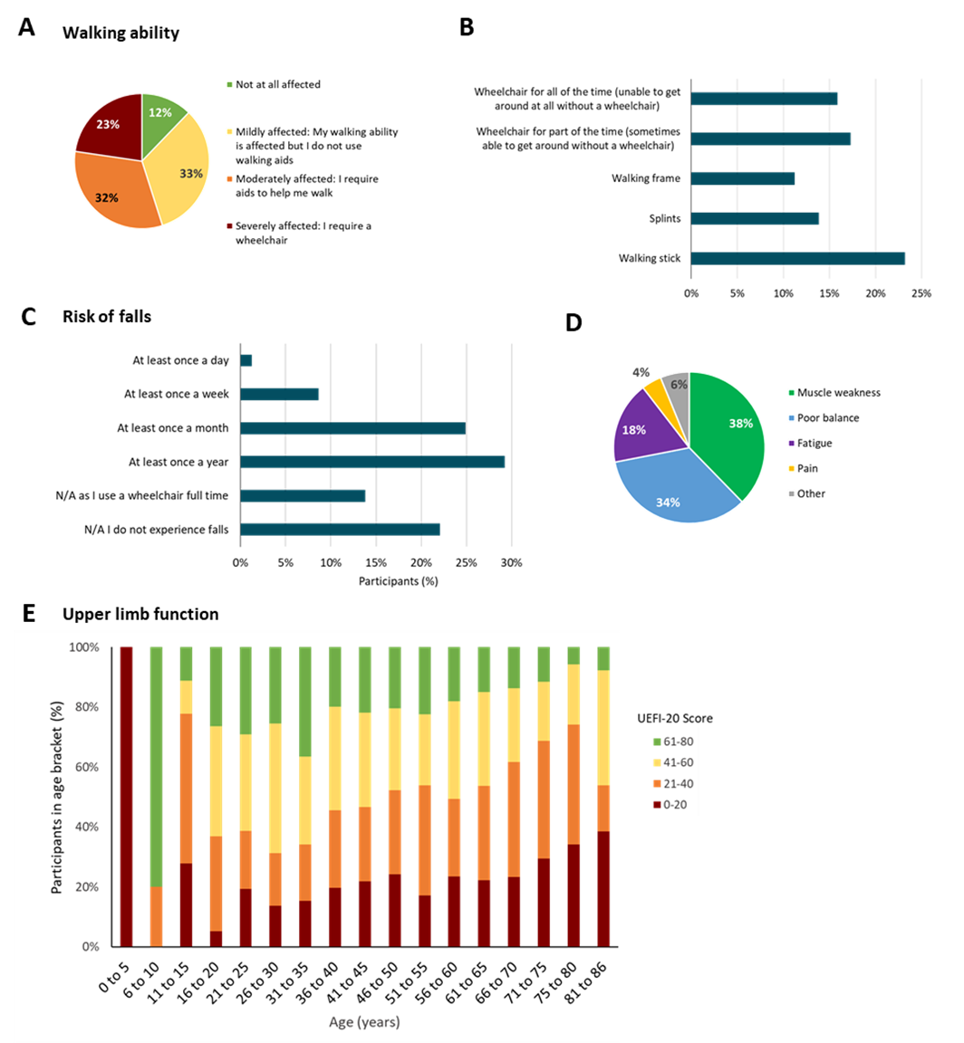
Supplemental Figure 3: Current management of FSHD. Bar graphs showing [A] medication and [B] other therapies that participants are currently using to manage their condition. X axis indicates the percentage of participants (total n=1147) using the specified therapy. [C] Bar graph showing what participants (% of total n=1147) perceive as the biggest limitations of their current treatment regimen.
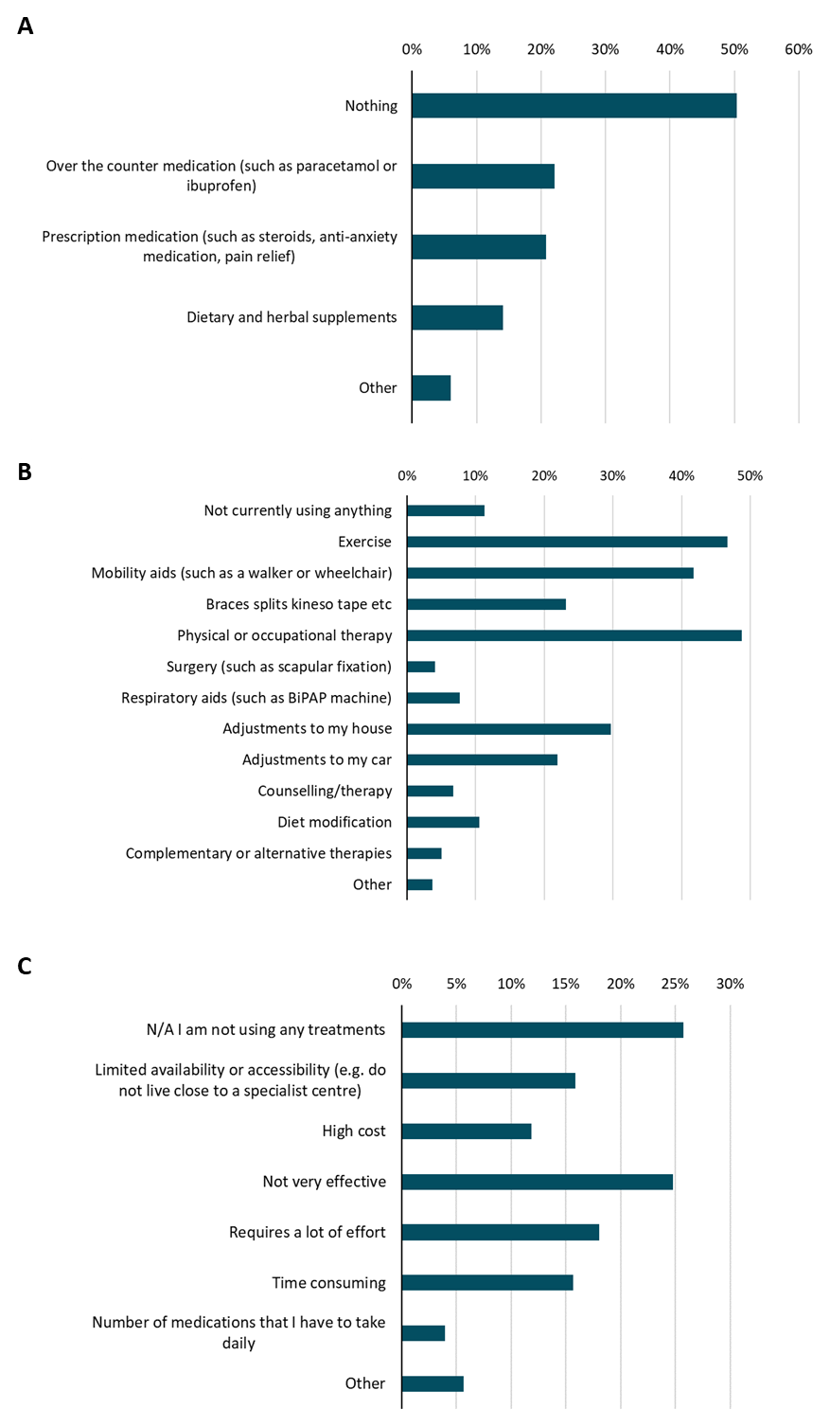

Supplemental Figure 4. Effect of age on what participants find most encouraging when deciding to participate in a clinical trial. Box and whisker plot showing the age of participants that chose each factor to be most encouraging (scored 5/5) when deciding to take part in a clinical trial. Age of all participants is shown in grey. All encouraging factors are shown in white. Unpaired t-test shows that participants selecting compensation for travel (Q15.1) is significantly different (P=0.014) compared to all participants. All other comparisons were not significant.
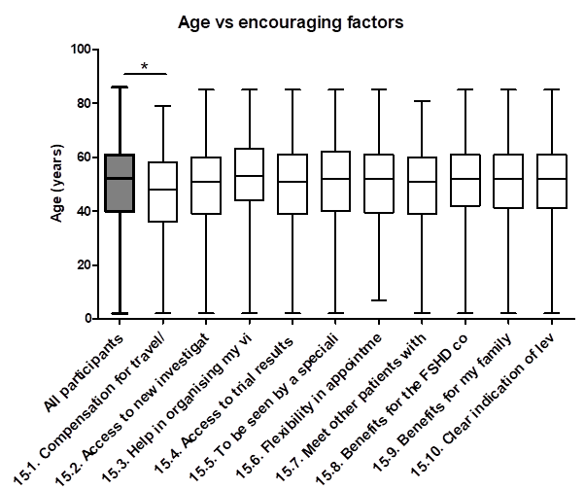

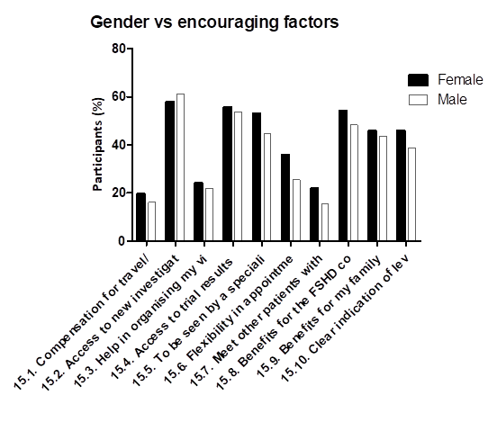
Supplemental Figure 5. Effect of gender on what participants find most encouraging when deciding to participate in a clinical trial. Bar chart showing gender (female – black, male – white) vs factors that participants chose to be most encouraging (scored 5/5) when deciding to take part in a clinical trial. Unpaired t-test showed that there was no significant difference (P=0.5376) between gender and what participants found encouraging.

Supplementary Figure 6. Effect of ambulation on what participants find most encouraging when deciding to participate in a clinical trial. Bar chart showing self-reported ambulation (Green – not affected and can walk normally, Yellow – mildly affected but does not require walking aids, orange – moderately affected and require walking aids, red – severely affected and require wheelchair) vs. factors that participants chose to be most encouraging (scored 5/5) when deciding to take part in a clinical trial. One way ANOVA shows that ambulation did not have a significant effect (P=0.8321) on what participants found most encouraging.

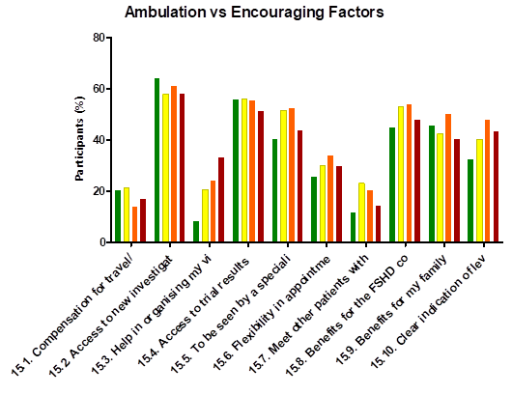

Supplementary Figure 7. Effect of age on what participants find most discouraging when deciding to participate in a clinical trial. Box and whisker plot showing the age of participants that chose each factor to be most discouraging (scored 5/5) when deciding to take part in a clinical trial. Age of all participants is shown in grey. All discouraging factors are shown in white. Unpaired t-test showed that fear of side effects from treatment (* P=0.0387), Facility of the clinical trial is far away (** P=0.0024), Would have to miss work/school (**** P<0.0001) and Lack of financial compensation for time spent on the trial (*** P=0.0004) were statistically significant compared to all participants.

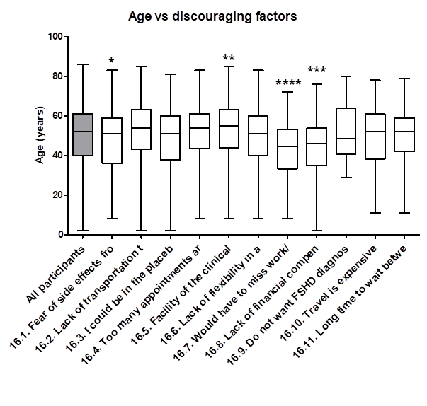

Supplementary Figure 8. Effect of gender on what participants find most discouraging when deciding to participate in a clinical trial. Bar chart showing gender (female – black, male – white) vs factors that participants chose to be most discouraging (scored 5/5) when deciding to take part in a clinical trial. Unpaired t-test showed that there was no significant difference (P=0.0878) between gender and what participants found discouraging.

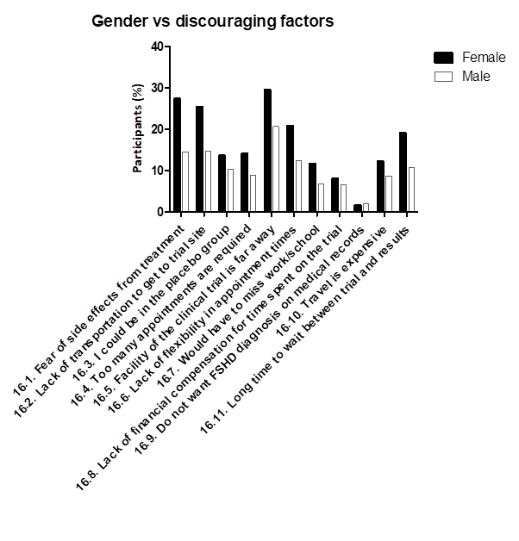

Supplementary Figure 9. Effect of ambulation on what participants find most discouraging when deciding to participate in a clinical trial. Bar chart showing self-reported ambulation (Green – not affected and can walk normally, Yellow – mildly affected but does not require walking aids, orange – moderately affected and require walking aids, red – severely affected and require wheelchair) vs. factors that participants chose to be most discouraging (scored 5/5) when deciding to take part in a clinical trial. One way ANOVA shows that ambulation did not have a significant effect (P=0.4161) on what participants found most discouraging.
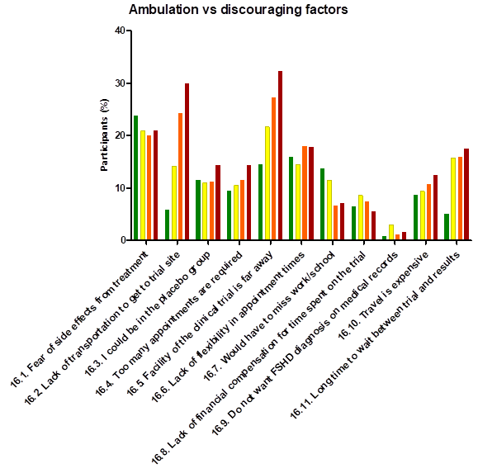

Supplemental Figure 10: Travel to clinical trials. [A] Willingness of overnight stay during clinical trial. Bar chart indicates the proportion of participants that would be willing to stay in a hotel suitably equipped to meet their needs and for how many nights. [B] Time to travel to clinical trial site. Bar graph indicates the length of time (hours) that participants would be willing to travel to take part in a clinical trial. [C] Proportion of respondents who would be willing to travel abroad for a clinical trial. [D] Proportion of participants who would travel to a country with a different language. Colours indicate the following: Yes –blue; No – purple; Not sure - grey. (n=1147)
