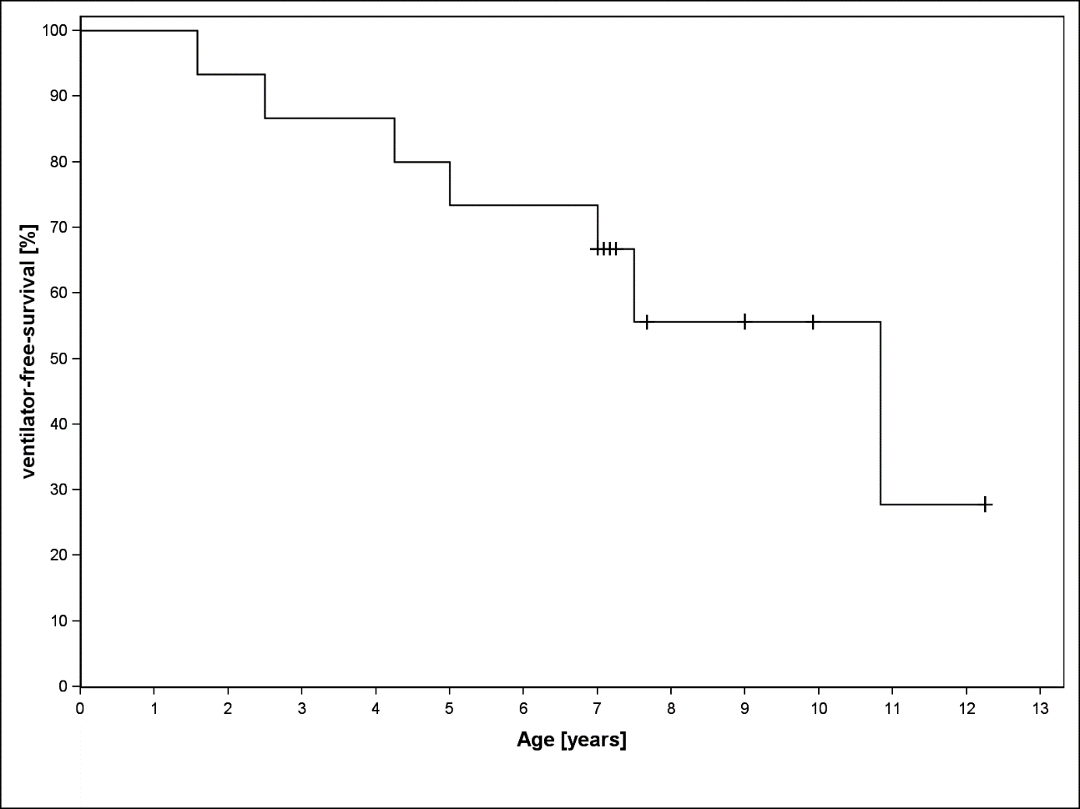
Supplemental Figure 1 A: Ventilator-free survival of 15 IOPD patients

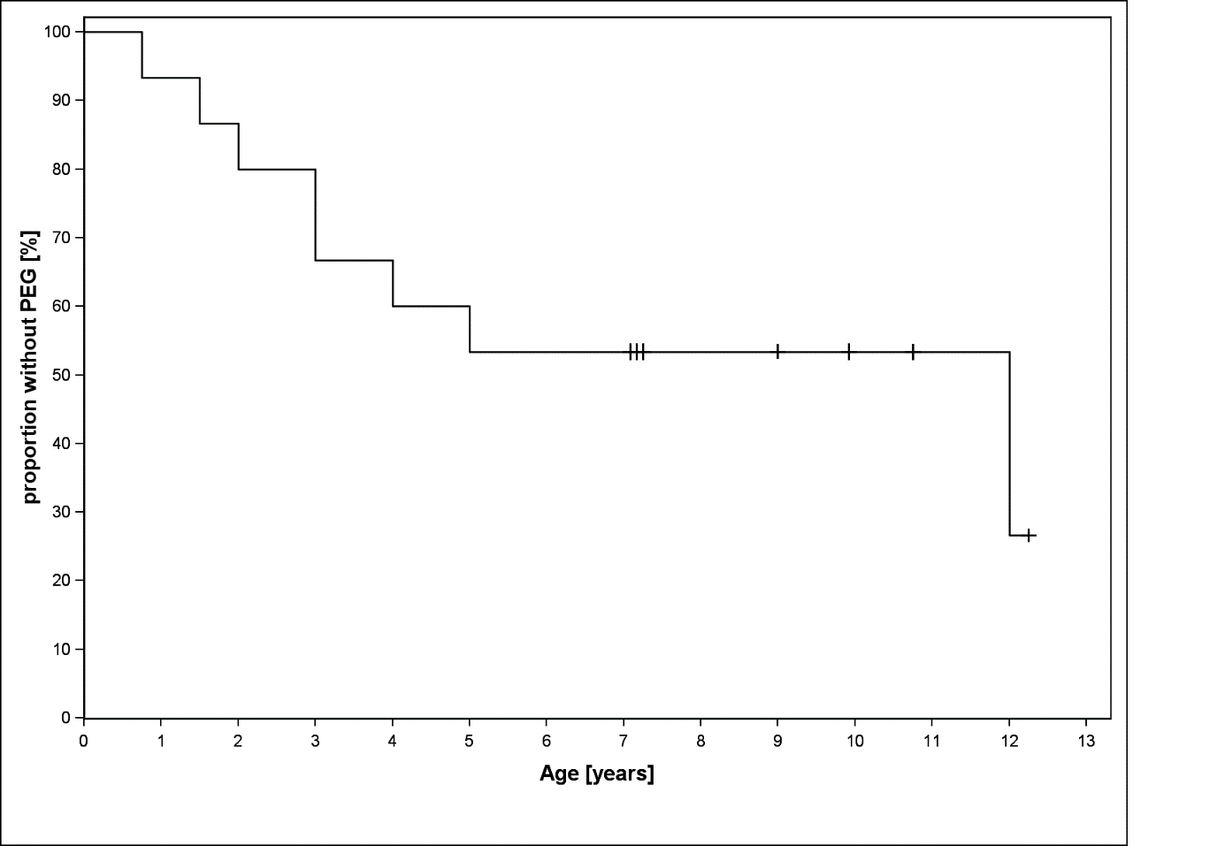
Supplemental Figure 1 B: Gastrostomy-free survival in 15 IOPD patients

Supplemental Table 2: Results of the standardized scoring of magnetic resonance imaging abnormalities in patients with IOPD
Patient | Age | PWM centrum semiovale | PWM frontal/ occipital | Corpus callosum | PLIC | ALIC | External capsule | Sub-cortical | U-fibres | Decus-satio | Cortico-spinal | Widened lateral ventricle | Widened 4th ventricle | Basal ganglia
11 | 1.1 | 1 | 1 | 0 | 0 | 0 | 0 | 0 | 0 | 0 | 0 | 0 | 0 | 0
6 | 1.7 | 1 | 1 | 0 | 0 | 0 | 1 | 0 | 0 | 0 | 0 | 0 | 0 | 0
2 | 1.9 | 1 | 1 | 0 | 0 | 0 | 1 | 0 | 0 | 0 | 0 | 0 | 0 | 0
11 | 2.1 | 1 | 1 | 1 | 0 | 0 | 0 | 0 | 0 | 0 | 0 | 0 | 0 | 0
15 | 3.0 | 0 | 0 | 0 | 0 | 0 | 0 | 0 | 0 | 0 | 0 | 0 | 0 | 0
6 | 3.2 | 2 | 2 | 1 | 1 | 1 | 2 | 2 | 0 | 1 | 2 | 0 | 0 | 0
3 | 3.6 | 1 | 0 | 0 | 0 | 0 | 0 | 0 | 0 | 0 | 0 | 1 | 0 | 0
4 | 3.11 | 2 | 2 | 1 | 2 | 0 | 1 | 2 | 0 | 0 | 1 | 0 | 0 | 0
15 | 4.0 | 1 | 0 | 1 | 0 | 0 | 0 | 0 | 0 | 0 | 0 | 0 | 0 | 0
11 | 7.3 | 2 | 2 | 1 | 2 | 0 | 2 | 0 | 0 | 0 | 0 | 1 | 1 | 1
11 | 8.2 | 2 | 2 | 2 | 2 | 0 | 2 | 1 | 0 | 0 | 0 | 1 | 1 | 1
10 | 9.2 | 0 | 0 | 0 | 0 | 0 | 0 | 0 | 0 | 0 | 0 | 0 | 0 | 0

The shades of grey reflect the severity of involvement: from light (restricted, stage 1) to dark (widespread, stage 3). 0 = normal, 1 = slightly abnormal, 2 = abnormal. PWM, periventricular white matter; PLIC, posterior limb of internal capsule; ALIC, anterior limb of internal capsule.
MRI white matter changes in: stage 0: none, stage 1: supratentorial region: frontal and occipital periventricular white matter, centrum semiovale, corpus callosum, external capsule, posterior and anterior limb of the internal capsule; stage 2: subcortical white matter and U-fibres; stage 3: infratentorial region: decussation and cortical spinal tract at the brain-stem level
Supplemental Table 3: Motor milestones and ventilator status in relation to dosage regimen for 15 patients with IOPD
Treatment regimen | Loss of previously acquired motor milestones | Respiratory deterioration with need for ventilation
Standard dosage (n = 4) | 3 (75%) | 3 (75%)
Intermediate dosage (n = 4) | 2 (50%) | 2 (50%)
High dosage (n = 7) | 0 (0%) | 0 (0%)

