6 Supplementary:
SF1, SF2, SF4, SF5, SF6 and SF7 provide templates for plotting patient centiles.
ST1, ST4 and ST7 provide the information necessary to plot all of the centiles (1st through 99th) and the 0.4th and 99.6th centiles.
ST2, ST5 and ST8 provide the centiles for a child of a certain age, with a certain NSAA, RFFV and 10MWRV respectively. For example, on ST2, we see that a 10 year old, scoring a NSAA total score of 19 would be on the 59.3rd centile.
ST3, ST6 and ST9 provide the Z-scores for a child of a certain age, with a certain NSAA, RFFV and 10MWRV respectively. For example, on ST3, we see that a 10 year old, scoring a NSAA total score of 19 would have a Z-score of 0.24.
6.1 NSAA
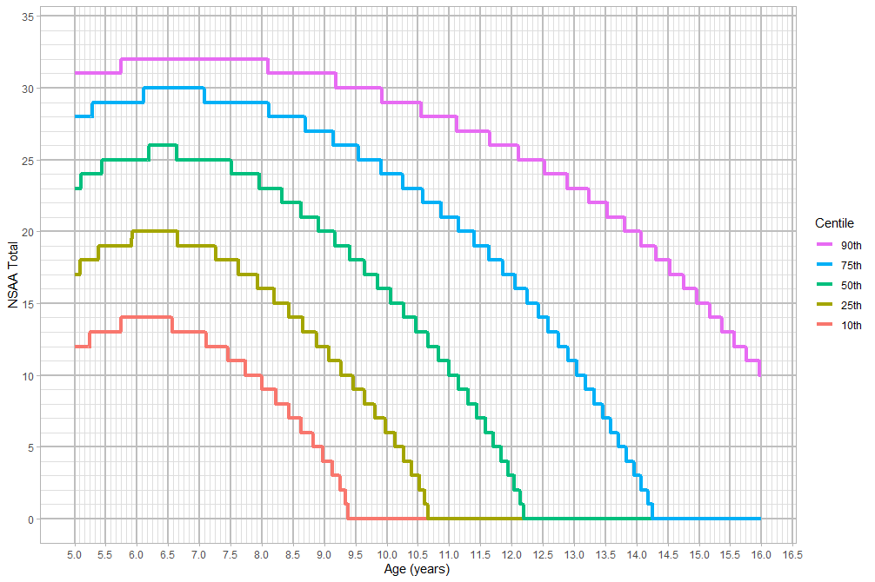
Supplementary Figure 1: NSAA Centiles by Age (blank)
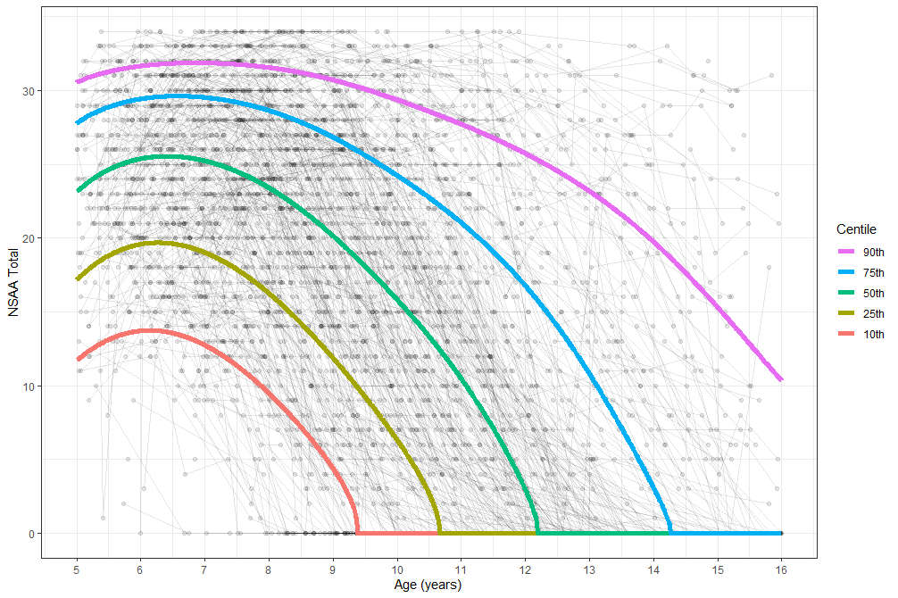
Supplementary Figure 2 NSAA Centiles by Age (smooth)
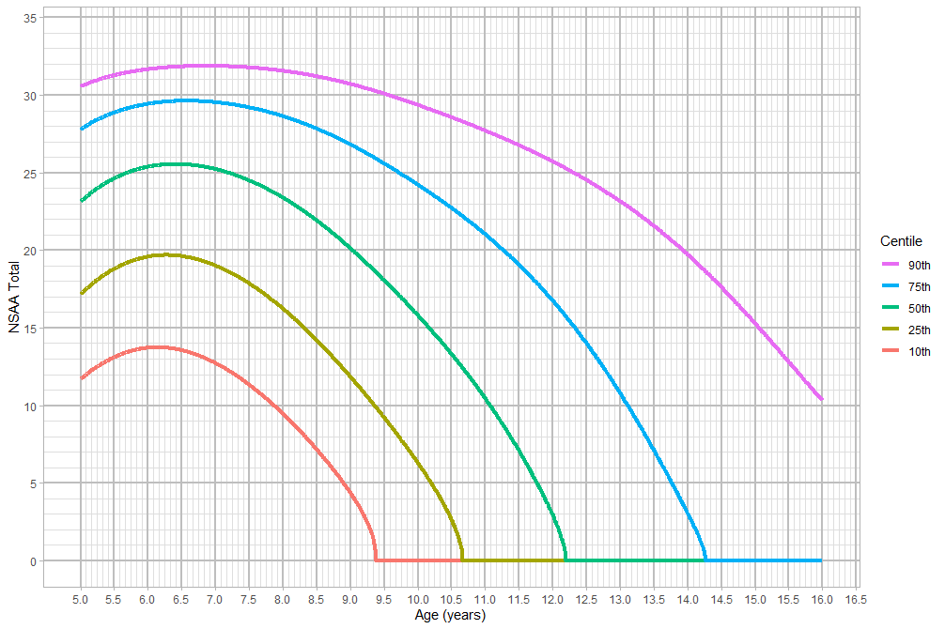
Supplementary Figure 3: NSAA Centiles by Age (smooth, blank)

7.2 RFF

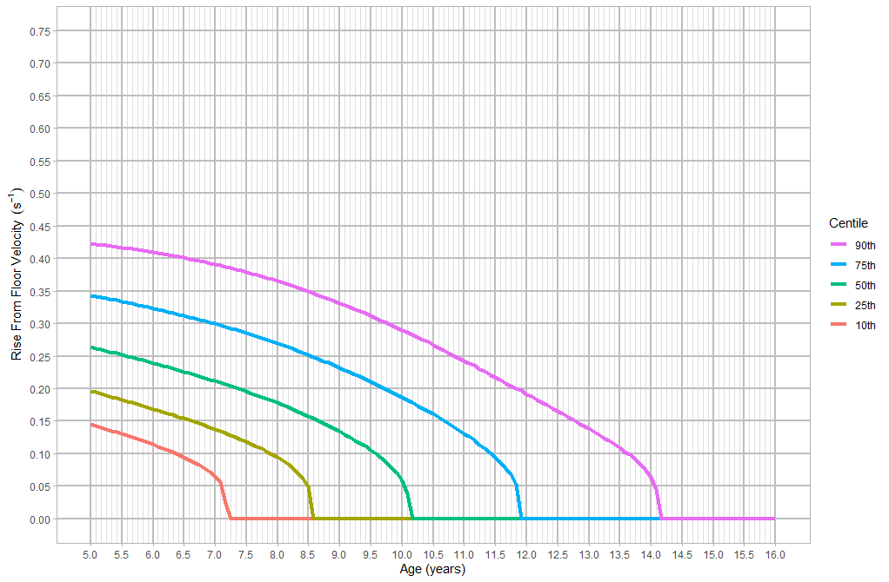
Supplementary Figure 4: RFFV Centiles by Age (blank)
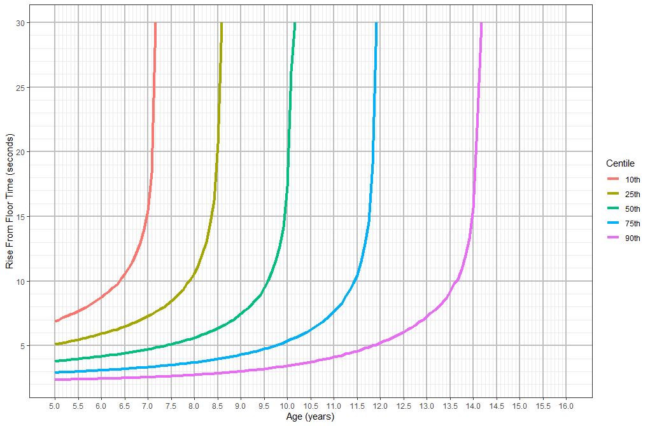
Supplementary Figure 5: RFF Time Centiles by Age (blank)

7.3 10MWR
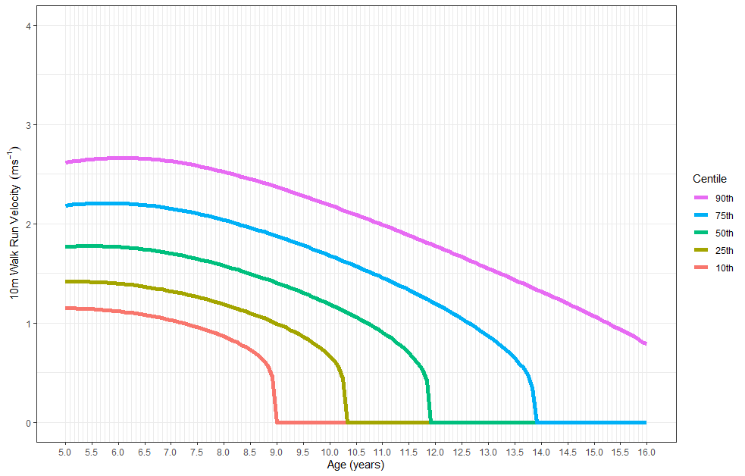
Supplementary Figure 6: 10MWRV Centiles by Age (blank)

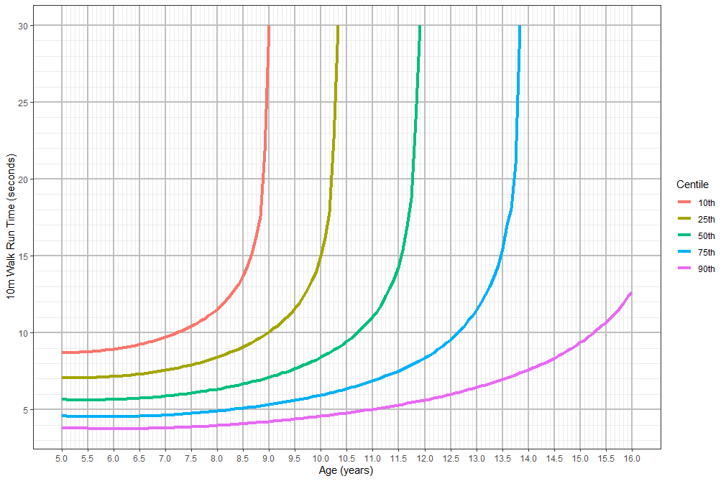Supplementary Figure 7: 10MWR Time Centiles by Age (blank)

