SUPPLEMENTARY MATERIALS
Supplementary Figure 1. RESTORE study design.
The RESTORE registry captures data on patients diagnosed with SMA meeting eligibility criteria from individual de novo (i.e., new, independent) clinical study sites. Target enrollment is ≥500 patients, with a 5-year enrollment period and a follow-up duration up to 15 years.

HCRU, health care resource utilization; IND, investigational new drug; MAP, managed access program; SMA, spinal muscular atrophy; US FDA, US Food and Drug Administration.
Supplementary Figure 2. Patients achieving or maintaining CHOP INTEND scores of ≥40 points with SMA identified by newborn screening or clinical diagnosisª
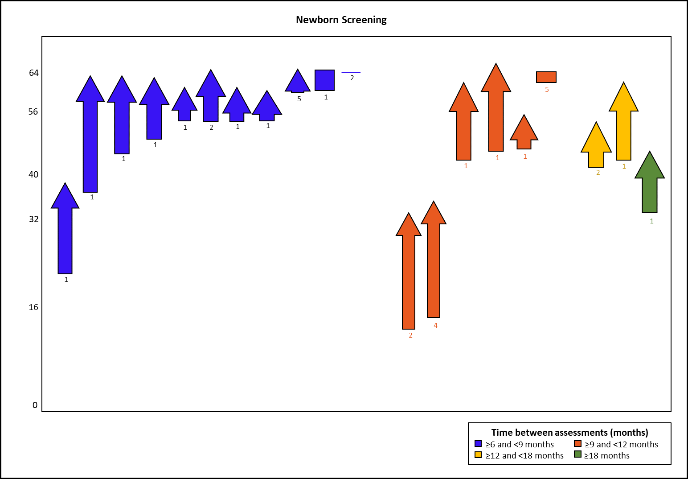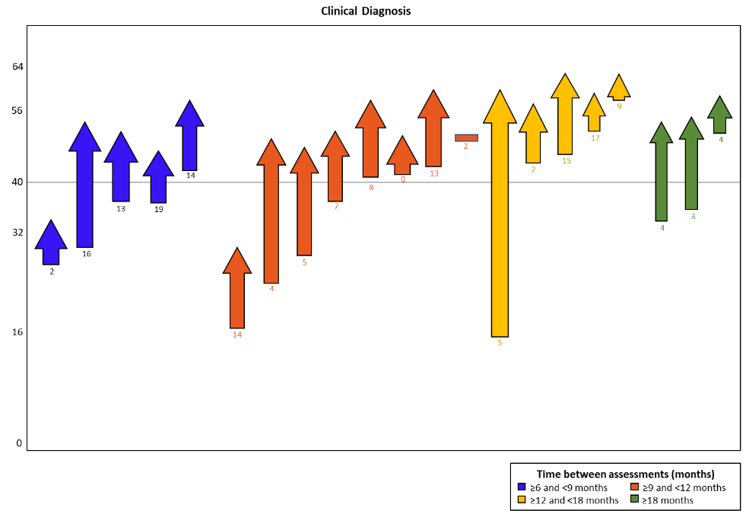
CHOP INTEND, Children’s Hospital of Philadelphia Infant Test of Neuromuscular Disorders; SMA, spinal muscular atrophy.
ªLength of each bar represents difference in score between assessments, with arrows pointing upward (increase) or downward (decrease) in score. The numbers below the graph represent age at infusion.

Supplementary Table 1. Neuromuscular measures used in RESTORE
Assessment | Description
Children’s Hospital of Philadelphia Infant Neuromuscular Disorders (CHOP INTEND) | - 16-item assessment of motor function  - Each item is scored on a uniform 0 to 4 scale ranging from 0 (no response) to 4 (complete level of response)  - Maximum score on the CHOP INTEND is 64
Hammersmith Infant Neurological Examination – Section 2 (HINE-2) | - 26-item neurologic assessment that evaluates cranial nerve function, posture, movements, tone, and reflexes and reactions  - Each item is scored on a scale of 0 to 3 using 0.5-point increments  - Greater scores indicate better neurologic performance  - Maximum score on the HINE-2 is 26
Hammersmith Functional Motor Scale Expanded (HFMSE) | - 33-item assessment of physical abilities  - Each item is scored on a scale of 0 to 2, ranging from 0 (unable) to 2 (unaided)  - Maximum score on the HFMSE is 66

Supplementary Table 2. Demographics and baseline clinical characteristics for patients identified by newborn screening or clinical diagnosis with two or more CHOP INTEND assessments, with ≥6 months between first and last assessments
Characteristics | Newborn screening (n=20) | Clinical diagnosis (n=21)
Age at onasemnogene abeparvovec infusion, months
Mean (SD) | 2.15 (2.43) | 8.1 (6.0)
Median | 1 | 6.0
Min, Max | 1, 11 | 0, 19
Weight at onasemnogene abeparvovec infusion/first treatment, kg
Mean (SD) | 4.71 (1.41) | 6.72 (1.85)
Median | 4.35 | 6.8
Min, Max | 2.9, 8.3 | 3.3, 9.8
Sex
Female, n (%) | 11 (55.0) | 10 (47.6)
Male, n (%) | 9 (45.0) | 11 (52.4)
SMA type, n (%)
1 | 8 (40.0) | 19 (90.5)
2 | 1 (5.0) | 2 (9.5)
3 | 0 (0.0) | 0 (0.0)
Missing | 11 (55.0) | 0 (0.0)
SMN2 copy number, n (%)
One | 0 (0.0) | 0 (0.0)
Two | 13 (65.0) | 13 (62.0)
Three | 4 (20.0) | 8 (38.0)
Four or more than four | 3 (15.0) | 0 (0.0)
Unknown | 0 (0.0) | 0 (0.0)
SD, standard deviation; SMA, spinal muscular atrophy; SMN2, survival motor neuron 2 gene.

Supplementary Table 3. Summary of HINE-2 and HFMSE scores
 | Assessment | n | Change in score (first to last) |  |  |  | Mean monthly change in score |  |  |  | Time between first and last assessments, months
 |  |  | Mean (SD) | Median | (Min, max) | IQR | Mean (SD) | Median | (Min, max) | IQR | Mean (SD) | Median | (Min, max) | IQR
NBS | HINE-2 | 10 | 8.6 (3.95) | 8 | (3, 16) | (6–10) | 1.3 (0.37) | 1.4 | (0.4, 1.7) | (1.2–1.4) | 7.0 (2.28) | 6.4 | (4.0, 11.6) | (5.6–7.4)
 | HFMSE | 6 | 11.3 (9.63) | 10 | (2, 25) | (3–18) | 1.4 (0.85) | 1.2 | (0.7, 3.0) | (0.8–1.3) | 8.1 (6.37) | 6.0 | (2.6, 18.9) | (2.8–12.5)
Clinical diagnosis | HINE-2 | 12 | 6.2 (4.67) | 6 | (-1, 15) | (2.5– 9.5) | 0.7 (0.56) | 0.5 | (–0.4, 1.7) | (0.4–1.0) | 9.7 (5.28) | 11.0 | (1.2, 17.5) | (5.4–12.5)
 | HFMSE | 14 | 10.1 (8.68) | 7.5 | (0, 26) | (3–14) | 0.7 (0.54) | 0.7 | (0, 1.9) | (0.4–1.2) | 12.2 (4.94) | 12.5 | (5.5, 20.8) | (8.4–15.6)
Overall | HINE-2 | 22 | 7.3 (4.43) | 6.5 | (–1, 16) | (4–10) | 0.9 (0.56) | 1.0 | (–0.4, 1.7) | (0.4–1.4) | 8.4 (4.34) | 7.4 | (1.2, 17.5) | (5.6–11.4)
 | HFMSE | 20 | 10.5 (8.73) | 7.5 | (0, 26) | (3–17) | 0.9 (0.69) | 0.8 | (0, 3.0) | (0.4–1.3) | 11.0 (5.57) | 10.8 | (2.6, 20.8) | (6.0–14.8)
HFMSE, Hammersmith Functional Motor Scale Expanded; HINE-2, Hammersmith Infant Neurological Examination – Section 2; IQR, interquartile range; NBS, newborn screening; SD, standard deviation.

Supplementary Table 4. Percentage of patients achieving minimal clinically important differences in motor outcomesª
 | Assessment | n | Improved overall |  | Maintained |  | Other |  | Achieved MCID^{b}
 |  |  | n | % | n | % | n | % | n | %
NBS | HINE-2 | 10 | 10 | 100 | 0 | 0 | 0 | 0 | 10 | 100
 | HFMSE | 6 | 6 | 100 | 1 | 16.7 | 0 | 0 | 5 | 83.3
Clinical diagnosis | HINE-2 | 12 | 11 | 91.7 | 0 | 0 | 1 | 8.3 | 11 | 91.7
 | HFMSE | 14 | 13 | 92.9 | 3 | 21.4 | 0 | 0 | 11 | 78.6
Overall | HINE-2 | 22 | 21 | 95.5 | 0 | 0 | 1 | 4.6 | 21 | 95.5
 | HFMSE | 20 | 19 | 95.0 | 4 | 20.0 | 0 | 0 | 16 | 80.0
Hammersmith Functional Motor Scale Expanded; HINE-2, Hammersmith Infant Neurological Examination – Section 2; MCID, minimal clinically important difference; NBS, newborn screening.
ªImproved=patients who achieved a greater score at the last assessment compared with the first assessment; maintained=patients remained stable and were at the same value at the first and the last assessments; and other=patients who achieved a score that was not recorded at a subsequent evaluation.
^{b}MCIDs: HFMSE=≥3-point change; and HINE-2=≥2-point change.

Supplementary Table 5. Treatment-emergent adverse events for patients identified by newborn screening or clinical diagnosis
 | Newborn screening  (n=97) | Clinical diagnosis  (n=70)
Any grade TEAE, n (%) | 35 (36.1) | 46 (65.7)
≥Grade 3 TEAE, n (%) | 11 (11.3) | 29 (41.4)
Any serious AE, n (%) | 9 (9.3) | 22 (31.4)
Related AE, n (%) | 26 (26.8) | 28 (40.0)
Serious related AE, n (%) | 4 (4.1) | 4 (5.7)
AESIs
Hepatotoxicity, n (%) | 19 (19.6) | 30 (42.9)
Transient thrombocytopenia, n (%) | 5 (5.2) | 18 (25.7)
Cardiac AEs, n (%) | 8 (8.2) | 14 (20.0)
Thrombotic microangiopathy | 0 (0.0) | 1 (1.4)
AE, adverse event; AESI, adverse event of special interest; TEAE, treatment-emergent adverse event.

Supplementary Table 6. Treatment-emergent adverse events for patients by weight group (<8.5kg or ≥8.5 kg) at onasemnogene abeparvovec infusion
 | Patients with weight  <8.5 kg  (n=120) | Patients with weight ≥8.5 kg  (n=21)
Any grade TEAE, n (%) | 59 (49.2) | 13 (61.9)
≥Grade 3 TEAE, n (%) | 30 (25.0) | 5 (23.8)
Any serious AE, n (%) | 26 (21.7) | 1 (4.8)
Related AE, n (%) | 39 (32.5) | 10 (47.6)
Serious related AE, n (%) | 7 (5.8) | 0 (0.0)
AESIs
Hepatotoxicity, n (%) | 35 (29.2) | 10 (47.6)
Transient thrombocytopenia, n (%) | 19 (15.8) | 3 (14.3)
Cardiac AEs, n (%) | 16 (13.3) | 5 (23.8)
Thrombotic microangiopathy | 1 (0.8) | 0 (0.0)
AE, adverse event; AESI, adverse event of special interest; TEAE, treatment-emergent adverse event.

Supplementary Table 7. Treatment-emergent adverse events for patients by age group at onasemnogene abeparvovec infusion
 | Patients with <6 months of age (n=107) | Patients ≥6 months and <12 months of age (n=26) | Patients ≥12 months and <24 months of age  (n=29) | Patients ≥24 months of age  (n=5)
Any grade TEAE, n (%) | 42 (39.3) | 15 (57.7) | 20 (69.0) | 4 (80.0)
≥Grade 3 TEAE, n (%) | 18 (16.8) | 9 (34.6) | 11 (37.9) | 2 (40.0)
Any serious AE, n (%) | 16 (15.0) | 9 (34.6) | 5 (17.2) | 1 (20.0)
Related AE, n (%) | 29 (27.1) | 5 (19.2) | 17 (58.6) | 3 (60.0)
Serious related AE, n (%) | 3 (2.8) | 1 (3.9) | 3 (10.3) | 1 (20.0)
AESIs
Hepatotoxicity, n (%) | 24 (22.4) | 6 (23.1) | 16 (55.2) | 3 (60.0)
Transient  thrombocytopenia, n (%) | 8 (7.5) | 5 (19.2) | 9 (31.0) | 1 (20.0)
Cardiac AEs, n (%) | 11 (10.3) | 4 (15.4) | 5 (17.2) | 2 (40.0)
Thrombotic microangiopathy | 0 (0.0) | 0 (0.0) | 1 (3.4) | 0 (0.0)
AE, adverse event; AESI, adverse event of special interest; TEAE, treatment-emergent adverse event.

