Supplementary data
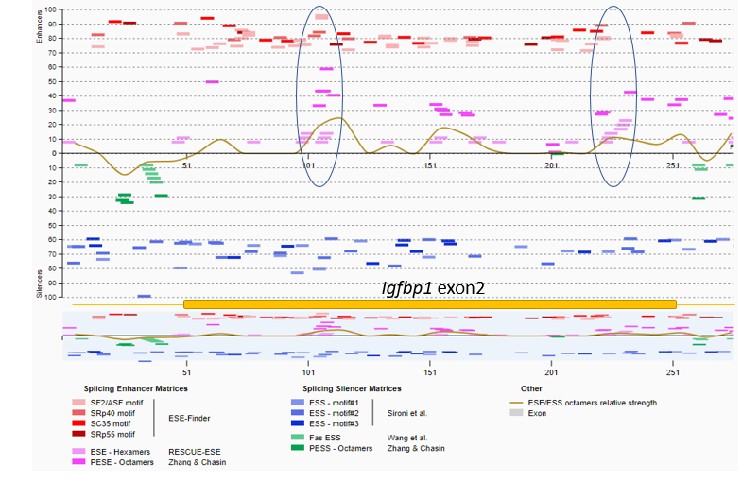
Figure S1. ESE motifs on exon 2 of Igfbp1 pre-mRNA as representative example of AON design.

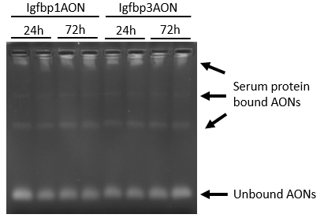
Figure S2. Gel picture showing the self-dimerization and degradation test results for Igfbp1 and Igfbp3 AONs treated with mouse serum for 24 or 72h. The bands on the gel show AON/protein complexes and unbound AONs.
Figure S3. The Volcano plot showing the differentially expressed genes related to myogenic pathways; blue dots represent the downregulated genes, green dots represents the upregulated genes

Figure S4. The tolerability of the Igfbp1 and Igfbp3 AON treatment was assessed by quantification of markers for kidney and liver function and damage in wildtype mice (n=6 per group). ALP: alkaline phosphatase, GOT: glutamic oxaloacetic transaminase, GPT: glutamic-pyruvic transaminase. Lower dosage; 40 mg/kg two times per week. Higher dosages; 50 mg/kg (Igfbp1AON) and 60 mg/kg (Igfbp3AON) four times per week during six weeks.

