Supplementary Data

- Supplementary Figure 1: Heat map of the correlation between deficits of the different muscle groups assessed.
- Supplementary Table 1: Muscular determinants of the gait pattern. The forward stepwise multiple regression results
- Supplementary Appendix 1: Checklist STROBE Statement—Checklist of items that should be included in reports of case-control studies

Supplementary Figure 1: Correlation matrix between the muscle groups impairments in adults with LOPD (color figure for the online PDF).

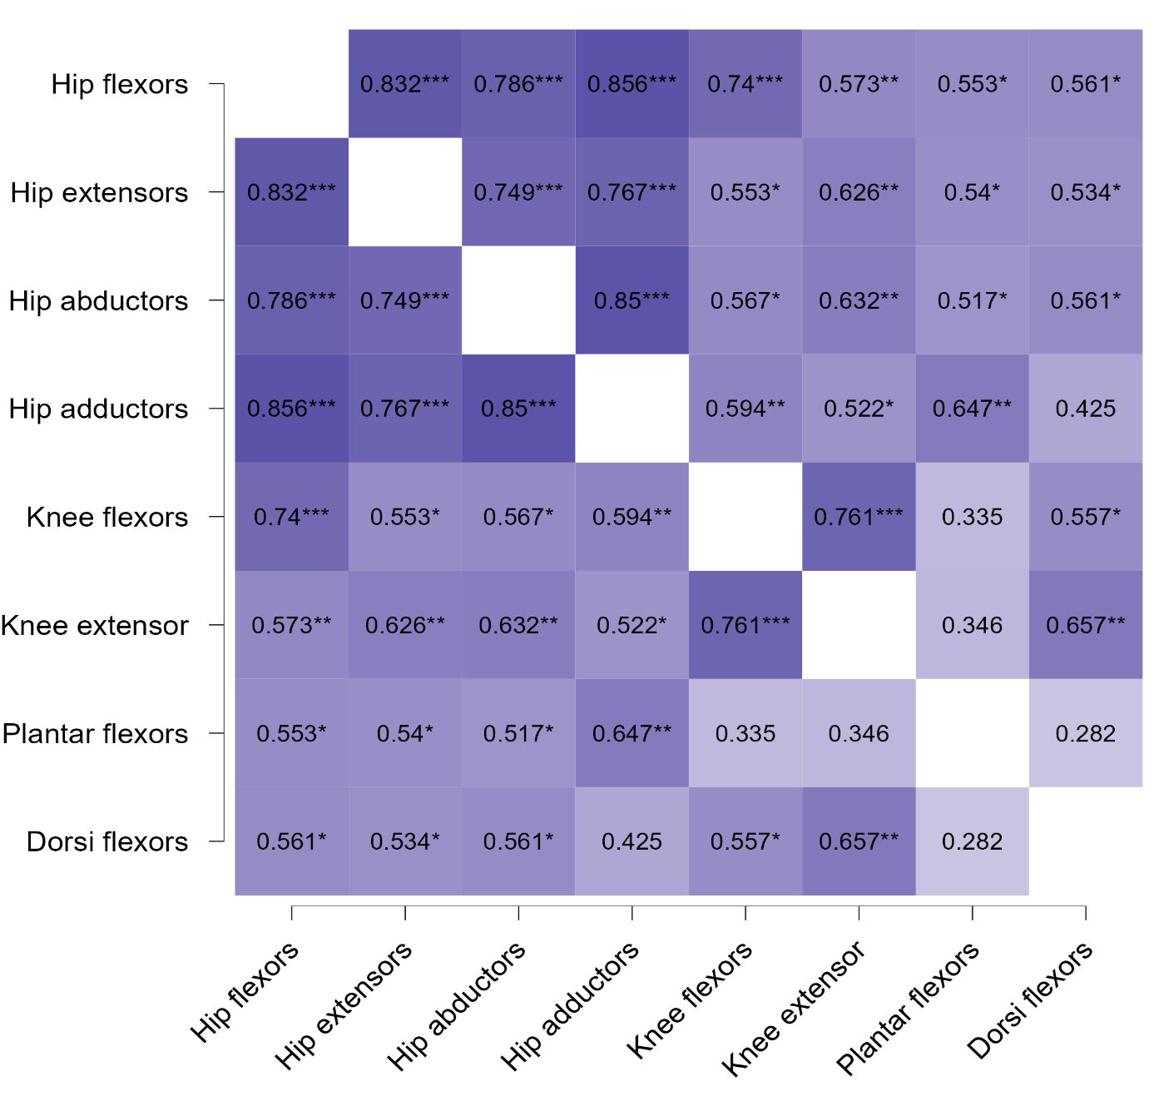
* significant spearman correlations p <0.05; ** significant spearman correlations p <0.01; ** significant spearman correlations p <0.001

Supplementary Figure 1: Correlation matrix between the muscle groups impairments in adults with LOPD (black/white figure for print).

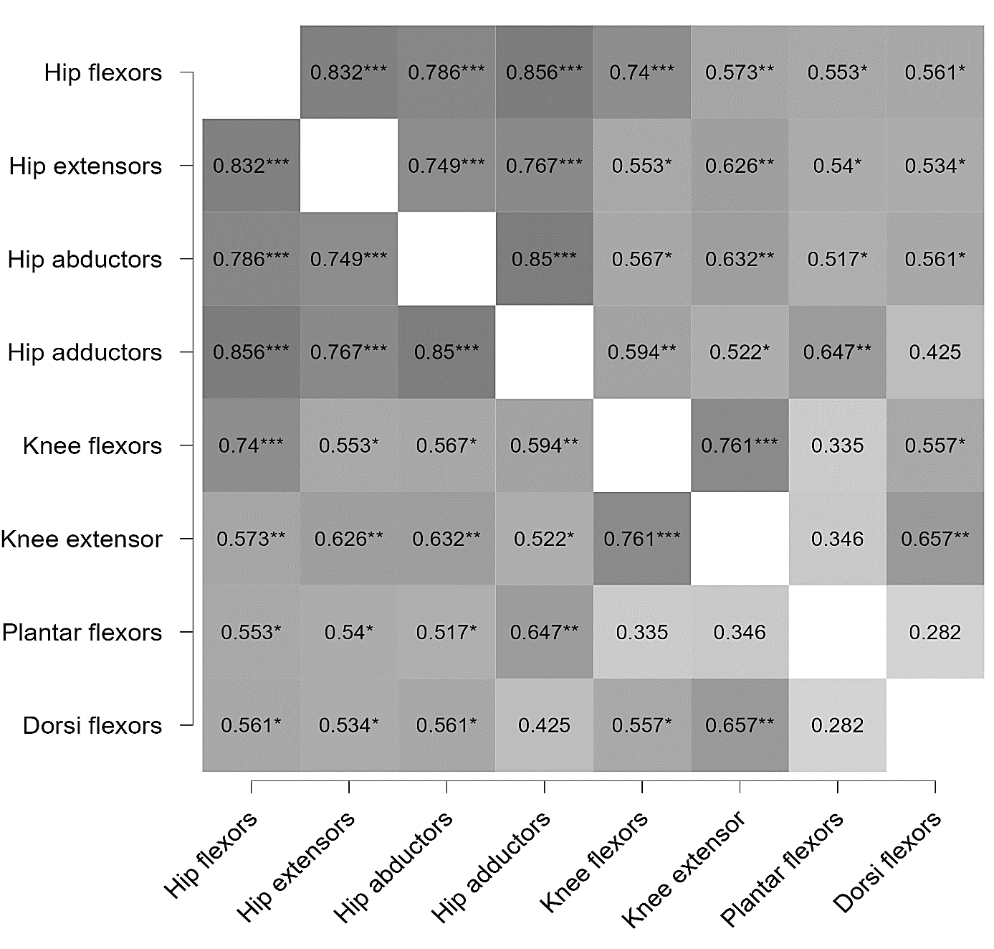

* significant spearman correlations p <0.05; ** significant spearman correlations p <0.01; ** significant spearman correlations p <0.001

Supplementary Table 1. Muscular determinants of the gait pattern. The forward stepwise multiple regression results
 | Assessment | Input variables* | Regression results
Muscle determinants of contralateral pelvis drop ROM | Isokinetic  dynamometer | - Hip abductors (ρ=-0.82, p <0.001)  - Knee flexors (ρ=-0.50, p=0.043)  - Knee extensors (ρ=-0.54, p=0.019)  - Plantar flexors (ρ=-0.51, p=0.038)  - Dorsal flexors (ρ=-0.68, p=0.004) | Strength assessed by dynamometer  1. Hip abductors (p <0.001; adjusted R²=0.75)  2. Hip abductors + plantar flexors (p <0.001; adjusted R²=0.85)
Muscle determinants of maximum hip abduction peak (swing phase) | Isokinetic  dynamometer | - Hip flexors (ρ=-0.75, p= <0.001)  - Knee flexors (ρ=-0.62, p=0.009) | Strength assessed by dynamometer  1. Hip flexors (p <0.001; adjusted R²=0.51)
Muscle determinants of hip frontal ROM | Isokinetic  dynamometer | - Hip flexors (ρ=-0.70, p=0.003)  - Hip extensors (ρ=-0.54, p=0.036) | Strength assessed by dynamometer  1. Hip flexors (p <0.001; adjusted R²=0.46).
Muscle determinants of mean knee position at foot strike | Isokinetic  dynamometer | - Hip flexors (ρ=-0.63, p=0.007)  - Hip abductors (ρ=-0.53, p=0.28)  - Plantar flexors (ρ=-0.51, p=0.037)  - Dorsal flexors (ρ=-0.56, p=0.021) | Strength assessed by dynamometer  1. Hip flexors (p=0.007; adjusted R²=0.38)  2. Hip flexors + hip abductors (p=0.003; R²=0.50)
ROM: Range Of Motion;
* Threshold of probability of entry defined at p≥0.05

Supplementary Appendix 1: Checklist STROBE Statement—Checklist of items that should be included in reports of case-control studies

 | Item No | Recommendation | Page No
Title and abstract | 1 | (a) Indicate the study’s design with a commonly used term in the title or the abstract | 1
 |  | (b) Provide in the abstract an informative and balanced summary of what was done and what was found | 2-3
Introduction
Background/rationale | 2 | Explain the scientific background and rationale for the investigation being reported | 4-5
Objectives | 3 | State specific objectives, including any prespecified hypotheses | 5-6
Methods
Study design | 4 | Present key elements of study design early in the paper | 6-7
Setting | 5 | Describe the setting, locations, and relevant dates, including periods of recruitment, exposure, follow-up, and data collection | 7
Participants | 6 | (a) Give the eligibility criteria, and the sources and methods of case ascertainment and control selection. Give the rationale for the choice of cases and controls. | 7
 |  | (b) For matched studies, give matching criteria and the number of controls per case | 5
Variables | 7 | Clearly define all outcomes, exposures, predictors, potential confounders, and effect modifiers. Give diagnostic criteria, if applicable | 8-10
Data sources/measurement | 8* | For each variable of interest, give sources of data and details of methods of assessment (measurement). Describe comparability of assessment methods if there is more than one group | 8-10
Bias | 9 | Describe any efforts to address potential sources of bias | 10
Study size | 10 | Explain how the study size was arrived at | 7
Quantitative variables | 11 | Explain how quantitative variables were handled in the analyses. If applicable, describe which groupings were chosen and why | 8-10
Statistical methods | 12 | (a) Describe all statistical methods, including those used to control for confounding | 10
 |  | (b) Describe any methods used to examine subgroups and interactions | -
 |  | (c) Explain how missing data were addressed | 10
 |  | (d) If applicable, explain how matching of cases and controls was addressed | 10
 |  | (e) Describe any sensitivity analyses | -
Results
Participants | 13* | (a) Report numbers of individuals at each stage of study—eg numbers potentially eligible, examined for eligibility, confirmed eligible, included in the study, completing follow-up, and analyzed | 11
 |  | (b) Give reasons for non-participation at each stage | -
 |  | (c) Consider use of a flow diagram | -
Descriptive data | 14* | (a) Give characteristics of study participants (eg demographic, clinical, social) and information on exposures and potential confounders | 11
 |  | (b) Indicate number of participants with missing data for each variable of interest | -
Outcome data | 15* | Report numbers in each exposure category, or summary measures of exposure | -

Main results |  | 16 | (a) Give unadjusted estimates and, if applicable, confounder-adjusted estimates and their precision (eg, 95% confidence interval). Make clear which confounders were adjusted for and why they were included | 11-13
 |  |  | (b) Report category boundaries when continuous variables were categorized | -
 |  |  | (c) If relevant, consider translating estimates of relative risk into absolute risk for a meaningful time period | -
Other analyses |  | 17 | Report other analyses done—e.g., analyses of subgroups and interactions, and sensitivity analyses | 11-13
 | Discussion
 | Key results | 18 | Summarize key results with reference to study objectives | 14
 | Limitations | 19 | Discuss limitations of the study, taking into account sources of potential bias or imprecision. Discuss both direction and magnitude of any potential bias. | 18
 | Interpretation | 20 | Give a cautious overall interpretation of results considering objectives, limitations, multiplicity of analyses, results from similar studies, and other relevant evidence. | 14-18
 | Generalizability | 21 | Discuss the generalizability (external validity) of the study results | 14-18
 | Other information
 | Funding | 22 | Give the source of funding and the role of the funders for the present study and, if applicable, for the original study on which the present article is based. | 19

*Give information separately for cases and controls.

Note: An Explanation and Elaboration article discusses each checklist item and gives methodological background and published examples of transparent reporting. The STROBE checklist is best used in conjunction with this article (freely available on the Web sites of PLoS Medicine at http://www.plosmedicine.org/, Annals of Internal Medicine at http://www.annals.org/, and Epidemiology at http://www.epidem.com/). Information on the STROBE Initiative is available at http://www.strobe-statement.org.

