SUPPLEMENTARY MATERIALS
Supplementary Listing 1. DEVOTE principal investigators and site study personnel. Supplementary Listing 2. DEVOTE list of the independent data monitoring committee (IDMC) members.
Supplementary Table 1. Listing of HFMSE and RULM total scores by participant and select study day.
Supplementary Figure 1. Dysphagia assessment using the Parent Assessment of Swallowing Ability questionnaire (PASA).

Supplementary Listing 1. DEVOTE Principal Investigators and Site Study Personnel
Principal Investigators and site study personnel participating in Part A:
Estonia: Inga Talvik, MD, Kristel Blumenfeldt, Ljudmilla Dõtsman, Anna Dudkina, Cristina Lõokene, Kaidi Lunge, MD, Urve Oim, MD, Ljubov Proštšalõkina, Ionella Rebane, Valentin Sander, MD, Kadi Veri, MD; Ireland: Denise McDonald, MD, Sinead Brennan, Annmarie Brogan, Lucy Coy, Aileen Darcy, Sarah Doyle, Harvey Susan, MD, Orla Hoban, Tracy McCrudden, Fiona O’Dea, Declan O’Rourke, MD, Reena Patel, Sharon Rafferty, Karen Reidy, Anthea Seager, Andrea Stanton, Andrea Tobin; Latvia: Marta Celmina, Mikus Diriks, Karina Jakovleva, MD, Anna Poplavska, MD, Guntis Rozentals, MD, Signe Setlere, MD, Arta Smite-Laguna, Jurgis Strautmanis, MD; Spain: Samuel Ignacio Pascual Pascual, MD,
Sofia Bueno, Paul Burnham, Jose Manuel Caballero, MD, Cristina Cardenas Sarralde, Cristina Contreras Olmedo, Milagros Coso, Maria del Rio Durango, Maria Espinosa, MD, Ariadna Fernandez, Janire Fernandez Cuenca, María García Romero, MD, Pilar Gomez Salcedo, Yaqing Huang, Jose Lopez Araujo, Gloria Lopez Sobrino, MD, Isabel Malpartida Jimenez, Mercedes Martinez Moreno, Fatima Mendoza Duran, Carmen Munoz Jimenez, Anais Sevillano Blanco, Andrea Tejedor Perez, Nuria Torre Buxalleu; Francina Munell Casadesus, MD, Carla Aguilar Blancafort, Mireia Alvarez Molinero, MD, Laura Costa Comellas, MD, Gisela Gili Serrat, David Gomez Andres, MD, Gonzalo Mazuela, Zurine Ortiz de Zarate Caballero, MD, Pablo Piera Perez, Bernat Planas Pascual, MD, Penelope Romero Duque, Ainara Salazar, MD, Pilar Sune Martin, Esther Toro Tamargo, MD; Andres Nascimento Osorio, MD, Marta Sanchez, MD, Laura Sole Heuberger, Alicia Rodriguez Ramírez, Laura Carrera Garcia, MD, Alba Martinez, Obdulia Moya Arcos, Sandra Roca Urraca, Maria Valle Saez, Daniel Natera de Benito, MD, Jesica Maria Exposito Escudero, MD, Carlos Ignatio Ortez Gonzalez, MD, Julia Medina Cantillo, MD, Miriam Coto Moreno, Paula Areste Castillo, Isabel Miquel Aymar, Francesca Abate, Alba Murciano Cabeza; Taiwan, Republic of China: Yuh-Jyh Jong, MD, Yun-Hui Chou, Jui-Fen Chuang, Hsin-Ting Chuang, Hao-Wei Chung, MD, Ju-Jung Hou, Jong-Hau Hsu, MD, Wan-Yi HSU, MD, Hsin-Yueh Hu, Yu-Ning Huang, Tz-Yu Huang, Chih-Neng Kang, Chen-Chun Kuo, Wen-Chen Liang, MD, Yi-Ching Lin, Ying-Ju Ou, Hsiang-Hung Shih, MD, Tai-Lin Tseng, Jia-Hong Wang, Chen-Hua Wang, MD, Yi-Ching Wu; Wen-Chin Weng, MD, Yi-Chien Chen, Ko-Hsin Chen, Yin Hsiu Chien, MD, Ya Ting, Chiu, Shu-Wei Chou, MD, Ting Chou, Hsi-Wen Huang, MD, Hsing-Hao Huang, MD, Wang-Tso Lee, MD, Ping-Hui Lin, Mei-Lan Liou, Jeng-Yi Shieh, MD, Ju-Ying Shih, Yun-Wen Tang, Yi-Chi Tseng, Yung-Li Yang, MD; United States: John Day, MD, Tiffany Chang, Steven Chinn, MD, James Cutler, Genevieve D Souza, MD, Sally Dunaway Young, Tina Duong, Teresa Frisch, Richard Gee, Maxwell Greene, MD, Tracy King, Jenna Klotz, MD, Emily Lien, Tia Lum, Mary Jane Mateo, Michelle Ngo, Carolyn Nguyen, Birdie Nguyen, Tia Nguyen, Sai Nimmagadda, Shirly Paulose, Laura Phan, MD, RJ Ramamurthi, MD, Jacinda Sampson, MD, Monica Sangco, Claire Spahn, Veronica Stevens, Carolina Tesi-Rocha, MD, Susan Thomas, Karolina Watson, Lesly Welsh, Connie Wolford, Libby Yats.

Principal Investigators and site study personnel at sites open for enrollment as of November 29, 2022 (in addition to sites in Part A)
Australia: Eppie Yiu, MD, Ian Woodcock, MD, Monique Ryan, MD, Justine Adams, Zoe Bourke, Kate Carroll, Jo Cheah, Katy De Valle, Rachel Kennedy, Donna Legge, Kee Lim, Jemima Mitchell, Kathryn Santamaria, Emma Scott, Sarah Catling-Seyffer, Daniella Villano; Brazil: Jonas Alex Morales Saute, MD, Ana Leticia Amorim de Albuquerque, MD, Michele Becker, MD, Fernanda Brenda Possetto, Vitória Brum Silva Nunes, Renato Chagas Ribeiro, Edlus Colares, Larissa Pozzebon da Silva, Karina Donis, MD, Bruno Dorr, Daniel Fasolo, Ana Luiza Fonseca Siqueira, MD, Esteban Gonzales, Gerson Guerra, Mariana Horn Scherer, MD, Ana Luisa Fernandes Dubiela, Thais Martins, MD, Elaine Miglorini, MD, Márcia Narcizo Rodrigues, Johanna Nehm, Karen Daniela Picolli Lucas, Ana Lucia Portella Staub, MD, Rodrigo Rosa de Stefani, MD, Marina Bauer Zambrano, Joao Henrique Zucco Viesi, MD; Juliana Gurgel Giannetti, MD, Maria Eduarda Amaral Pinto, Marina Belisario Carvalhais, Vanilda Borges, Arianne Caroline Rocha, Mariana Ferreira Bizzi, Patricia Ferreira Fonseca, Baltazar Leao Reis, Márcia Maria Leonardo, Hannelore Maciel, Bruna Magalhaes, Ana Carolina Monteiro Lessa de Moura, Beatriz Vilela Morais de Azevedo, MD, Josyene Simão, Sabrina Stephanie Lana Diniz, Gilzani Teixeira da Cunha, Alexandre Varella Gianetti; Edmar Zanoteli, MD, Jonas Alex Morales Saute, MD, Mariana Artilheiro, MD, Juliana Caires de Oliveira Achili Ferreira, Umbertina Conti Reed, MD, Rodrigo de Holanda, MD, Ana Cristina dos Santos Monteiro, Clara Gontijo Camelo, MD, Juliana Iannicelli, MD, Luiz Henrique Libardi, MD, Ciro Matsui, MD, Fernanda Nunes, Helio Rodrigues Gomes, MD, Thais Tiemi Araki; Canada: Craig Campbell, MD, Sulaiman Al-Mobarak, MD, Chantal Cacciotti, Melissa Greenwood, Cara Grobbecker, Rhiannon Hicks, Mona Hnaini, MD, Teresa Longfield, Michael Mayich, Wendy McDonald, Faith Norris, Jennifer Petzke, Cheryl Scholtes, Mona ElWanni, Kayleigh Tam; Kathryn Selby, MD, Erin Adams, Cyrus Boelman, MD, Silvana Echeverri, Inderpal Gill, Sanja Hadzi-Nikolova, Lawrence Hahn, Sydney Huebner, James Lee, MD, Nela Martic, Olivia Nguyen, Vesna Popovska, MD, Elke Roland, MD, Angelina Woof; Chile: Claudia Castiglioni, MD, Damaris Colicheo, Marianela De la Fuente, Jose Miguel Guanipa, Javiera Figueroa Jofre Ines, MD, Valeria Jorquera, Jaime Lara Sasso, Constanza Larraguibel, Pamela Andrea Lolas Mutis, Valentina Martínez, Marcia Ocares, Maria Angelica Palomino Montenegro, MD, Gonzalo Rivera, MD, Valentina Seguel, Bernardita Isabel Suarez Squadritto, MD; Ricardo Erazo, MD, Patricia Acuña, Rudy Clavero Bocca, MD, Sebastian Eulufi Munoz, MD, Pamela Alejandra Figueroa Ojeda, MD, Jorge Ignacio Galecio Moraga, MD, Patricio Lacaux, MD, Daniela Constanza Mistretta Solorza, MD, Mariana Munoz, Salomé Rivera, Constanza Ruiz; China: Hui Xiong, MD, Yanbin Fan, MD, Wenzhu Li, Qiao Li, Min Lu, Ao Ma, Lun Qin, Cuijie Wei, MD, Jingyao Xu, Xiaoling Yang, MD, Linrong Yang, Wei Zhang, Jie Zhang, MD, Qian Zhang; Rong Luo, MD, Qianyun Cai, MD, Zhuo Chen, Yuan Chen, Hailing Fu, Jing Gan, MD, Haoran Han, Yaning Huo, Yang Jing, Yumei Lan, Fengshan Li, Xianghong Lian, Ling Liu, Yanhui Liu, Yantao Liu, Juan Lv, Minxing Shi, Qiuji Tao, Yu Tian, Yawen Xue, Hua Yang, MD, Jie Yang, Jia Zhang, MD, Lijuan Zhou; Li Liu, MD, Yanna Cai, Jingrong Cai, Lin Ding, Rong Du, MD, Yuyu Feng, MD, Junjing Huang, Minyan Jiang, MD, Mei Jie, Duan Li, MD, Jie Li, Taolin Li, MD, Cuili Liang, MD, Ruizhu Lin, MD, Wenhai Liu, Shaomei Lu, Zhikun Lu, MD, Jiali Lu, Huifen Mei, MD, Huiyi Ou, Yayi Peng, Min Rao, Huiying Sheng, Jing Wang, Xiaoyue Wang, Zena Xie, Kaishou Xu, Kaixin Yang, Xiaojuan Zeng, Yani Zhang, MD, Wen Zhang, MD, Ruidan Zheng, MD, Danping Zheng, Bihu Zhong; Baomin Li, MD, Limin Jiao, Manman Li, Jun Li, MD, Yaping Liu, Jiaqi Liu, Lu Yang, Ping Yin, Dongqing Zhang, MD, Mengyu Zhang; Columbia: Blair Ortiz Giraldo, MD, Liliana Maria Arango Gaviria, MD, Luis Horacio Atehortua, Carolina Isabel Atehortua Tuberquia, Lina Barrera Restrepo, Carlos Arturo Campo Ternera, MD, Eduardo Cortes Silva, MD, Yenny Marjory Diaz Maldonado, Lilyana Estrada Cano, Karen Yalenia Loaiza Valencia, MD, Daniel Horacio Ocampo Osorio, Carlos Penata, Sanal Richard, Catalina Maria Vasco Gutierrez, Jose Carlos Vasquez Quinonez, Oscar Alonso Villada; Fernando Suarez Obando, MD, Angelica Maria Amador Gutierrez, Angelica Maria Arango Gutierrez, Nixon Giovany Archila Rodriguez, Stela del Pilar Baracaldo Gomez, MD, Diana Carol Benitez Ramirez, MD, Maria Alejandra Betancur Diaz, MD, Edna Julieth Bobadilla Quesada, MD, Juliana Andrea Bravo Gallego, Diego Alberto Caicedo Callejas, Angie Kares Cardona Camacho, Paula Cordon, Martha Beatriz Delgado Ramirez, MD, Edy Yesenia Diaz Garrido, MD, Christian Javier Duarte Parra, Veronica Echeverry Mallarino, MD, Lady Gonzales, Viviana Marcela Mendez Calderon, Luis Morillo, MD, Ivonne Katherine Sabogal Alfaro, Diana Ximena Salgado, Alejandra Sanin Hoyos, MD, Diana Pilar Soto Pena, MD, Jenny Marcela Velasco Ramirez, Natalia Velasquez Leon; France: Claude Cances, MD, Francoise Auroil, Valerie Bellio, Laetitia Caturla, Emmanuel Cheuret, MD, Pascal Cintas, MD, Sandrine Destarac, Lucie Dufour, Bastien Estublier, MD, Camille Jurado, Géraldine Labouret, MD, Marianne Mus, Gil Olaia, Lea Saintouil, Audrey Tranier; Susana Quijano Roy, MD, Christine Barnerias, MD, Audrey Benezit, MD, Valerie Bigue, Cecilia Bocassin, Isabelle Bossard, Nora Bougherriou, Lyna Dehache, Isabelle Desguerre, Marta Gomez, MD, Martine Huguet, Fatima Izedaren, Hugues Michelon, Najia Naas, Nelly Pellerin, Lucine Sonnet, Maryvonne Villart; Germany: Astrid Pechmann, MD, Stefanie Ajayi, Sabine Borell, MD, Simone Bürklin, Matthias Eckenweiler, MD, Juliane Hug, Janbernd Kirschner, Stefanie Koelble, Thorsten Langer, MD, Inka Lotz, Beate Lubrich, MD, Nadja Mingirulli, MD, Cornelia Mueller, MD, Bianca Rippberger, David Schorling, MD, Marleen Schulz, Sabine Stein, Pirmin Tritschler, Sibylle Vogt, Silke Wehrle, Anja Wehrle, Sabine Wider, Barbara Wirth, Theresa Woltering; Andreas Hahn, MD, Thea Beatrice Abele, MD, Andrea Hackemer, Christina Lampe, MD, Annina Lang, Kyriakos Martakis, MD, Lena Russ; Greece: Dimitrios Zafeiriou, MD, Euthymia Vargiami, Maria Kyriazi, MD, Pinelopi Dragoumi, MD, George Tsigaras, Maria Milioudi, MD; Hungary: Andras Fogarasi, MD, Timea Bodo, MD, Lorincz Gergely, Nikoletta Gyarmati, Tamas Hangyal, Monica Hantos, Rozalia Kissne Banfi, Nikoletta Mihaly, Borbala Mikos, MD, Stefka Nora, Orsolya Schulcz, Diana Suru, Dora Szotak, Annamaria Voros, Kristof Zagonyi, MD; Agnes Herczegfalvi, MD, Ildiko Andor, Fanni Zsofia Csoma, Ilona Sarolta Dobner, MD, Maria Anna Huduk, Bernadett Kiss, Timea Kopasz, Gabor Kovacs, MD, Szabo Lena, MD, Zoltan Liptai, MD, Nagy Maria, Gabriella Medve, Anetta Schmuck, Sara Stickl, Veronika Szlama-Balogh, Tamas Terebessy, MD, Veronika Voros; Israel: Aviva Fattal-Valevski, MD, Itay Ayalon, MD, Dafna Bomze, Shirley Friedman, MD, Sharona Katzenellenbogen, Lihi Ken, Rachel Labrisch, Revital Lavi, MD, Angela Lev-Or, Adi Mendel, Osnat Pasha, Efraim Sadot, MD, Liora Sagi, MD, Ilya Sherman, Anna Shtamler, Anat Weizman; Sharon Aharoni, MD, Galit Amsalem, Yael Bernfeld, Dafna Bomze, Yaara Daud, Hanna Eisenberg, Lihi Ken, Gita Kirshner, Lee Kisler, Liraz Krauss, Alla Kuzminsky, MD, Osnat Lichtenfeld, Lea Malachi, Tanya Moss, Konstantin Nerkasov, MD, Yoram Nevo, Andrei Olaru, MD, Yarden Priel, Yulia Regev, Tammi Shnayderman, Tammy Taizi, Yael Tennebaum, Miriam Vasse, Miri Vax, Yelena Zeitlin, MD; Italy: Valeria Sansone, MD, Emilio Albamonte, MD, Elena Bazzoni, Elena Carraro, MD, Loretta Cervi, MD, Giovanni Colacicco, MD, Alessandra Di Bari, Maria Chiara Frisoni, MD, Elena Gotti, Cristina Grandi, Felicia Iossa, Luca Mauro, Massimo Medaglia, Marta Moscardi, Michela Nani, Rachele Piras, MD, Jasmine Refran, Francesca Salmin, MD, Alice Zanolini, MD; Eugenio Mercuri, MD, Laura Antonaci, MD, Fabiana Bonetto, Valeria Bovetti, Ilaria Bucci, Giorgia Coratti, Miriam Cruciani, Roberto De Sanctis, Elisa De Sanctis, Roberto Digilio, MD, Orazio Genovese, MD, Emilia Laudati, Roberto Marchetta, Marika Pane, MD, Lucia Pavan, Maria Carmela Pera, MD, Marco Piastra, MD, Daniela Pilunni, Andrea Piras, Alessia Ravenda, Diletta Rossi, Maria Rosaria Vizzino; Japan: Yasuhiro Takeshima, MD, Tetsuro Fujino, MD, Kai Fujisawa, MD, Toru Furukawa, Mayumi Hasegawa, Iyo Hashimoto, Noriko Hatakeda, Takuya Horibe, MD, Kuniko Hoshikawa, Kaori Koshiro, Moe Kuma, Tomoko Lee, MD, Ibu Maede, Kana Matsumoto, Akiko Mishima, Keishi Morita, MD, Juria Nakabayashi, Hideo Nakagawa, Tomomi Niegawa, MD, Takafumi Nishioka, MD, Hiromi Okumura, Mitsuki Okumura, Misako Okuno, MD, Masae Ota, Naoko Sata, Ryutaro Saura, MD, Hideki Shimomura, MD, Yasuhiko Tanaka, MD, Kae Tanaka, MD, Sayo Taniguchi, Naoko Taniguchi, MD, Sachi Tokunaga, MD, Mari Toyooka, Kozo Tsuda, MD, Ai Yanagida, Hanae Yasui, Ayako Yuri; Kayoko Saito, MD, Munehiko Agata, Miki Aruga, Kaoru Eto, MD, Yuko Fujimoto, Yukihiro Hamada, Takuma Hashizume, MD, Sugine Hikichi, Kazuyoshi Hiraki, Rieko Ikoma, Keiko Ishigaki, MD, Kumiko Ishiguro, MD, Jun Ishii, Saki Ishikawa, Kota Kajima, Shinobu Kashiwase, Tamaki Kato, MD, Keitaro Kawabe, Takuya Kawamoto, Yuki Kihara, MD, Azusa Kurashige, Yukie Matsumoto, Mari Matsuo, MD, Mami Michishita, MD, Mutsumi Mimura, Hiroshi Mori, Atsuko Morinaga, Hiromi Muroyama, Satoru Nagata, MD, Hidetsugu Nakatsukasa, MD, Aiko Nishikawa, MD, Yuriko Ogawa, MD, Takuya Okawa, MD, Akiko Omiya, MD, Chihiro Ono, Midori Saito, Shuji Sakai, MD, Takatoshi Sato, MD, Yuya Sato, MD, Minobu Shichiji, MD, Rina Shimomura, MD, Moeka Shioya, Kotomi Shiraki, Naoko Sugawara, Hayato Suzuki, Junko Tada, Yuka Takahashi, Yuri Takeuchi, Masahiko Taniguchi, Takayo Tsuyama, Tomomi Uchida, Mari Urano, Haruka Yamashita, Tomoe Yanagishita, MD, Chihiro Yasuda, Yoshiko Yatabe; Kotaro Yuge, MD, Hanae Asahara, Kazuhito Fukushima, Munetsugu Hara, MD, Atsumi Hashimoto, Kyoko Higuchi, Saori Honda, Ayumi Ichiba, Ryuta Ishii, MD, Takahiro Ishimoto, MD, Satoko Kajihara, Yutaka Kajiwara, MD, Wakana Kamimura, Seiji Karakawa, Mitsuko Kato, Taketomo Kikuchi, Takatoshi Komiya, Yu Kotake, MD, Takato Kotaki, Shunji Koya, Yutaro Kubo, MD, Takuya Kubota, Eri Kuboyama, Tomomi Kumashiro, Hiroo Matsuse, MD, Sayuri Minami, Ryoko Miwa, Yusuke Miyagi, MD, Ryosuke Miyake, MD, Hiroyuki Miyazaki, MD, Yuko Mizoguchi, Yasuko Mizushima, Yugi Moto, MD, Takahiro Myoi, MD, Shinichiro Nagamitsu, MD, Tetsuya Naito, Mai Nakamura, MD, Izumi Nakashima, Yuki Noguchi, Nanako Oshima, MD, Koki Ota, MD, Yoshiro Sakai, Mari Sakai, Kensuke Sakata, MD, Makoto Sasaguri, MD, Wakako Shichida, Mika Suzuki, Makoto Takahashi, Tomoki Tanaka, MD, Kanae Tateishi, Hanayo Tetsuda, Keitaro Tsuda, MD, Naoya Tsumura, MD, Saori Uchida, Yuki Umeno, Yukako Yae, MD, Masaki Yamashita, Daisuke Yamashita, MD, Yushiro Yamashita, MD, Nobuaki Yamauchi, Waka Yamauchi, Mariko Yanaga, Fukuno Yaosaka, Airi Yoshida, MD, Miki Yuki; Republic of Korea: Jong-Hee Chae, MD, Jae So Cho, MD, Sol Choi, Ji Yeon Han, MD, Hong Won Jang, Seoyoung Jeong, Min Jung Kang, HyunJung Kim, Sae Mi Kim, Mi Ae Kim, Bitnarae Kim, Minhye Kim, MD, Hye Jin Kim, MD, JiIn Kim, Hyunjung Kim, Young Jun Ko, MD, Heewon Ku, Hyeonju Kwon, Joo Yeon Lee, Jin-Ah Lee, Seungbok Lee, MD, Young-Sook Lee, EunJi Lee, Heyjoon Son, MD, Hyewon Woo, MD; Su-Kyeong Hwang, MD, Hyun Woo Bae, MD, Sungmin Choi, Su-Kyeong Hwang, Eunkyung Hwang, Soo Hyun Kim, MD, Bo Min Kim, Eunji Kim, Soon-Hak Kwon, MD, Seung Jae Lee, MD, Chang Hee Lee, Yu-Sun Min, MD, Yujeong Roh, JungNam Seo, Jin Ju Seol; Lebanon: Hicham Mansour, MD, Gabriella Alam, Neemet Anouti, MD, Tarek Atallah, MD, Elie Bechara, MD, Sandra Berbari, Carla Chikhani, Marie-Therese Eid, MD, Ziad Youssef El Khoury, MD, Nour Farhat, Wael Abi Ghanem, Pierre Hage, MD, Ghassan Hmaimess, Joanne Khoury, Rania Naoufal, MD; Mexico: Eduardo Javier Barragan Perez, MD, Daniel Eduardo Alvarez Amado, MD, Jesus Alfonso Armijo Gomez, MD, Juan Carlos Garcia Beristain, MD, Jose Felix Gaytan Morales, MD, Leticia Gonzalez Zamora, Erika Islas Ortega, Eva Maria Leal Hernandez, Israel Parra Ortega, Veronica Quintana Vega, Jose Rivero Corona, Eliseo Ruiz Bedolla, Ximena Suarez Bonilla, MD, Joanne Nataly Vela Gonzalez; Hugo Ceja Moreno, MD, Sulei Bautista Gonzalez, Manuel Osvaldo Castillo Macias, Nelsi Alejandra Gonzalez Gonzalez, Javier Macias Anguiano, Rosa Elizabeth Marquez Palacios, MD, Mario Alejandro Ochoa Garcia, MD, Diana Vianney Perez Quintos, MD, Andrea Del Rocio Quiroz Saavedra, MD, Clara Ramirez Gonzalez, MD, Eloy Sanchez Hernandez, Paola Carolina Serrano Ochoa, Gizeth Xcaret Velazquez Olvera; Matilde Ruiz Garcia, MD, Elizabeth Gutierrez, Maria Alejandra de Jesus Gutierrez Ortega, MD, Blanca Gloria Hernandez Antunez, MD, Patricia Herrera Mora, MD, Everardo Ramos Zavala, Damaris Sanchez Olvera, Aide Sanchez Olvera, Jose Luis Vazquez Izeta, MD, Victor Venegas Rodriguez, MD; Netherlands: Ludo Van der Pol, MD, Ilham Abarbie, Fay Lynn Asselman, Amber Bart, Marga Bel Hooijer, Inge Cuppen, MD, Elisabeth de Doelder, Jacqueline Geurtsen, Jared Green, MD, Ewout Groen, Inge Klaassen, Thijs Ruyten, Suzanne Schinkel, Miranda Van Bloemendaal, Lidia Van Breukelen, Dorien Van Der Vries, Danny Van der Woude, Christa Van Ekris, Erin Van Gool, Saskia Verboom, Karen Vlaardingerbroek, Renske Wadman, MD; Poland: Katarzyna Kotulska Jozwiak, MD, Katarzyna Baczynska, Anna Bystrek, Dariusz Chmielewski, MD, Justyna Chodnicka, Malgorzata Chomik, Anna Ciupa, Wanda Czarnecka, Maria Czubla, Malgorzata Janowicz, Elzbieta Jurkiewicz, MD, Agnieszka Kempisty, MD, Izabela Kepa, Elzbieta Koslacz, Dariusz Kozak, Magdalena Krawiec, Ewelina Kujda, Joanna Lackoronska, Malgorzata Majcher, Bozena Nowak, Magdalena Ogrodnik, Jolanta Pacek, Katarzyna Pierzchlewicz, MD, Jacek Podogrodzki, Katarzyna Pregowska, MD, Anna Prusik, Anna Samsel, Maria Ślesicka, Anna Solis, Ryszard Sot, Jolanta Suwala, Monika Szkop, Monika Szymanek, Joanna Watroba, Beata Wozna, Malgorzata Zawisza, Małgorzata Zielinska, Justyna Ziendalska, Agnieszka Zmorzynska; Maria Mazurkiewicz-Beldzinska, MD, Miroslawa Dubaniewicz-Wybieralska, MD, Monika Grabiasz, Katarzyna Karpinska, Jagoda Kolendo, Malgorzata Lemka, MD, Boguslawa Litka, Lukasz Manski, Agnieszka Matheisel, MD, Sandra Modrzejewska, MD, Miroslawa Pochron, Piotr Potaz, MD, Wieslawa Przywojska, Agnieszka Sawicka, MD, Anna Stiepanow-Trzeciak, Boguslawa Szmaja, Jakub Szymarek, MD, Michalina Wierzbicka, Ewa Wnorowska, Marta Zawadzka, MD, Jan Zurek, MD; Russian Federation: Dmitry Vlodavets, MD, PhD, Svetlana Artemyeva, MD, Antonina Grigorieva, MD, Dmitry Kazakov, Tatyana Okhapkina, MD, Yulia Papina, MD, Olga Shidlovskaya, MD, Irina Shyliakova, MD, Aleksandr Stevanovich; Olga Lvova, MD, Polina Kostromina, MD, Tatyana Nekrasova, MD, Kristina Nevmerzhitskayа, MD, Elena Sapego, MD, Inna Tuktareva; Saudi Arabia: Ali Al Shehri, MD, Mahmoud Abu Riash, Musaad Abukhalid, MD, Fatima Ahmed, Nouf Al Ashwal, Abdullah Ali Al Nowaiser, Weaam Alammar, MD, Mohammad Al-Muhaizea, MD, Riyadh Al-Okaili, MD, Haya Alothaimeen, Mashael Alsaud, MD, Dalal Ghouth Alsayed, Joti Bhattacharya, MD, Marjorie Dador, Rozeena Huma, MD, Francis Limjuico, Ghaliah Omar Alzaid, Samar Talal Nouri; Fouad Alghamdi, MD, Fawzia Amer, MD, Mona Ibrahim Mohammed Ali, MD, Walaa Khaled AI-Abdulqader, Mahammad Awadalla, Shaikha Dossary, Fathiya Assiri, Lamees Algain, MD, Amina Bukhamsin, Reem Gaw, Zakaria Basbous, Tasneem Al Atwi; Nahla Alshaikh, MD, Alaa Hassabelrasoul, MD, Abdullah Alzahrani, MD, Hani Alsawadi, MD, Hisham Aburjeila, MD, Khalid Alqarni, Maha Gashlan, MD, Mohammad Alharbi, MD, Mohammad Tamboosi, Mona Aljehani, MD, Mushtaha Ibrahim, MD, Raneem Sedayou, Rawah Nasraldeen, Sahar Bagazi; Spain: Inmaculada Pitarch Castellano, MD, María Álvarez Cerezo, Octavio Ballesta López, Natalia Benito, Paula Lizandra Cortes, Lujan Diago Marsall, Alba Gabaldón Albero, María Eugenia Ibáñez Albert, MD, Juan Carlos León Castro, María del Mar Melero Moreno, Nancy Carolina Ñungo Garzón, MD, Víctor Palacios Roblizo, Ángeles Pastor Giménez, Silvia Pérez Albertos, María Tordera Baviera, Juan Francisco Vázquez Costa, MD; United States: Julie Parsons, MD, Jessica Alvarez, Alisha Anderson, Aparna Annam, MD, Susan Apkon, MD, Alan Bielsky, MD, Ellen Burke, Brittany Murphy, Terri Carry, Carla Cobos Hernandez, Katherine Cooper, Ellen Dallow, MD, Obehi Enabulele, Lauri Filar, Peter Fuhr, MD, Christiane Furlong, Gordon Katie, Alison Grimsley, Susan Gross, Becky Howard, Hannah Johnson, MD, Carolyn Kelley, Jenae Kuebler, Kyle Kusmik, Lisa Lewis, Hanalei McLaughlin, Meghan Moore Burk, Melissa Munzing, Kirsten Petty, Kim Pham, Sydney Popovich, LaDessa Scheinost, Stephanie Shea, MD, Chelsea Stillman, MD, Allison Stone, Bailey Switzer, Temple Sarah, Alicia VanFleet, Kazy Welch, Michele Yang, MD, Vaz Zavaletta, MD; Nancy Kuntz, MD, Leon Epstein, MD, Molly Gallivan, Kiana King, Yoomi Lee, Tara Mongkolpradit, Yvette Ondouah Nzutchi, Ami Patel, Ariana Pavlopoulos, Vamshi Rao, MD, Denise Rizzo, Sonny Sherwood, Kathryn Sparks, Ishita Tejani, Mary Wright; Thomas Crawford, MD, Sasha Beselman, Matthew Elrick, MD, Lindsay Gehring, Gary Gong, MD, Elisa Herrera, Manisha Hong, Majid Khan, MD, Miranda King, Agnes King Rennie, Meghan Moore, Jessica Nance, MD, Vivian Rexroad, Joanne Shay, MD, Angela Stemple, Stephanie Talley, Robin Thorne, Samuel Vanderhoek, MD, Kerry Vela, Laura Wachter; Basil Darras, MD, Charles Berde, MD, Laura Bostwick, Carlos Rafael Carmelo Rincon, MD, Stephen Chu, Ivy Dang, Pradeep Dinakar, MD, Abigail Druffner, Audrey Ellis, Partha Ghosh, MD, Robert Graham, MD, Melissa Harris, Leslie Hayes, MD, Joel Jerome, Liudmila Kochyeiva, Anjali Koka, MD, Regina Laine, Victoria LaRow, Ileana Larrea Diaz, Alexis Levine, Elizabeth Maczek, MD, Margaret Marlatt, Laura Minevitz, Kristina Nedeljkovic, Amy Pasternak, MD, Maria Pinkham, Bobbie Riley, MD, Peter Riley, Michael Scoville, Rasha Srouji; Richard Finkel, MD, Sarah Aldridge, Elena Caron, MD, Robbin Christensen, Matthew Civitello, Amanda Curry, Victoria Delaney, Michelle Fite-Weatherford, Samuel Hughes, Jackie Joy, Angela London, Maggi Meyer, Rhonda Okoth, Christina Owens, Colin Quillivan, Christopher Scobey, Camille Smith, Tonya Ureda; Susan Iannaccone, MD, Kaitlin Batley, MD, Troy Boxum, Diana Castro, MD, Alan Farrow-Gillespie, MD, Ben Hyde, Ann Marie Jones, Holly Lawrence, Leslie Nelson, MD, Kelly Peschke, Tammy Ramm, Jay Ramos, Kristy Riddle, Alexandria Silver, John Sweatlock, Leah Taylor, Melanie Valle, Deryk Walsh.

Supplementary Listing 2. DEVOTE list of the independent data monitoring committee (IDMC) members.
Walter Bradley, DM, FRCP (Chairperson); Nicholas Johnson, MD, MS-CI; Stephen Reingold PhD; Janbernd Kirschner, MD; and Charles Davis, PhD.
On November 22, 2021 Chairperson Walter Bradley resigned from the committee, Prof. Janbernd Kirschner became Chair and Nathalie Goemans, MD, PhD joined as a member.

Supplementary Table 1. Listing of HFMSE and RULM total scores by participant and select study day.
 | Study day | HFMSE | RULM
Participant 1 | Baseline | 62 | 35
 | Day 149 | 63 | 37
 | Day 302 | 66 | 37
Participant 2 | Baseline | 28 | 28
 | Day 149 | 30 | 25
 | Day 302 | 21 | 28
Participant 3 | Baseline | 63 | 37
 | Day 149 | 62 | 37
 | Day 302 | 63 | 37
Participant 4 | Baseline | 24 | 23
 | Day 149 | 24 | 26
 | Day 302 | 24 | 27
Participant 5 | Baseline | 52 | 35
 | Day 149 | 54 | 37
 | Day 302 | 53 | 37
Participant 6 | Baseline | 6 | 7
 | Day 149 | 7 | 10
 | Day 302 | 3 | 8

HFMSE, Hammersmith Functional Motor Scale – Expanded; RULM, Revised Upper Limb Module.
Supplementary Figure 1. Dysphagia assessment using the Parent Assessment of Swallowing Ability questionnaire (PASA).

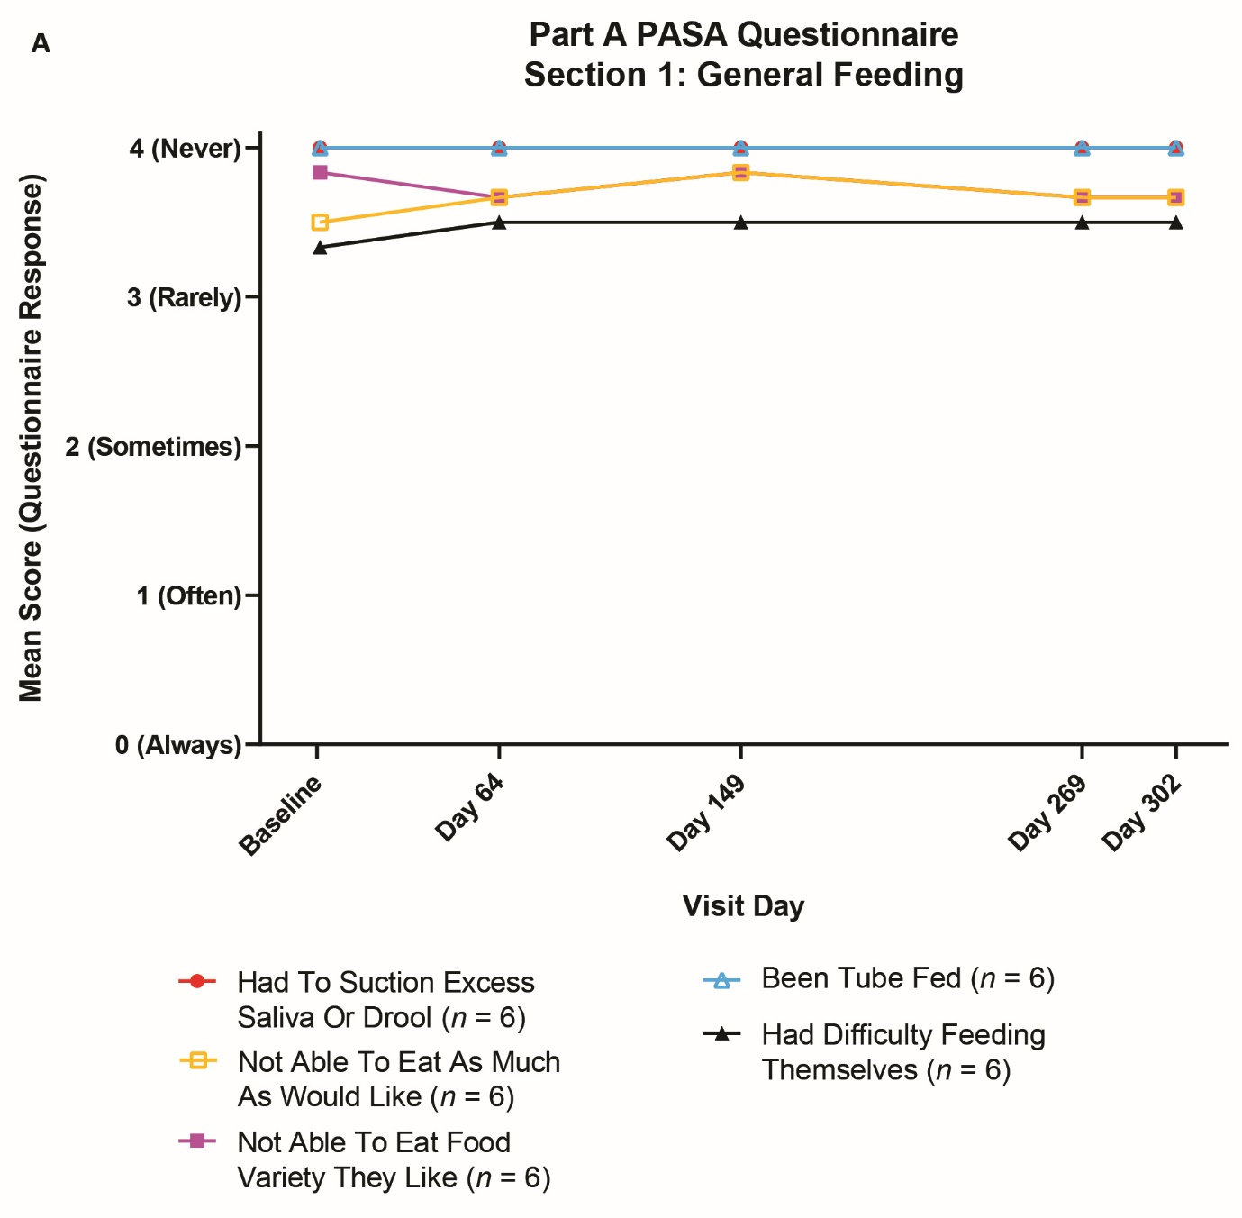

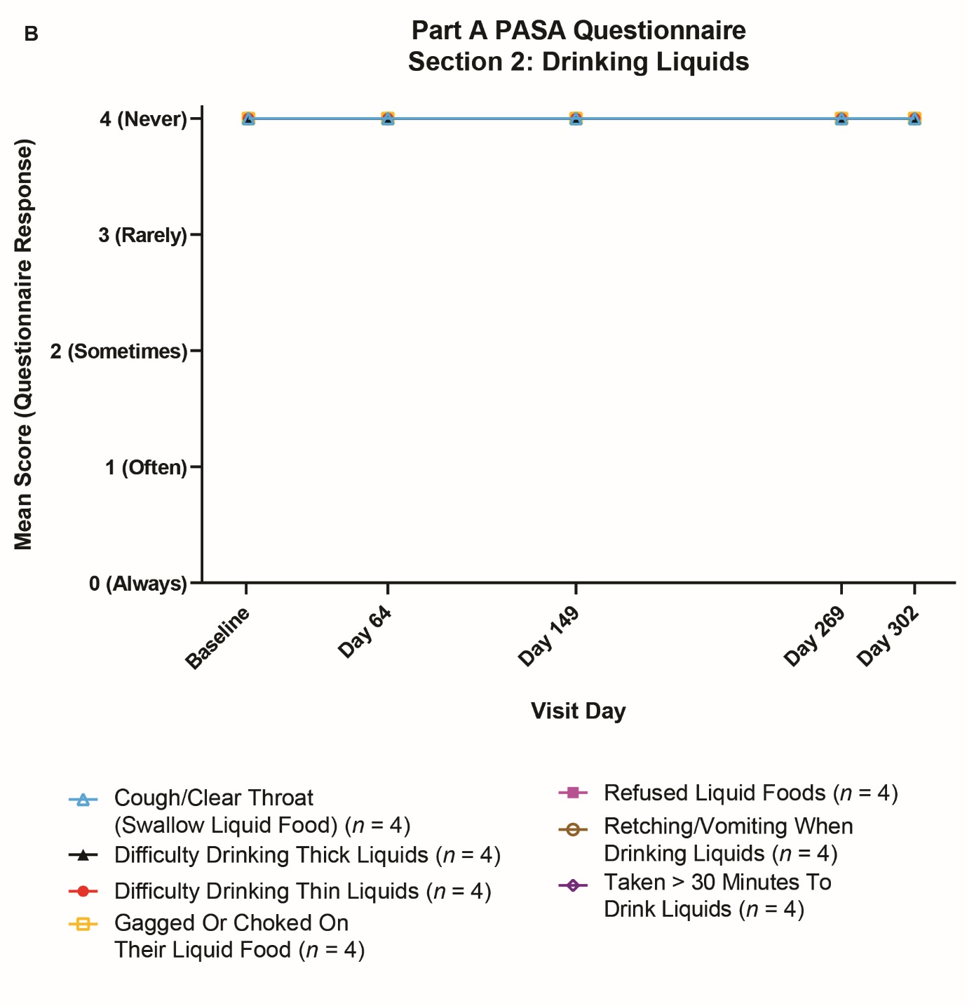
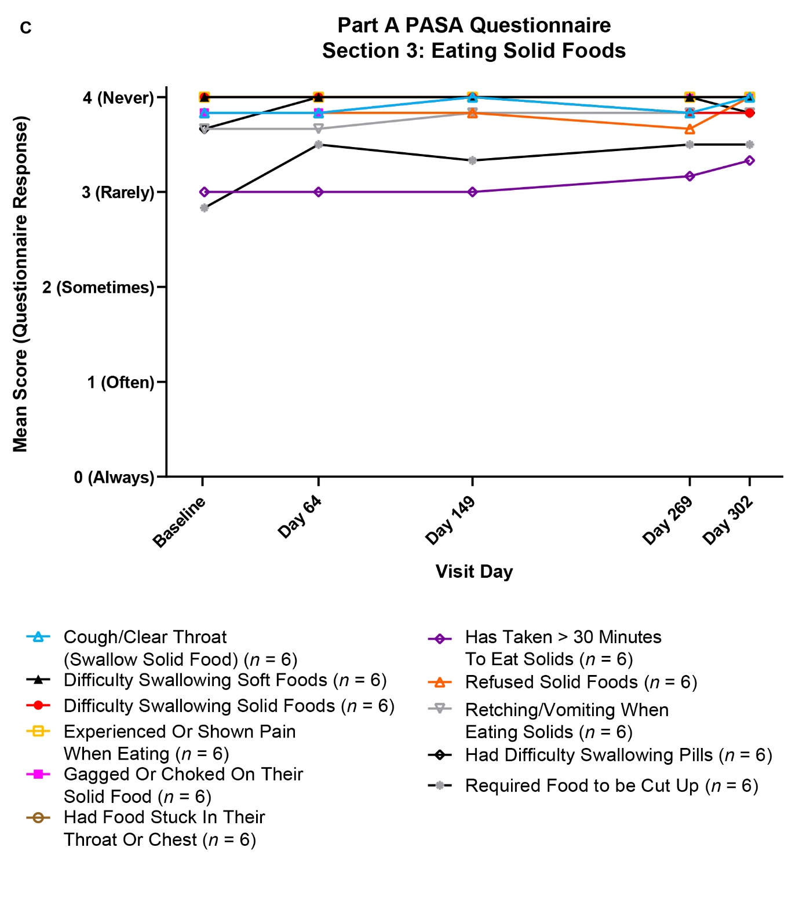
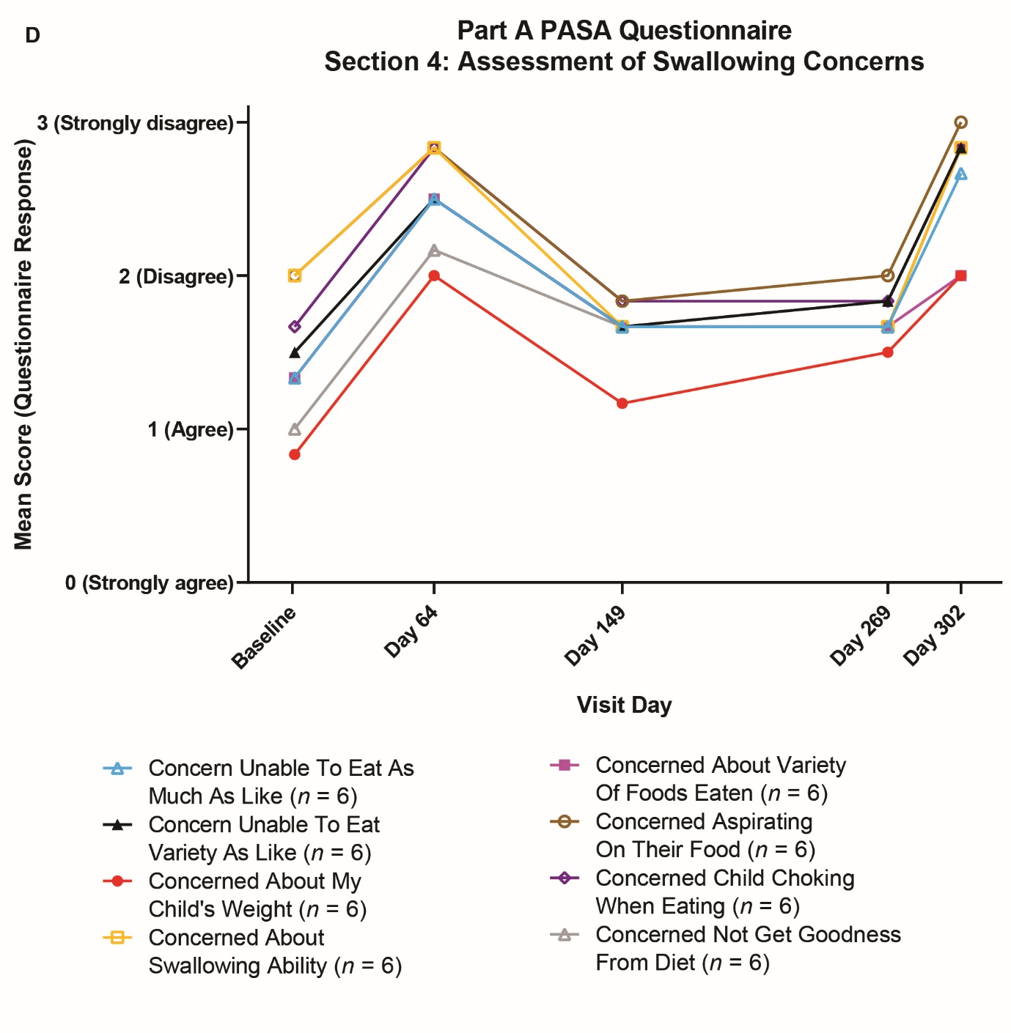
In Panels A–C, the majority of participants have a score of 4 (never) for all the assessments at each visit. In Panel B, only 4 participants were drinking liquid foods.

