SUPPLEMENTARY MATERIAL
Supplementary Table 1. CINRG DNHS Investigators and Affiliations
University of California, Davis, Sacramento, California, USA
C.M. McDonald
E.K. Henricson
R.T. Abresch
N.C. Joyce
Sundaram Medical Foundation and Apollo Children’s Hospital, Chennai, India
V. Vishwanathan
S. Chidambaranathan
Holland Bloorview Kids Rehab Hospital, Toronto, Ontario, Canada
W.D. Biggar
L.C. McAdam
Alberta Children’s Hospital, Calgary, Alberta, Canada
J.K. Mah
Queen Silvia Children’s Hospital, Göteborg, Sweden
M. Tulinius
Children’s National Medical Center, Washington DC, USA
A. Cnaan
L.P. Morgenroth
R. Leshner
C. Tesi-Rocha
M. Thangarajh
T. Duong
Royal Children’s Hospital, Melbourne, Victoria, Australia
A. Kornberg
M. Ryan
Hadassah Hebrew University Hospital, Jerusalem, Israel
Y. Nevo
Instituto de Neurociencias Fundacion Favaloro, Buenos Aires, Argentina
A. Dubrovsky
University of Pittsburgh and Children’s Hospital of Pittsburgh, Pittsburgh, Pennsylvania, USA
P.R. Clemens
H. Abdel-Hamid
Washington University in St Louis, St Louis, Missouri, USA
A.M. Connolly
A. Pestronk
Children’s Hospital of Virginia, Richmond, Virginia, USA
J. Teasley
University of Tennessee, Memphis, Tennessee, USA
T.E. Bertorini
Children’s Hospital at Westmead, Sydney, New South Wales, Australia
R. Webster
University of Alberta, Edmonton, Alberta, Canada
H. Kolski
Mayo Clinic, Rochester, Minnesota, USA
N. Kuntz
S. Driscoll
J.B. Bodensteiner
University of Puerto Rico, San Juan, Puerto Rico
J. Carlo
University of Pavia and Niguarda Ca’ Granda Hospital, Milan, Italy
K. Gorni
Texas Children’s Hospital, Houston, Texas, USA
T. Lotze
University of Minnesota, Minneapolis, Minnesota, USA
J.W. Day
P. Karachunski

Supplementary Fig. 1. Six-Minute Walk Distances and North Star Ambulatory Assessment for Viltolarsen-Treated Participants Over 4 years of treatment
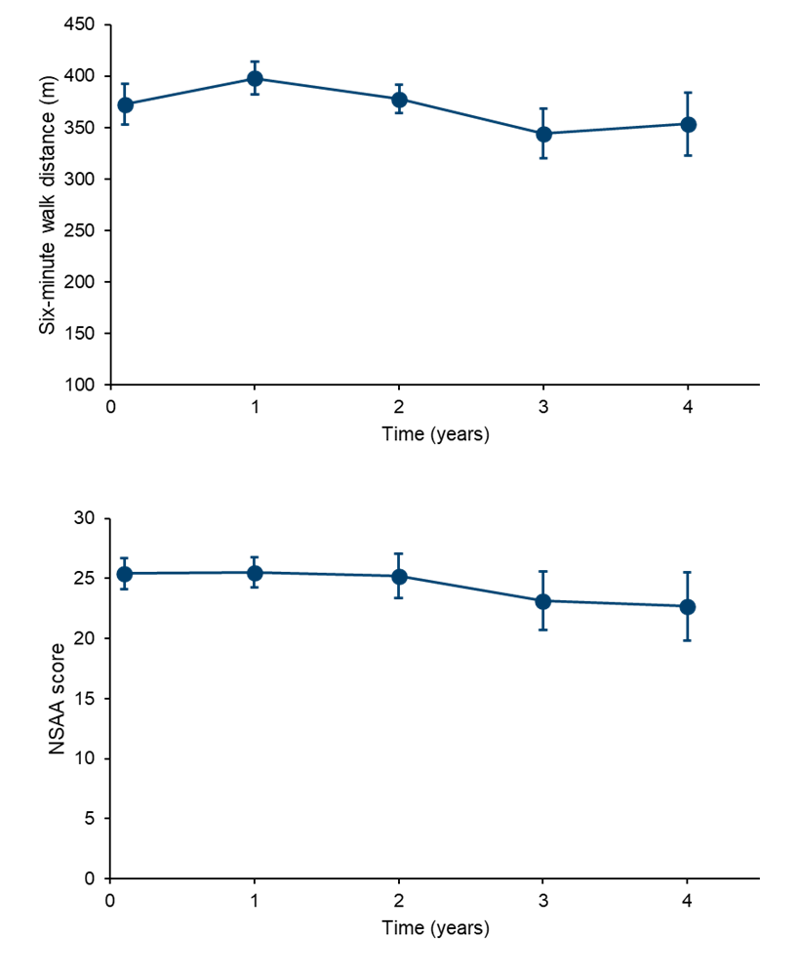
Six-minute walk distance sample size (n): 16, 14, 16, 13, 14
NSAA score sample size (n): 16, 15, 16, 14, 14
NSAA, North Star Ambulatory Assessment.

