Supplementary Material.

Supplemental Figure 1. Mass spectrometry peptides for targeted SILAM approach. MS peptides used for targeted detection of dystrophin, laminin-α2, α-dystroglycan and filamin C showing respective UniProt ID and peptide sequence.

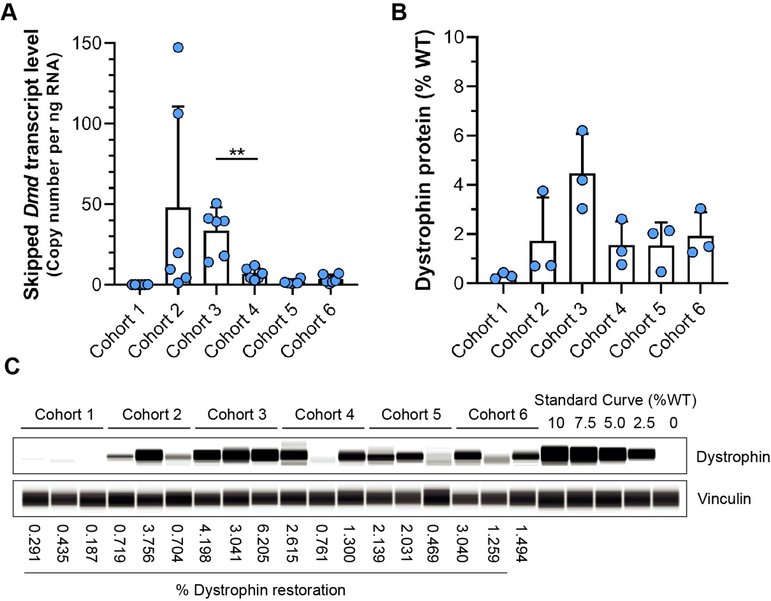
Supplemental Figure 2. Quantification of exon skipped dystrophin mRNA transcript and protein levels in treated mdx. A) Absolute quantification of skipped Dmd mRNA transcript levels by Droplet digital PCR (ddPCR) for mdx cohorts 1-6; data reported as transcript copies per nanogram RNA B-C) Quantification of restored dystrophin protein levels by automated Western blot (WES) for mdx cohorts 1-6. WT standard curve was used to calculate % dystrophin protein in treated mdx muscles; data normalized to vinculin proteins levels (loading controls). Discrepancies between dystrophin protein band intensities (C) and quantified dystrophin protein levels (B, C) are influenced by the variable vinculin protein levels between samples that serves to normalize our observed dystrophin levels for quantification.

Supplemental Figure 3. Comparative chromatograms from PRM-MS of representative samples from treated mdx and WT cohorts. A-B) Dystrophin from muscle lysates was enriched by gel fractionation followed by in-gel trypsin digestion. Eluted peptides were subjected to DDA analysis to identify suitable peptides for targeted PRM-MS. PRM methods were created using peptide retention times and m/z charges obtained from DDA files, with new methods created for each run. Raw files were imported into Proteome Discoverer 2.0 and subsequent files were used in Skyline to display chromatographic data for individual peptides for mdx (A) and WT (B) samples corresponding to cohorts 2-6. Fragment ion peak areas for heavy and light peptides were averaged and used to calculate relative isotope incorporation (heavy/heavy + light). Chromatogram peak ratios depict combined transitions ions for light (red) and heavy (blue) peptides.
Supplemental Figure 4. Modeling the influence of muscle degeneration on protein turnover and half-life in treated mdx muscle. Statistical modeling of protein dynamics accounting for muscle degeneration on protein turnover and half-life to complement the data shown in Figure 6, for dystrophin (A, A’), α-dystroglycan (B, B’), laminin-α2 (C, C’), titin (D, D’) and filamin C (E, E’). Rate of muscle degeneration in mdx cohorts was calculated based on the data shown in Figure 5, where we demonstrated ~1% degeneration of myofibers per day throughout the time frame of our study. Here, we modeled a conservative degeneration rate of 0.25% per day (A-E) due to the variation in pathology occurring between the age of 8-16 weeks investigated in this study. We also modeled the influence of our calculated degeneration rate of 1% per day (A’-E’) for all proteins of interest.

