# SUPPLEMENTARY MATERIAL

**Supplementary Table 1. Patient baseline characteristics by data sourcea for patients included in the main LOA analysis**

|  |  |  |  |  |
| --- | --- | --- | --- | --- |
|  | Eteplirsen  (Studies 201/202/405)  N = 12 | Leuven  N = 3 | Telethon N = 8 | DEMAND III  N = 60 |
| **Demographics** |  |  |  |  |
| Age (years), mean ± SD | 9.48 ± 1.18 | 10.63 ± 1.77 | 9.20 ± 1.34 | 8.41 ± 2.14 |
| Median | 9.75 | 11.50 | 8.90 | 8.13 |
| IQR | [8.68, 10.57] | [10.05, 11.65] | [8.48, 10.13] | [6.65, 9.75] |
| Range | [7.36, 11.03] | [8.60, 11.80] | [7.30, 11.50] | [5.25, 15.36] |
| **Function** |  |  |  |  |
| 6MWT (meters) | 363.17 ± 42.19 | 377.67 ± 65.03 | 355.13 ± 74.96 | 348.26 ± 92.91 |
| Timed ten-meter walk/run velocity (m/s) | 1.71 ± 0.44 | 2.15 ± 0.71 | 1.43 ± 0.48 | 1.56 ± 0.55 |
| Timed rise from floor velocity (s-1) | 0.18 ± 0.09 | 0.17 ± 0.12 | 0.21 ± 0.14 | 0.19 ± 0.27 |
| **Steroid type** |  |  |  |  |
| Deflazacort | 8 (66.7%) | 3 (100.00%) | 4 (50.00%) | 25 (43.10%)b |
| Prednisone | 4 (33.3%) | 0 (0.00%) | 4 (50.00%) | 33 (56.90%)b |
| Missing | 0 / 12 (0.00%) | 0 / 3 (0.00%) | 0 / 8 (0.00%) | 2 / 60 (3.33%) |
| **Total follow-up time (years)** |  |  |  |  |
| Mean ± SD | 5.72 ± 0.90 | 3.16 ± 1.12 | 3.88 ± 0.35 | 0.92 ± 0.03 |
| Median | 6.06 | 3.55 | 4.00 | 0.92 |
| IQR | [4.95, 6.29] | [2.73, 3.79] | [4.00, 4.00] | [0.92, 0.92] |
| Range | [4.13, 6.88] | [1.90, 4.03] | [3.00, 4.00] | [0.69, 0.93] |

**Notes***:*

aPatient characteristics for the current eteplirsen sample were measured at eteplirsen initiation (at the start of Studies 201 or 202). This sample included patients included in the Kaplan-Meier analyses (n = 83); 9 SOC patients were excluded from the Cox analyses (n = 74) due to missing characteristics on baseline timed functional tests or steroid information.

b Due to 2 patients having missing values for the steroid type at baseline, the percentages of patients with deflazacort and prednisone are based on n = 58 patients and add up to 100%.

Means ± SDs are shown for continuous characteristics; counts with percentage shown for categorical characteristics.

**Abbreviations***:* 6MWT: six-minute walk test;IQR: interquartile range; SD: standard deviation; SOC: standard of care.

|  |  |  |  |
| --- | --- | --- | --- |
|  | Entire samplea  N = 12 | Included in Study 405  N = 10 | Not included in Study 405  N = 2 |
| **Demographics** |  |  |  |
| Age (years), mean ± SD | 9.48 ± 1.18 | 9.35 ± 1.24 | 10.14 ± 0.71 |
| Median | 9.75 | 9.49 | 10.14 |
| IQR | [8.68, 10.57] | [8.30, 10.39] | [9.89, 10.39] |
| Range | [7.36, 11.03] | [7.36, 11.03] | [9.64, 10.65] |
| **Function, mean ± SD** |  |  |  |
| 6MWT (meters) | 363.17 ± 42.19 | 355.70 ± 42.48 | 400.50 ± 0.71 |
| Timed ten-meter walk/run (seconds) | 6.18 ± 1.49 | 6.19 ± 1.59 | 6.10 ± 1.27 |
| Timed rise from floor (seconds) | 8.23 ± 7.57 | 8.93 ± 8.15 | 4.75 ± 1.77 |
| Timed four-stair climb (seconds) | 4.15 ± 1.14 | 4.28 ± 1.21 | 3.50 ± 0.28 |
| NSAA total score | 24.92 ± 4.93 | 24.40 ± 5.02 | 27.50 ± 4.95 |
| FVC (liters) | 1.66 ± 0.31 | 1.72 ± 0.30 | 1.38 ± 0.21 |
| **Steroid type, n (%)** |  |  |  |
| Deflazacort | 8 (66.7%) | 6 (60.0%) | 2 (100.0%) |
| Prednisone | 4 (33.3%) | 4 (40.0%) | 0 (0.0%) |
| Missing | 0 / 12 (0.0%) | 0 / 10 (0.0%) | 0 / 2 (0.0%) |

**Supplementary Table 2. Eteplirsen-treated patient characteristics by availability in the chart review study (Study 405)**

**Notes***:*

a Eteplirsen initiation was at the start of Study 201 (for treatment-arm patients) or the start of Study 202 (for placebo-arm patients);

**Abbreviations:** 6MWT: six-minute walk test; FVC: forced vital capacity; IQR: interquartile range; NSAA: North Star Ambulatory Assessment; SD: standard deviation

**Supplementary Figure 1. Sensitivity analysis: Kaplan-Meier curves for time to loss of ambulation by treatment group, calculated under alternative assumptions for patients not participating in Study 405**

**Notes:**

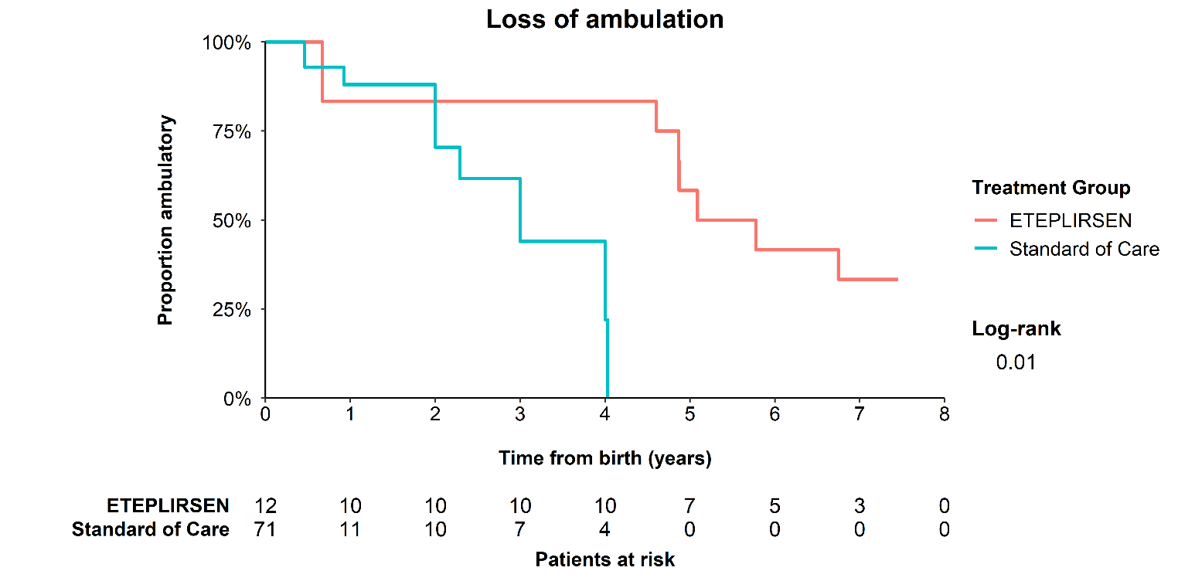

**Proportion ambulatory**

In this analysis, one patient in Studies 201/202 who did not participate in Study 405 was assumed to lose ambulation as suggested by the case manager poll conducted by study sponsor; the other patient in Studies 201/202 who did not participate in Study 405 was assumed to remain ambulatory until the end of Study 405, when the follow-up was censored.

**Supplementary Table 3. Sensitivity analysis: Median time to loss of ambulation by treatment group, calculated under alternative assumptions for patients not participating in Study 405**

|  |  |  |  |
| --- | --- | --- | --- |
|  | N | Patients with events | Median time to event (years), 95% CI |
| Eteplirsen | 12 | 8 | 5.43 (4.87, -) |
| Standard of Care | 71 | 14 | 3.00 (2.29, -) |

**Abbreviation:** CI: confidence interval

**Supplementary Figure 2. Sensitivity analysis: Kaplan-Meier curves for time from birth to loss of ambulation by treatment group**

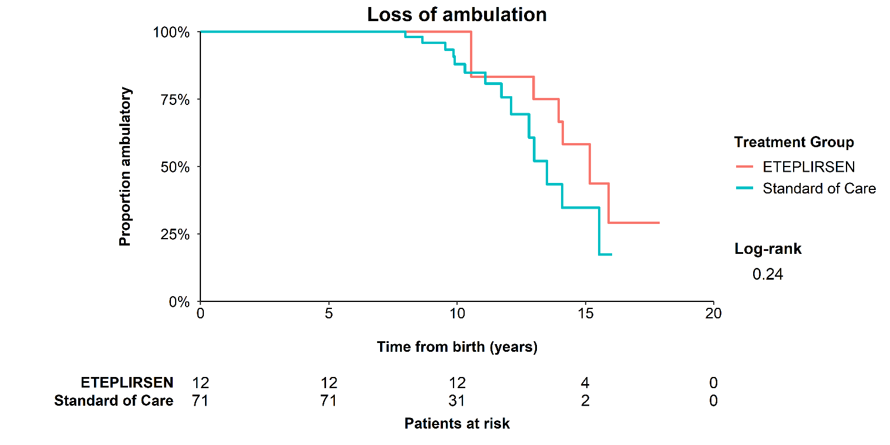

**Supplementary Table 4. Sensitivity analysis: Median time from birth to loss of ambulation by treatment group**

|  |  |  |  |
| --- | --- | --- | --- |
|  | N | Patients with events | Median time to event (years),  95% CI |
| Eteplirsen | 12 | 7 | 15.16 (13.95, -) |
| Standard of care | 71 | 14 | 13.50 (12.80, -) |

**Abbreviation**: CI: confidence interval

**Supplementary Figure 3. Sensitivity analyses: Kaplan-Meier curves for time from baseline to LOA under different assumptions for patients with uncertain dates of LOA recorded for eteplirsen-treated patients**

**Note:** The Kaplan-Meier curves are plotted on the graph with 201/202/405 patient data imputed under alternative assumptions based on the available information for patients where the date of LOA was recorded imprecisely. The date of LOA was assumed to be either: the lower bound of the uncertainty interval (i.e. the earliest event date consistent with the data), the midpoint of the uncertainty interval, and the upper bound of the uncertainty interval, (i.e. the latest event date consistent with the data)

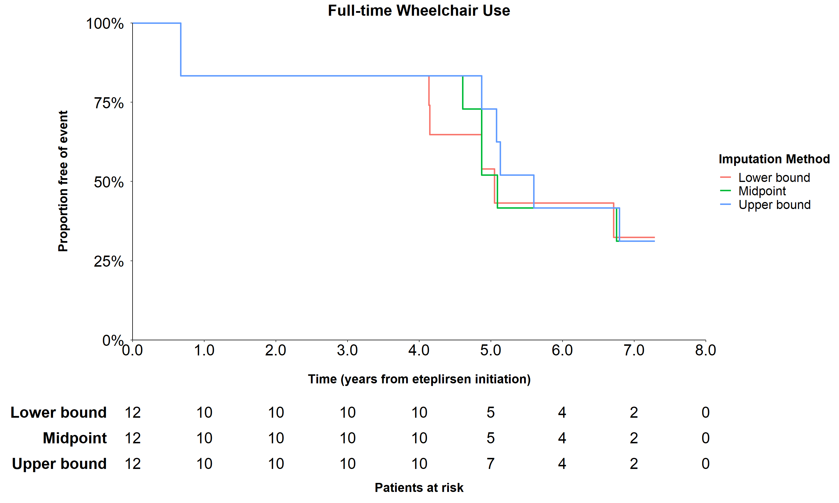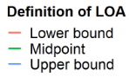

**Supplementary Table 5. Sensitivity analyses: Comparison of median time from baseline to LOA under different assumptions for patients with uncertain dates of LOA recorded for eteplirsen-treated patients**

|  |  |  |  |
| --- | --- | --- | --- |
| **Imputation method** | **Total patients** | **Patients with events** | **Median time to event (years), 95% CI** |
| Lower bound (sensitivity analysis) | 12 | 7 | 5.05 (4.15, -) |
| **Midpoint (main analysis)** | **12** | **7** | **5.09 (4.87, -)** |
| Upper bound (sensitivity analysis) | 12 | 7 | 5.60 (5.08, -) |

**Abbreviation**: CI: confidence interval

**Supplementary Table 6. Patient baseline characteristics by data source, for the LOA sensitivity analysis using the expanded SOC group including CINRG DNHS patients**

|  |  |  |  |  |  |
| --- | --- | --- | --- | --- | --- |
|  | Eteplirsen Studies (201/202/405)  N = 12 | Leuven  N = 3 | Italian Group  (Telethon)  N = 8 | DEMAND III  N = 60 | CINRG DNHS  N = 8 |
| **Demographics** |  |  |  |  |  |
| Age (years), mean ± SD | 9.48 ± 1.18 | 10.63 ± 1.77 | 9.20 ± 1.34 | 8.41 ± 2.14 | 6.11 ± 0.77 |
| Median | 9.75 | 11.50 | 8.90 | 8.13 | 5.83 |
| IQR | [8.68, 10.57] | [10.05, 11.65] | [8.48, 10.13] | [6.65, 9.75] | [5.54, 6.53] |
| Range | [7.36, 11.03] | [8.60, 11.80] | [7.30, 11.50] | [5.25, 15.36] | [5.41, 7.56] |
| **Function** |  |  |  |  |  |
| 6MWT (meters) | 363.17 ± 42.19 | 377.67 ± 65.03 | 355.13 ± 74.96 | 348.26 ± 92.91 | 452.34 ± 207.19 |
| Timed ten-meter walk/run velocity (m/s) | 1.71 ± 0.44 | 2.15 ± 0.71 | 1.43 ± 0.48 | 1.56 ± 0.55 | 1.73 ± 0.51 |
| Timed rise from floor velocity (s-1) | 0.18 ± 0.09 | 0.17 ± 0.12 | 0.21 ± 0.14 | 0.19 ± 0.27 | 0.22 ± 0.10 |
| **Steroid type** |  |  |  |  |  |
| Deflazacort | 8 (66.7%) | 3 (100.00%) | 4 (50.00%) | 25 (43.10%) | 5 (62.50%)a |
| Prednisone | 4 (33.3%) | 0 (0.00%) | 4 (50.00%) | 33 (56.90%) | 3 (37.50%)a |
| Missing | 0 / 12 (0.00%) | 0 / 3 (0.00%) | 0 / 8 (0.00%) | 2 / 60 (3.33%) | 0 / 8 (0.00%) |
| **Total follow-up time (years)** |  |  |  |  |  |
| Mean ± SD | 5.72 ± 0.90 | 3.16 ± 1.12 | 3.88 ± 0.35 | 0.92 ± 0.03 | 1.55 ± 0.82 |
| Median | 6.06 | 3.55 | 4.00 | 0.92 | 1.33 |
| IQR | [4.95, 6.29] | [2.73, 3.79] | [4.00, 4.00] | [0.92, 0.92] | [1.00, 2.00] |
| Range | [4.13, 6.88] | [1.90, 4.03] | [3.00, 4.00] | [0.69, 0.93] | [0.56, 3.12] |

**a** Due to 2 patients having missing values for the steroid type at baseline, the percentages of patients with deflazacort and prednisone are based on n = 69 patients and add up to 100%.

**Abbreviations:** 6MWT: six-minute walk test; CINRG DNHS: Cooperative International Neuromuscular Research Group Duchenne Natural History Study FVC: forced vital capacity; IQR: interquartile range; NSAA: North Star Ambulatory Assessment; SD: standard deviation

**Supplementary Figure 4. Sensitivity analysis: Kaplan-Meier curves for time from baseline to LOA comparing eteplirsen-treated patients with expanded SOC group including CINRG DNHS patients**

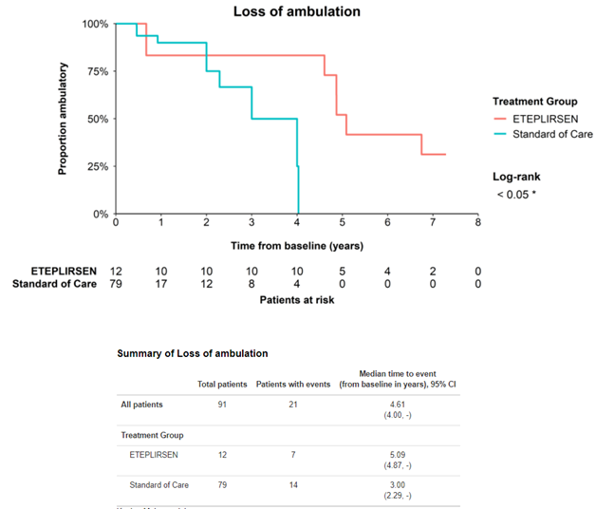

**Supplementary Table 7. Sensitivity analysis: Median time from baseline to LOA by treatment group** **comparing eteplirsen-treated patients with expanded SOC group including CINRG DNHS patients**

|  |  |  |  |
| --- | --- | --- | --- |
|  | N | Patients with events | Median time to event (years),  95% CI |
| Eteplirsen | 12 | 7 | 5.09 (4.87, -) |
| Standard of care (expanded) | 79 | 14 | 3.00 (2.29, -) |

**Supplementary Figure 5. Sensitivity analysis: Kaplan-Meier curves for time from birth to LOA comparing eteplirsen-treated patients with expanded SOC group including CINRG DNHS patients**

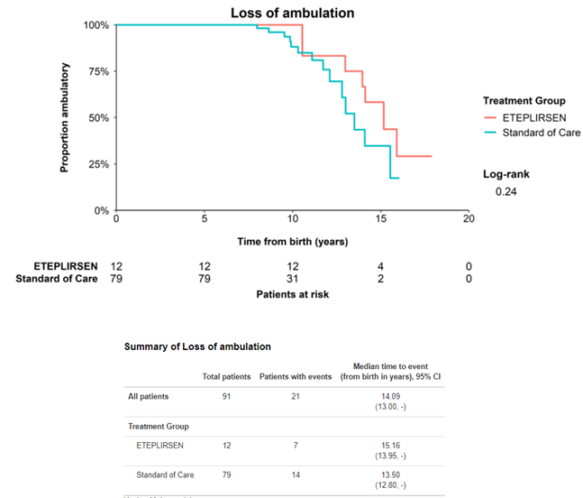

**Supplementary Table 8. Sensitivity analysis: Median time from birth to LOA by treatment group** **comparing eteplirsen-treated patients with expanded SOC group including CINRG DNHS patients**

|  |  |  |  |
| --- | --- | --- | --- |
|  | N | Patients with events | Median time to event (years),  95% CI |
| Eteplirsen | 12 | 7 | 15.16 (13.95, -) |
| Standard of care (expanded) | 79 | 14 | 13.50 (12.80, -) |