SUPPLEMENTARY APPENDIX
Table S1.
Overview of the number of patients in the database per age group and the number of patients analysed per clinical milestone.
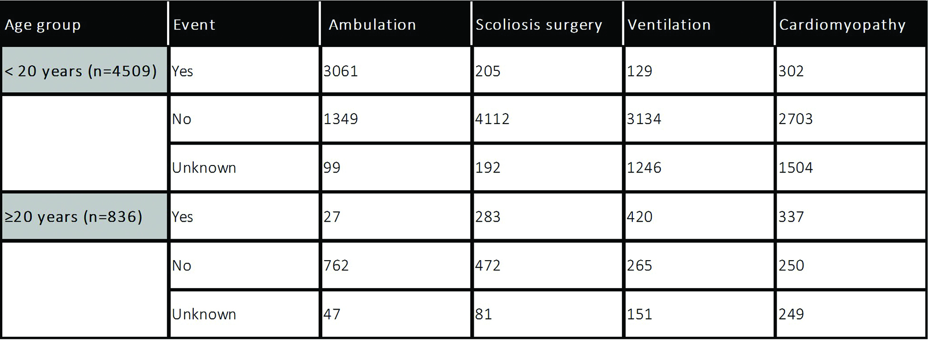
Table S2.
Overview of corticosteroid use per age group within the database.
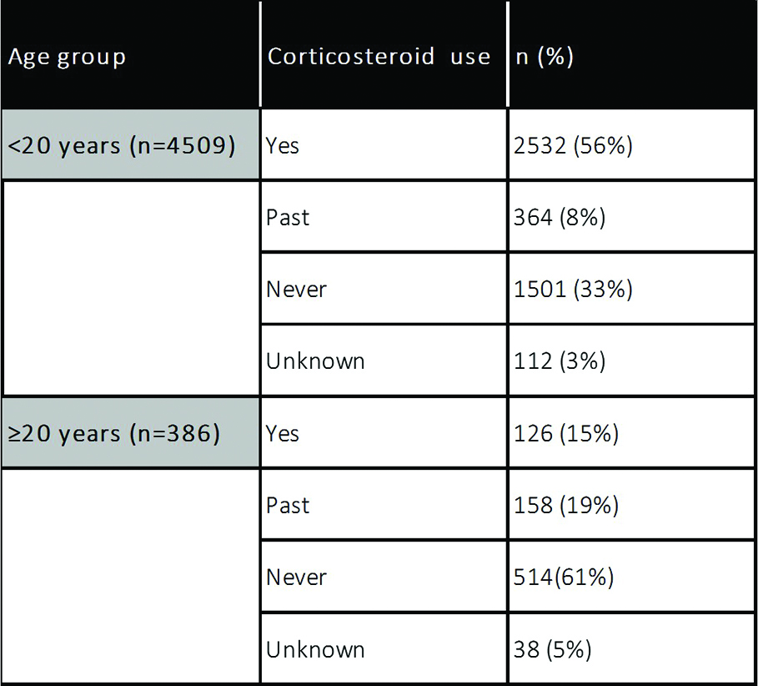

Table S3.
Life table for wheelchair dependence (loss of ambulation) stratified by corticosteroid use.The table summarizes the survival data in terms of the number of patients at risk for loss of ambulation and the proportion surviving (proportion of patients not being wheelchair dependent) at each time point. This table corresponds to the figure 2. Turnbull analysis for loss of ambulation.
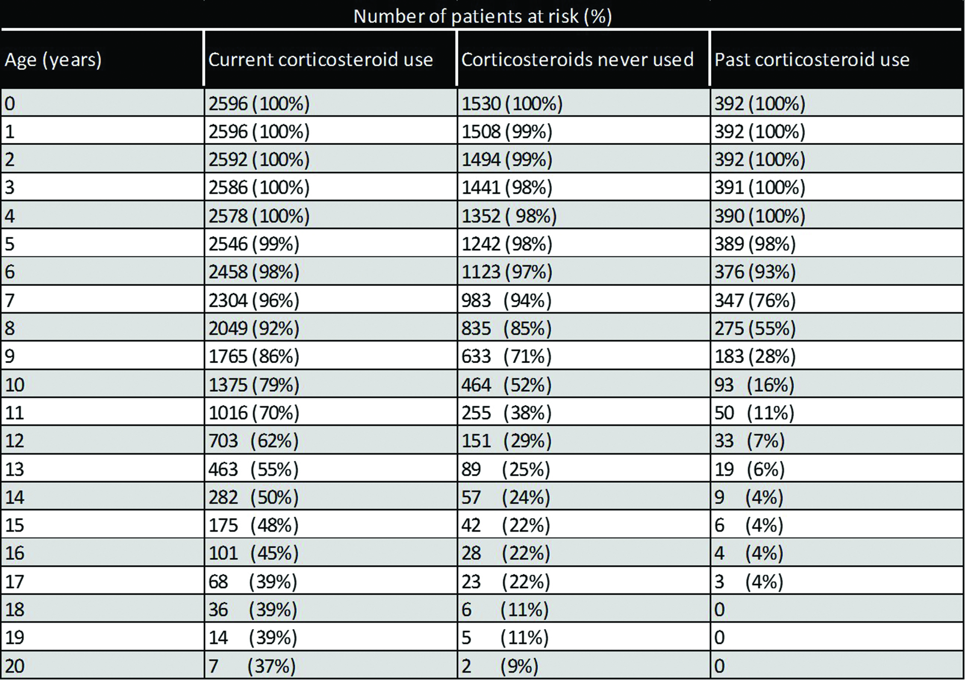

Supplementary Figures
Figure S1.
Turnbull analysis of scoliosis surgery (A), ventilation (B) and cardiomyopathy (C).The red line indicates the “corticosteroid yes” group, the green line the “corticosteroid never used” group and the blue line the “past corticosteroid use” group.
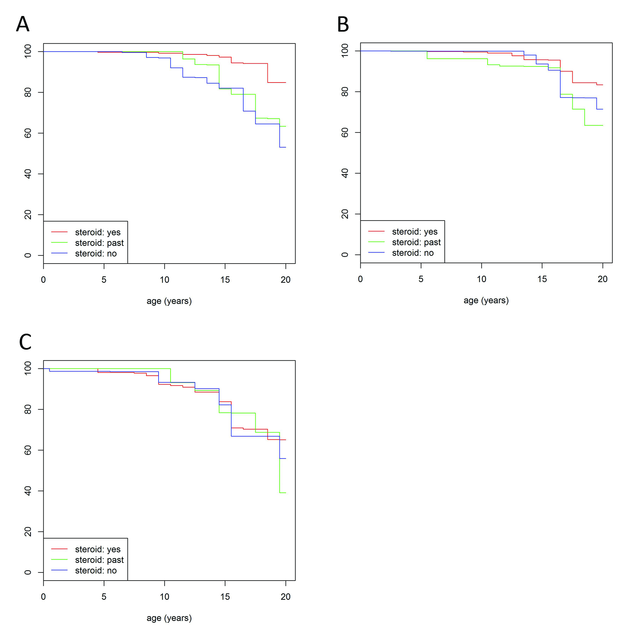

Figure S2A.

Single exon deletion in patients under the age of 20 years.
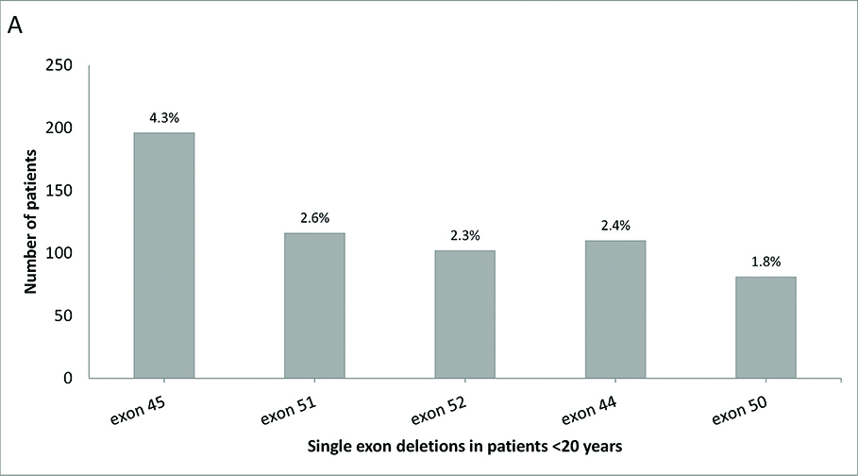

Figure S2B.
Single exon deletion in patients aged 20 years and older.
