Supplementary Material Figure 1: Kaplan-Meier analysis for the time to 10% relative decline in FVC%p (first event analysis)

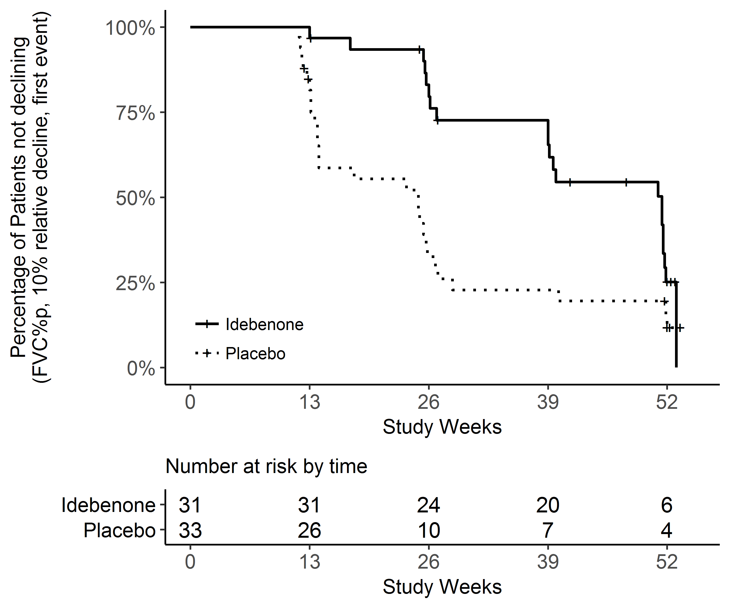

Supplementary Material Figure 2: Kaplan-Meier analysis for the time to decline below 50% of FVC%p from baseline to week 52 (first event analysis)

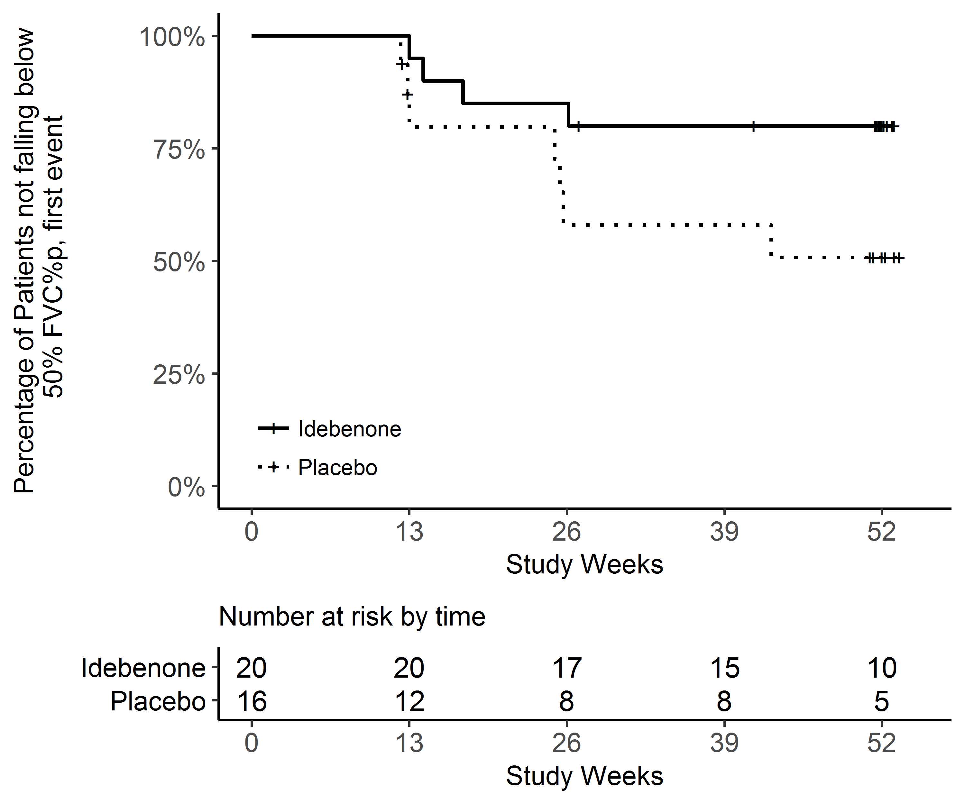

Supplementary Material Figure 3: Kaplan-Meier analysis for the time to decline below any of the 50%, 40% or 30% thresholds for FVC%p from baseline to week 52 (first event analysis)

