Supplementary Material

Characterization of Neurodevelopmental Abnormalities in iPSC-Derived Striatal Cultures from Patients with Huntington’s Disease

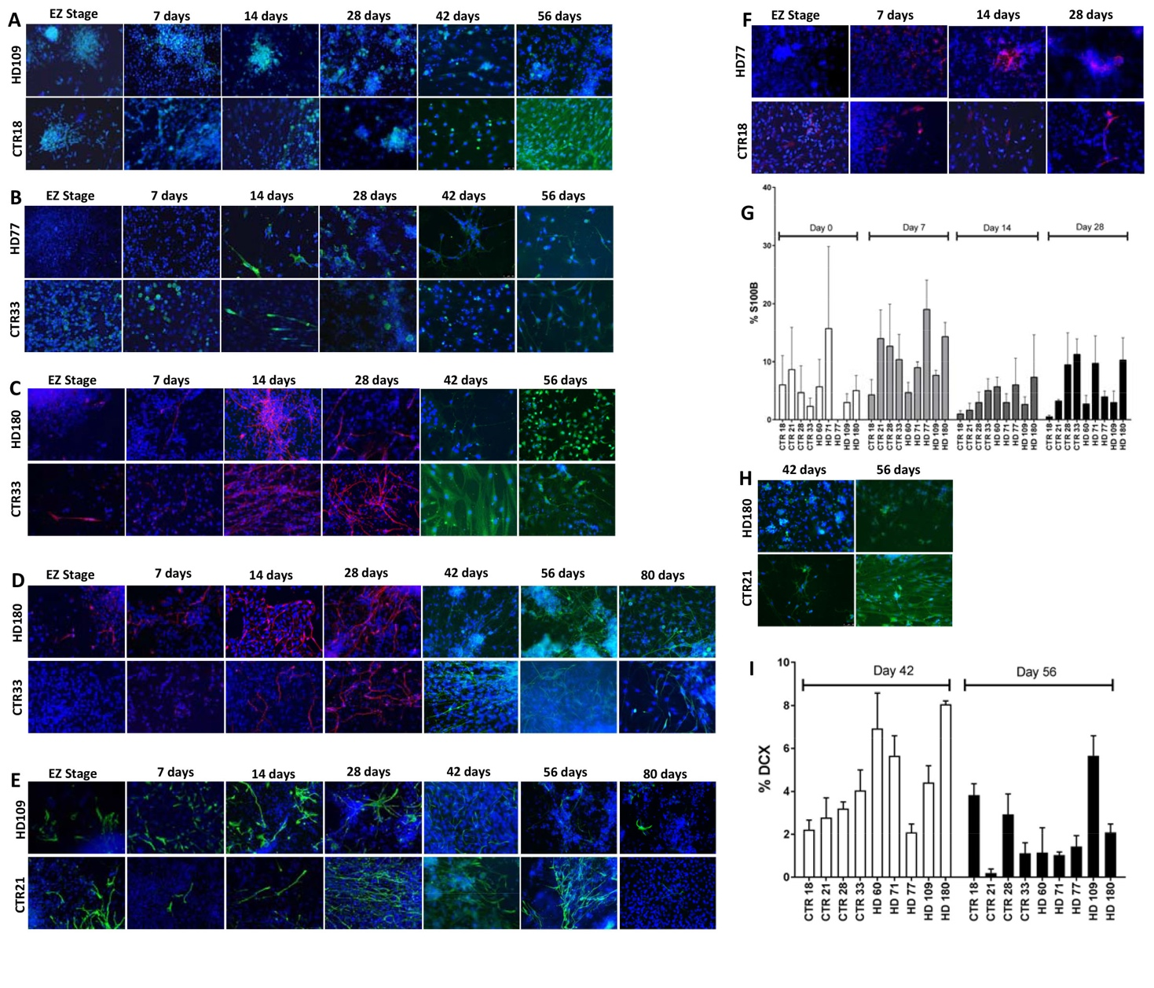

Supplementary Figure 1. Characterization of various neuronal and glial markers at various time points (day 0 (EZ stage), 7, 14, 28, 42, 56, and 80). A) Representation image of NeuroD1, B) NG2, C) Map2ab, D) TuJ1, E) GFAP, and F) S100β G) Stereological quantification of S100β. H) Representative images of DCX. I) Stereological quantification of DCX. Error bars represent SEM.

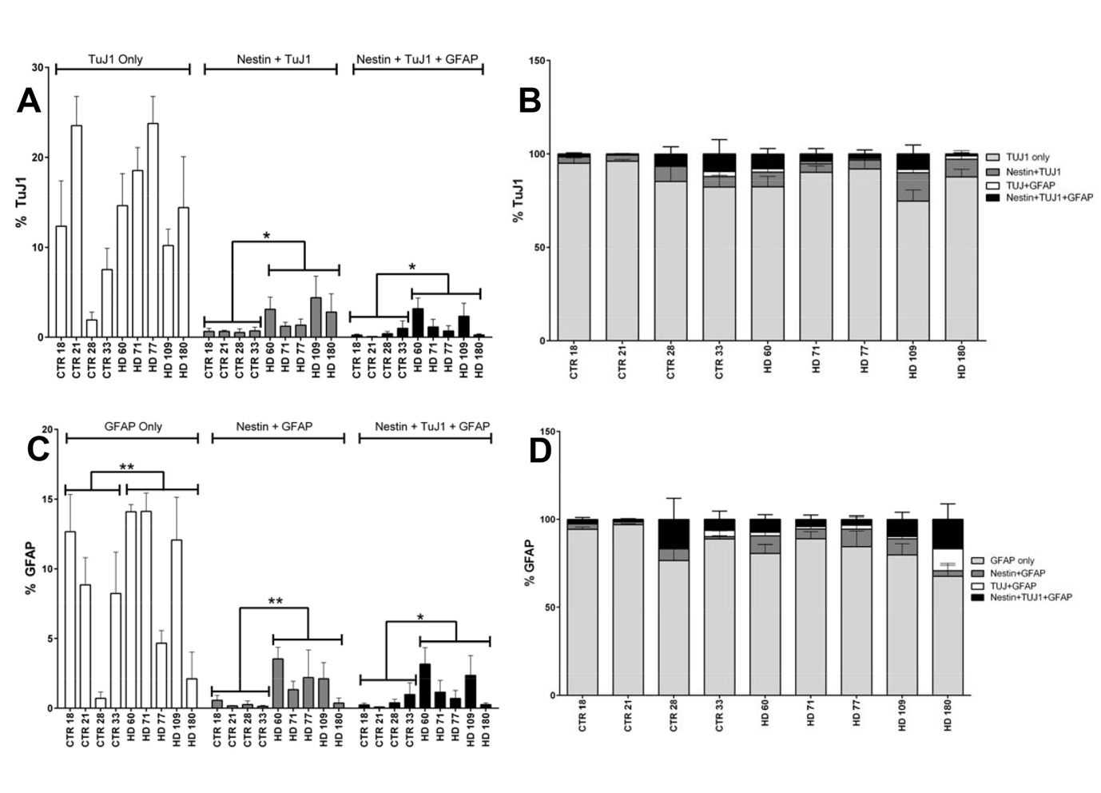

Supplementary Figure 2. A) While no significant difference was seen in total in TuJ1 expression between HD and control cell lines at 42 days of differentiation, when broken down by co-expression with Nestin and/or GFAP, some significant differences were seen between the two groups (Student’s T Test). B) No TuJ1 population (alone or co-expressing Nestin and/or GFAP) is over represented in HD lines at 42 days of differentiation (one-way ANOVA). C) While no significant difference was seen in total in GFAP expression between HD and control cell lines at 42 days of differentiation, when broken down by co-expression with Nestin and/ or TuJ1, some significant differences were seen between the two groups (Student’s T Test). D) No GFAP population (alone or co-expressing Nestin and/or TuJ1) is over represented in HD lines at 42 days of differentiation (one-way ANOVA). Error bars represent SEM.

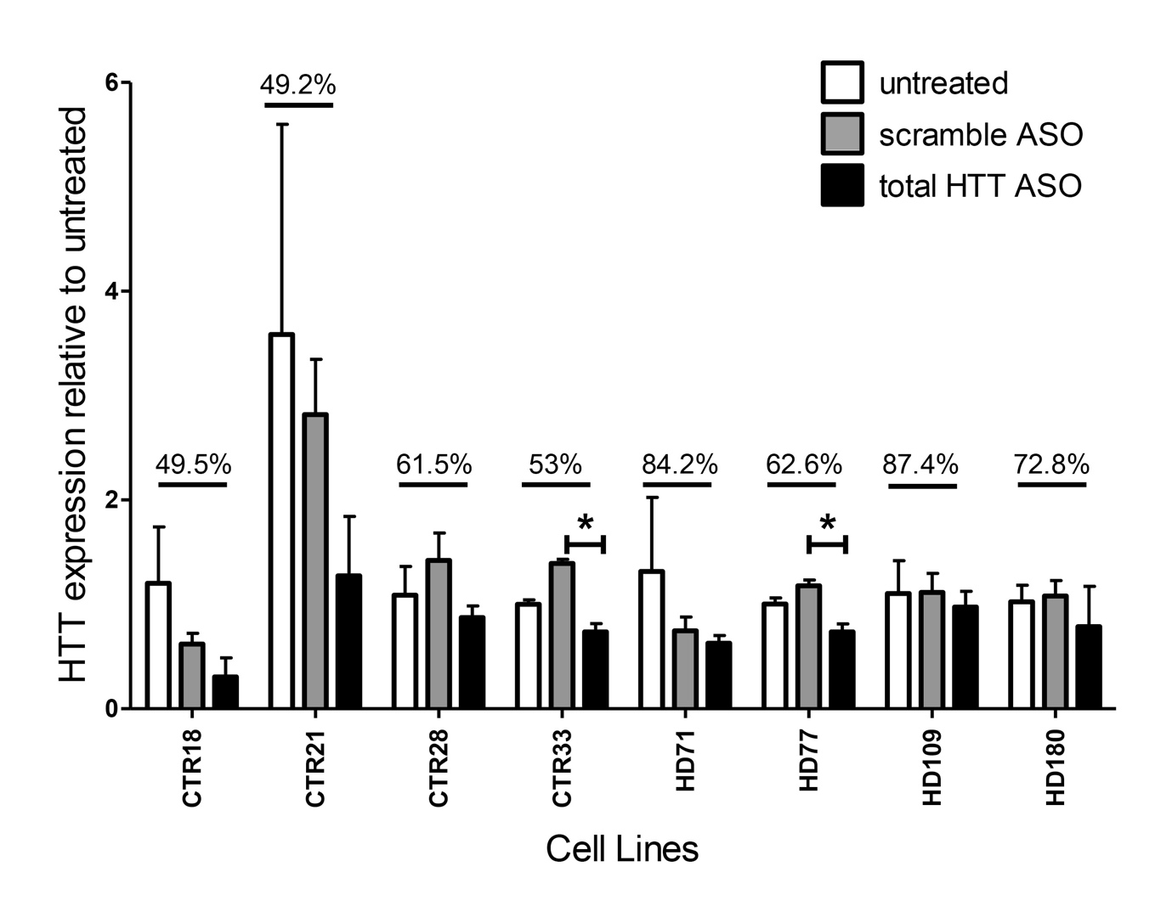
Supplementary Figure 3. Knock-down of HTT RNA is seen after treating HD and control iPSC-derived neural cultures using total HTT ASOs (black bars) but not scramble ASO (grey bars) during the entire course of differentiation, compared to the untreated samples (white bars). HTT expression levels after HTT ASO treatment relative to untreated are written on graph for each cell line, and significant differences between total HTT ASO-treated and scramble-treated within cell lines was determined by Student’s T test (*p<0.05) as compared to scramble-treated. Error bars represent SEM.

Supplementary Table 1. Cell Line Information

