Supplementary Data
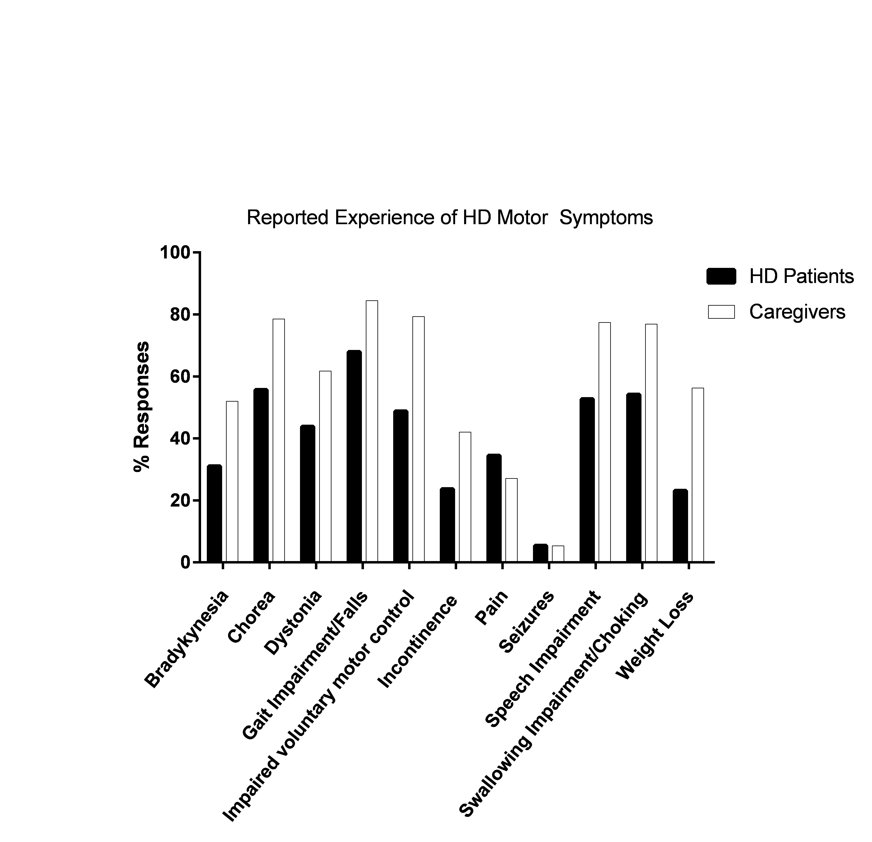Supplementary Data 1: HD Patient and Caregiver reports on experience of motor symptoms of HD. HD Patient (N=203) Caregiver (N=727).

