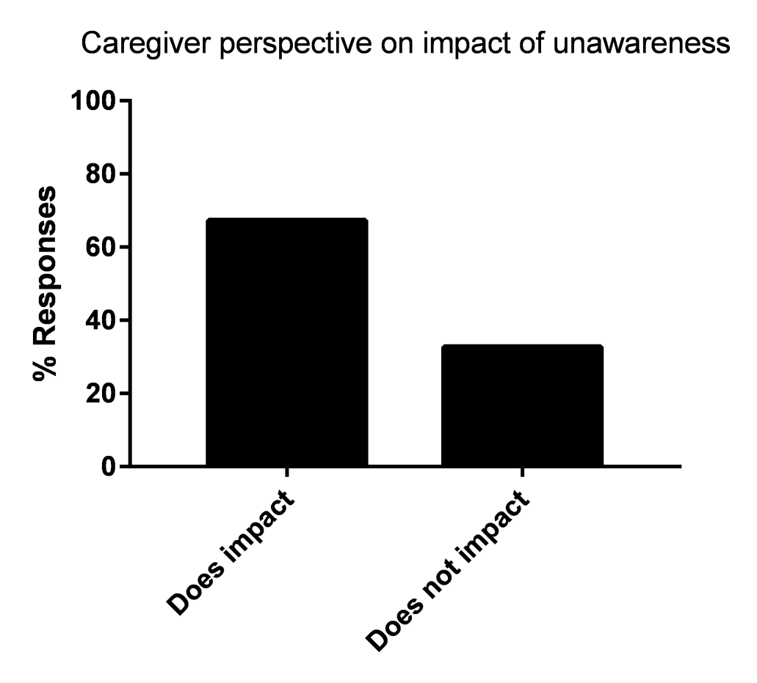
Supplementary Data 2: Caregiver perspective on impact of unawareness in making it more difficult to manage HD symptoms treatable with medication (N=156).

