Supplementary Table 1: List of injected animals.
AAV | Injection type | Injection volume | Mouse genotype | Age at Injection | n | Survival | Use
pAAV-hSyn1-TFEB-HA | Unilateral | 2 | Q175/Q7 | 3 m | 2 | 1 m | IHC
pAAV-hSyn1-GFP | Unilateral | 2 | Q175/Q7 | 3 m | 2 | 1 m | IHC
pAAV-hSyn1-TFEB-HA | Bilateral | 2 | Q175/Q7 | 3 m | 4 | 1 m | WB
pAAV-hSyn1-GFP | Bilateral | 2 | Q175/Q7 | 3 m | 4 | 1 m | WB
pAAV-hSyn1-TFEB-HA | Bilateral | 2 | Q175/Q7 | 3 m | 2 | 2 m | IHC
pAAV-hSyn1-GFP | Bilateral | 2 | Q175/Q7 | 3 m | 2 | 2 m | IHC
Non-injected |  |  | Q175/Q7 | - | 2 | 5 m | IHC
pAAV-hSyn1-TFEB-HA | Bilateral | 2 | Q175/Q7 | 3 m | 4 | 2 m | WB
Non-injected |  |  | Q175/Q7 | - | 4 | 5 m | WB
Non-injected |  |  | WT |  | 4 | 5 m | WB
WB, Western blot; IHC, immunohistochemistry

Supplementary Table 2: Staining intensity and number of DARPP32 positive neurons in AAV hSyn1 TFEB-HA, AAV hSyn1 GFP and non-injected mice. Mice represented in figures are indicated.
Genotype | Treatment | Post-injection interval | Mouse# | DARPP32 staining intensity | DARPP32 positive neuron numbers
 |  |  |  | mean change ± SEM (%) | Whole striatum estimate
Q175/Q7 | TFEB-HA | 1 month | Mouse 1 | -7.69±1.28%
 |  |  | Mouse 2 | -7.64±2.53%
 | GFP |  | Mouse 3 | -3.73±3.09%
 |  |  | Mouse 4 | -1.85±1.38%
Q175/Q7 | TFEB-HA | 2 months | Mouse 5 | -33.36±2.87% | 566766.81
 |  |  | Mouse 6 | -11.00±2.12%
 | GFP |  | Mouse 7 | -1.78±0.88%
 |  |  | Mouse 8 | -2.24±0.88% | 614247.44
 | None |  | Mouse 9 | 0.89±1.40%
 |  |  | Mouse 10 | -0.58±2.86% | 652665.06
WT | TFEB-HA | 2 months | Mouse 11 | -11.32±2.72%
 |  |  | Mouse 12 | -21.51±1.35%
 | GFP |  | Mouse 13 | 1.57±1.14%
 |  |  | Mouse 14 | 5.22±0.93%
Mean change ± SEM (%) in the injected area relative to unaffected region.

Supplementary Figure 1
Co-localization of TFEB-HA and NeuN in AAV-hSyn1-TFEB-HA injected mouse, 1 month post-injection. Maximum projection of z-stack scan through striatum double stained for HA and NeuN. All TFEB-HA positive cells (red in merge, arrows) are also positive for NeuN (green in merge; arrows). Nuclei were counterstained by DAPI (blue in merge). Smaller nuclei (arrowheads) most likely of glial cells are negative for both TFEB-HA and NeuN (arrowheads denote position of the same nuclei in NeuN and TFEB-HA channels).
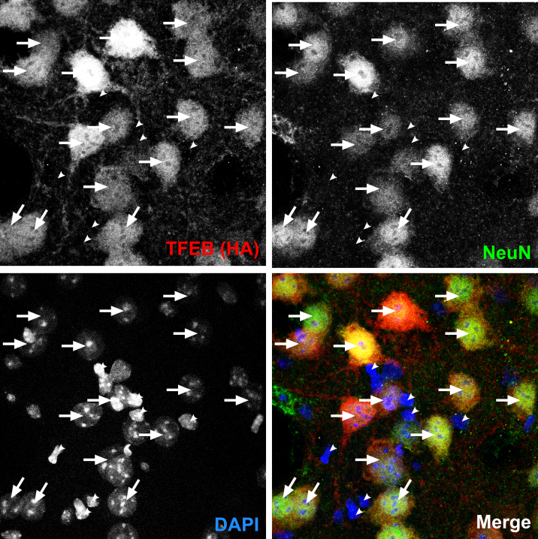

Supplementary Figure 2
Western blot analysis of DARPP32, GFAP and PDE10A in striatal crude homogenates of mice injected with either AAV hSyn1 TFEB-HA or AAV hSyn1 GFP and analyzed 1 month post-injection. A) Western blots for DARPP32, GFAP and PDE10A, GAPDH was used as a loading control. B) Bar graphs show results of densitometry for Western blots in A. All mice are age matched and were examined at 1 months post-injection. Each column represents sample from a different mouse, N=4 mice per treatment group, p-values from unpaired t-test.
