**Supplementary materials**

**Figure 1S.** HPLC-DAD profiles at 520 and 380 nm of Purple Queen sample, 2018 fruits.

(**a**) Anthocyanins from juice (**b**) Ellagitannins from decoction.

**a)**

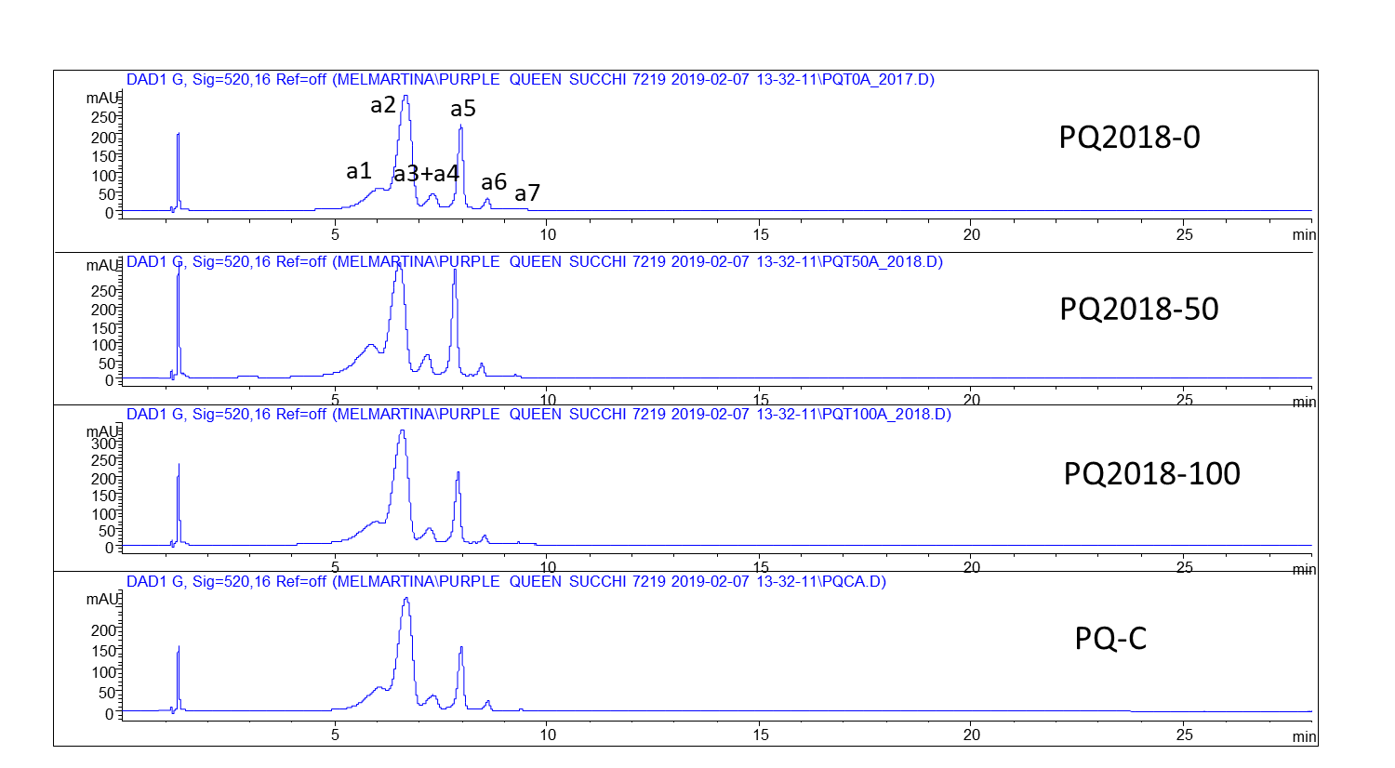

**b)**

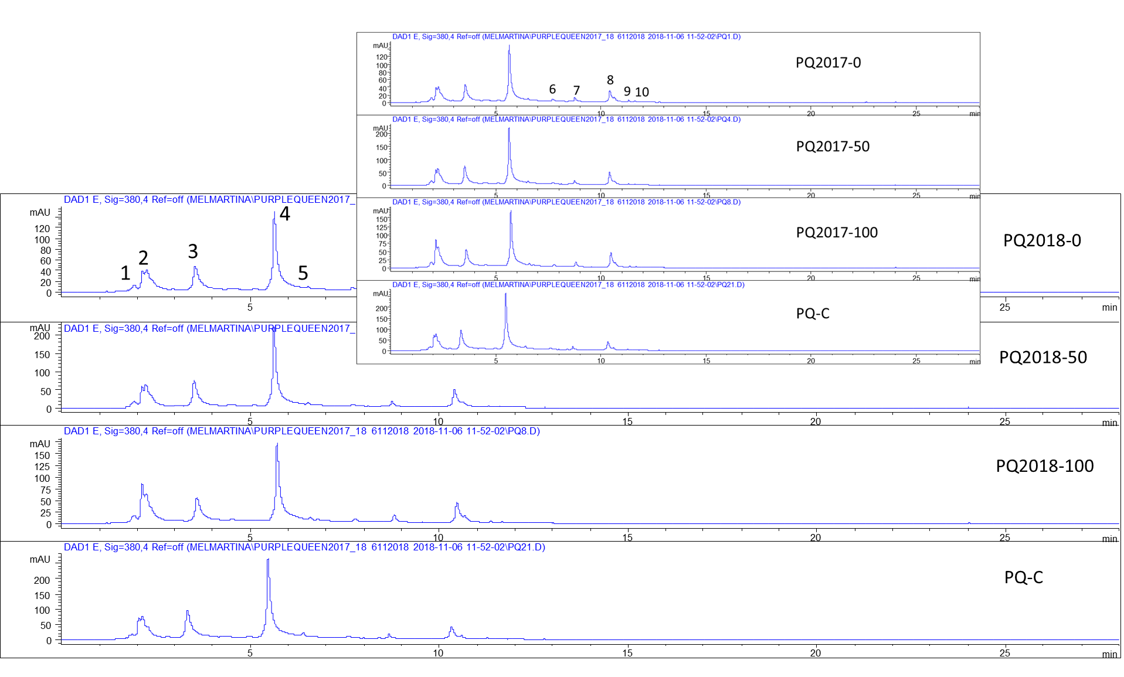

**Figure 2S.** Mass spectra of delphinidin-3,5-diglucoside (partially co-eluted with cyanidin 3,5-diglucoside) using fragmentor at 200 V (a) and 300 V(b); the ions are in agreement with Table 2S.

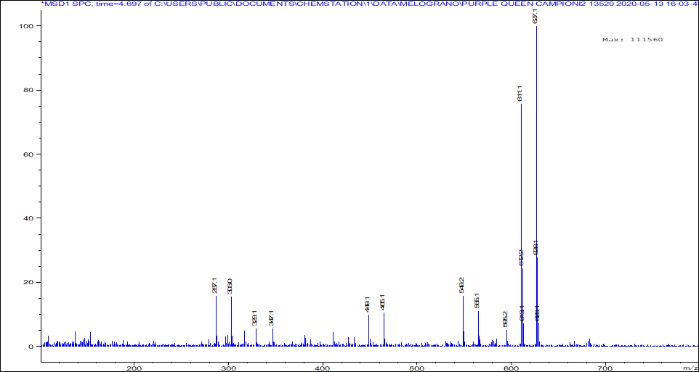

a)

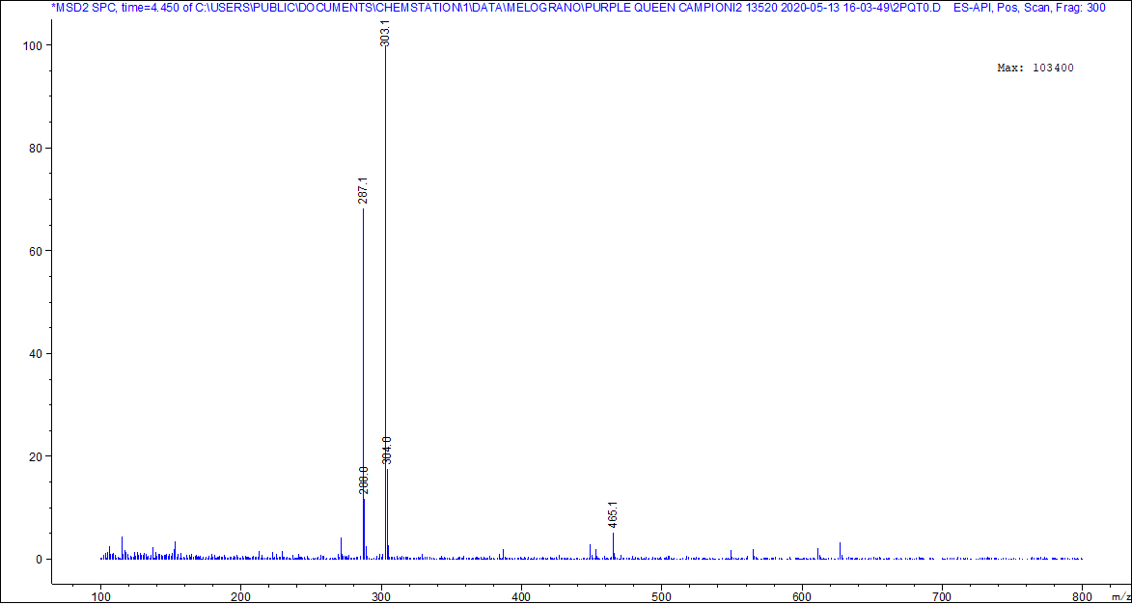

b)

**Figure 3S.** Mass spectra of cyanidin-3,5-diglucoside using fragmentor at 200 V (a) and 300 V(b); the ions are in agreement with Table 2S.

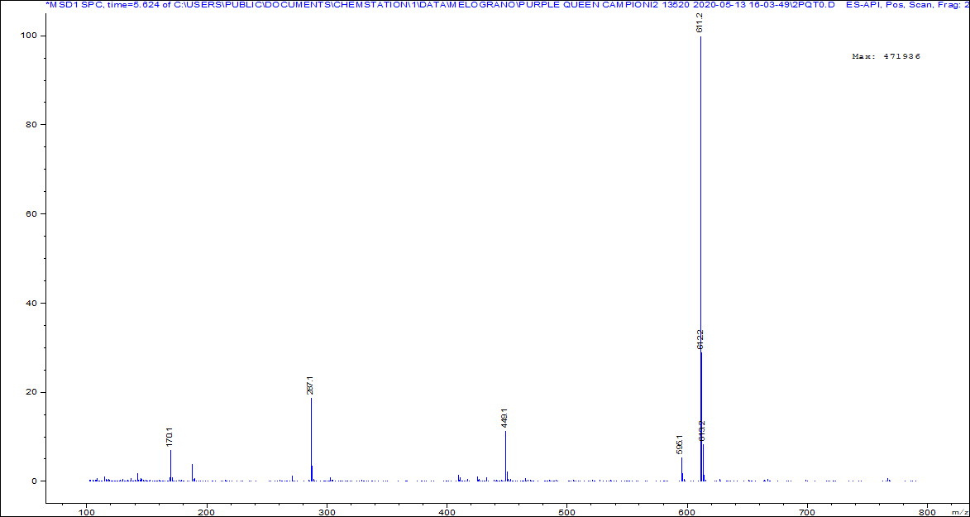

a)

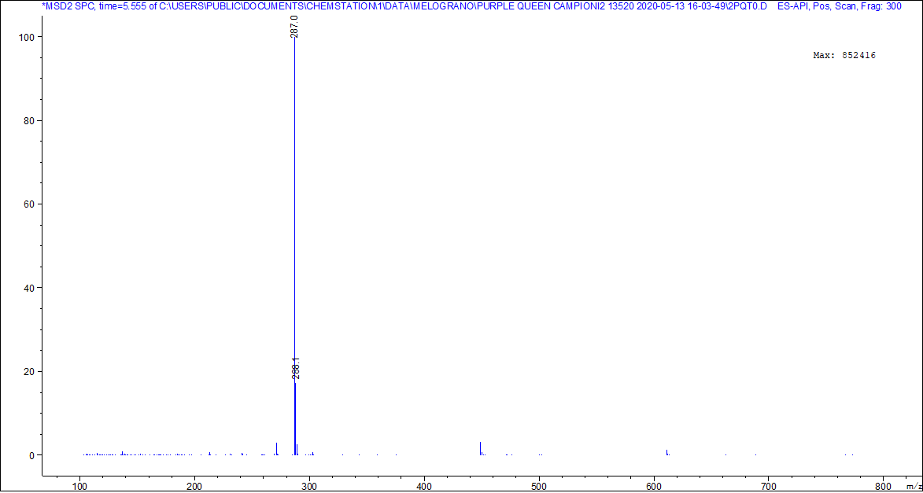

b)

**Figure 4S.** Mass spectra of pelargonidin-3,5-diglucoside co-eluted with delphinidin-3-glucoside using fragmentor at 200 V (a) and 300 V(b); the ions are in agreement with Table 2S.



a)

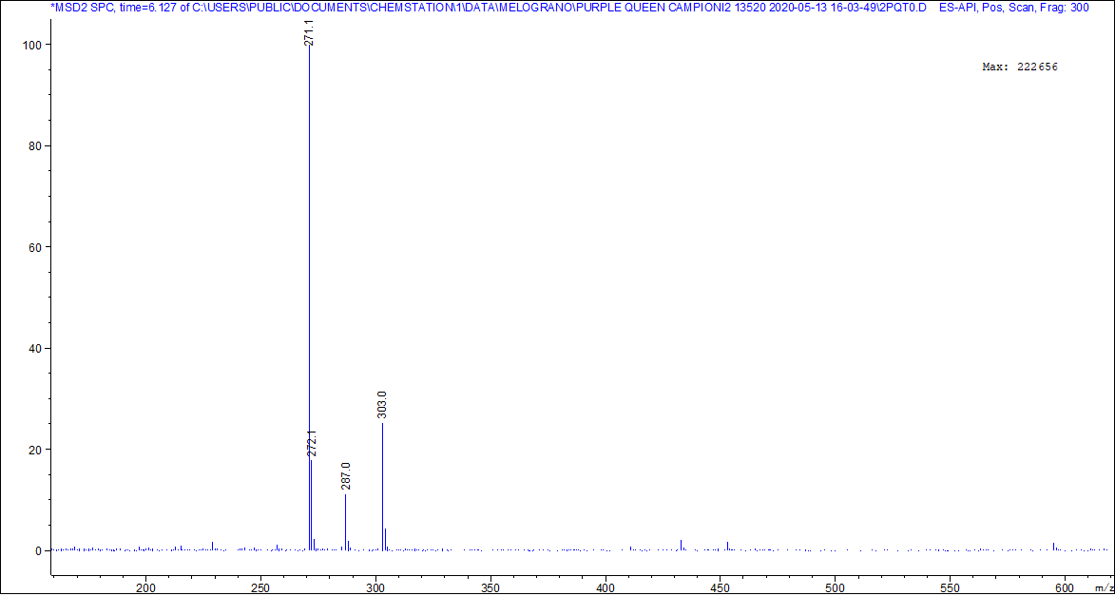

b)

**Figure 5S.** Mass spectra of cyanidin-3-glucoside using fragmentor at 200 V (a) and 300 V(b); the ions are in agreement with Table 2S.

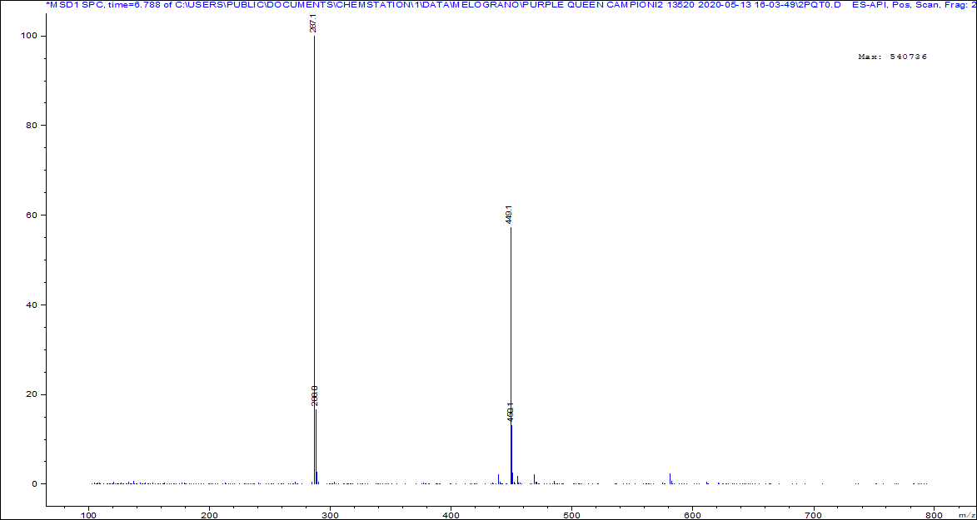

a)



b)

**Figure 6S.** Mass spectra of pelargonidin-3-glucoside (with some co-eluted compounds) using fragmentor at at 200 V (a) and 300 V(b); the ions are in agreement with Table 2S.

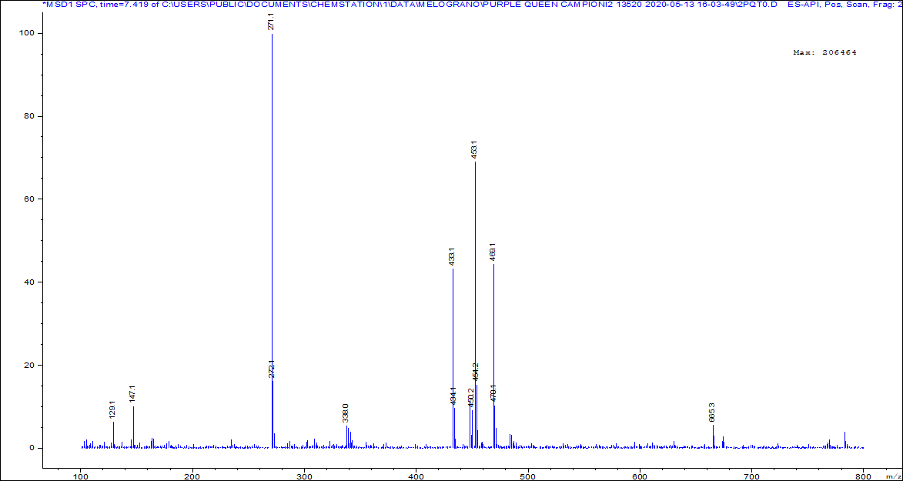

a)



b)

**Figure 7S.** Mass spectrum of galloyl-hexoside (with co-eluted compounds) with fragmentor at 70; the ions are in agreement with Table 2S.

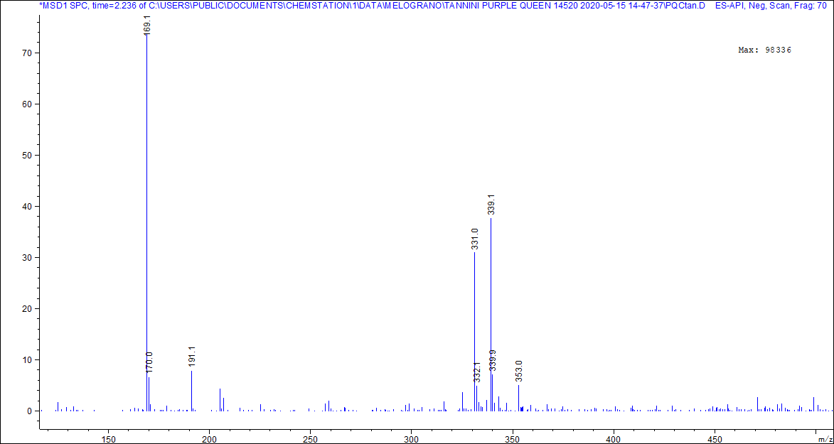

**Figure 8S.** Mass spectrum of α punicalagin and β punicalagin at 70 V; the ions are in agreement with Table 2S.

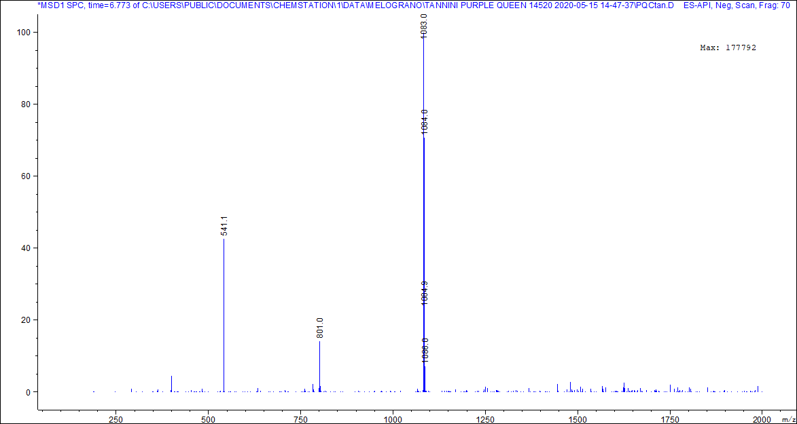

**Figure 9S.** Mass spectrum of ellagic acid pentoside at 70 V; the ions are in agreement with Table 2S.

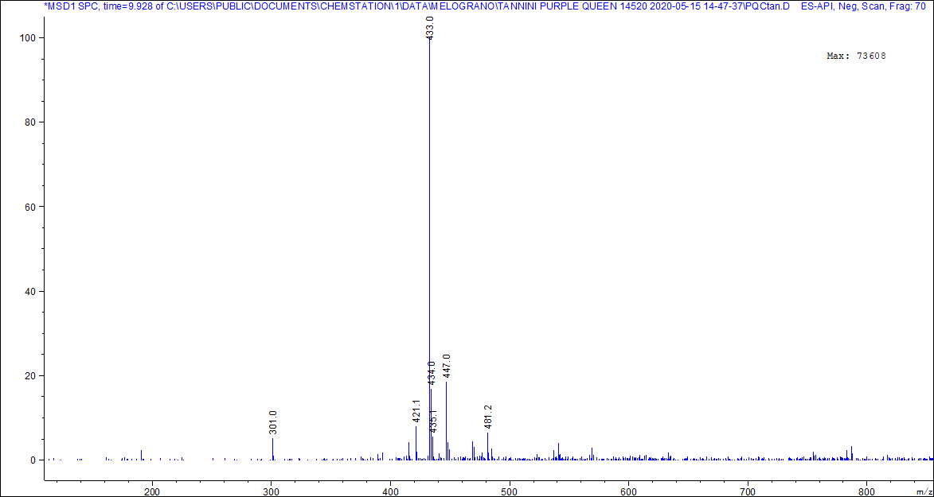

**Figure 10S.** Mass spectrum of ellagic acid at 70 V; the ions are in agreement with Table 2S.

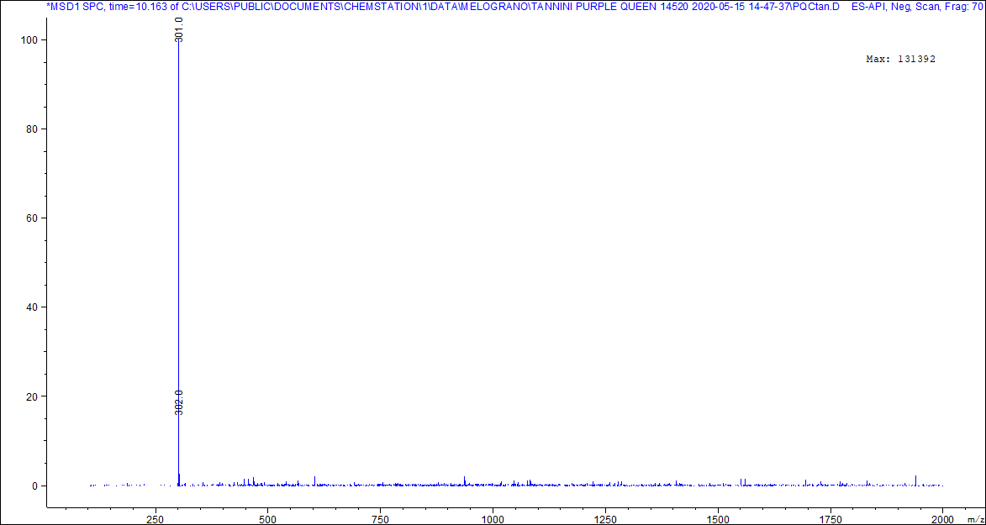

**Table 1S.** Weight of the different tissuesof fruits from Purple Queen® grown on different substrates. Values are the mean (n=10) and standard deviation (in brackets).

|  |  |  |  |  |
| --- | --- | --- | --- | --- |
| Samples | Year | Fruit total weight (g) | Aril total  weight (g) | Peel total weight (g) |
| PQ-0 | 2017 | 303 (37) | 139 (46) | 164 (23) |
| 2018 | 294 (27) | 125 (43) | 168 (17) |
| PQ-50 | 2017 | 250 (29) | 109 (43) | 142 (24) |
| 2018 | 265 (35) | 112 (42) | 152 (19) |
| PQ-100 | 2017 | 207 (31) | 87 (42) | 121 (23) |
| 2018 | 217 (25) | 88 (41) | 129 (16) |
| PQ-C | 2018 | 303 (39) | 133 (44) | 170 (27) |

**Table 2S.** Main identified compounds in Purple Queen samples juices and decoction.

|  |  |  |  |  |
| --- | --- | --- | --- | --- |
| Analytes | RT | [M-H]-  m/z | Fragments  m/z | Identified compounds |
| 2 | 2.2 | 331 | 169 | galloyl-hexoside |
| 3 | 3.9 | 1083 | 541 | α-punicalagin |
| 4 | 5.9 | 1083 | 541 | β-punicalagin |
| 7 | 9.9 | 433 | 301 | ellagic acid pentoside |
| 8 | 10.4 | 301 | - | ellagic acid |
| Anthocyanins | RT | [M]+  m/z | Fragments  m/z | Identified compounds |
| A1 | 6.1 | 627 | 465; 303 | delphinidin-3,5- diglucoside |
| A2 | 6.8 | 611 | 449; 287 | cyanidin-3,5-diglucoside |
| A3 | 7.5 | 595 | 433; 271 | pelargonidin-3,5- diglucoside |
| A4 | 7.6 | 465 | 303 | delphinidin-3-glucoside |
| A5 | 8.1 | 449 | 287 | cyanidin-3-glucoside |
| A6 | 8.8 | 433 | 271 | pelargonidin-3- glucoside |

**\*** The detection of each compounds was performed by MS analyses and a comparison with reference standards