SUPPLEMENTARY MATERIALS

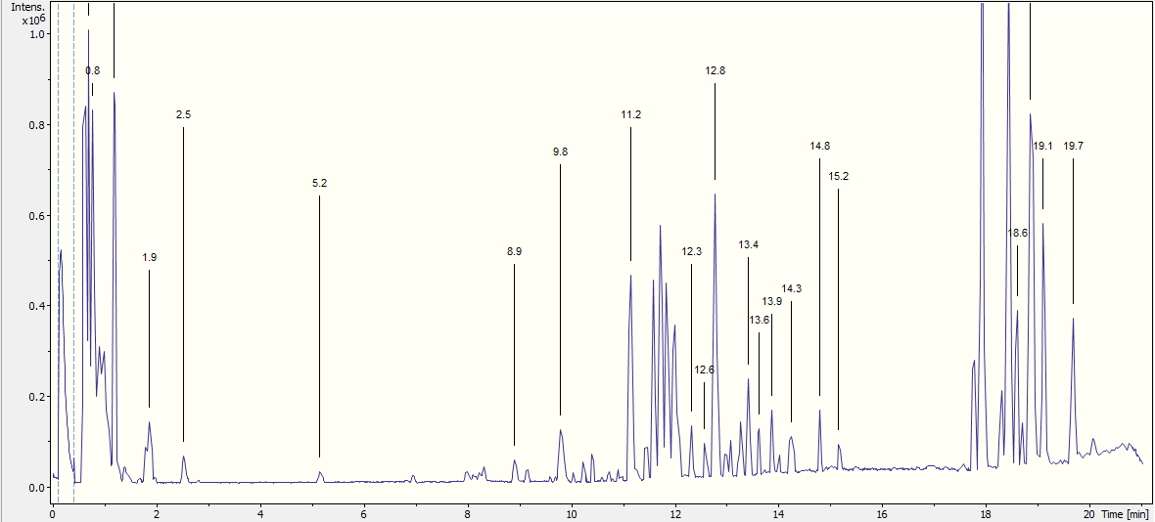
Fig. S1. Chromatogram of V. corymbosum extract obtained by ethanol maceration of fresh leaves (L1A).
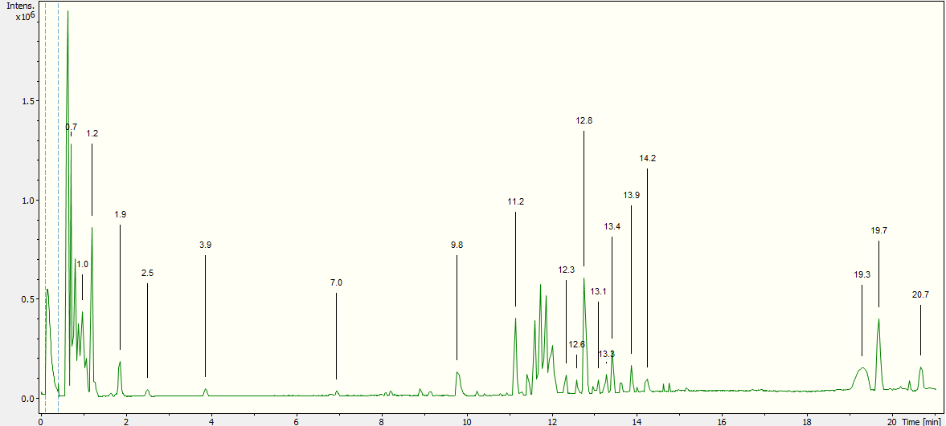
Fig. S2. Chromatogram of V. corymbosum extract obtained by decoction of fresh leaves (L1C).

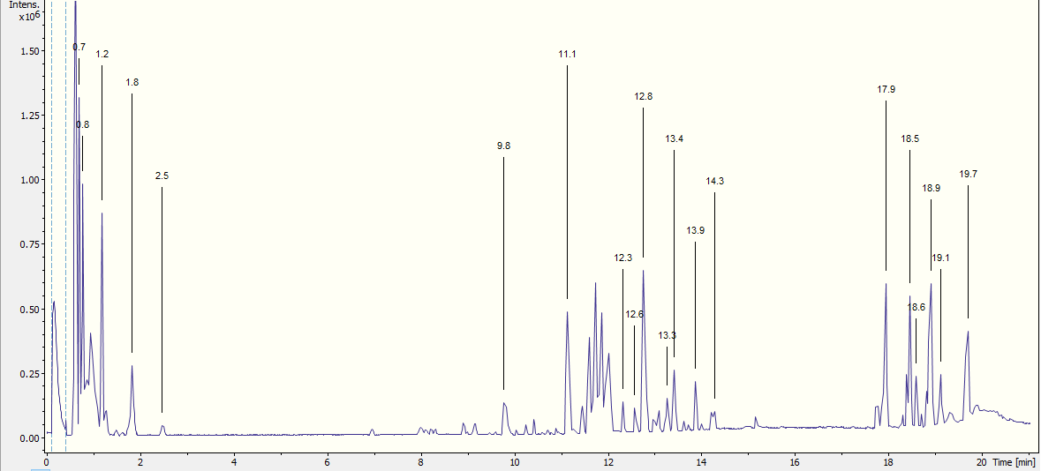
Fig. S3. Chromatogram of V. corymbosum extract obtained by ethanol Soxhlet apparatus extraction of fresh leaves (L1D).
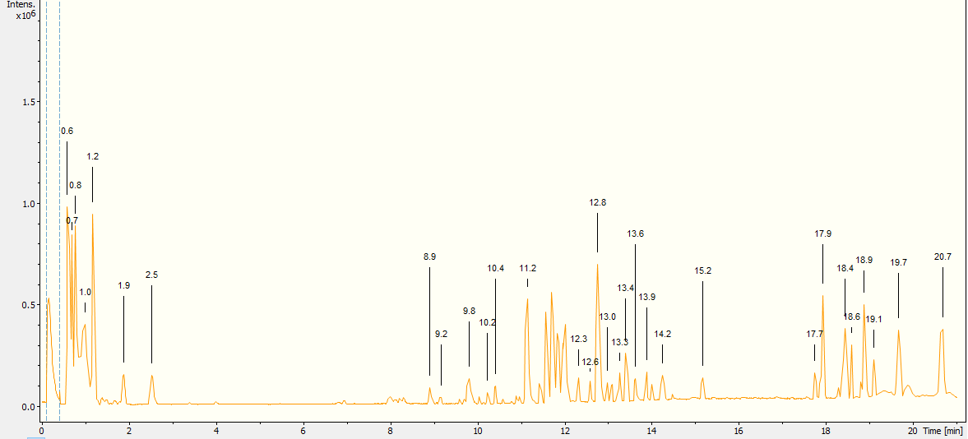
Fig. S4. Chromatogram of V. corymbosum extract obtained by ethanol ultrasound assisted-maceration of fresh leaves (L1E).

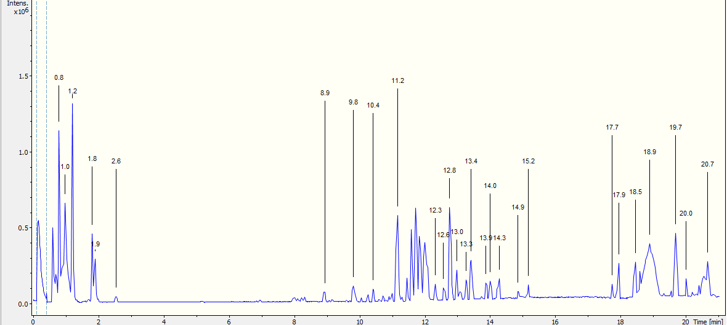
Fig. S5. Chromatogram of V. corymbosum extract obtained by ethanol maceration of dried leaves (L2A).
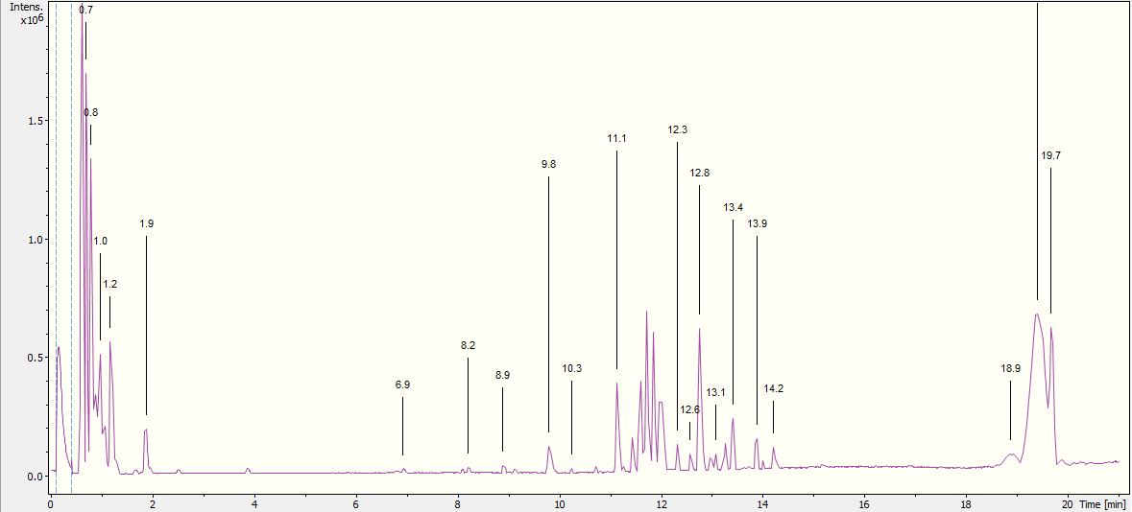
Fig. S6. Chromatogram of V. corymbosum extract obtained by decoction of dried leaves (L2C).

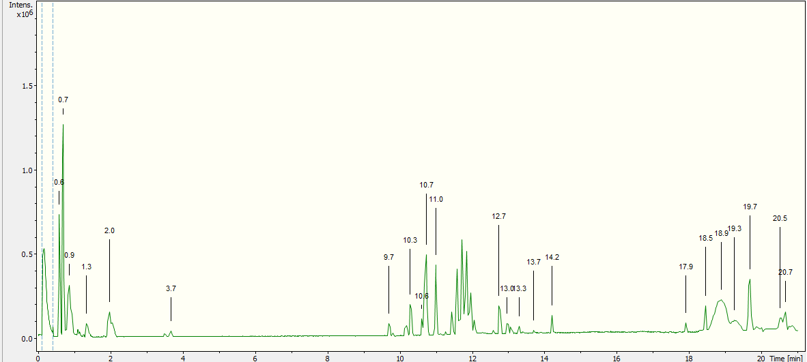
Fig. S7. Chromatogram of V. corymbosum extract obtained by ethanol maceration of fresh fruits (F1A).
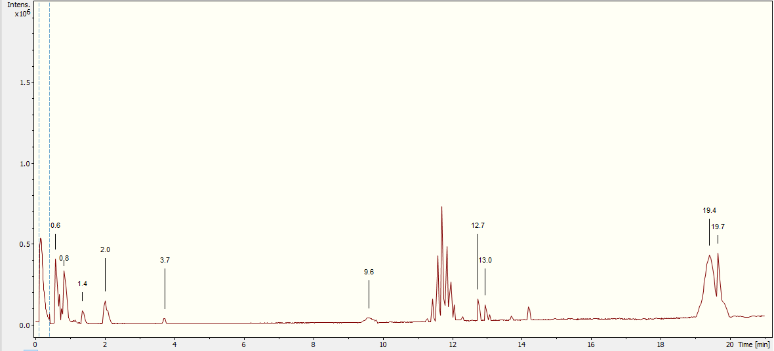
Fig. S8. Chromatogram of V. corymbosum extract obtained by decoction of fresh fruits (F1C).

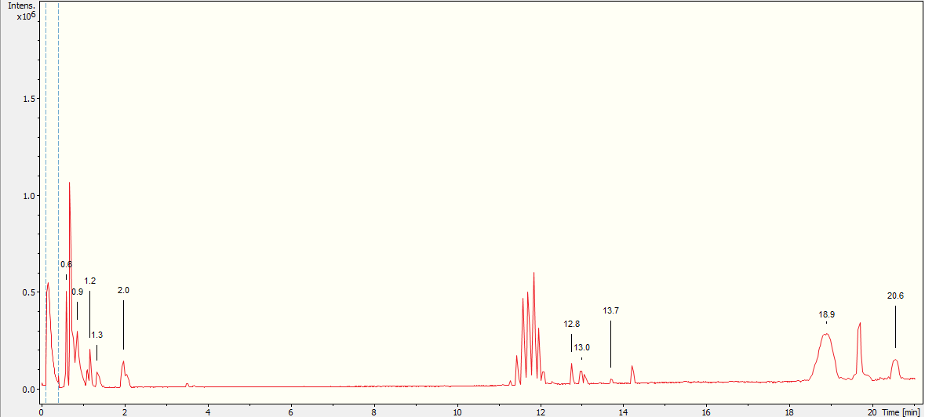
Fig. S9. Chromatogram of V. corymbosum extract obtained by hydroalcoholic maceration of dried fruits (F2B).

