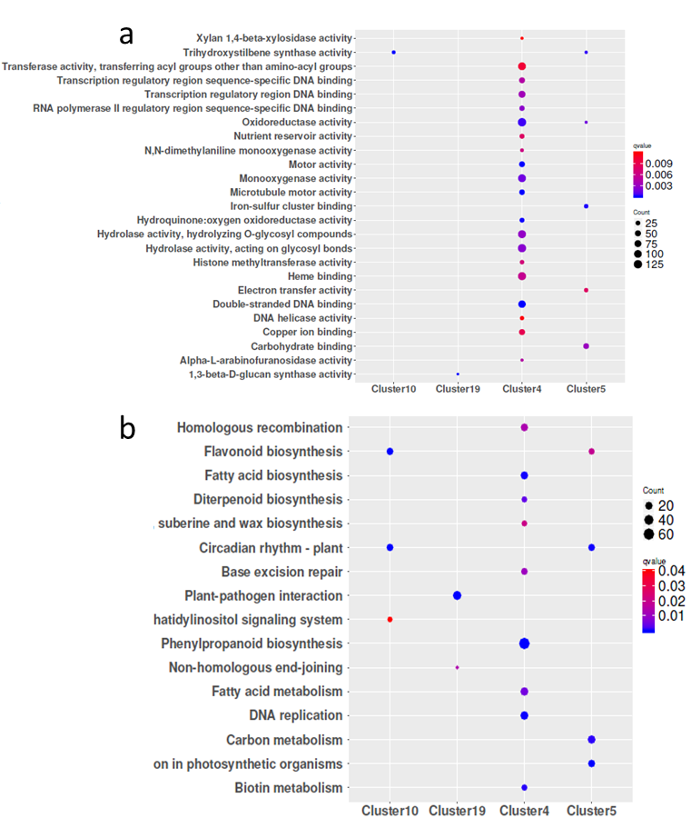
Fig. S1 GO and KEGG enrichment analysis of mRNA in important clusters. Enrichment term is represented by colored dots (blue indicates high enrichment and red indicates low enrichment). a, GO terms in molecular categories from GO enrichment analysis; b, KEGG terms.

