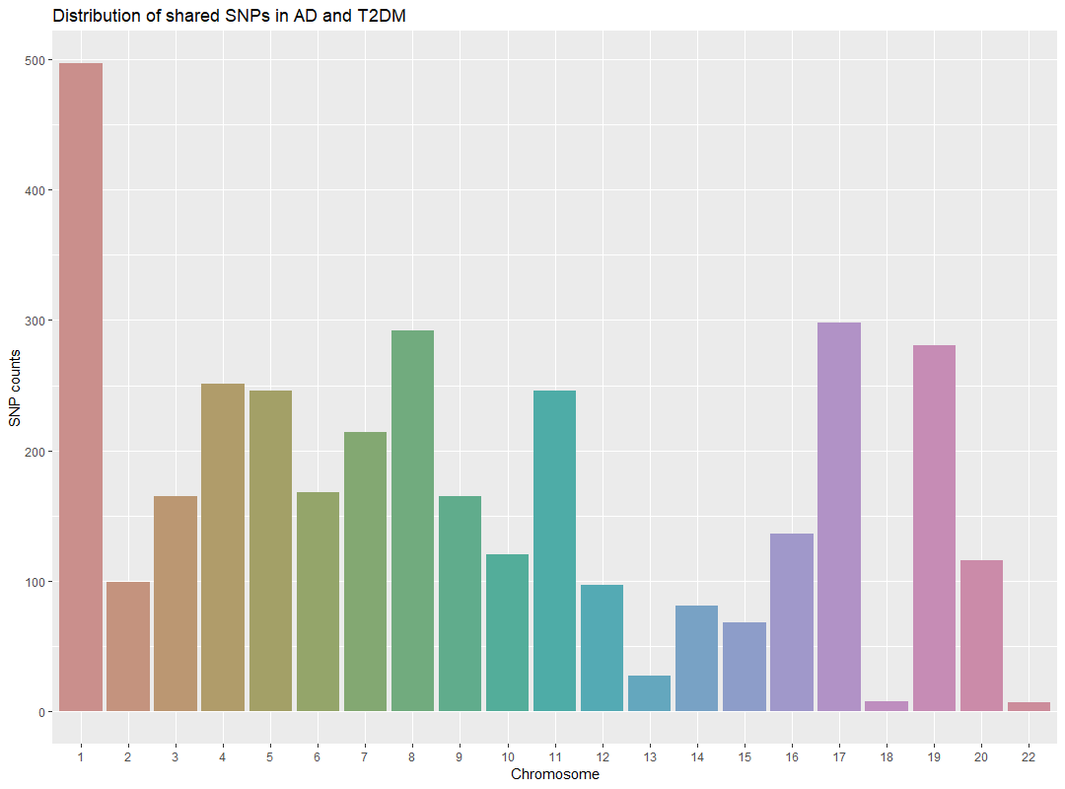
Supplementary File 2. SNPs count per chromosome: The bar plot illustrates the distribution of 3572 shared SNPs between T2DM and AD across each chromosome resulting from the linkage disequilibrium analysis.

