Supplementary Material

PRKAG2 Gene Expression Is Elevated and its Protein Levels Are Associated with Increased Amyloid-β Accumulation in the Alzheimer’s Disease Brain
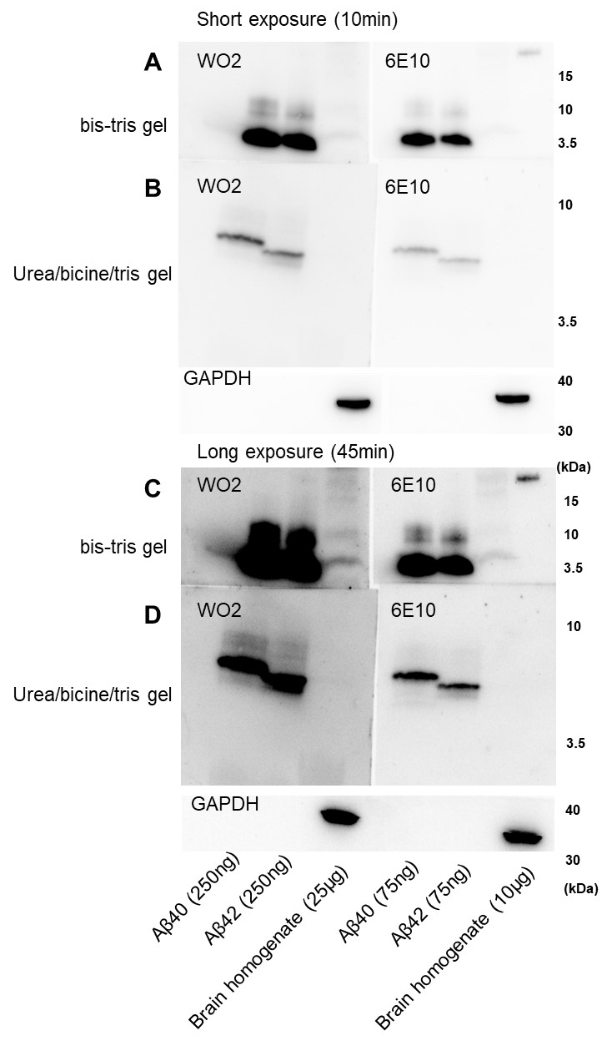

Supplementary Figure 1. Detection of Aβ₄₀ and Aβ₄₂ species in brain homogenates using urea/bicine/tris gel electrophoresis and western blotting. Brain homogenates were analyzed alongside purified Aβ₄₀ and Aβ₄₂ peptides using the 12% bis-tris gels (A, C) and 16% urea/bicine/Tris gels (B, D). Aβ was detected with 6E10 and WO2 antibodies using enhanced chemiluminescence reagent (ECL, Amersham). Short (10 min, A, B) and long exposures (45 min, C, D) after ECL treatment is shown here. Aβ₄₂ peptide migrated faster compared to Aβ₄₀ on the urea/bicine/Tris gels, whereas the 12% bis-tris gels did not clarify Aβ₄₀ and Aβ₄₂ species. Aβ in the brain homogenates was detectable using the 12% bis-tris gels using both 6E10 and WO2 antibodies, but was undetectable in the 16% urea/bicine/Tris gels. It was notable that the Aβ bands detected by the 16% urea/bicine/Tris gels was weaker compared to the 12% bis-tris gels, suggesting that Aβ immunoblotting detection sensitivity was lower in the 16% urea/bicine/Tris gels.

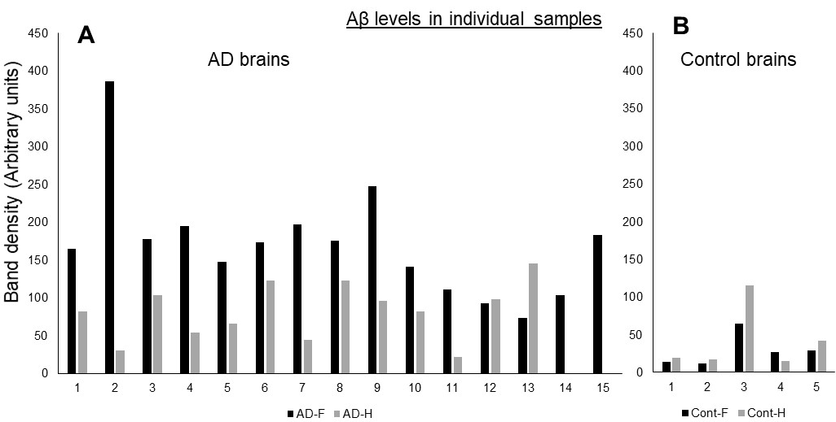
Supplementary Figure 2. Aβ quantification in individual postmortem samples of frontal cortex and hippocampal samples of AD and control brains using western blotting analysis
Aβ protein levels was quantified by western immunoblotting (6E10 antibody) in the levels detected in individual samples of frontal cortex and hippocampal samples of AD (A) and control (B), as shown in Figure 2. No hippocampus tissue samples were available for analysis for 14 and 15. Low Aβ levels (as compared to Fig. 2) were observed in AD frontal cortex samples 13 and AD hippocampus samples 2, 7, and 11. High Aβ levels (as compared to Fig. 2) was observed in Control hippocampus sample 3. This data indicates the variability in the levels of Aβ was observed in regions of frontal cortex and hippocampus in AD and control brains.

