Supplementary Material

Spatially Distributed Amyloid-β Reduces Glucose Metabolism in Mild Cognitive Impairment

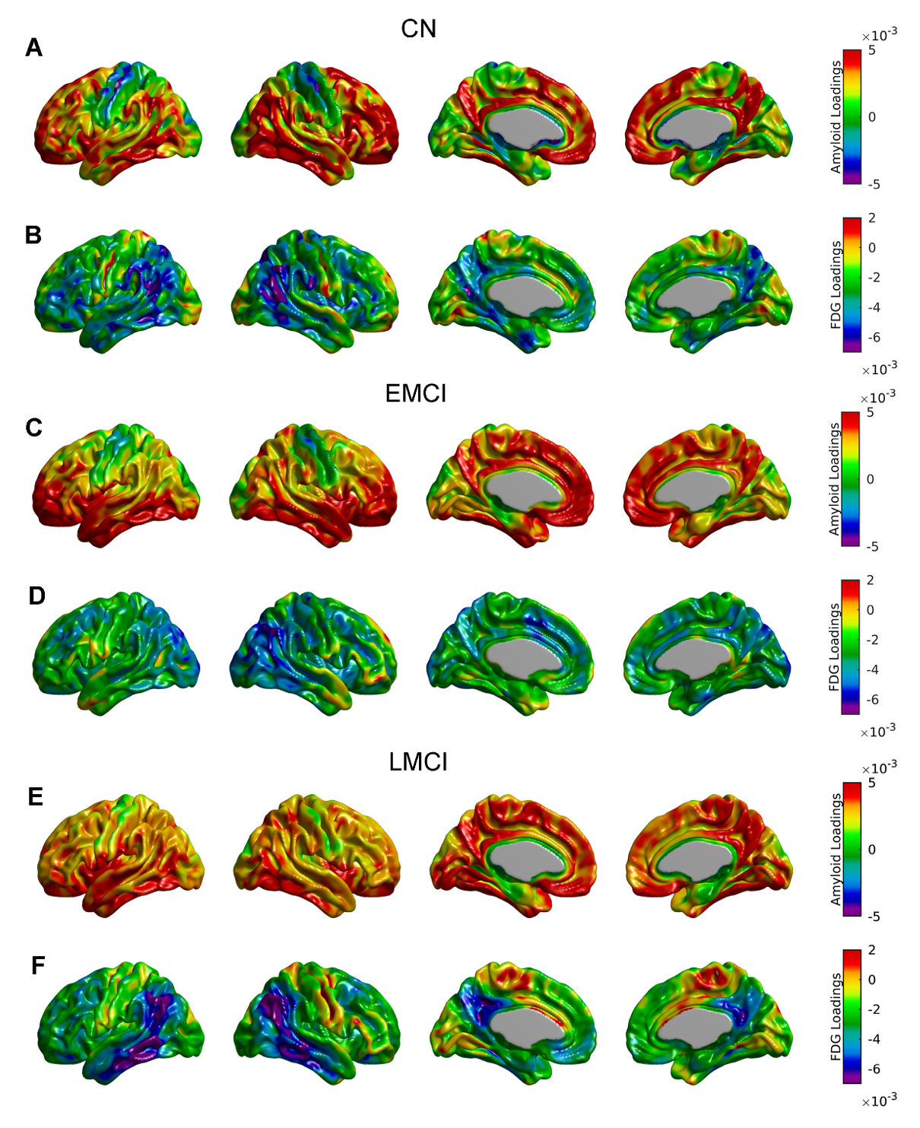
Supplementary Figure 1. Surface projections for Aβ (A, C, and E) and glucose metabolism (B, D, and F) spatial loadings corresponding to first component of the SVD analysis in the CN, EMCI, and LMCI cohorts. This first component accounted for 15.21%, 25.17%, and 28.55% of the total co-variability, respectively. Strongest contributions to the three FDG eigenimages are located in the inferior parieto-temporal areas. Medial prefrontal cortex is a common region of high contribution to the three amyloid eigenimages, while other strong contributing regions go from inferior parietal regions in CN to inferior temporal in LMCI subjects.
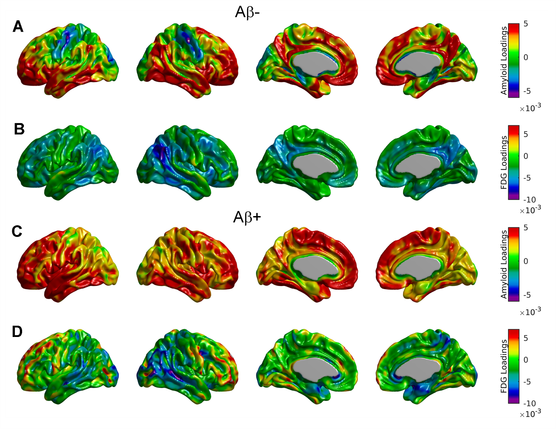
Supplementary Figure 2. Surface projections for Aβ (A, C) and glucose metabolism (B, D) spatial loadings corresponding to first component of the SVD analysis in the Aβ- and Aβ+ cohorts. This first component accounted for 8.42% and 8.26% of the total co-variability, respectively. Strongest contributions to the FDG eigenimage for the Aβ- cohort are located in the in the right angular gyrus, posterior cingulate, and precuneus areas, while there is no clear indication of focal relationship with distributed Aβ in the Aβ+ cohort. Posterior cingulate cortex, precuneus, lateral inferior temporal gyrus, insula, and medial prefrontal cortex are regions of high contribution to the Aβ eigenimage for the Aβ- cohort.

