Supplementary Material

TSPO Ligands Boost Mitochondrial Function and Pregnenolone Synthesis

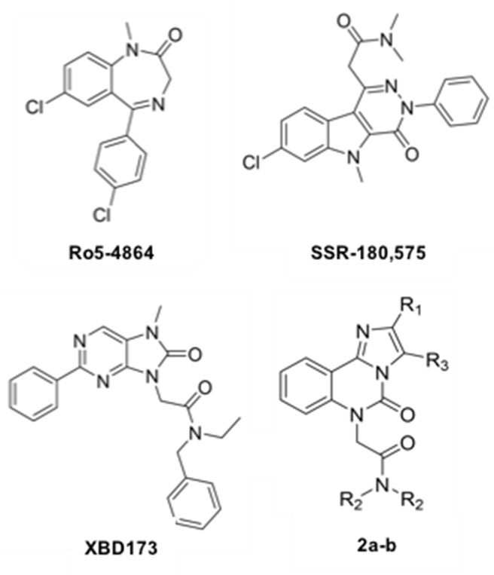

Supplementary Figure 1. TSPO ligands of references and the design of the imidazo[1,2-c]quinazolin-5-ones as new TSPO ligands. 2a is an 3-deaza analog derived from the CBR ligand CGS-13767. The insertion of an acetamide moiety as well as the transformation of the triazoloquinazoline scaffold into imidazoquinazoline led to compound 2a which showed no affinity for CBR up to 10 mM, but a promising affinity for TSPO with both [3H]-PK11195 and [3H]-Ro5-4864 (400 nM and 80 nM, respectively). 2a is a derivate of 2b and is structurally very close of it but with a drop of affinity (IC50 = 400 nM and 80 nM using [3H]-PK11195 and [3H]-Ro5-4864, respectively).

Supplementary Figure 2. ªBinding assay performed on rat heart microsomes; ^{b}Binding assay performed on rat brain microsomes; ^{c}Binding assay performed on rat kidney mitochondrial fragments [1]; ^{d}Binding assay performed on rat brain with [³H]flunitrazepam [1]; ^{e}nd, not determined; ^{f}Binding assay performed on rat kidney membranes [2]; ^{g}Binding assay performed on rat cerebellum membranes [2];^{h}Binding assay performed on rat whole brain mitochondrial fractions [3]; ^{i}Binding assay performed on rat cerebellum membranes [3].

REFERENCES
[1] Hirsch JD, Beyer CF, Malkowitz L, Loullis CC, Blume AJ (1989) Characterization of ligand binding to mitochondrial benzodiazepine receptors. Mol Pharmacol 35, 164-172.
[2] Ferzaz B, Brault E, Bourliaud G, Robert JP, Poughon G, Claustre Y, Marguet F, Liere P, Schumacher M, Nowicki JP, Fournier J, Marabout B, Sevrin M, George P, Soubrie P, Benavides J, Scatton B (2002) SSR180575 (7-chloro-N,N,5-trimethyl-4-oxo-3-phenyl-3,5-dihydro-4H-pyridazino[4,5-b]indole-1-acetamide), a peripheral benzodiazepine receptor ligand, promotes neuronal survival and repair. J Pharmacol Exp Ther 301, 1067-1078.
[3] Kita A, Kohayakawa H, Kinoshita T, Ochi Y, Nakamichi K, Kurumiya S, Furukawa K, Oka M (2004) Antianxiety and antidepressant-like effects of AC-5216, a novel mitochondrial benzodiazepine receptor ligand. Br J Pharmacol 142, 1059-1072.

