Supplementary Material

Diagnostic Work-Up Is More Complete in Rural than in Urban Areas for Patients with Dementia: Results of a Swedish Dementia Registry Study

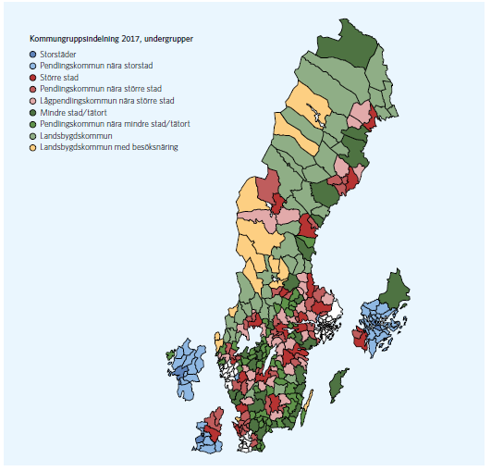
Supplementary Figure 1. Classifications of Swedish municipalities 2017 produces by the Swedish Association of Local Authorities and Regions (Kommunsgruppsindelning, 2017). Blue colors refer to urban areas, red colors refer to intermediate areas, green and yellow colors refer to rural areas. Legend translation by Kommungruppsindelning (2017) in order of appearance in Figure 1. A) Large cities and municipalities near large cities. 1) Large cities - municipalities with a population of at least 200 000 inhabitants with at least 200 000 inhabitants in the largest urban area. 2) Commuting municipalities near large cities – municipalities where more than 40 % of the working population commute to work in a large city or municipality near a large city. B) Medium-sized towns and municipalities near medium-sized towns. 3) Medium-sized towns – municipalities with a population of at least 50 000 inhabitants with at least 40 000 inhabitants in the largest urban area. 4) Commuting municipalities near medium-sized towns - municipalities where more than 40 % of the working population commute to work in a medium-sized town. 5) Commuting municipalities with a low commuting rate near medium-sized towns - municipalities where less than 40 % of the working population commute to work in a medium-sized town. C) Smaller towns/urban areas and rural municipalities. 6) Small towns - municipalities with a population of at least 15 000 inhabitants in the largest urban area. 7) Commuting municipalities near small towns - municipalities where more than 30% of the working population commute to work in a small town/ urban area or more than 30% of the employed day population lives in another municipality. 8) Rural municipalities - municipalities with a population of less than 15 000 inhabitants in the largest urban area, very low commuting rate (less than 30%). 9) Rural municipalities with a visitor industry – municipalities in rural area that fulfil at least two criteria for visitor industry, i.e. number of overnight stays, retail-, restaurant- or hotel turnover per head of population.

Source: Kommungruppsindelning (2017) Omarbetning av Sveriges Kommuner och Landstings kommungruppsindelning, http://webbutik.skl.se/sv/artiklar/kommungruppsindelning-2017.html#sthash.37iAvhQF.dpuf (last accessed: 10 June 2018) reproduced with permission.

