Supplementary Material

Amyloidogenic Nanoplaques in Blood Serum of Patients with Alzheimer’s Disease Revealed by Time-Resolved Thioflavin T Fluorescence Intensity Fluctuation Analysis

Supplementary Material 1
Materials
Patient cohort and ethics
Blood samples were obtained upon informed consent from apparently healthy blood donors (control group) and from individuals who were, after examination in primary care settings, referred to the Memory Clinic, Karolinska University Hospital, Huddinge (patient cohort). Collection and handling of blood samples was approved by a regional ethics committee in Stockholm, permit nr. 2012/1019-31/1.
At the moment of admission AD diagnosis was not yet established and the patients did not take any pharmacological substances, such as cholinesterase inhibitors or N-methyl-D-aspartate (NMDA) receptor antagonists, typically used for the treatment of AD symptoms. However, due to their advanced age, many individuals in the patient cohort had age-related health problems and were on some prescribed medications. Detailed demographics and other relevant patient information are given in Supplementary Table 1.

Blood collection and sample preparation
Blood from superficial veins of the upper limbs is collected using the evacuated tube system for venepuncture (BD Vacutainer® tubes, Becton, Dickinson and Company) and treated as described below to yield blood serum. ThT was added to the sample before submission to time resolved fluorescence intensity fluctuation analysis (FIFA).

Blood serum
To obtain blood serum, 5 ml of blood is collected in a BD Vacutainer® Plastic Serum tube with Red BD HemogardTM Closure, which contains micronized silica particles with SiO₂ as the main clot activator component sprayed on the inner walls of the tube to accelerate the clotting process and does not contain thrombin. To activate blood clotting, the tube is gently inverted 180º and back 5-6 times and the blood is allowed to clot for 60 min. Thereafter, the tube is centrifuged for 10 min at 2500×g and the supernatant above the clot, i.e., the blood serum is visually inspected for turbidity and for evidence of hemolysis. Turbid blood serum samples and samples with grossly visible pink discoloration were not subjected to further analysis even though we have established in separate control experiments that moderate turbidity and hemolysis do not affect the outcome of the results (data not shown). In hemolyzed blood serum, passing of large cellular fragments through the OVE could be occasionally observed. Such traces are readily identifiable, as they give rise to an unstable base line, and excluded from further analysis. In our study, less than 0.1 % of time series were excluded due to unstable base line.
For immediate use, 200 µl of the blood serum is aliquoted into a well of an 8-well chambered coverglass (Lab-Tek Chambered Coverglass, Thermo Scientific, USA), mixed with 1.6 µl of 2.5 mM ThT to a final concentration of 20 µM ThT and subjected to FIFA as described below. All experiments are run in duplicates.

Chemicals
All chemicals were used without further purification and purchased from commercial sources as follows: Rhodamine 6G (Sigma-Aldrich); Thioflavin T (Sigma-Aldrich); Carboxylate functionalized quantum dot nanocrystals, d = 20 nm, emission maxima at 525 nm (Qdot® 525 ITK™ Carboxyl Quantum Dots) and yellow-green fluorescent (Ex/Em: 505/515) carboxylate-modified polystyrene nano/microspheres of diameter d = 100 nm (FluoSpheres® Size Kit #2) from Molecular Probes. Fluosphere suspension was sonicated 30-60 min before use.

Supplementary Table 1. Demographics, pharmacotherapy, and diagnosis of patients and control subjects.

No | Gender | Age | Count rate  (kHz) | f_{SEO}  (10⁻³ s⁻¹) | MMS | CSF  Aβ₄₂  (ng/l) | CSF  _{total}Tau  (ng/l) | CSF  _{phospo}Tau  (ng/l) | Diagnosis | Pharmacotherapy | Comorbidity
1* | F | 58 | 92 | 8.0 | 26 | 766 | 140 | 24 | MCI | Antidepressants, Sifrol, Paracetamol | Gastric bypass, Depression
2 | M | 61 | 269 | 1.0 | 21 | 281 | 617 | 83 | AD | ASA, Statins | Transient Ischemic Attack (2002)
3 | F | 61 | 255 | 5.4 | 24 | 338 | 234 | 33 | AD | Levaxin, Symbicort | Hypothyroidism
4 | M | 84 | 324 | 3.1 | 27 | 315 | 574 | 64 | AD | Trombyl, Amlodipin, Losarstad | Renal insufficiency, Hypertension,  Prostate cancer
5 | F | 65 | 232 | 2.3 | 25 | 684 | 610 | 83 | AD | Losartan | Hypertension
6 | F | 62 | 299 | 2.7 | 25 | 756 | 251 | 35 | MCI | Haldol, Venlafaxin, Propavan, Imovane | Depression, Generalized anxiety disorder, Smoker
7 | M | 64 | 465 | 3.0 | 29 | 1020 | 466 | 60 | MCI | Vesicare, Pulmicort, Aerius | Asthma
8 | F | 64 | 334 | 1.3 | 24 | 457 | 356 | 46 | early AD | Levaxin, Adalat, Alenat | Lung cancer (2000), Primary Biliary Cirrhosis, Hypothyroidism, Raynaud syndrome
9 | M | 58 | 109 | 1.7 | 30 | 822 | 188 | 31 | SCI | Tostrex, Cabergoline | Pituitary adenomas, Hyperprolactinemia
10 | M | 77 | 175 | 0.9 | 24 | 441 | 367 | 47 | AD | Not on any medication | Lupus Erythematosus (2014), Psoriasis
11 | M | 81 | 242 | 3.7 | 19 | 466 | 523 | 62 | AD and  Vascular Dementia | Oral Antihyperglycemic Agents, Antihypertensives | Hypertension, Renal insufficiency, Obstructive Sleep Apnea, Diabetes Mellitus Type 2, Gout
12 | M | 82 | 103 | 1.7 | 23 | 679 | 524 | 59 | AD and  Vascular Dementia | Insulin, Statins | DM type 2
13 | F | 58 | 253 | 2.2 | 30 | 485 | 477 | 57 | AD | Not on any medication | Burnout
14 | F | 66 | 196 | 1.6 | 30 | 328 | 326 | 37 | early AD | Citalopram, Naproxen, Statins, Antihypertensives | Hypertension, Transient Ischemic Attack, Depression
15 | F | 77 | 169 | 1.4 | 24 | 543 | 450 | 60 | AD and  Vascular Dementia | Pantoloc, Calcichew, Salures, Acetylcystein, Betmiga | Hypertension
16 | F | 58 | 211 | 0.3 | 26 | 1100 | 235 | 60 | SCI | Omeprazol, Levaxin, ASA, Metformin, Omeprazxol, Cymbalta | Diabetes Mellitus Type 2, Depression, Obesity, Hypothyroidism
17 | F | 60 | 182 | 1.2 | 25 | 800 | 276 | 35 | MCI | Omeprazol, Laktuloz | Depression, Epilepsy
18 | M | 77 | 171 | 1.0 | 25 | 423 | 924 | 96 | AD | ASA, Seloken, Amlodipin, Lipitor | Hypertension, Angina Pectoris
19 | F | 48 | 160.5 | 4.0 | 17 | 294 | 554 | 49 | AD | Not established | Not established
20 | M | 75 | 135.5 | 2.3 | 30 | 474 | 491 | 61 | # | Omeprazol, ASA, Behepan | Transient Ischemic Attack
21 | F | 61 | 119 | 1.7 | 28 | 332 | 545 | 53 | # | Lopid | Hypercholesterolemia
22 | F | 56 | 111 | 2.8 | 23 | 428 | 1050 | 98 | AD | Not established | Not established
23 | F | 68 | 109 | 1.5 | 30 | 450 | 541 | 58 | # | Omeprazol, Oral Antihyperglycemic Agents, Statins | Diabetes Mellitus Type 2, Hyperlipidemia
24 | F | 78 | 135.5 | 0.2 | 22 | 252 | 373 | 44 | # | Calcichew, Alenat | Monoclonal Gammopathy of Undetermined Significance, Osteoporosis
 | Patients  n_{p} = 24  15F:9M | 66 ± 10 | 202 ± 92 | 2.3 ± 1.7 | 25 ± 4 | 539 ± 236 | 462 ± 214 | 56 ± 20
 | Controls  n_{c} = 33  17F:16M | 39 ± 15 | 155 ± 43 | 1.5 ± 1.2
*This patient, who has undergone a gastric bypass operation, presents a very high f_{SEO} value that is far away from other observations. This value was excluded from the analysis of MCI shown in Fig. 4B.
#Diagnosis not established at the time of data analysis. The primary data were included in the overall analysis of patients versus control (Fig. 4A).
MCI, mild cognitive impairment; SCI, subjective cognitive impairment

Supplementary Material 2
Time-Resolved ThT Fluorescence Intensity Fluctuation Measurement
Instrument
Time-resolved fluorescence intensity fluctuation measurements are performed using a ConfoCor 2 system (Carl Zeiss, Jena, Germany), consisting of an inverted microscope equipped with a C-Apochromat 40 ×, NA = 1.2, water immersion UV-VIS-IR objective. ThT fluorescence is excited using the 458 nm line of the Argon laser. The incident laser light is tightly focused into the sample by passing through the objective lens; laser intensity measured at the objective is 6 µW. The elastically scattered light and the spectrally distinct fluorescence light are collected backwards through the same objective lens and separated using the HFT 458 main dichroic beam splitter. The emitted light is spatially filtered by passing through a pinhole to the silicon avalanche photodiode detector (SPCM-AQR-1X; PerkinElmer, USA). The pinhole size in front of the detector was set to 70 µm (1 Airy).

Instrument calibration
Standard aqueous solutions of Rhodamine 6G (Rh6G), 10-25 nM, are used for instrument calibration. For this purpose, temporal autocorrelation analysis was applied (as described in Supplementary Material 1). The same optical setting that is used for ThT, as described above, is used for Rh6G and the signal was recorded in a series of 10 consecutive measurements, each measurement lasting 10 s. Under these settings, the translation diffusion time of Rh6G was determined to be τ_{D,Rh6G} = (24 ± 2) μs (n = 460); the counts per molecule and second (CPMS) was CPMS = (5.1 ± 0.6) kHz, and the structural parameter was S_{p} = 5 (Supplementary Figure 1). The OVE size was determined to be V ≈ 2.0×10⁻¹⁶ l. FCS measurements were validated using the individually modified ConforCor3 system that is available in our laboratory [1]. Significant differences between measurements’ outcomes obtained using one or the other system were not observed.

Time-resolved ThT fluorescence intensity fluctuation measurement on blood serum
As described in the main text, ThT fluorescence intensity fluctuations in the blood serum were recorded in a series of 300 measurements, each measurement lasting 10 s, yielding a total run time of 3000 s. All measurements were performed at 20°C in an air-conditioned room.

Supplementary Material 3
Temporal Autocorrelation Analysis of Fluorescence Intensity Fluctuations
In temporal autocorrelation analysis, signal self-similarity analysis is performed to detect non-randomness in data, and to identify an appropriate time series model if the data are not random. As a first step in this process, the so-called normalized intensity autocorrelation function G(τ) is calculated:
, (1)
where ⟨F(t)⟩ is the mean fluorescence intensity over the whole time series; δF(t) = F(t) - ⟨F(t)⟩ is a fluctuation in fluorescence intensity recorded at the time point t; δF(t + τ) = F(t + τ) - ⟨F(t)⟩ is a fluctuation in fluorescence intensity in the same time series recorded at a later time point, t + τ; and τ is the time lag between them.
The normalized autocorrelation function G(t) is then plotted as a function of different time lags τ, to yield an autocorrelation curve tACC. For processes that are random, G(t) ≈ 1 for all lag time values. For processes that are not random, the tACC has a maximal limiting value of G (τ) as τ → 0, which decreases to the value of G(τ) = 1 at long time lags, indicating that the correlation between the initial and the current property value of the fluorescence signal has been lost. For the simplest case of fluorescence intensity fluctuations generated by free three-dimensional (3D) translational diffusion of fluorescent molecules, the tACC has one characteristic decay time, which represents the average time that it takes for a molecule to pass through the OVE, i.e. it is equal to the translational diffusion time (τ_{D}). The limiting value of G(t) at t = 0, is inversely related to the average number of molecules (N) in the OVE and thus is representative of their concentration [2, 3].
In order to extract N and τ_{D} values, the experimentally obtained tACC is fitted using a theoretical autocorrelation function (AF_{t}). For example, if one fluorescent species is present in the sample and transition between the singlet and the triplet state is the only intramolecular process affecting the fluorescence of the observed molecule, the tACC can be described using the following AF_{t}:
$G\left(τ\right)=1+ \frac{1}{N}∙\frac{1}{\left(1+\frac{τ}{τ_{D}}\right)∙\sqrt{1+\frac{1}{S_{p}^{2}}∙\frac{τ}{τ_{D}}}}∙\left[1+\frac{T}{1-T}e^{-\frac{τ}{τ_{T}}}\right]$. (2)
In equation (2) N is the average number of molecules in the OVE; S_{p} is the spatial parameter, also called structural parameter, $S_{p}= \frac{ω_{z}}{ω_{xy}}$, where $ω_{xy}$ and $ω_{z}$ are the 1/e² radial and axial radius, respectively, of the OVE; τ is the time lag; τ_{D} is the translation diffusion time; T is the average equilibrium fraction of molecules in the triplet state and τ_{T} is the triplet correlation time, related to the rate constants for intersystem crossing and the triplet decay.
Spatial properties of the OVE are determined experimentally in instrument calibration measurements. The calibration is performed using a standard solution of a reference fluorescent dye for which the concentration and the translational diffusion coefficient are known. The experimentally derived tACC recorded for the standard solution is fitted by the autocorrelation function (2) allowing all parameters to freely vary and the values for N, τ_{D}, $S_{p}^{2}$, T and τ_{T} are determined by fitting. Using the known value of the translational diffusion coefficient D for the reference dye and the determined values of τ_{D}, the radial radius of the OVE can be determined from:
$τ_{D}= \frac{ω_{xy}^{2}}{4D}$ , (3)
and the axial radius $ω_{z}$ from the structure parameter $S_{p}^{2}$. For all further measurements, the structure parameter value is fixed to the value determined in the calibration measurements.

For our system, standard solutions of Rh6G in water were used for instrument calibration. For this purpose, Rh6G fluorescence was excited using the 458 nm line of the Argon laser (Supplementary Figure 1).

Supplementary Figure 1. Instrument calibration. Temporal autocorrelation curve recorded in a 25 nM water solution of Rh6G (black circles) using the same optical setting as for the ThT-assay. Autocorrelation function for free three-dimensional (3D) diffusion (red), yielded by fitting the average number of molecules in the OVE, N = 2.5; translational diffusion time, τ_{D, Rh6G} = 24 µs; and structural parameter S_{p} = 5. Under these conditions, the average count per second per molecule for Rh6G was CPMS = (5.1 ± 0.6) kHz.

Supplementary Material 4
Time-Resolved ThT Fluorescence Intensity Fluctuation Analysis (FIFA)
The frequency with which the structured amyloidogenic nanoplaques pass through the OVE is determined by performing an automated single event counting analysis to identify rare bursts in ThT fluorescence intensity that reflect the occasional passage of ThT-active structured amyloidogenic nanoplaques through the OVE. For this purpose, a program was written using the Matlab software. A fluorescence peak, i.e., “a single event”, is defined as an increase in fluorescence intensity, ΔF(t), that differs from the mean fluorescence intensity of the whole time series, ⟨F(t)⟩, by a value that is five times larger than the standard deviation (SD) of the whole time series, ΔF(t) = (F(t) – ⟨F(t)⟩) > 5×SD. The number of observed fluorescence peaks is then normalized to the total measurement time (here 3000 s) and the thus obtained frequency of single events occurrence (f_{SEO}) is expressed in s⁻¹ and compared across samples.
The size of the ThT-active structured amyloidogenic oligomeric aggregates is determined in the following way. All recorded time traces were subjected to temporal autocorrelation analysis. Time traces where passage of ThT-active structured amyloidogenic oligomeric aggregates is observed gave rise to a tACCs, whereas time traces that only contained background signal did not build up a noticeable tACC during the 10 s measurement and were excluded from further analysis. All tACCs were then normalized to the same amplitude, G(τ) = 1 at τ = 10 µs, and all tACCs from the patient or the control groups, were separately combined to yield an average tACC for the patient and the control groups, respectively. Difference in the molecular size is then assessed from the difference in characteristic decay times of the tACCs – the longer the characteristic decay time of the tACC, the larger is the nanoplaque.
The above described procedures for determining the f_{SEO} and the size of the ThT-active structured amyloidogenic oligomeric aggregates were validated using dilute aqueous suspension of fluospheres (d = 100 nm) of known concentrations, 1 fM ≤ c ≤ 50 nM. This validation analysis confirmed that the translational diffusion time was correctly determined using the applied analysis (Supplementary Figure 2), and that the concentration by counting the single events, i.e., by determining the frequency of single event occurrence f_{SEO} veritably reflects the actual concentration (Supplementary Figure 3).

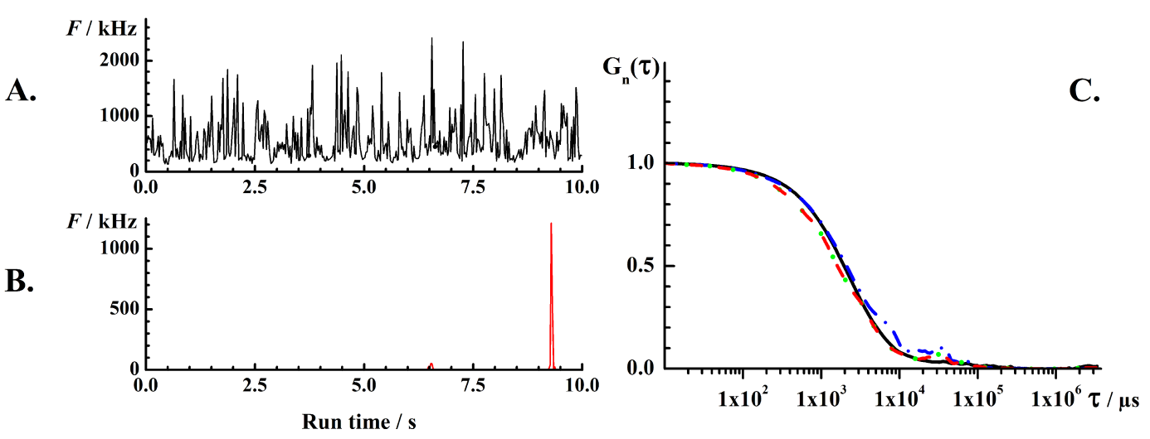
Supplementary Figure 2. Diffusion time of fluospheres determined from the analysis of f_{SEO} agrees within the experimental error with the value obtained by temporal autocorrelation analysis. A) Fluorescence intensity fluctuations recorded in a 50 nM aqueous suspension of fluospheres. B) Fluorescence intensity fluctuations recorded in a 50 pM aqueous suspension of fluospheres. C) tACCs normalized to the same amplitude, G_{n}(τ) = 1 at τ = 10 µs, obtained by analyzing fluorescence intensity fluctuations recorded in 50 nM or 50 pM aqueous suspension of 100 nm fluospheres. Black solid line: Average normalized tACC obtained from a series of 10 consecutively acquired measurements of fluorescence intensity fluctuations, with each individual measurement lasting 10 s, recorded in a 50 nM aqueous suspension of 100 nm fluospheres. Blue dash-dot line: Normalized tACC obtained by temporal autocorrelation analysis of fluorescence intensity fluctuations recorded for 3000 s in a 50 pM aqueous suspension of 100 nm fluospheres. Green dotted line: Average normalized tACC obtained from 300 consecutively acquired measurements of fluorescence intensity fluctuations, with each individual measurement lasting 10 s, recorded in a 50 pM aqueous suspension of 100 nm fluospheres. Red dashed line: Average normalized tACC obtained by analyzing fluorescence intensity fluctuations, with each individual measurement lasting 10 s, recorded in a 50 pM aqueous suspension of 100 nm fluospheres where single events occurrence was identified as described in Data analysis. The dashed-dotted, dotted and dashed tACCs were obtained from measurements performed in the same sample, but using different data analysis procedures. The overlap of the normalized tACCs, indicates that all procedures tested yield, within the experimental error, the same result.

Supplementary Figure 3. The frequency of single events occurrence (f_{SEO}) is linearly proportional to the actual concentration of 100 nm fluospheres in dilute aqueous suspension at c ≤ 10 fM. The slope of the regression line is (2.3 ± 0.3), and the coefficient of determination R² = 0.92.
Supplementary Material 5
Autofluorescence Measurements on Blood Serum
Serum without ThT was used as a control for assessing the effect of random disturbances on the obtained results (Supplementary Figure 4). As can be seen, while fluorescence intensity peaks are occasionally detected in the serum without ThT (olive and dark cyan), the mean frequency of their occurrence is significantly lower than in the serum with ThT (purple and wine); there is no difference in the frequency at which these peaks occur in the control and the patient group; and the standard deviation is larger than the mean, suggesting that the mean value of random disturbances is not significantly different from zero (Supplementary Figure 4).

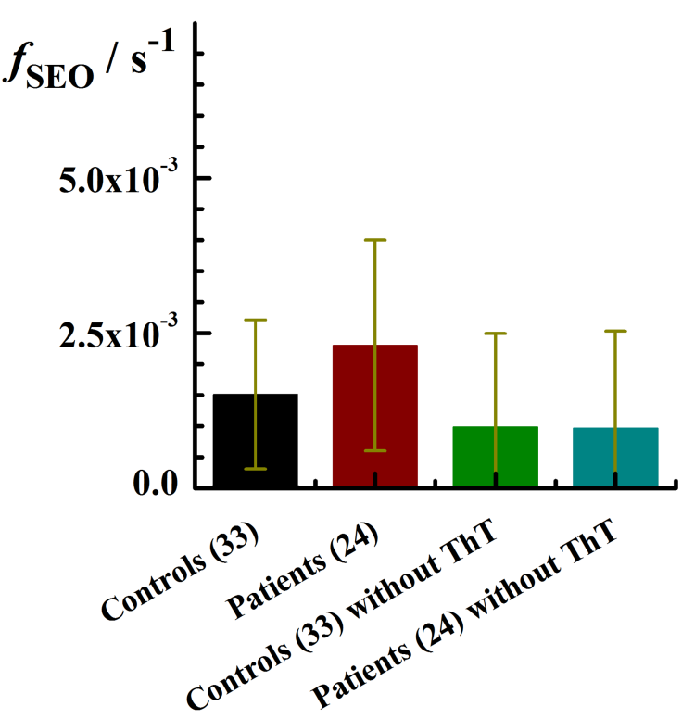

Supplementary Figure 4. Control experiments comparing the mean f_{SEO} in serum with ThT for the control (black) and the patient (wine) groups with the measurement in serum without ThT for the control (olive) and the patient (dark cyan) groups.

Supplementary Material 6
Effect of Age-Related Differences between the Control and Patient Cohorts
Our analysis also shows that the serum concentration of structured amyloidogenic nanoplaques increases somewhat with aging, as evident from the frequency of single event occurrence that increases with a slope of (1.6 ± 1.0)×10⁻⁵ s⁻¹ year ⁻¹ and an intercept of (9.4 ± 0.6)×10⁻⁴ s⁻¹ (Supplementary Figure 5, solid line). However, the adjusted R-squared value, = 0.032, indicates that this correlation is very weak. As a matter of fact, the same data set could be fitted with a zero-slope linear regression, with an intercept of (1.3 ± 0.2)×10⁻³ s⁻¹, and a residual sum of squares (RSS) value that is lower for the zero-slope linear regression, RSS_{z-slr} = 30.2, than for the best fit linear regression, RSS_{lr} = 66.7.

Supplementary Figure 5. The concentration of ThT-active structured amyloidogenic nanoplaques in blood serum increases with aging. The f_{SEO} as a function of age in apparently healthy controls (black circles) and patients (wine dots). Data from AD patients are blue-lined. The green-lined point originates from a patient that had gastric bypass. The slope of the linear regression equation is (1.6 ± 1.0)×10⁻⁵ s⁻¹ year ⁻¹ and the intercept (9.4 ± 0.6)×10⁻⁴ s⁻¹. The adjusted R-squared value, = 0.032, indicates that this correlation is very weak.
REFERENCES
[1] Vukojevic V, Heidkamp M, Ming Y, Johansson B, Terenius L, Rigler R (2008) Quantitative single-molecule imaging by confocal laser scanning microscopy. Proc Natl Acad Sci U S A 105, 18176-18181.
[2] Elson EL (2001) Fluorescence correlation spectroscopy measures molecular transport in cells. Traffic 2, 789-796.
[3] Vukojevic V, Pramanik A, Yakovleva T, Rigler R, Terenius L, Bakalkin G (2005) Study of molecular events in cells by fluorescence correlation spectroscopy. Cell Mol Life Sci 62, 535-550.

