Supplementary Material

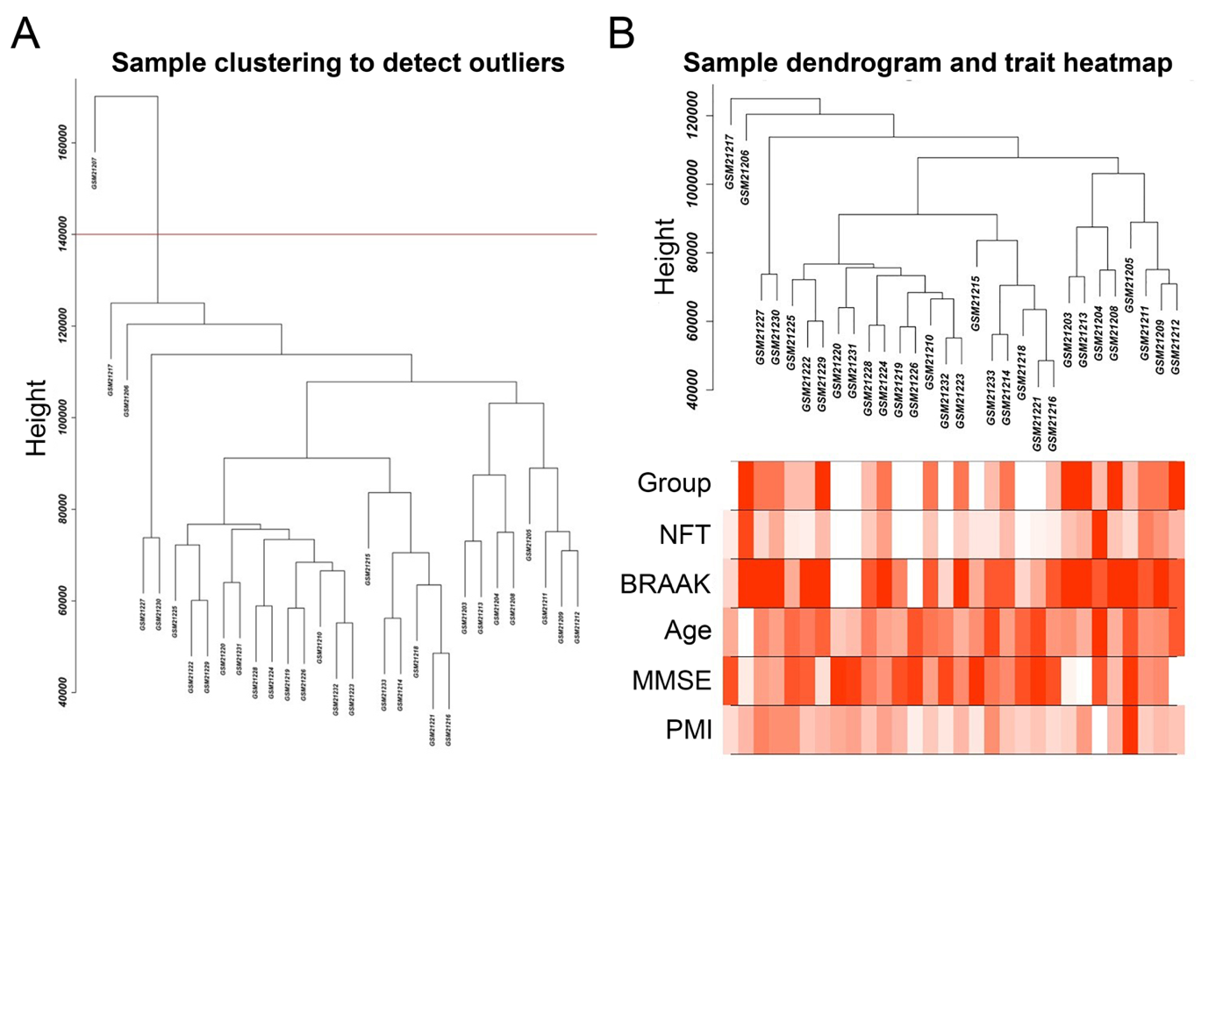
Supplementary Fig. 1. Preprocessing of the mRNA expression data. A) Gene expression database GSE1297 including 31 groups of samples were read by R software, clustered, and one outlier sample (GSM21207) with significantly high average expression level was removed. B) The mRNA expression data of the remaining 30 groups of samples were matched to clinical data.

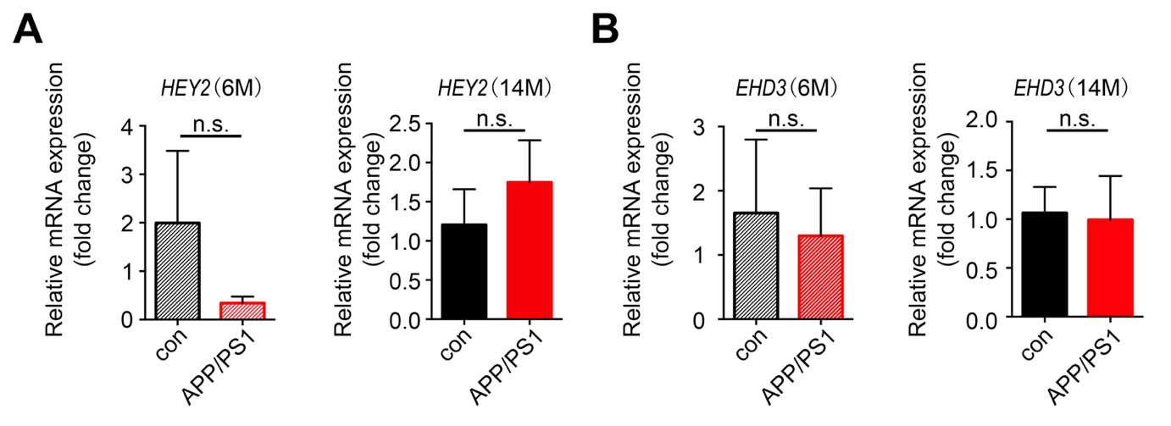

Supplementary Fig. 2. Validation of the key genes in AD transgenic mice. Total RNAs were isolated from hippocampal tissues of APP/PS-1 transgenic mice and wild type control mice for qRT-PCR analysis of the expression of key genes identified in WGCNA. A, B) Expression of HEY2, EHD3 in 6-month-old and 14-month-old mice; n = 3 per group. *p<0.05, **p<0.01, ***p<0.001 versus Con. Data are mean±SEM.

