Supplementary Material
Supplementary Table 1. Spearman correlation analysis between anosognosia scores and neuropsychological assessments in AD patients

 | r | p
Demographic factors
Age | 0.27 | NS
Level of education (years) | 0.22 | NS
Cognitive level
MMSE (/30) | -0.39 | NS
Memory functions
Visual memory
RBMT III (Total corrected answers, /30) | -0.36 | NS
Verbal memory
RBMT III (Total corrected answers, /50) | -0.16 | NS
FCSRT (Sum of free recalls, /48) | 0.27 | NS
FCSRT (Sum of free & cued recalls, /48) | -0.01 | NS
Spatial memory
RBMT III (Total corrected answers, /26) | -0.05 | NS
Prospective memory
RBMT III (Total corrected answers, /12) | 0.39 | NS
Ability to learn a new task
RBMT III (Total corrected answers, /68) | -0.14 | NS
Executive functions
Flexibility
TMT B-A, time | 0.23 | NS
Inhibition
Stroop test, interference score (IS), time | 0.30 | NS
Initiation
Phonologic fluency (P) | -0.32 | NS
Semantic fluency (Animals) | -0.35 | NS
Verbal working memory
Digit span, forward (/16) | 0.12 | NS
Digit span, backward (/16) | -0.02 | NS
Processing speed
Stroop denomination, time | -0.07 | NS
Stroop reading, time | -0.01 | NS
TMT A, time | 0.22 | NS
Language
Naming (/36) | -0.18 | NS
Praxis
Gestural praxis (/23) | -0.12 | NS
Behavioral assessment
Depression Scale (/38) | 0.04 | NS
Apathy (/36) | 0.23 | NS
Autonomy
ADL (/6) | -0.43 | NS
IADL (/8) | -0.42 | NS

MMSE, Mini-Mental State Examination; RMBT III, Rivermead Behavioral Memory Test III; FCSRT, Free and Cued Selective Reminding Test; TMT, Trail Making Test; ADL, Activities of Daily Living Questionnaire; IADL, The Lawton Instrumental Activities of Daily Living Scale

Supplementary Fig. 1. Regions showing less density of grey matter (A) and hypometabolism (B) in patients with AD in comparison to healthy controls

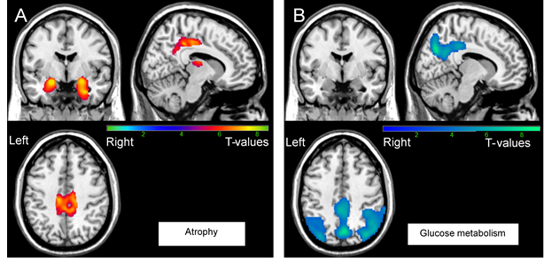
Results were obtained from 27 T1-3D scans (A) and 28 FDG-PET scans (B). The statistical threshold is p_{FWE-corr} < 0.05 (k >200 voxels).

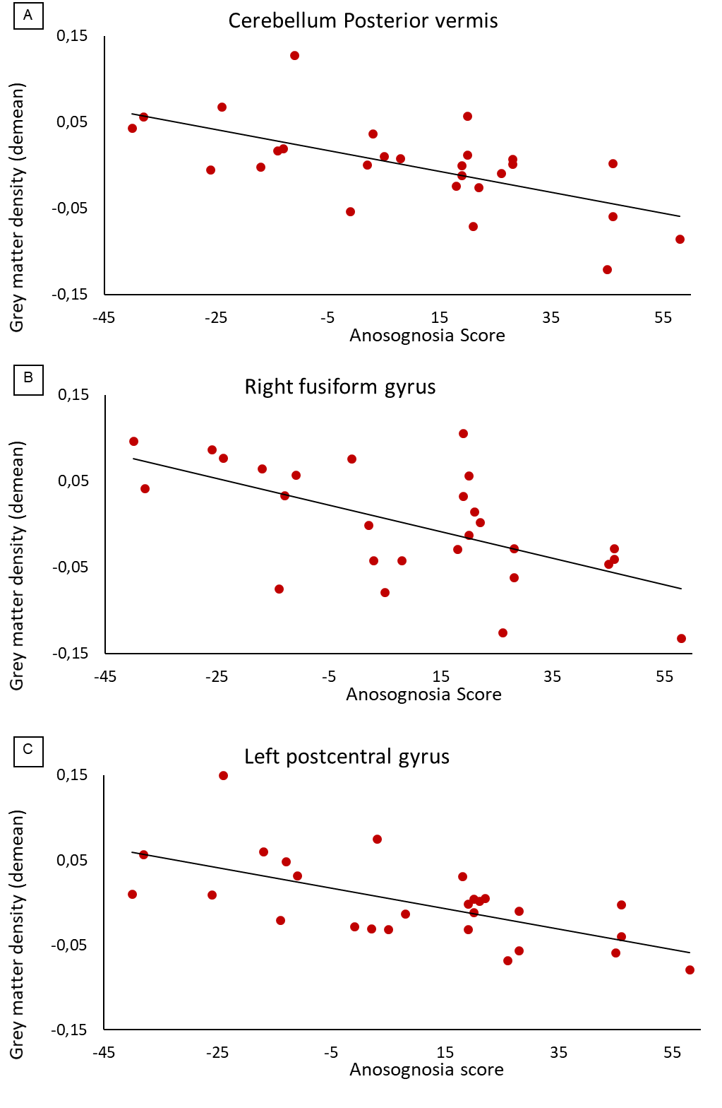
Supplementary Fig. 2. Correlations between the anosognosia score and MRI scans
Results were obtained from 27 T1-3D scans in Alzheimer’s disease patients. The statistical threshold is p_{uncorr} < 0.001 (k > 70 voxels). Correlations are realized on the whole cluster of the Cerebellum (A), right fusiform gyrus (B) and the left postcentral gyrus (C) after extraction of data with MARSBAR.

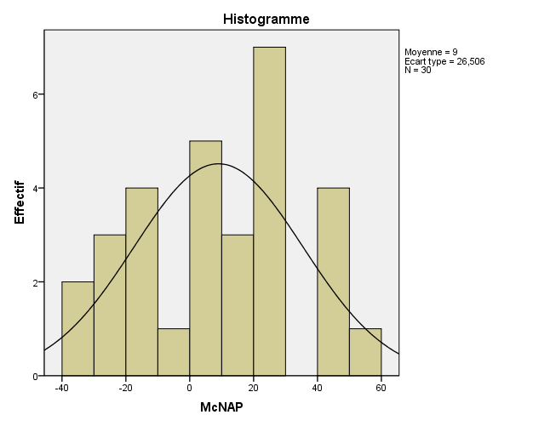
Supplementary Fig. 3. Distribution of the anosognosia score in the Alzheimer’s disease group
Effective
Anosognosia Score

Histogram shows the normal distribution of the anosognosia score in the Alzheimer’s disease patients (n=30).

