Supplementary Material

Supplementary Table 1.Overview of the six-week cognitive intervention.

week 1 | week 2 | week 3 | week 4 | week 5 | week 6
memory functioning and mnemonics overview  goal:  overview of external and internal mnemonics | strategy: organization of information  goal:  creating a structure | strategy: association and mentalimagery  goal: remembering names | strategy:  story technique  goal: remembering words | strategy: PQRST method  goal: remembering stories | mindfulness training and transfer into daily life  goal:  transferring strategies into daily life / focus attention

Supplementary Table 2.Full statistic of stepwise linear regressions between brain volume and change in cognition after mnemonic strategy training in patients with mild cognitive impairment. Significant predictors are listed first, excluded variables are shown indented.
table continues

Outcome variable | Model | adj. R² | β | p-value
Verbal delayed recall | left entorhinal cortex volume | 0.27 | 0.47 | 0.01
 | frequency of completed homework | 0.19 | 0.44 | 0.02
 | age at baseline |  | 0.26 | 0.13
 | baseline performance |  | -0.26 | 0.13
 | left hippocampal volume |  | -0.34 | 0.09
 | APOE ε4 homozygotes |  | -0.24 | 0.16
 | APOE ε4 heterozygotes |  | 0.16 | 0.43
MMSE | baseline performance | 0.69 | -0.84 | <0.001
 | age at baseline |  | -0.06 | 0.65
 | right hippocampal volume |  | -0.17 | 0.28
 | right entorhinal cortex volume |  | 0.15 | 0.34
 | frequency of completed homework |  | -0.03 | 0.83
 | APOE ε4 homozygotes |  | -0.16 | 0.24
 | APOE ε4 heterozygotes |  | 0.04 | 0.77
MMSE | baseline performance | 0.72 | -0.86 | <0.001
 | age at baseline |  | -0.05 | 0.71
 | left hippocampal volume |  | -0.16 | 0.27
 | left entorhinal cortex volume |  | 0.07 | 0.60
 | frequency of completed homework |  | 0.01 | 0.93
 | APOE ε4 homozygotes |  | -0.17 | 0.17
 | APOE ε4 heterozygotes |  | -0.01 | 0.97
Spatial navigation | baseline performance | 0.49 | -0.72 | 0.001
 | age at baseline |  | 0.06 | 0.74
 | right hippocampal tail |  | 0.22 | 0.35
 | volume of the right subiculum |  | 0.08 | 0.69
 | frequency of completed homework |  | 0.01 | 0.94
 | APOE ε4 homozygotes |  | -0.02 | 0.90
 | APOE ε4 heterozygotes |  | -0.17 | 0.46
adj, adjusted; MMSE, Mini-Mental Status Examination; MCI, mild cognitive impairment

Supplementary Table 3.Full statistic of stepwise linear regressions between change in cognition after mnemonic strategy training and age plus baseline performance in patients with mild cognitive impairment (simple model). Significant predictors are listed first, excluded variables are shown indented. Note: For verbal delayed recall, neither age nor baseline performance was a significant predictor.

Outcome variable | Model | adj. R² | β | p-value
Verbal delayed recall | baseline performance |  |  | n.s.
 | age |  |  | n.s.
MMSE | baseline performance | 0.53 | -0.74 | <0.001
 | age |  | -0.12 | 0.49
Spatial navigation | baseline performance | 0.49 | -0.72 | <0.001
 | age |  | 0.06 | 0.74
adj, adjusted; MMSE, Mini-Mental Status Examination;n.s., not significant

Supplementary Table 4.Correlation between predictor variables and the increase between pre- and post-training. Note that for the baseline performance, the correlation was calculated with the respective variable (e.g., MMSE at baseline).

 | verbal delayed recall change | MMSE change | RLT change
age at baseline | r_{s}= -0.14 (p=0.54) | r_{s}= 0.23 (p=0.31) | r_{s}= 0.06 (p=0.78)
baseline performance | r_{s}= -0.30 (p=0.17) | r_{s}= -0.82 (p<0.001) | r_{s}= 0.72 (p<0.001)
frequency of completed homework | r_{s}= 0.65 (p<0.001) | r_{s}= 0.02 (p=0.93) | r_{s}= 0.11 (p=0.64)
left entorhinal cortex volume* | r_{s}= 0.58 (p=0.005)
left hippocampal volume | r_{s}= 0.17 (p=0.48) | r_{s}= -0.41 (p=0.07)
right hippocampal volume |  | r_{s}= -0.53 (p=0.02)
right hippocampal tail volume |  |  | r_{s}= -0.58 (p=0.006)
right subiculum volume |  |  | r_{s}= 0.40 (p=0.09)
presence of one APOE ε 4 allele | r_{s}= -0.06 (p=0.79) | r_{s}= 0.18 (p=0.42) | r_{s}= 0.52 (p=0.02)
presence of two APOE ε 4 alleles | r_{s}= -0.34 (p=0.13) | r_{s}= -0.07 (p=0.74) | r_{s}= 0.20 (p=0.39)
MCI subtype | r_{s}= 0.28 (p=0.19) | r_{s}= 0.14 (p=0.55) | r_{s}= 0.07 (p=0.75)
rs, Spearman’s rho; MMSE, Mini-Mental Status Examination; RLT, Route Learning Task errors; MCI, mild cognitive impairment.
*The correlation between left hippocampal volume and left entorhinal cortex was r= 0.47 (p<0.05)

Supplementary Table 5. Results of the bootstrapping procedure (n=1000 samples) for predicting the change in verbal delayed recall after six weekly sessions of cognitive training (i.e., pre- to post-training).

 | variable selection  (in %) | positive predictor  (in %) | negative predictor  (in %)
motivation | 85.2 | 99.1 | 0.9
left entorhinal cortex volume | 71.9 | 98.8 | 1.2
baseline performance | 50.8 | 7.6 | 92.4
left hippocampal volume | 43.3 | 6.5 | 93.5
age | 32.1 | 19.6 | 80.4
APOe ε4 homozygotes | 22.4 | - | -
APOE ε4 heterozygotes | 11.8 | 26.9 | 73.1
motivation, frequency of completed homework task; APOE, apolipoprotein E

Supplementary Fig.1.Change in processing speed between pre- to post-training and 6 months later. The cognitive intervention group is shown in red, the ADNI and local memory clinic are depicted in blue (the latter two did not receive a cognitive training). Error bars indicate ± 1 standard error of the mean.

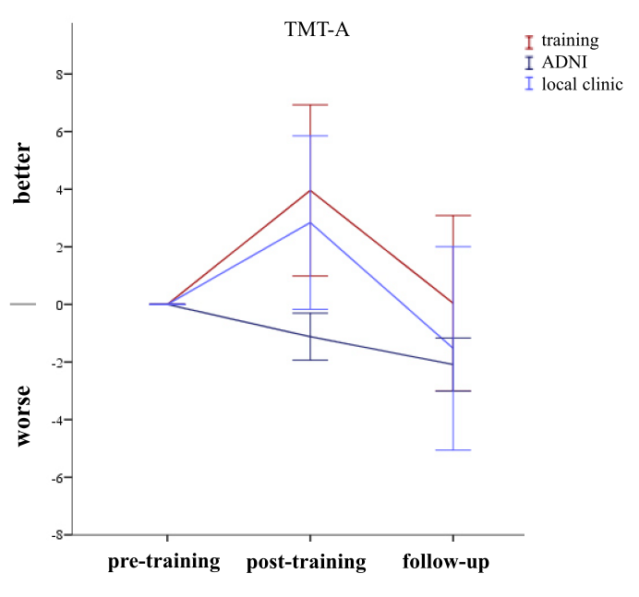

Supplementary Fig.2.Relationship between change in the Mini Mental Status Examination (MMSE), verbal delayed recall, spatial navigation (RLT), speed of information processing (TMT-A) and the respective baseline scores (pre- to post-training). Positive scores on the y-axis indicate improvement. Subjects with low baseline performance in the MMSE and spatial navigation showed best performance after the intervention.

