Supplementary Material

Structural Connectivity Alterations Along the Alzheimer’s Disease Continuum: Reproducibility Across Two Independent Samples and Correlation with Cerebrospinal Fluid Amyloid-β and Tau

Alan Tucholka, Oriol Grau-Rivera, Carles Falcon, Lorena Rami, Raquel Sánchez-Valle, Albert Lladó, Juan Domingo Gispert, José Luis Molinuevo, for the Alzheimer’s Disease Neuroimaging Initiative.

- COMPARISON OF THE TRACTOGRAPHY OF THE TWO DATABASES

The two databases have different population, MRI system and acquisition protocol, thus it would seem counter-intuitive to merge them. In Supplementary Material Section 3, we performed several analyses (correlation, normalized differences and Bland Altman) to compare the values of number of connections obtained from tractography, between HCB and ADNI:

Simple Correlation
We compared the normalized probability of connection between the 10% most connected regions between ADNI and HCB databases. The correlation is very high: p < 7 × 10−153 (see top image of Supplementary Fig. 1).

Normalized Differences
We calculated the absolute difference d of normalized values in SD units, using the following equation for each connection between two ROIs:

$$sdp=\frac{\left({nb}_{hcb}-1\right)*{sd}_{hcb}+\left({nb}_{adni}-1\right)*{sd}_{adni}}{{nb}_{hcb}-{nb}_{adni}-2}$$

$$d=\frac{{mean}_{hcb}-{mean}_{adni}}{sdp}$$
where nb_{hcb} (resp. adni) is the number of subjects in HCB (resp. ADNI) database, std_{hcb} (resp. adni) the standard deviation of the connectivity for a specific connection and mean_{hcb} (resp. adni) the mean value of connectivity for a specific connection in HCB (resp. ADNI) database. 95% of connections have a between-group variability lower than 0.273*SD of the intra-group variability (see middle image of Supplementary Fig. 1).

Bland Altman
The popular Bland-Altman method compares the difference between two measures (i.e., here the connectivity for the same connection between HCB and ADNI) with the average of the two measures. 1.96 × SD represents 95% limits of agreement (see bottom image of Supplementary Fig. 1).
The correlations analyses showed that the values of normalized probability of connection are in the same order of magnitude between the two databases. We choose not to discard the connections that are over 1.96×SD in the Bland-Altman plot or over 95% in the normalized differences because (and we can only speculate on that) they can be due to the pathology, difference in population (age, education, gender) or APOE status. This correlation study reinforces the idea to merge the two databases. We, however, found that the roi-to-roi number of connections, divided by the total intracranial volume are statistically different: p < 1.35 × 10⁻²¹ for a paired t-test on the average of the connection.

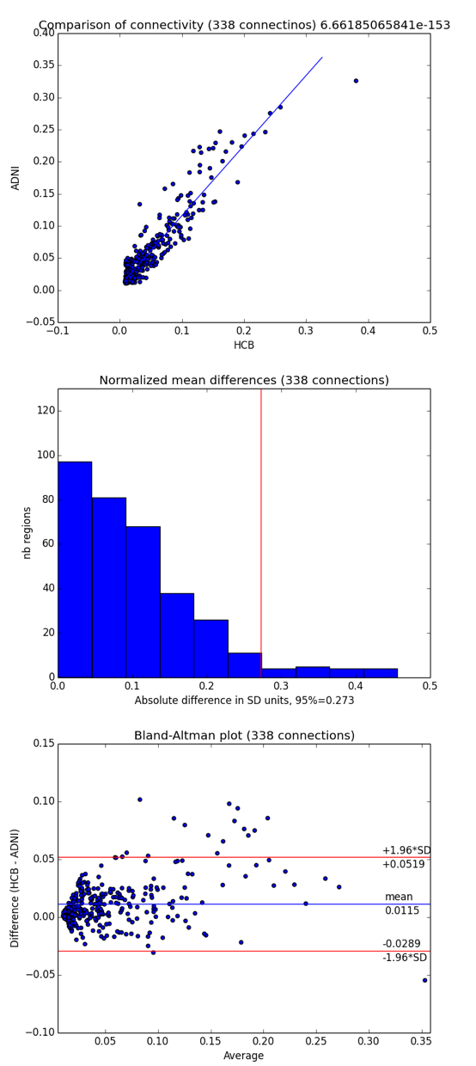
Supplementary Fig. 1. On the 338 strongest connections. Top: correlation of the normalized connectivity between HCB and ADNI; middle: normalized mean differences between HCB and ADNI, red line is at 95% of difference; bottom: Bland-Altmann graph on normalized connectivity between HCB and ADNI, red line represents 1.96 standard deviation (equivalent to the 95% limit of agreement).

- Aβ AND P-TAU IN HCB AND ADNI
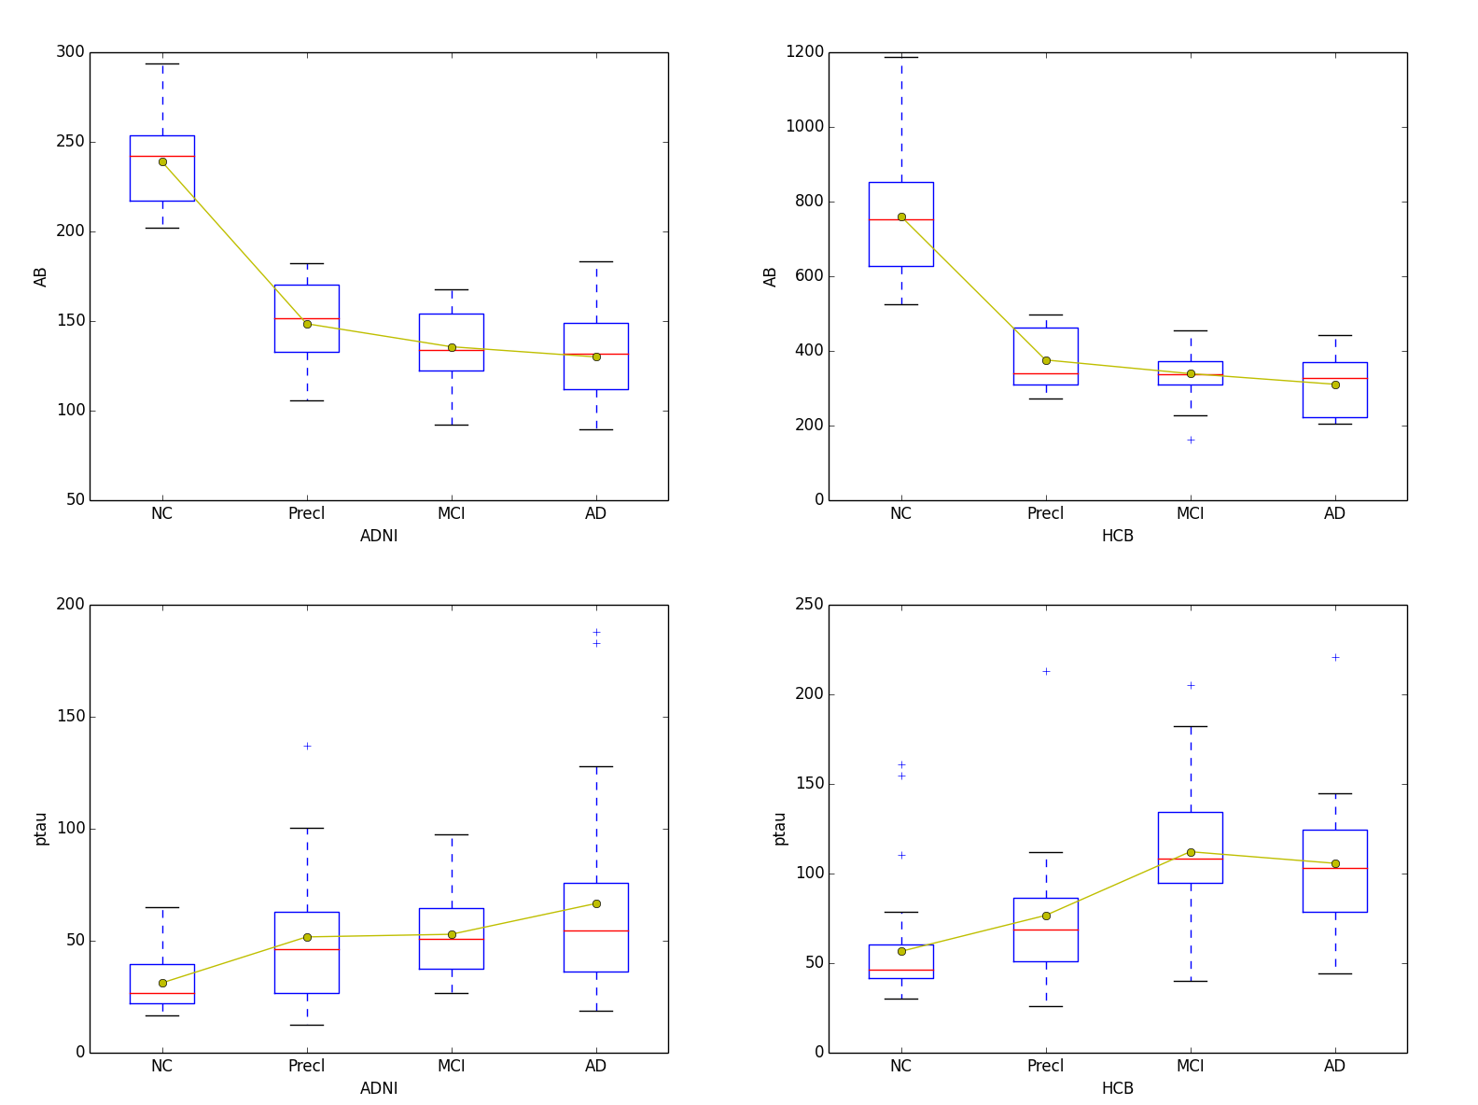

Supplementary Fig. 2. Aβ and ptau values for HCB and ADNI, by group (row) and database (column).

- CONTROLS VERUS PRE-AD
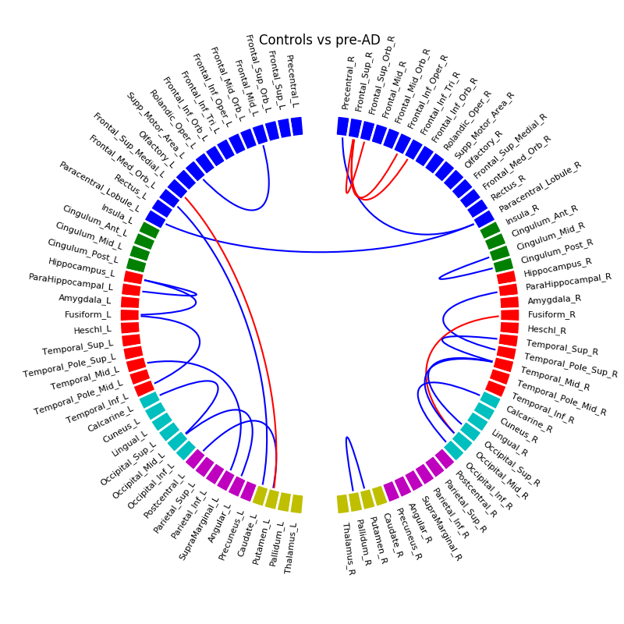

Supplementary Fig. 3. HCB database, Controls versus Pre-AD

(blue: decrease of connectivity, red: increase of connectivity)
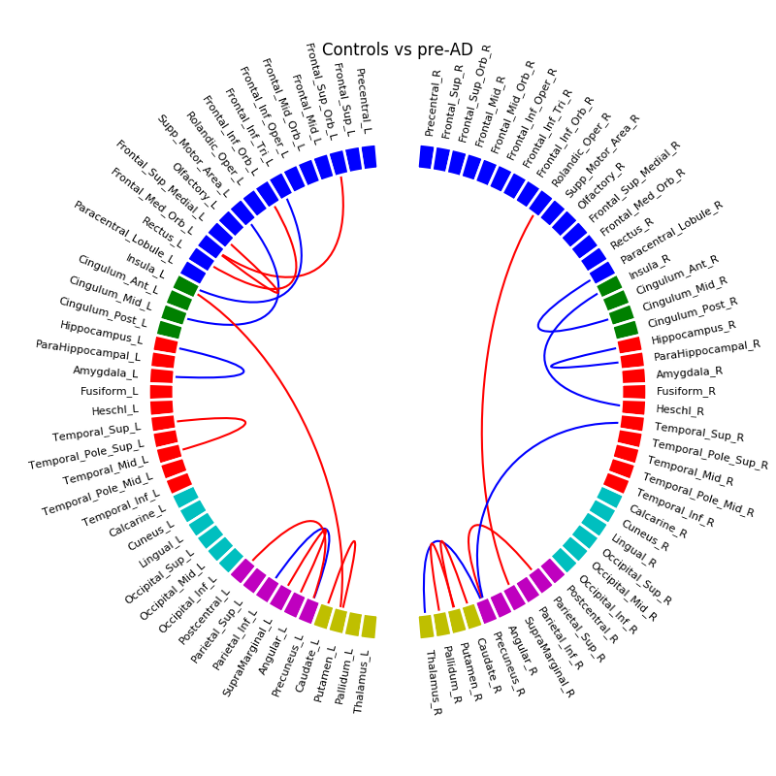

Supplementary Fig. 4. ADNI database, Controls versus Pre-AD

(blue: decrease of connectivity, red: increase of connectivity)

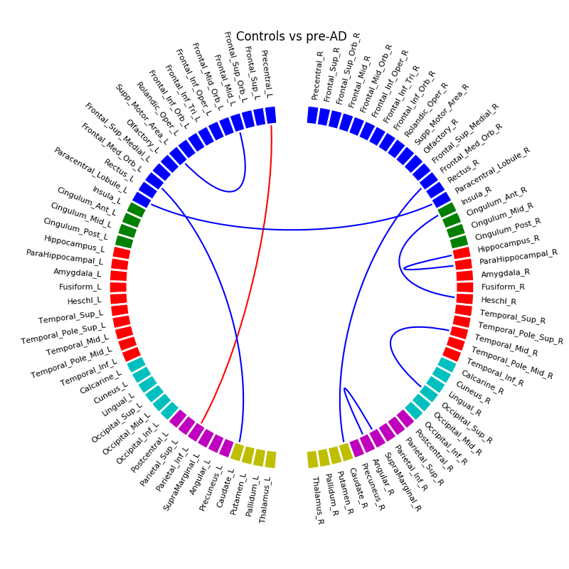
Supplementary Fig. 5. Common connections between HCM and ADNI database, Controls versus Pre-AD
(blue: decrease of connectivity, red: increase of connectivity)

- PRE-AD VERSUS MCI
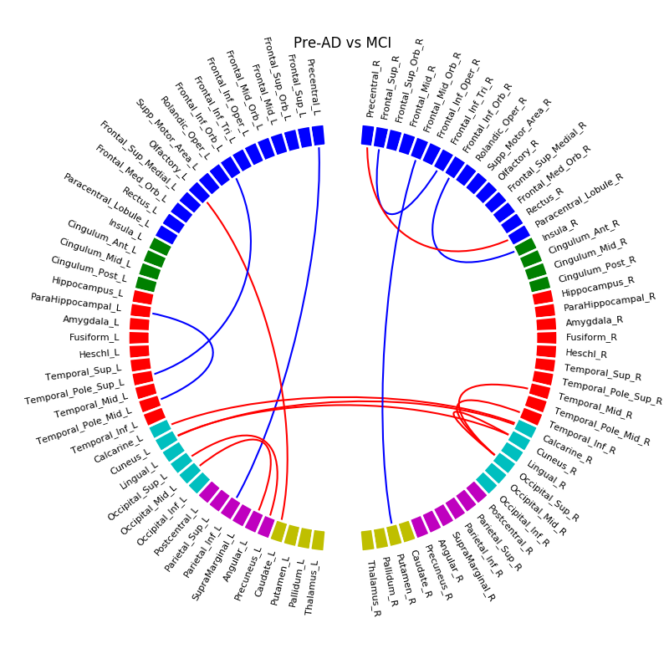

Supplementary Fig. 6. HCB database, Pre-AD versus MCI

(blue: decrease of connectivity, red: increase of connectivity)

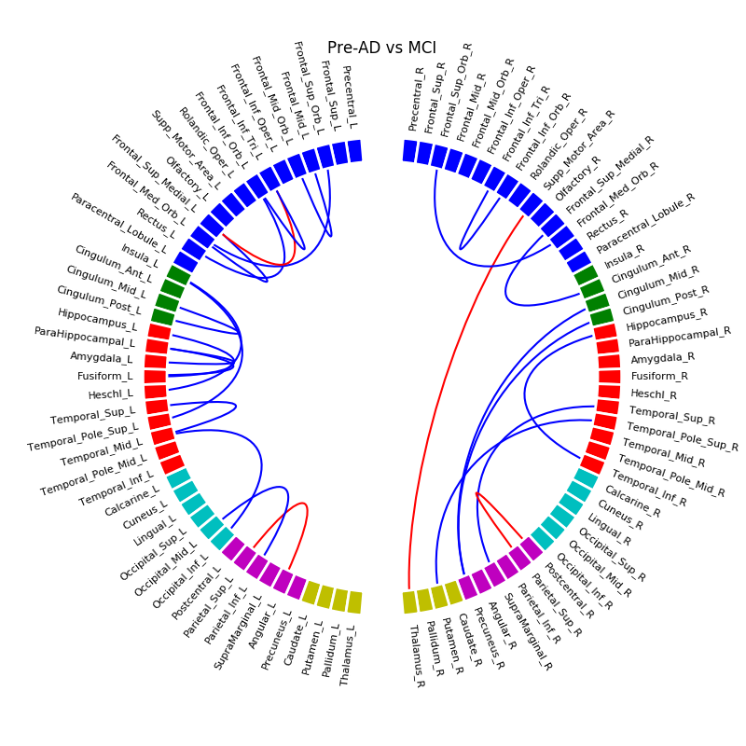

Supplementary Fig. 7. ADNI database, Pre-AD versus MCI

(blue: decrease of connectivity, red: increase of connectivity)

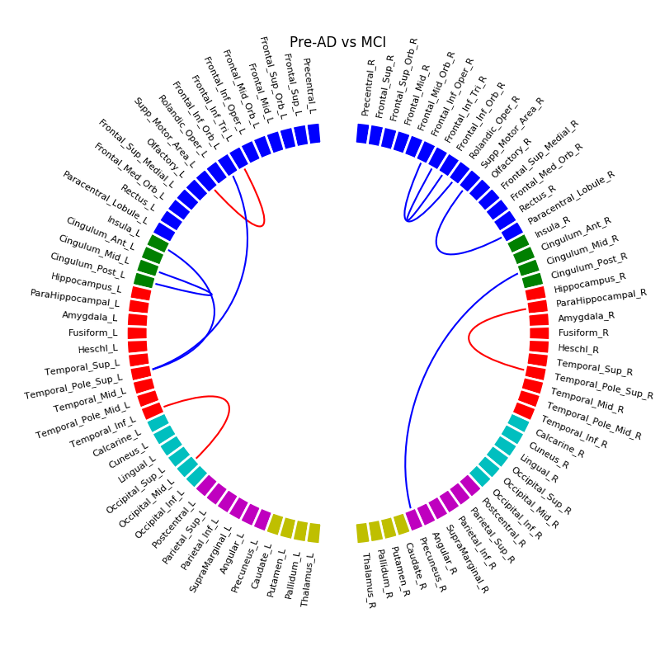
Supplementary Fig. 8. Common connections between HCM and ADNI database, Pre-AD versus MCI
(blue: decrease of connectivity, red: increase of connectivity)

- MCI VERSUS AD
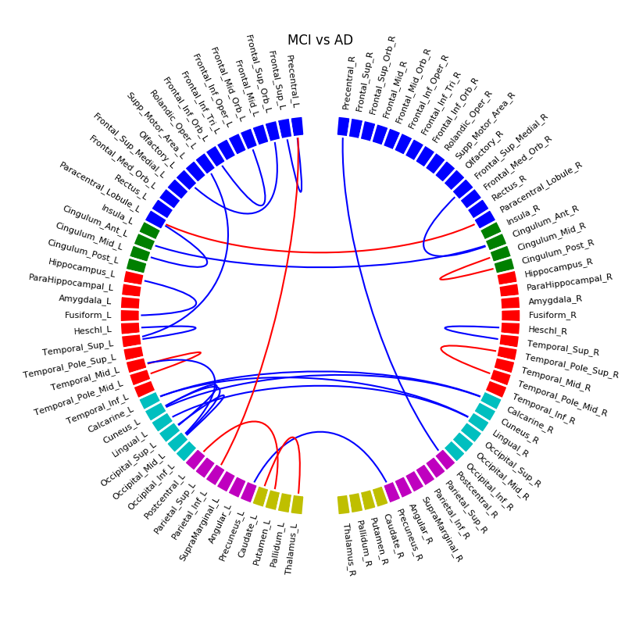

Supplementary Fig. 9. HCB database, MCI versus AD (blue: decrease of connectivity, red: increase of connectivity)

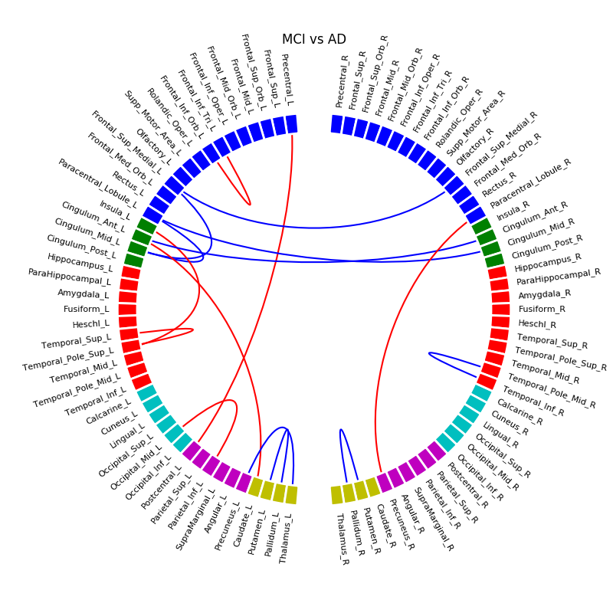

Supplementary Fig. 10. ADNI database, MCI versus AD (blue: decrease of connectivity, red: increase of connectivity)
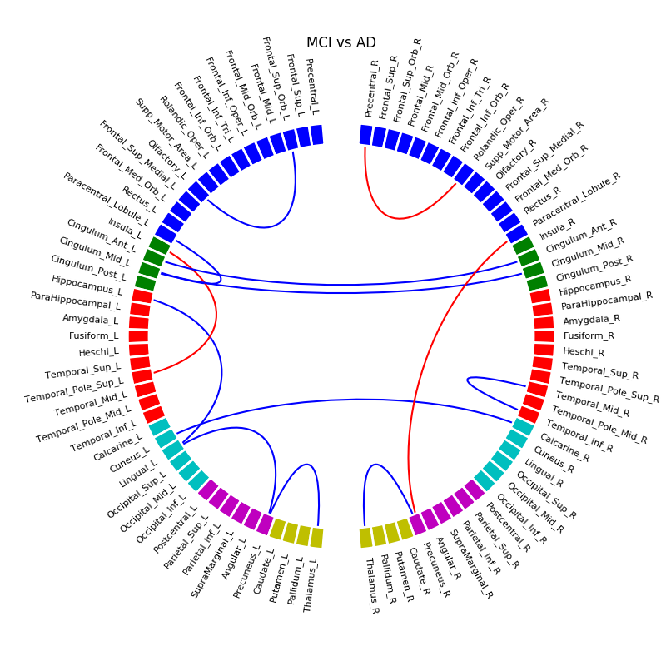
Supplementary Fig. 11. Common connections between HCM and ADNI database, MCI versus AD
(blue: decrease of connectivity, red: increase of connectivity)

- CONTROLS VERSUS MCI
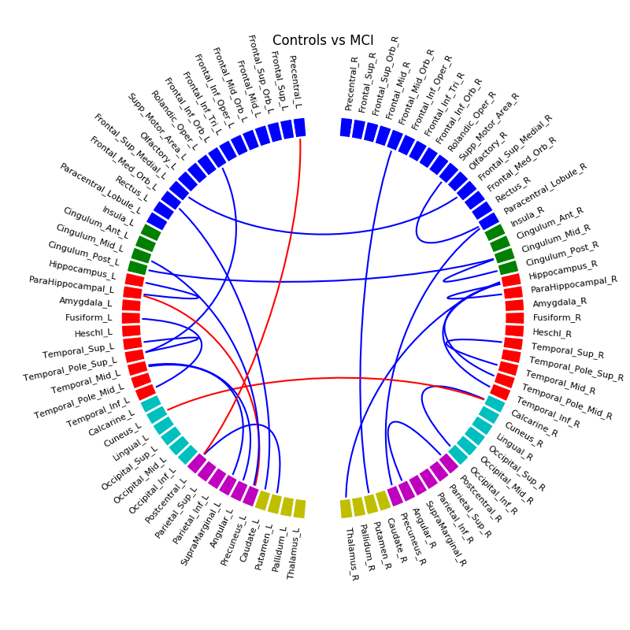

Supplementary Fig. 12. HCB database, Controls versus MCI

(blue: decrease of connectivity, red: increase of connectivity)
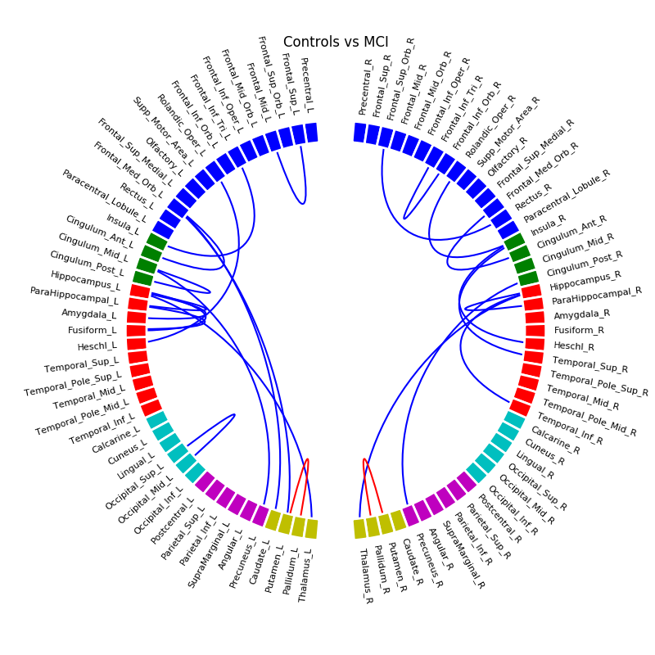

Supplementary Fig. 13. ADNI database, Controls versus MCI

(blue: decrease of connectivity, red: increase of connectivity)

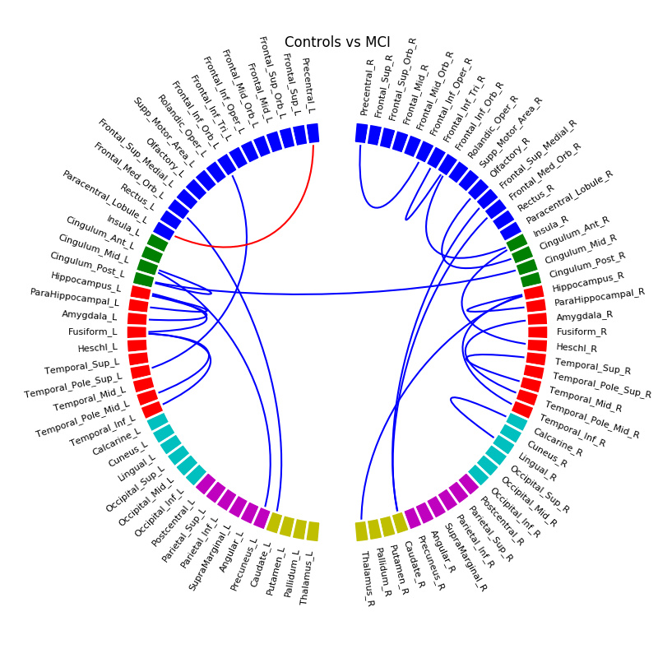
Supplementary Fig. 14. Common connections between HCM and ADNI database, Controls versus MCI
(blue: decrease of connectivity, red: increase of connectivity)

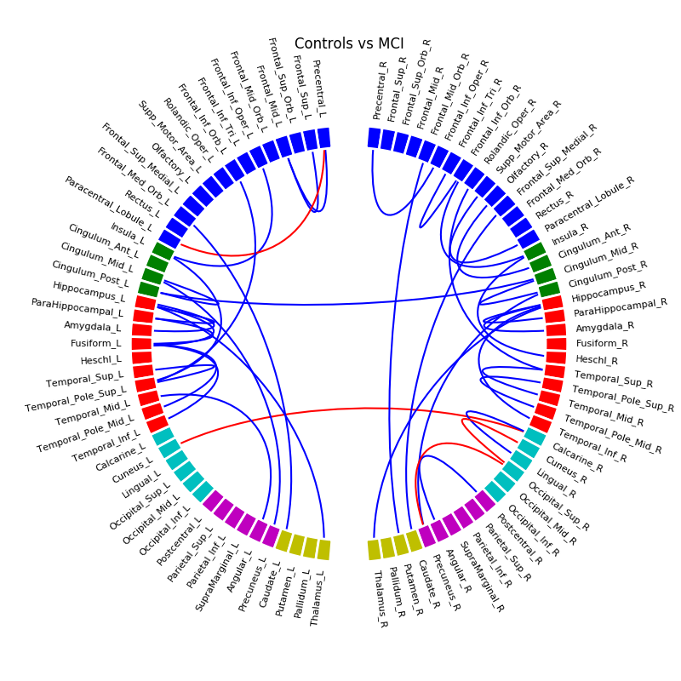
Supplementary Fig. 15. HCM and ADNI database merged together, Controls versus MCI
(blue: decrease of connectivity, red: increase of connectivity)

- CONTROLS VERSUS AD
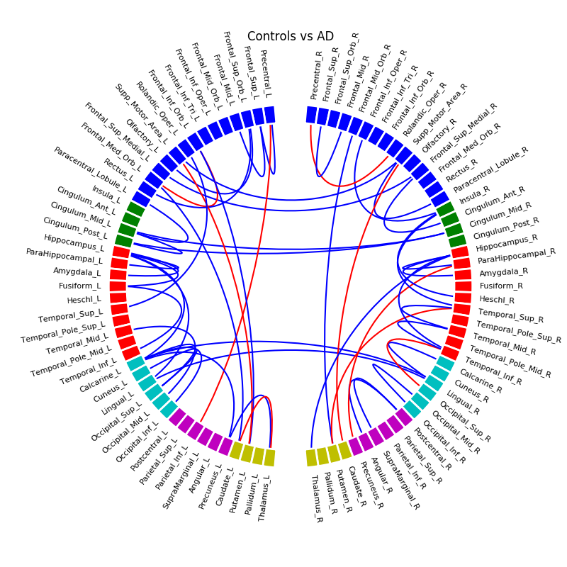

Supplementary Fig. 16. HCB database, Controls versus AD

(blue: decrease of connectivity, red: increase of connectivity

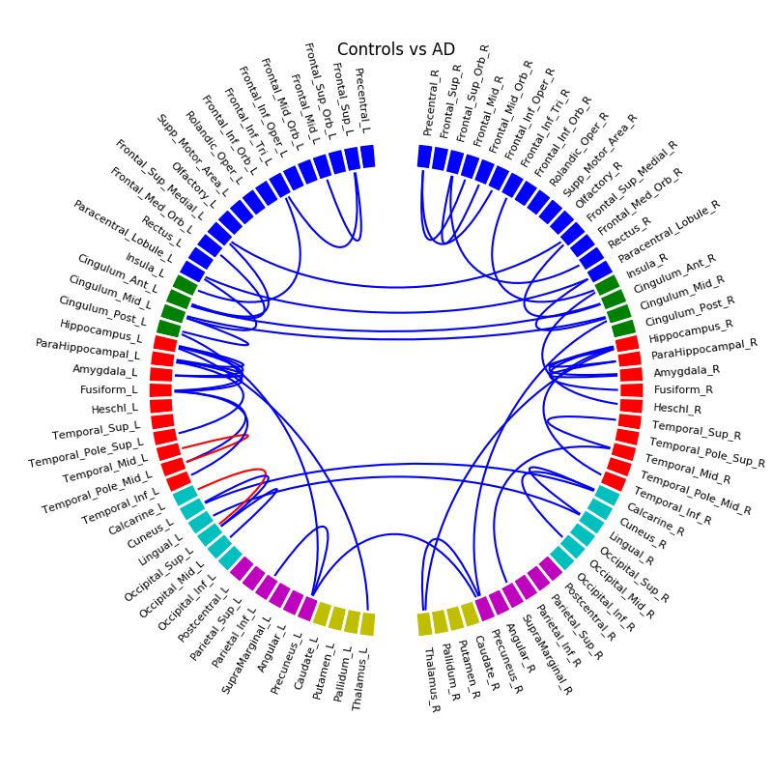

Supplementary Fig. 17. ADNI database, Controls versus AD

(blue: decrease of connectivity, red: increase of connectivity)

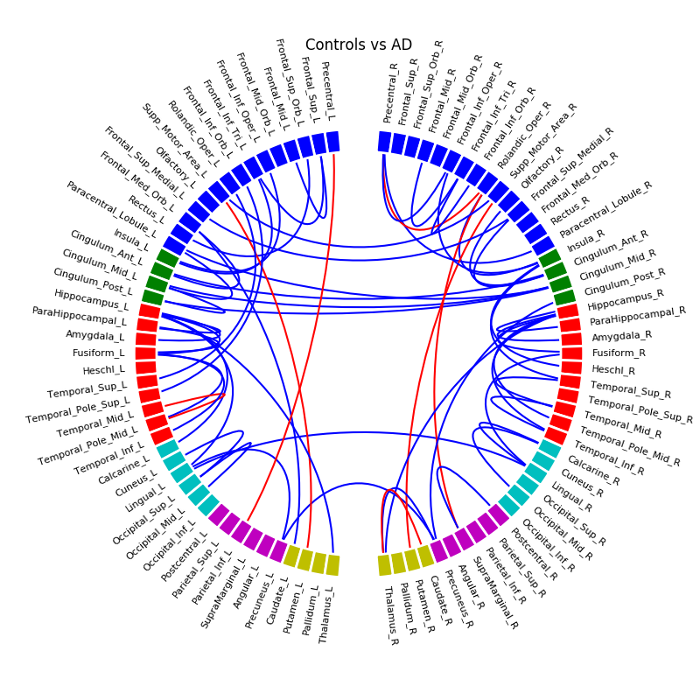
Supplementary Fig. 18. Common connections between HCM and ADNI database, Controls versus AD
(blue: decrease of connectivity, red: increase of connectivity)

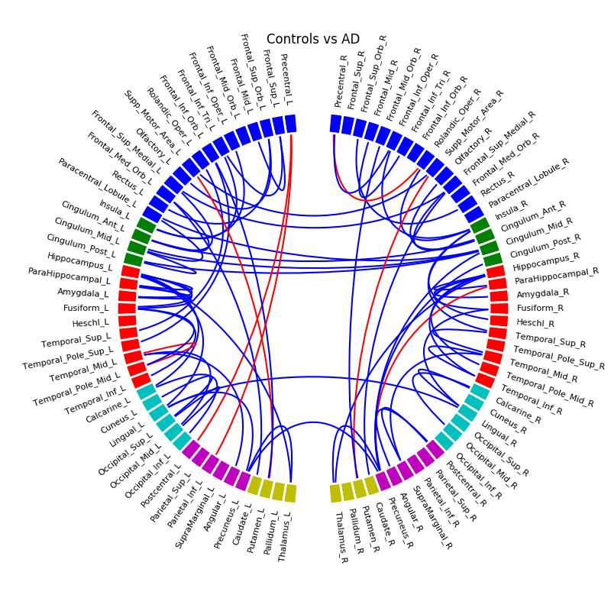
Supplementary Fig. 19. HCM and ADNI database merged together, Controls versus AD
(blue: decrease of connectivity, red: increase of connectivity)

- PRE-AD VERSUS AD
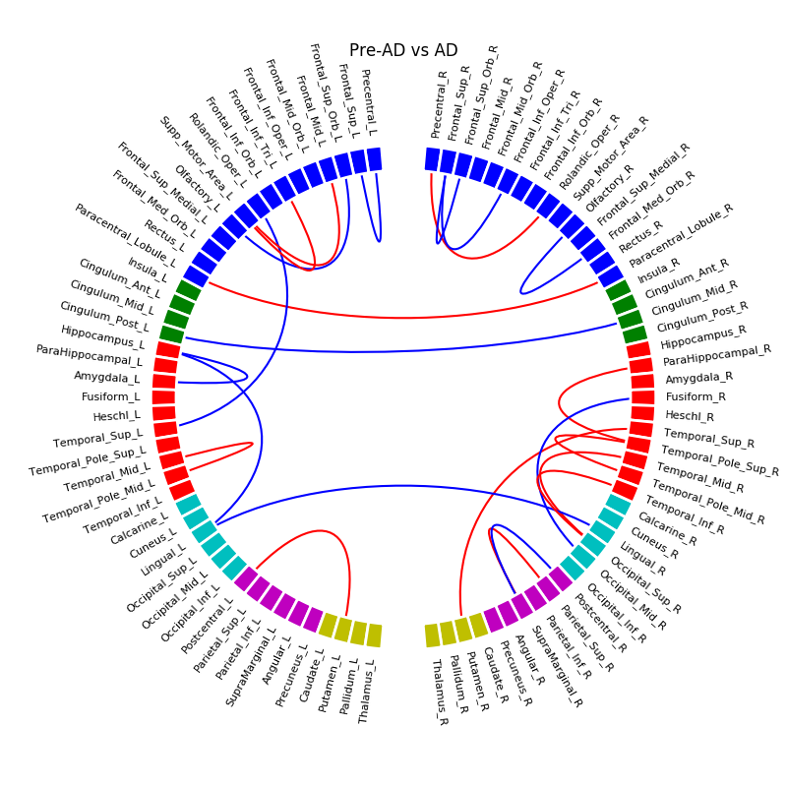

Supplementary Fig. 20. HCB database, Pre-AD versus AD (blue: decrease of connectivity, red: increase of connectivity)

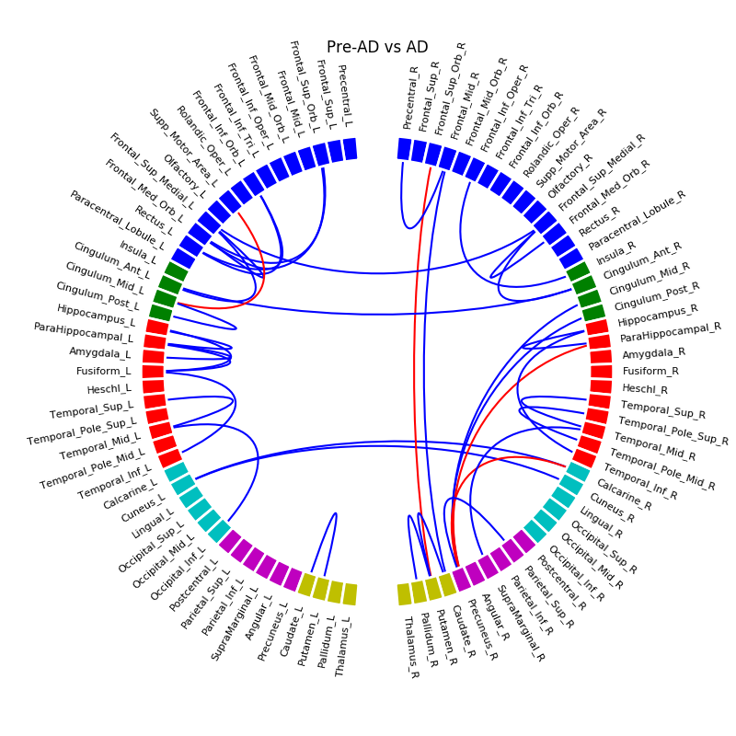

Supplementary Fig. 21. ADNI database, Pre-AD versus AD (blue: decrease of connectivity, red: increase of connectivity)

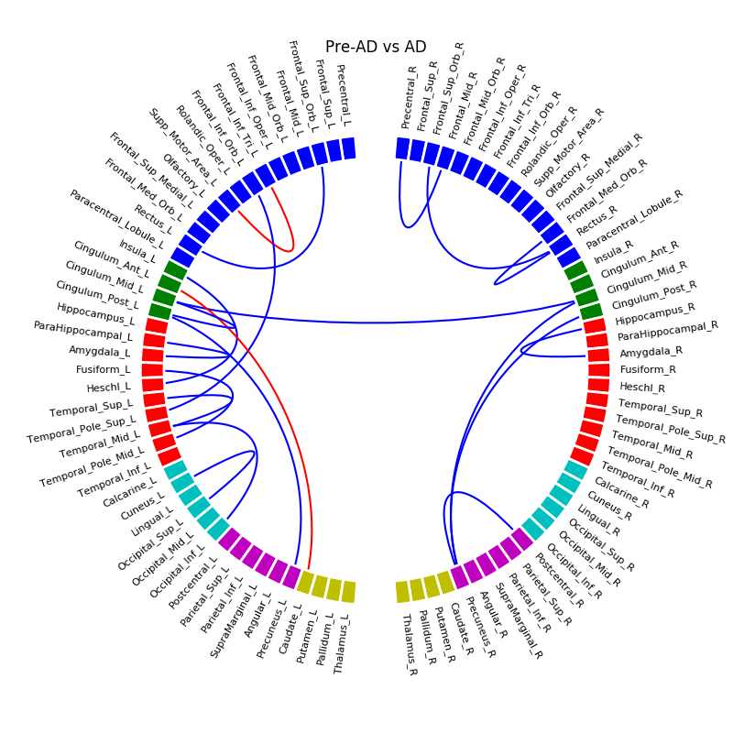
Supplementary Fig. 22. Common connections between HCM and ADNI database, Pre-AD versus AD
(blue: decrease of connectivity, red: increase of connectivity)

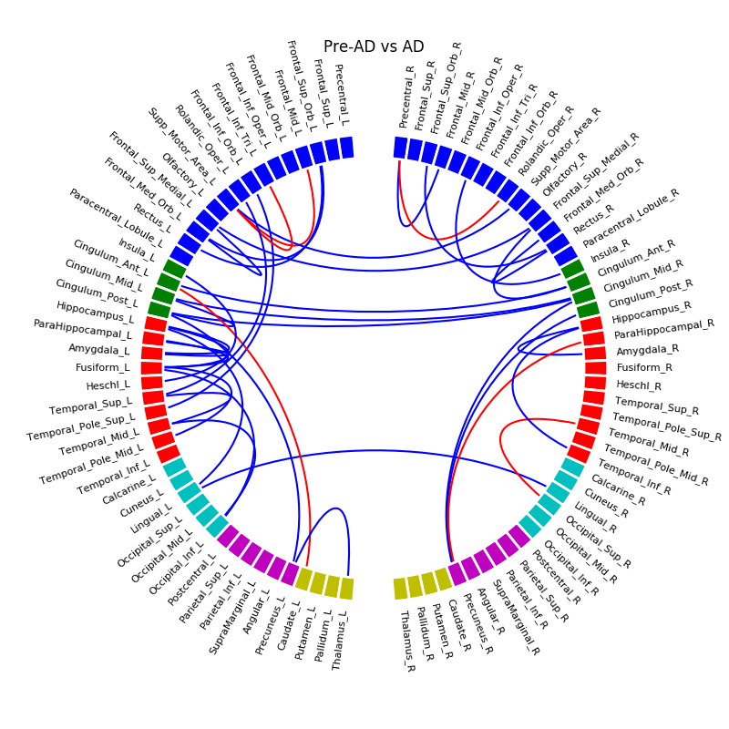
Supplementary Fig. 23. HCM and ADNI database merged together, Pre-AD versus AD
(blue: decrease of connectivity, red: increase of connectivity)

- CORRELATIONS OF CONNECTIVITY WITH Aβ
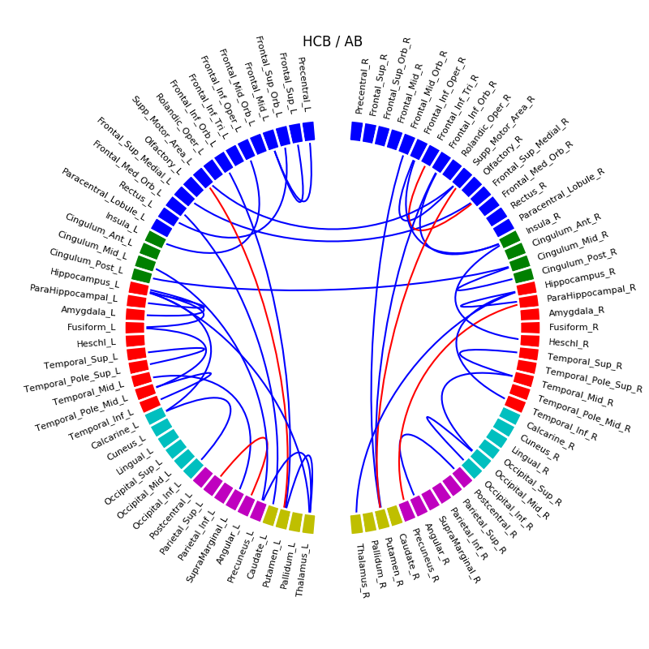

Supplementary Fig. 24. HCB database, correlations with Aβ (blue: positive correlation, red: negative correlation)
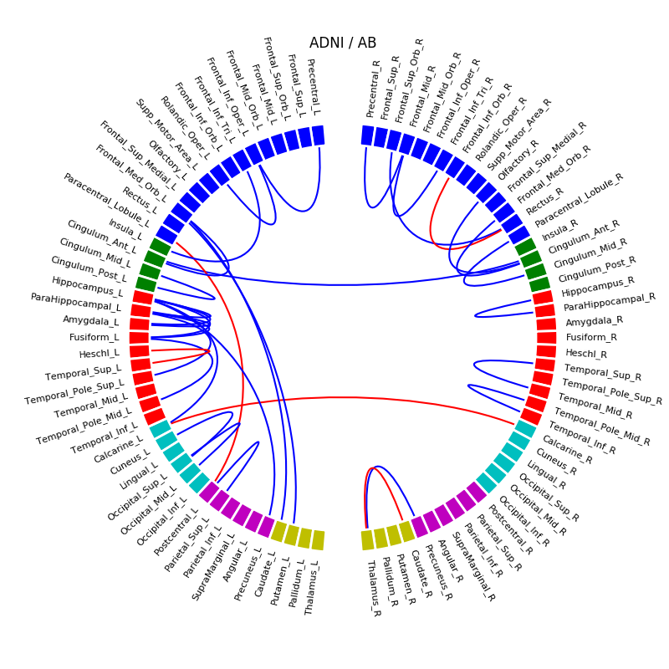

Supplementary Fig. 25. ADNI database, correlations with Aβ (blue: positive correlation, red: negative correlation)

- CORRELATIONS OF CONNECTIVITY WITH P-TAU

We observed a negative correlation between connectivity and quantity of p-tau (decrease of connectivity with increase of p-tau) in HCB database (see Supplementary Fig. 26) involving right hippocampus, occipital lobe, parietal, cingulate areas, and some superior frontal regions. Positive correlations were also observed between left and right posterior cingulate, and between occipital and parietal lobes. In ADNI (see Supplementary Fig. 27), we observed much less negative correlations than in HCB, and including left and right fronto-insula connections, and right hippocampus/parahippocampus connection. Positive correlations were found between left and right posterior cingulate, and some occipito-parietal and occipito-frontal connections. While merging together HCB and ADNI (see Supplementary Fig. 28) we found negative correlations involving right hippocampus and parahippocampus, occipital, and some right frontal regions, and positive correlations between left and right posterior cingulate, and anterior frontal connections.

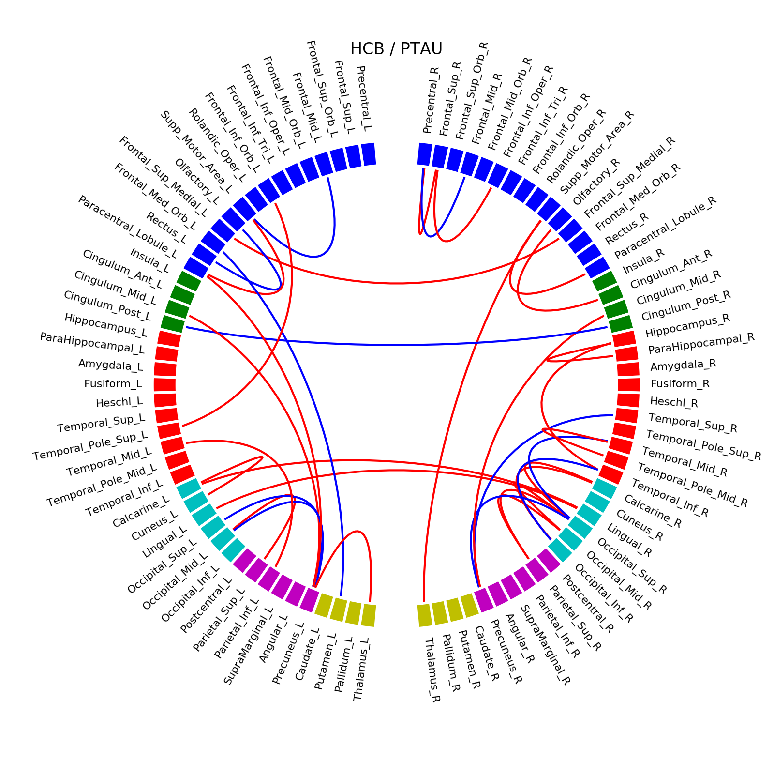

Supplementary Fig. 26. HCB database, correlations with p-tau (blue: positive correlation, red: negative correlation)
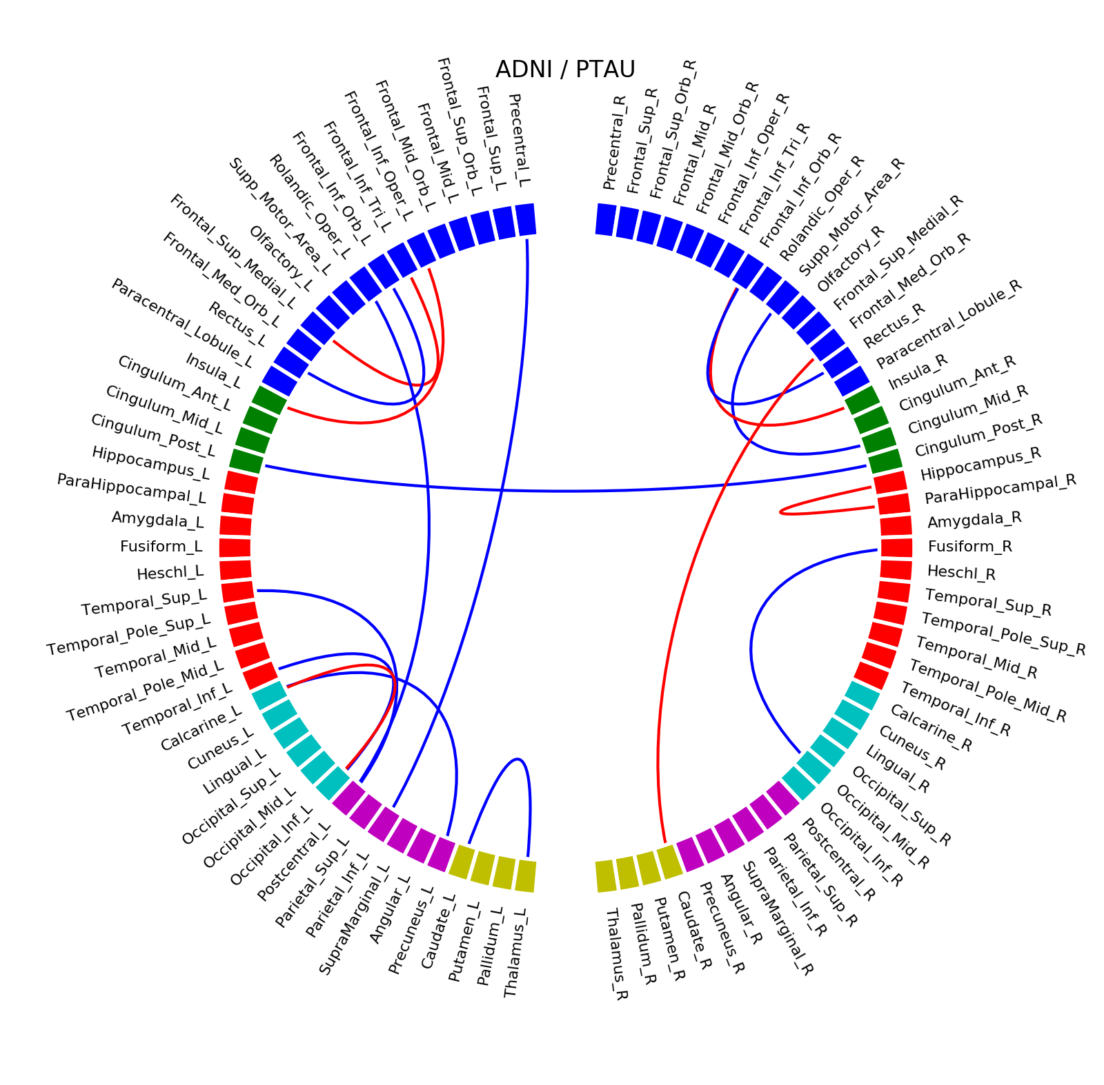

Supplementary Fig. 27. ADNI database, correlations with p-tau (blue: positive correlation, red: negative correlation)
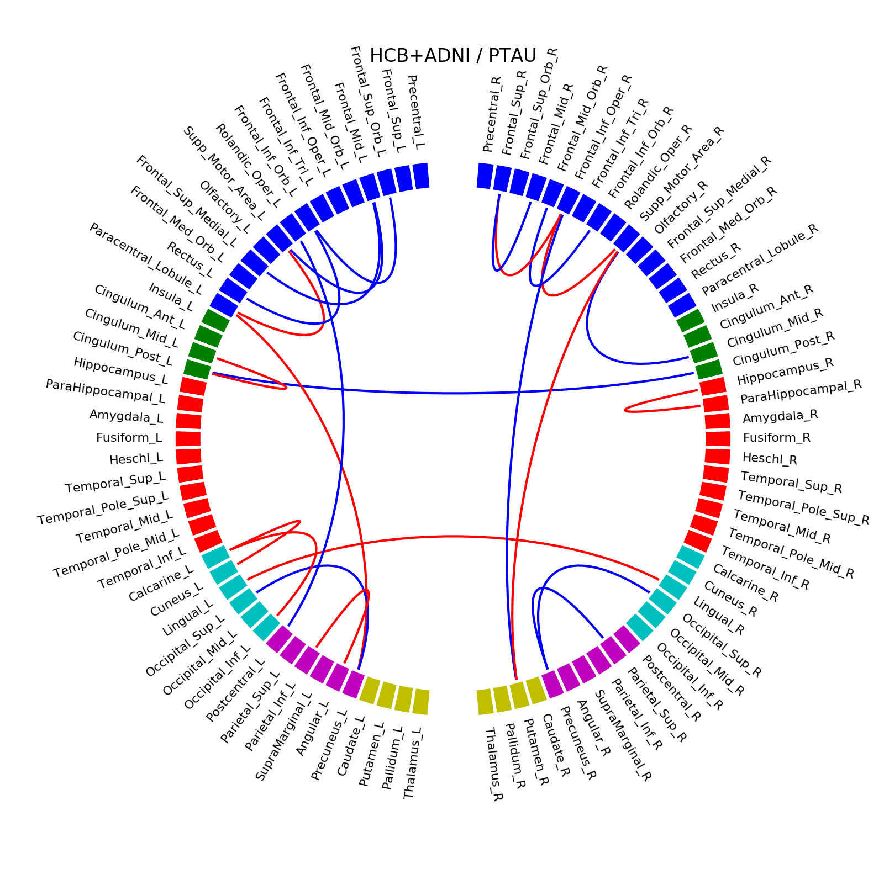
Supplementary Fig. 28. HCB and ADNI databases merged together, correlations with p-tau
(blue: positive correlation, red: negative correlation)

- DIFFERENCES IN CONNECTIVITY BETWEEN GROUPS IN HCB AND ADNI DATASETS MERGED TOGETHER AFTER REGIONAL VOLUME-ADJUSTED ANALYSES

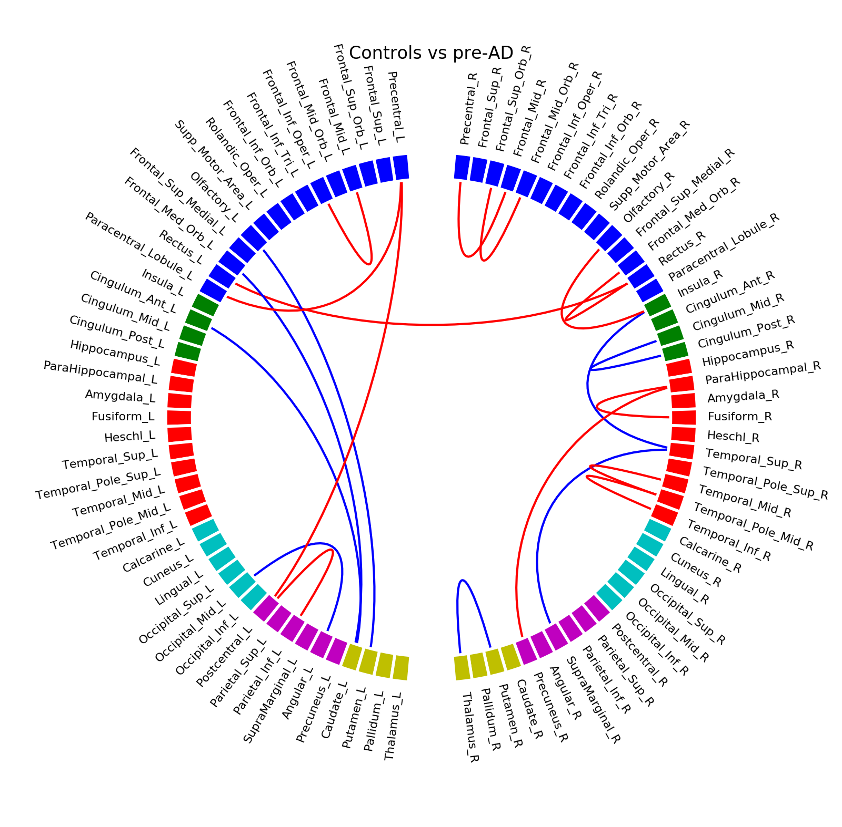

Supplementary Fig. 29. Difference of connectivity in Controls versus Pre-AD (blue: positive correlation, red: negative correlation) 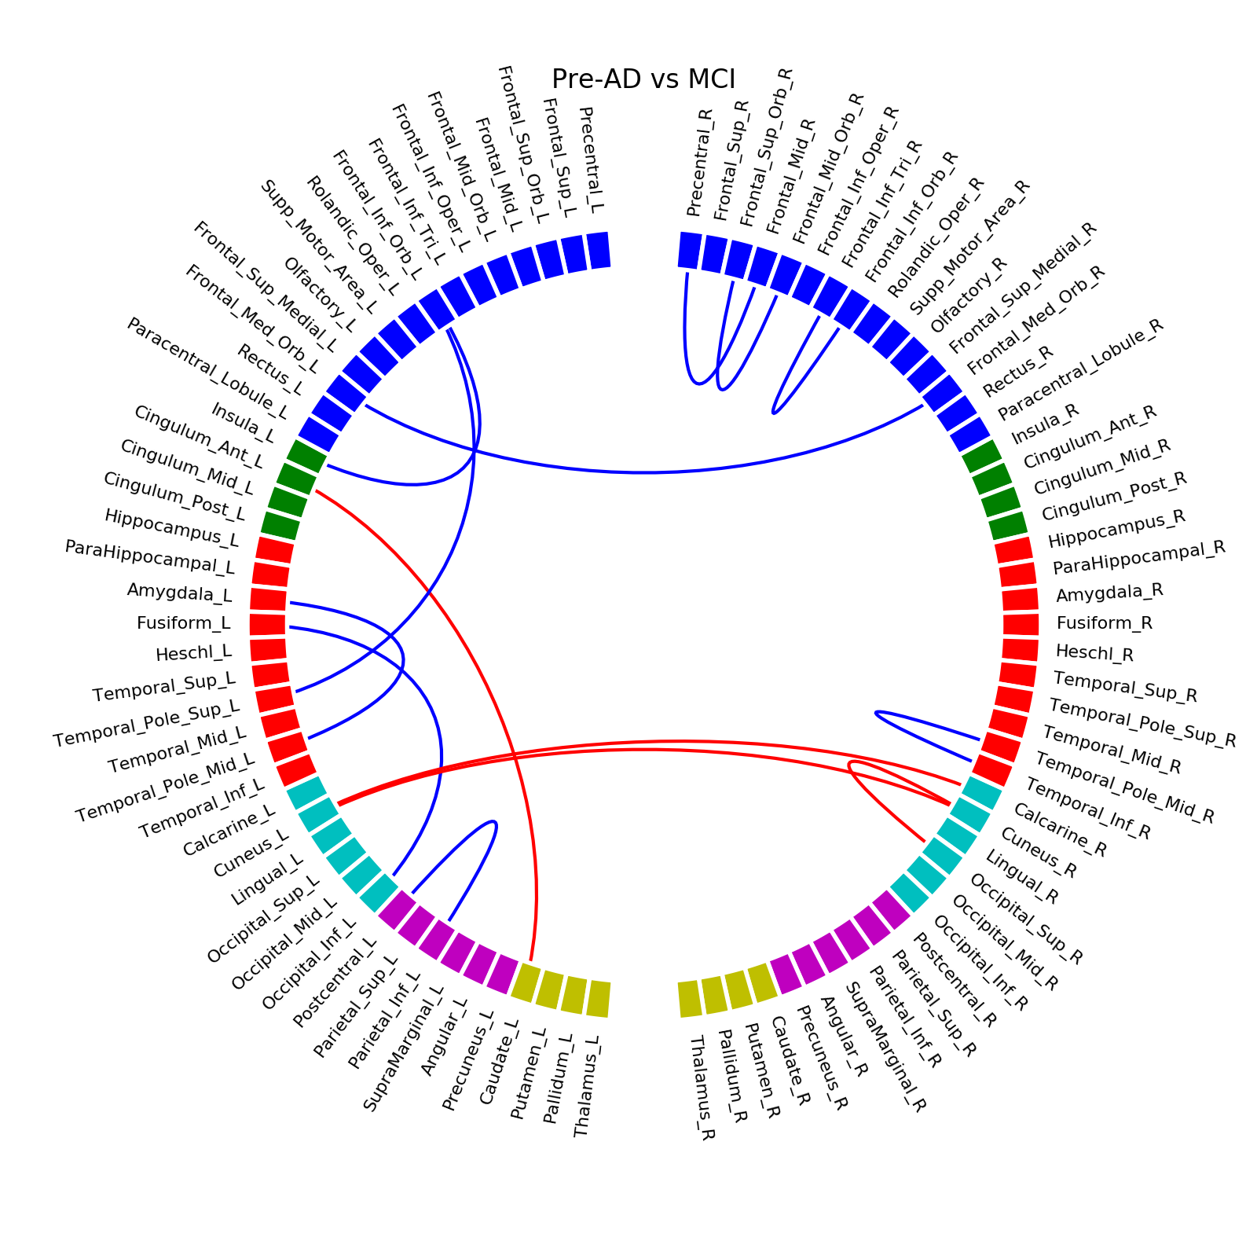
Supplementary Fig. 30. Difference of connectivity in Pre-AD versus MCI (blue: positive correlation, red: negative correlation)
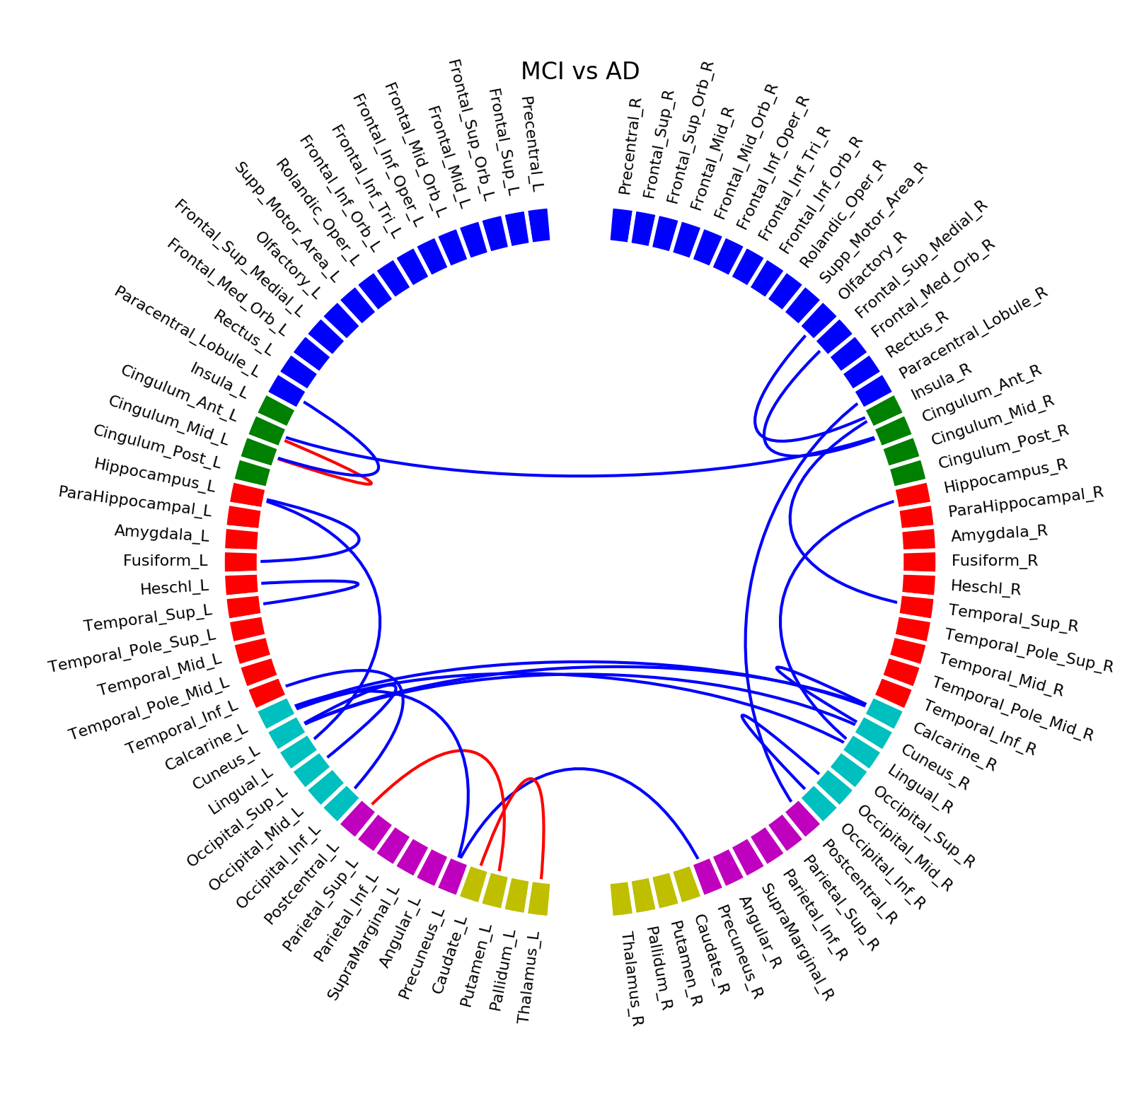
Supplementary Fig. 31. Difference of connectivity in MCI versus AD (blue: positive correlation, red: negative correlation)

