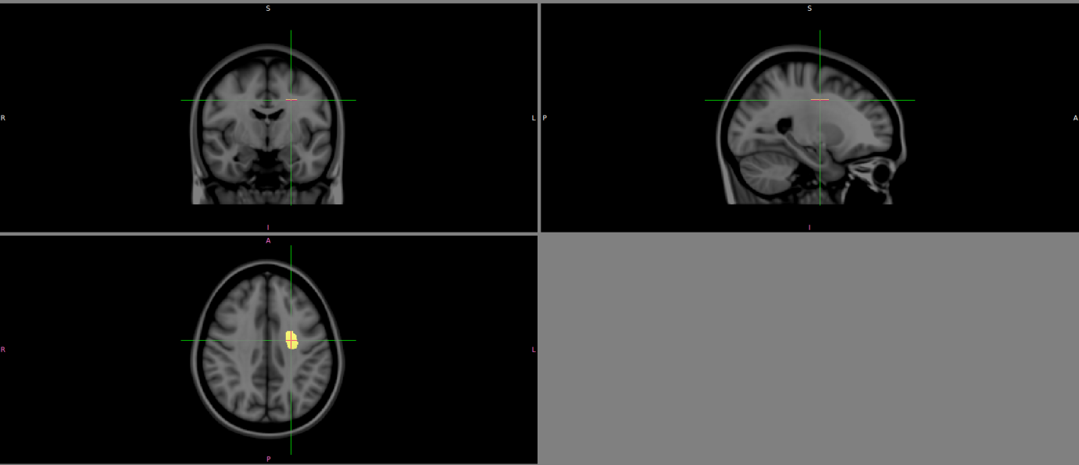

Supplementary Figure 1. An internal white matter reference to the figures. A free-hand region of interest was drawn in the left centrum semiovale on a given axial slice of MNI152 standard-space 1 mm T1-weighted average structural template image.

Supplementary Figure 2. Scatterplots representing the relationships between age and iron content in deep gray matter structures and Centrum Semiovale (control region). The Spearman correlations in the thalamus, caudate and putamen were significant.

