Supplementary Material
The expression levels of proteasome 20S α3 subunit and 20S α6 subunit were determined using semi-quantitative western blotting as for RPT6 but using a mouse monoclonal IgG (MCP257) for α3 (Supplementary Fig. 1) that recognized a very distinct band at approximately 29 kDa, which is consistent with published size [1] and data sheet from the supplier and a mouse monoclonal IgG (MCP20) for α6 (Supplementary Fig. 2) that recognized a very distinct band at approximately 28 kDa, which is consistent with published size [2] and data sheet from the supplier.

REFERENCES
[1] Wang P, Calise J, Powell K, Divald A, Powell SR (2014) Upregulation of proteasome activity rescues cardiomyocytes following pulse treatment with a proteasome inhibitor. Am J Cardiovasc Dis 4, 6-13.
[2] Camargo R, Faria LO, Kloss A, Favali CB, Kuckelkorn U, Kloetzel PM, de Sa CM, Lima BD (2014) Trypanosoma cruzi infection down-modulates the immunoproteasome biosynthesis and the MHC class I cell surface expression in HeLa cells. PLoS One 9, e95977.

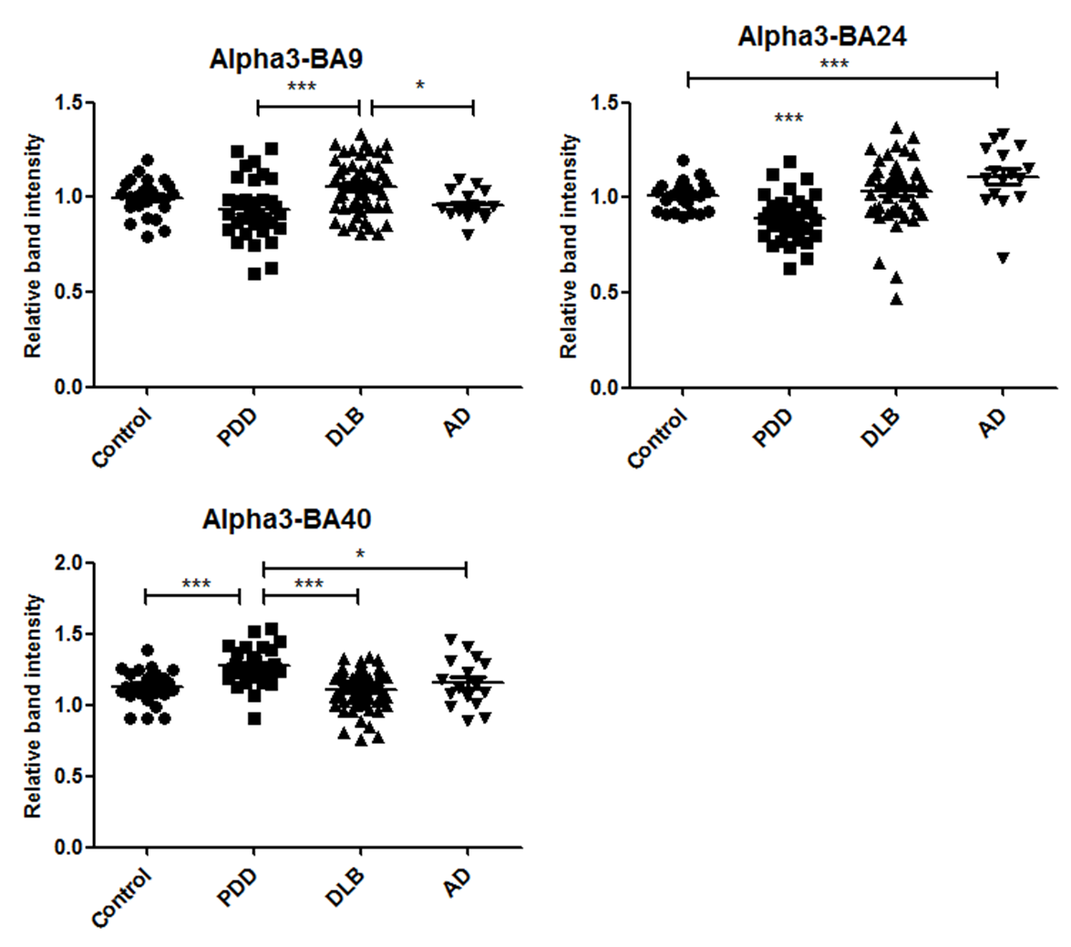

Supplementary Figure 1. In BA9, the α3 subunit of the 20S proteasome unit was significantly increased in PDD cases compared to DLB (U=488, p=0.002) and AD cases (U=227, p=0.01) according to Mann-Whitney U test. In BA24, PDD cases had significantly lower levels of α3 compared to control (U=151, p=0.00014), DLB (U=333, p=0.00001), and AD (U=66, p=0.00002). Control cases were significantly lower than AD cases (U=83, p=0.004). In BA40, PDD cases had significantly higher levels of α3 compared to control (p=0.001), DLB (p=0.000005), and AD (p=0.043) according to one-way ANOVA and Bonferroni post hoc test (F=10.495, df=3,126 p=0.000003).
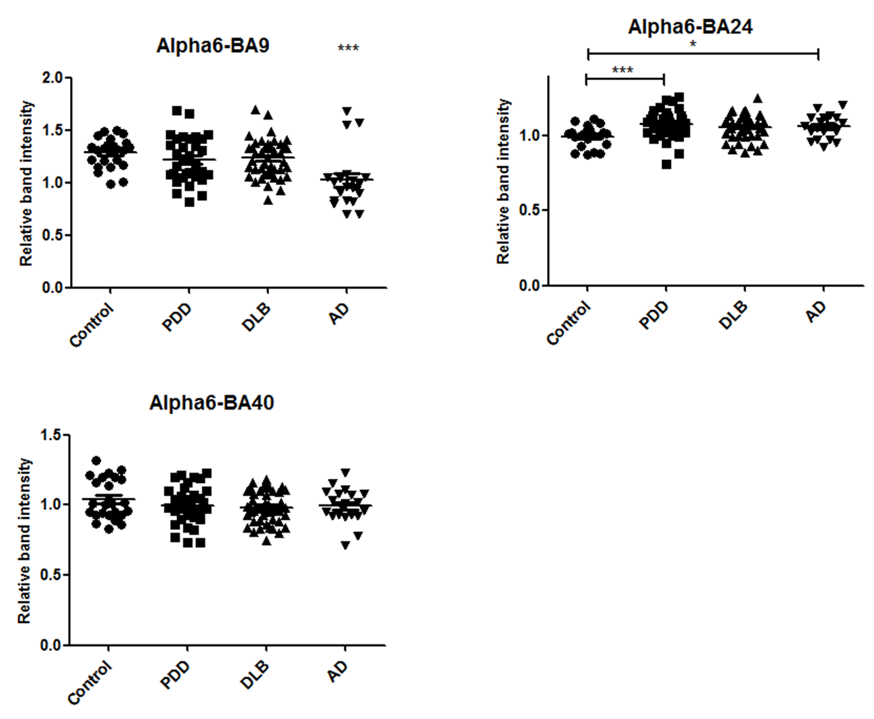

Supplementary Figure 2. The levels of α6 in BA9 were significantly decreased in AD cases compared to controls (U=84, p=0.0002), PDD (U=149.5, p=0.001), and DLB (U=175, p=0.00009). In BA24, the levels of α6 were significantly reduced in control cases compared to PDD cases (p=0.002) and DLB cases (p=0.007) according to one-way ANOVA and Bonferroni post hoc test (F=5.221, df=3,119, p=0.002). In BA40, there was no significant difference in the levels of α6 between diagnostic groups.
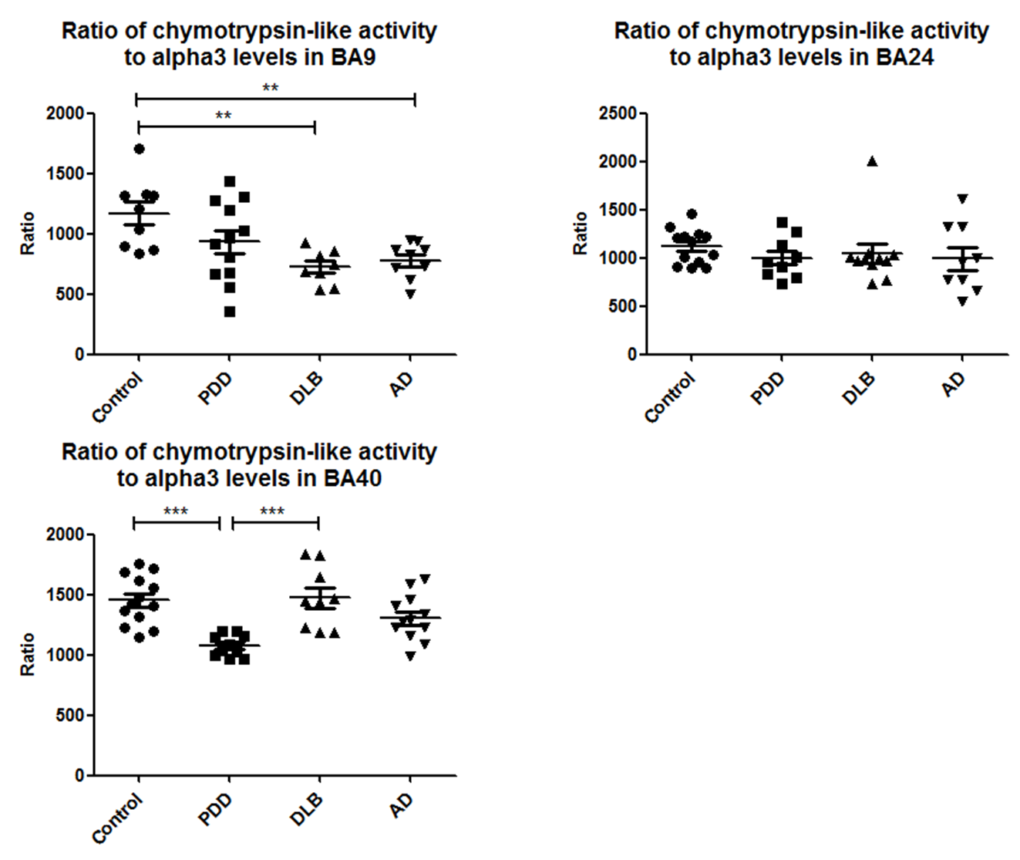

Supplementary Figure 3. The ratio of chymotrypsin-like activity to α3 levels was determined for each brain region. In BA9, this ratio was significantly higher in control cases compared to DLB and to AD cases (U=4, p=0.002) and (U=9, p=0.005). In BA24, there was no significant difference between diagnostic groups. In BA40, PDD cases had a significantly lower ratio compared to control (p=0.0002) and DLB (p=0.0004) according to one-way ANOVA and Bonferroni post hoc test (F=9.102, df=3,40, p=0.0001).
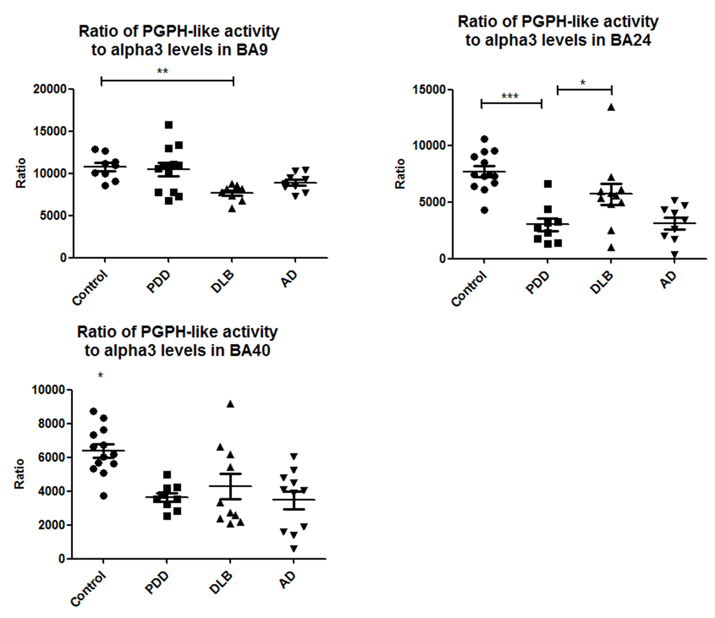

Supplementary Figure 4. Likewise, PGPH-like activity was expressed as a ratio to the level of α3. In BA9, this ratio was significantly decreased in DLB cases compared to control cases (U=1, p=0.001). In BA24, this ratio was significantly lower in PDD cases compared to control (p=0.00006) and DLB (0.044) according to one-way ANOVA (F=12.228, df=3,38, p=0.00001). In BA40, control cases had a significantly higher ratio than PDD (p=0.004), DLB (p=0.032), and AD (0.001) according to one-way ANOVA (F=7.502, df=3,39, p=0.0004).
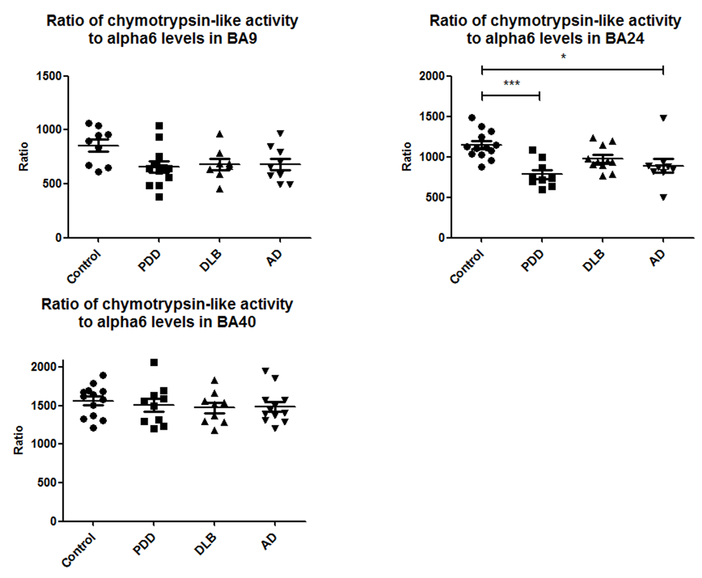

Supplementary Figure 5. The ratio of chymotrypsin-like activity to the level of α6 subunits in BA9 and in BA40 was not significantly different between diagnostic groups. However, in BA24, it was significantly higher in control cases compared to PDD and AD cases (p=0.0004 and p=0.018) according to one-way ANOVA and Bonferroni post hoc-test (F=7.351, df=3,38, p=0.001).
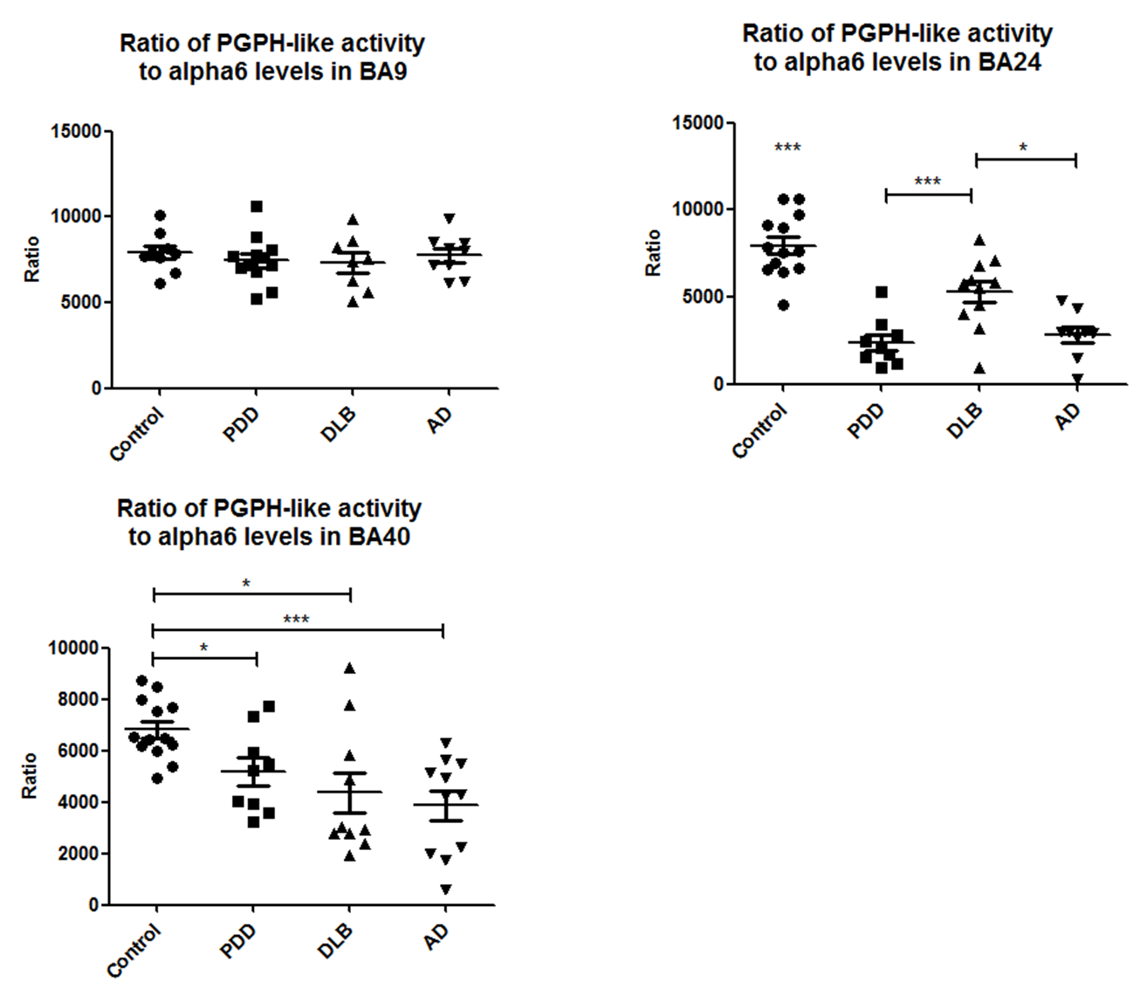

Supplementary Figure 6. There was no significant different in the ratio of PGPH-like activity to the level of α6 subunits in BA9 between diagnostic groups. However, in BA24 this ratio was significantly higher in control cases compared to PDD (p=0.00000002), DLB (p=0.003), and AD cases (p=0.0000001). DLB cases had a significantly higher ratio compared to PDD (p=0.003) and to AD cases (p=0.015), according to one-way ANOVA and Bonferroni post-hoc test (F=25.475, df=3,38, p=0.000000003). In BA40, this ratio was significantly higher in control cases compared to PDD (U=23, p=0.018), DLB (U=25, p=0.013), and AD cases (U=10, p=0.0004).

