Supplementary Material
Supplementary Table 1: Participant baseline characteristics and CSF markers for those with >20% change of BACE1 protein levels from baseline following acute (single) dosing with JNJ-54861911 at 1, 3, 10, 30, 90, and 150 mg or placebo.

Age | Sex | Treatment mg | APOE ε4 carrier status | Baseline BACE1 ng/mL | BACE1 ng/mL  24 h post dose | BACE1 %change from baseline | Baseline CSF Markers
 |  |  |  |  |  |  | Aβ₁₋₃₇ pg/mL | Aβ₁₋₃₈ pg/mL | Aβ₁₋₄₀ pg/mL | Aβ₁₋₄₂ pg/mL | ALZBIO3  Aβ₁₋₄₂ pg/mL | p-tau_{181p} pg/mL | t-tau pg/mL | sAβPP Total ng/mL | sAβPPα ng/mL | sAβPPβ ng/mL
63 | F | 1 | Y | 3.388 | 2.472 | -27 | 1115 | 3050 | 9092 | 1398 | 396.2 | 21 | 39.6 | 917 | 149 | 218
68 | F | Placebo | Y | 5.244 | 3.912 | -25.4 | 1139 | 4348 | 16246 | 960 | - | - | - | 1438 | 210 | 304
68 | F | 1 | Y | 3.6 | 9.228 | 156.3 | 792 | 2769 | 12696 | 1298 | 377.2 | 34.8 | 79.8 | 1032 | 150 | 215
74 | F | 1 | N | 3.356 | 4.144 | 23.5 | 991 | 2666 | 8993 | 1225 | 368.9 | 26.9 | 73.9 | 1168 | 154 | 222
72 | M | 3 | N | 7.4215 | 9.1775 | 23.7 | 1080 | 3415 | 9984 | 1384 | 385.7 | 20.5 | 48 | 841 | 130 | 160
57 | M | Placebo | N | 10.687 | 13.402 | 25.4 | 964 | 3386 | 11223 | 1411 | 368.7 | 28.3 | 46.3 | 1627 | 202 | 279
59 | F | 30 | N | 6.6325 | 10.081 | 52 | 795 | 2226 | 5477 | 879 | 353.7 | 23 | 43.8 | 989 | 141 | 184
64 | M | 30 | N | 9.5145 | 13.346 | 40.3 | 815 | 3021 | 6621 | 1022 | 346.9 | 28.9 | 52.5 | 968 | 146 | 208
70 | F | 90 | N | 18.8195 | 12.522 | -33.5 | 1548 | 4953 | 13608 | 1041 | 179.3 | 40.9 | 85.6 | 1159 | 149 | 226
67 | M | 90 | Y | 11.4725 | 14.8015 | 29 | 22.7 | 2643 | 6317 | 1282 | - | 9.3 | - | 1225 | 85 | 120
59 | F | 150 | N | 4.621 | 6.868 | 48.6 | 830 | 2262 | 6227 | 1213 | 322.5 | 23.6 | - | 984 | 190 | 235
58 | M | 150 | N | 5.461 | 7.593 | 39 | 627 | 1931 | 5829 | 1107 | 386.3 | 21.5 | 47.4 | 1044 | 149 | 205
Participants were enrolled in the single ascending dose study earlier described [28] and received a single dose administration of JNJ-54861911(dose 1 to 150 mg) or placebo. Only participants (n=45) who had CSF samples collected by indwelling catheters and had available BACE1 measures at baseline were included in the analysis. Individual participants (n=12) showing >20% change from baseline in CSF BACE1 levels are depicted including their baseline biomarker profiles, APOE ε4 status, and treatment allocation.

Supplementary Figure 1: Percent change in CSF BACE1 levels at 24-h post dose for those with >20% change in BACE1 protein levels from baseline following single dosing with JNJ-54861911 at 1, 3, 10, 30, 90, and 150 mg or placebo.
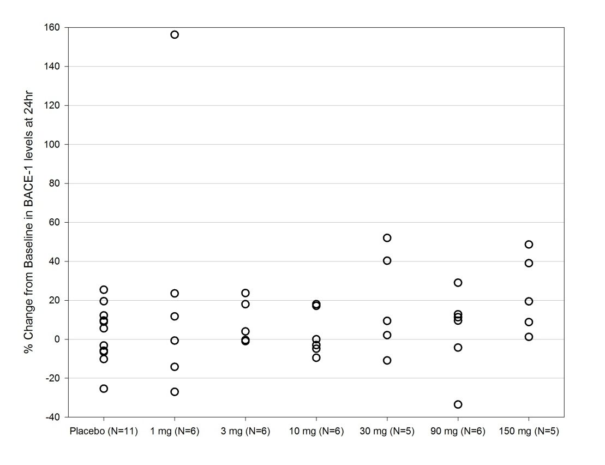
Data are represented as individual and mean percent change in CSF BACE1 from Day 1 baseline up to 24-h post dose. Participants were enrolled in the single ascending dose study earlier described [28] and received a single dose administration of JNJ-54861911(dose 1 to 150 mg) or placebo. Only participants (n=45) who had CSF samples collected by indwelling catheters and had available BACE1 measures at baseline were included in the analysis. Individual participants (n=12) showing >20% change from baseline in CSF BACE1 levels are depicted including their baseline biomarker profiles, APOE ε4 status and treatment allocation.

