Supplementary Table 1

Mean differences (β–coefficients) and 95% confidence intervals (CIs) of the association between diabetes and cognitive performance across domains

|  |  |  |  |  |  |  |  |  |  |  |  |  |
| --- | --- | --- | --- | --- | --- | --- | --- | --- | --- | --- | --- | --- |
|  | *n* | MMSE | |  | Perceptual speed | |  | Category fluency | |  | Letter fluency | |
|  | β (95% CI) | *p* |  | β (95% CI) | *p* |  | β (95% CI) | *p* |  | β (95% CI) | *p* |
| Diabetes‒free | 1538 | Reference |  |  | Reference |  |  | Reference |  |  | Reference |  |
| Prediabetes | 571 | -0.01 (-0.12 to 0.10) | 0.895 |  | -0.06 (-0.60 to 0.48) | 0.830 |  | 0.29 (-0.49 to 1.08) | 0.462 |  | 0.10 (-0.72 to 0.93) | 0.812 |
| Diabetes | 196 | -0.10 (-0.27 to 0.06) | 0.228 |  | -0.82 (-1.71 to 0.07) | 0.070 |  | -0.75 (-2.00 to 0.50) | 0.242 |  | -0.10 (-1.37 to 1.17) | 0.876 |
| Controlled | 52 | -0.03 (-0.34 to 0.27) | 0.823 |  | -0.62 (-2.41 to 1.18) | 0.501 |  | -0.84 (-2.78 to 1.10) | 0.396 |  | -0.17 (-2.47 to 2.12) | 0.882 |
| Uncontrolled | 144 | -0.13 (-0.31 to 0.06) | 0.177 |  | -0.90 (-1.86 to 0.06) | 0.066 |  | -0.71 (-2.20 to 0.78) | 0.349 |  | -0.07 (-1.50 to 1.36) | 0.921 |
|  |  | Semantic memory | |  | Episodic memory | |  | Digit span forward | |  | Digit span backward | |
|  |  | β (95% CI) | *p* |  | β (95% CI) | *p* |  | β (95% CI) | *p* |  | β (95% CI) | *p* |
| Diabetes‒free | 1538 | Reference |  |  | Reference |  |  | Reference |  |  | Reference |  |
| Prediabetes | 571 | -0.43 (-1.31 to 0.45) | 0.341 |  | 0.37 (-0.35 to 1.08) | 0.312 |  | 0.05 (-0.08 to 0.17) | 0.439 |  | 0.07 (-0.05 to 0.19) | 0.286 |
| Diabetes | 196 | 0.30 (-1.02 to 1.63) | 0.652 |  | -0.26 (-1.42 to 0.91) | 0.666 |  | -0.21 (-0.39 to -0.02) | 0.027 |  | -0.10 (-0.28 to 0.08) | 0.279 |
| Controlled | 52 | 1.24 (-0.78 to 3.26) | 0.230 |  | 0.73 (-1.18 to 2.64) | 0.456 |  | -0.31 (-0.64 to 0.01) | 0.059 |  | -0.11 (-0.38 to 0.15) | 0.403 |
| Uncontrolled | 144 | -0.06 (-1.64 to 1.52) | 0.941 |  | -0.64 (-2.01 to 0.72) | 0.355 |  | -0.17 (-0.38 to 0.04) | 0.119 |  | -0.09 (-0.31 to 0.12) | 0.398 |

Multi–adjusted model: adjusted for age, sex, and education, vascular risk factors, vascular disorders, depression, *APOE* ε4, and physical activity. *APOE*, apolipoprotein; MMSE, Mini-Mental State Examination

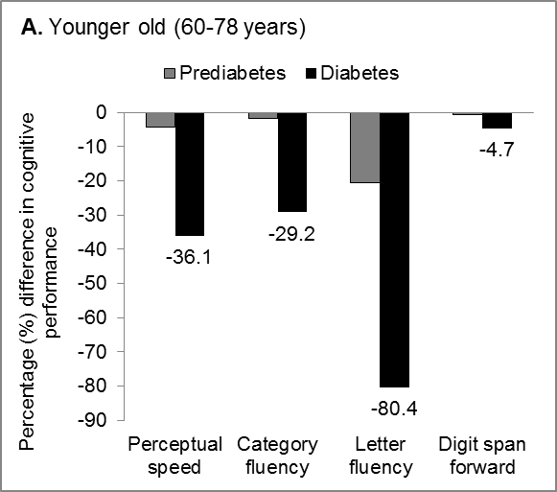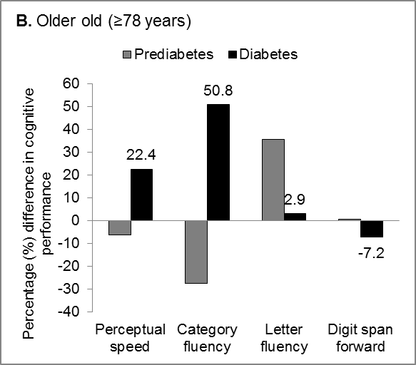

**‘**

**

*

**

**

Supplementary Fig. 1.Percentage differences in mean cognitive performance stratified by diabetes and age. Analyses were adjusted for age, sex, and education. Sex and education were centered at the proportion of female (0.58) and low education (0.14) within each age–group. All latent factor scores were multiplied by 100. \**p* < 0.05, \*\**p* < 0.01 (Reference group: diabetes‒free participants)

Supplementary Fig. 2. Unadjusted mean cognitive performance among participants with diabetes (*n* = 196) by glycemic control status. The figure shows the mean cognitive performance of participants with controlled (*n* = 52) and uncontrolled (*n* = 144) diabetes. T test for unequal variance was used to compare the mean cognitive performance between the two groups (\**p* < 0.05).